Project 2: Persuasive or Deceptive Visualization?

# Proposition 1: USA’s export advantage over China is significant with a trend to empower such advantage

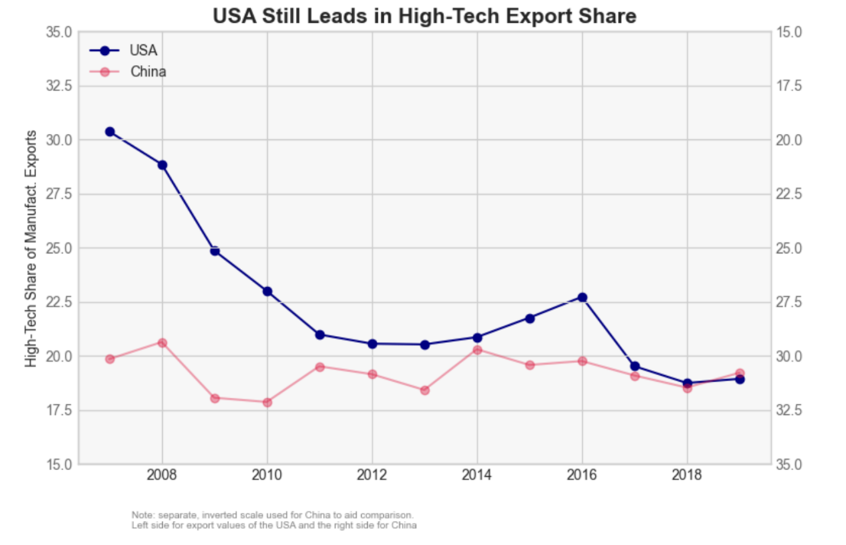Proposition 2: USA Still Leads in High-Tech Export Share

# Counter proposition 1: USA’s export advantage over China no longer persists.

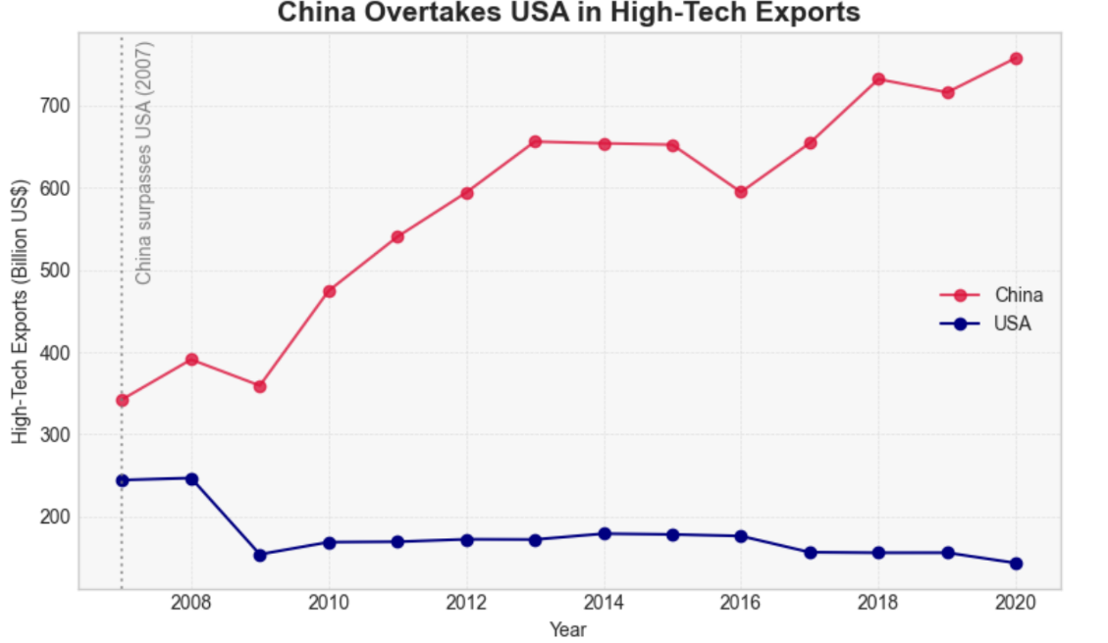Counter proposition 2: China Overtakes USA in High-Tech Exports

**Persuasive Visualization Writeup**

Propositions:

**“Whether USA’s export advantage over China is significant with a trend to empower such advantage”;**

**“Whether USA leads in high-tech export share”**

Visualization Proposition 1:

* **Data Used**:
  + Summation of all categories of exports
  + Filtered for *China* and *United States*, aligned by year.
* **Deceptive Techniques**:
  + Adjusted the **specific years** so that the proposition can be best supported
  + Also controlled the range of y axis to highlight contrast (the **same difference** is **more dramatic** in visualization #1 than that of #3)
  + Title is emotional and seditious, suggesting way of interpretation.

Visualization Proposition 2:

**Personal incline**: I myself lean to this visualization because the small footnote, along with the inverted y axis, not only takes me time to figure out but is also creative, in my opinion

* **Data Used**:
  + average_value_High-technology exports (% of manufactured exports)
  + Also considered China/U.S. **share of world exports** in current US$.
* **Deceptive Techniques**:
  + **Used two y axis on purpose**:
    - U.S. plotted on a **normal y-axis (left)**.
    - China plotted on a **hidden, inverted y-axis (right)**.
  + China’s percentages are **actually higher**, but plot **lower** due to axis inversion.
  + Tight **y-range for U.S. (15–35%)** exaggerates upward trend.
  + **Small** footnote mentions the inversion, but it’s easy to overlook.
  + Title frames narrative as “USA Still Leads…”, suggesting way of interpretation.