INVOICE

CRES DYNAMICS LTD — TAX INVOICE

FROM: Cres Dynamics Ltd Nairobi, Kenya Email: info@cresdynamics.com Phone: +254 0708 805 496 Website: cresdynamics.com KRA PIN:

TO: Client Name: _Mary Mwihaki

Company: SparkLights254

Address: University way Delta

Email: whispersfloral@gmail.com

INVOICE DETAILS

Invoice Number: CD-INV- 004/26

Invoice Date: 11/3/26

Payment Due Date: 18/3/26

Project Reference: CD- Floral Whispers Gifts E-Commerce

Payment Stage: ☐ Retainer

INVOICE ITEMS

#  1 | Hosting | Description | items  buckets/perfomance _. | Amount (KES)  498.00_
2_Management_ |  |  | SEO/Chat bot/ Pallete
4 |  |  |  |  | 2,000

TOTAL DUE KES

PAYMENT INSTRUCTIONS

Pay within 7 days of invoice date.

- M-Pesa: Paybill _542542 | Account: _43869

- Bank Transfer: Bank: I & M Bank | Account Name: Cres Dynamics Ltd | Account No:
_01207943936150 | Branch:
Ongata Rongai

Other:

Please use Invoice Number CD-INV- 004/25 as your payment reference.

NOTES

Late payments attract 2% monthly interest after the due date. For payment queries contact info@cresdynamics.com or
+254 0708 805 496.

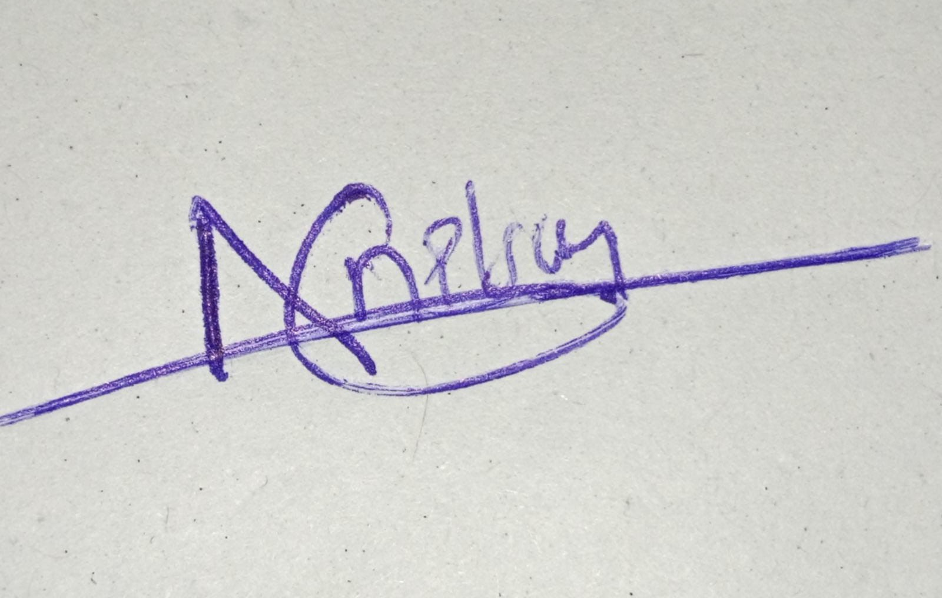
AUTHORISED BY:

Signature:

Name: Nelson Were

Title: Chief Executive Officer, Cres Dynamics Ltd Date: 11/March 2026

Thank you for your business. Cres Dynamics Ltd — cresdynamics.com

