Evaluating Personal Job Market Prospects in 2024
Final Report
Project Group 2
Carolina Resendez
Saori Kikuchi
April 11, 2026

Introduction
This project analyzes job market trends in 2024, focusing on required skills, salary patterns, and industry demand.
The goal is to identify key competencies needed for data-related careers and evaluate skill gaps within the team.

Data Cleaning
This page explains how the Lightcast job-posting dataset was prepared for analysis. The goal is to create a clean and consistent dataset for exploratory analysis, skill comparisons, clustering, regression, and classification.

Data Source
The project uses the file lightcast_job_postings.csv, stored in the data folder of the repository.

Initial Dataset Overview
The dataset contains 131 variables and includes structured fields related to job titles, salary ranges, skills, work arrangements, education, experience, and occupational classification systems such as SOC, ONET, and NAICS.
import pandas as pd
import numpy as np
import re
df = pd.read_csv("data/lightcast_job_postings.csv", low_memory=False, on_bad_lines="skip")
df.shape
(72498, 131)

Selected Columns
selected_cols = [
"TITLE_CLEAN",
"LOT_OCCUPATION_NAME",
"LOT_OCCUPATION_GROUP_NAME",
"LOT_SPECIALIZED_OCCUPATION_NAME",
"SALARY_FROM",
"SALARY_TO",
"ORIGINAL_PAY_PERIOD",
"SKILLS_NAME",
"SPECIALIZED_SKILLS_NAME",
"COMMON_SKILLS_NAME",
"SOFTWARE_SKILLS_NAME",
"CITY_NAME",
"STATE_NAME",
"REMOTE_TYPE_NAME",
"EDUCATION_LEVELS_NAME",
"MIN_YEARS_EXPERIENCE",
"MAX_YEARS_EXPERIENCE",
"SOC_2021_3_NAME",
"SOC_3_NAME",
"ONET_NAME",
"NAICS_2022_3_NAME",
"NAICS3_NAME",
"LIGHTCAST_SECTORS_NAME"
]
selected_cols = [c for c in selected_cols if c in df.columns]
df_clean = df[selected_cols].copy()
df_clean.shape
(72498, 23)

Standardizing Core Variables
df_clean["job_title"] = df_clean["TITLE_CLEAN"] if "TITLE_CLEAN" in df_clean.columns else np.nan
df_clean["occupation_name"] = df_clean["LOT_OCCUPATION_NAME"] if "LOT_OCCUPATION_NAME" in df_clean.columns else np.nan
df_clean["occupation_group"] = df_clean["LOT_OCCUPATION_GROUP_NAME"] if "LOT_OCCUPATION_GROUP_NAME" in df_clean.columns else np.nan
df_clean["specialized_occupation"] = df_clean["LOT_SPECIALIZED_OCCUPATION_NAME"] if "LOT_SPECIALIZED_OCCUPATION_NAME" in df_clean.columns else np.nan
df_clean["skills_all"] = df_clean["SKILLS_NAME"] if "SKILLS_NAME" in df_clean.columns else np.nan
df_clean["skills_specialized"] = df_clean["SPECIALIZED_SKILLS_NAME"] if "SPECIALIZED_SKILLS_NAME" in df_clean.columns else np.nan
df_clean["skills_common"] = df_clean["COMMON_SKILLS_NAME"] if "COMMON_SKILLS_NAME" in df_clean.columns else np.nan
df_clean["skills_software"] = df_clean["SOFTWARE_SKILLS_NAME"] if "SOFTWARE_SKILLS_NAME" in df_clean.columns else np.nan
df_clean["city"] = df_clean["CITY_NAME"] if "CITY_NAME" in df_clean.columns else np.nan
df_clean["state"] = df_clean["STATE_NAME"] if "STATE_NAME" in df_clean.columns else np.nan
df_clean["remote_type"] = df_clean["REMOTE_TYPE_NAME"] if "REMOTE_TYPE_NAME" in df_clean.columns else np.nan
df_clean["education_level"] = df_clean["EDUCATION_LEVELS_NAME"] if "EDUCATION_LEVELS_NAME" in df_clean.columns else np.nan
df_clean["min_experience"] = df_clean["MIN_YEARS_EXPERIENCE"] if "MIN_YEARS_EXPERIENCE" in df_clean.columns else np.nan
df_clean["max_experience"] = df_clean["MAX_YEARS_EXPERIENCE"] if "MAX_YEARS_EXPERIENCE" in df_clean.columns else np.nan
df_clean["soc_label"] = df_clean["SOC_2021_3_NAME"] if "SOC_2021_3_NAME" in df_clean.columns else df_clean["SOC_3_NAME"]
df_clean["naics_label"] = df_clean["NAICS_2022_3_NAME"] if "NAICS_2022_3_NAME" in df_clean.columns else df_clean["NAICS3_NAME"]
df_clean["onet_label"] = df_clean["ONET_NAME"] if "ONET_NAME" in df_clean.columns else np.nan
df_clean["sector_label"] = df_clean["LIGHTCAST_SECTORS_NAME"] if "LIGHTCAST_SECTORS_NAME" in df_clean.columns else np.nan

Salary Preparation
df_clean["salary_from_num"] = pd.to_numeric(df_clean["SALARY_FROM"], errors="coerce")
df_clean["salary_to_num"] = pd.to_numeric(df_clean["SALARY_TO"], errors="coerce")
df_clean["salary_mid"] = df_clean[["salary_from_num", "salary_to_num"]].mean(axis=1)
pay_period = df_clean["ORIGINAL_PAY_PERIOD"].astype(str).str.upper().str.strip()
annual_mask = pay_period.str.contains("YEAR|ANNUAL", na=False)
df_clean["annual_salary_mid"] = np.where(annual_mask, df_clean["salary_mid"], np.nan)

Feature Engineering
title_text = (
df_clean["job_title"].fillna("").astype(str) + " " +
df_clean["occupation_name"].fillna("").astype(str) + " " +
df_clean["specialized_occupation"].fillna("").astype(str)
).str.lower()
analytics_pattern = (
r"business analyst|data analyst|data scientist|data science|"
r"machine learning|ml engineer|business intelligence|bi analyst|"
r"analytics|data engineer|ai engineer|artificial intelligence"
)
df_clean["is_analytics_role"] = title_text.str.contains(analytics_pattern, regex=True, na=False).astype(int)
def count_items(x):
if pd.isna(x):
return 0
parts = re.split(r"[;|]", str(x))
parts = [p.strip() for p in parts if p and p.strip()]
return len(parts)
for col in ["skills_all", "skills_specialized", "skills_common", "skills_software"]:
df_clean[f"{col}_count"] = df_clean[col].apply(count_items)
df_clean["total_skill_count"] = (
df_clean["skills_all_count"]
+ df_clean["skills_specialized_count"]
+ df_clean["skills_common_count"]
+ df_clean["skills_software_count"]
)

Final Modeling Dataset
final_cols = [
"job_title",
"occupation_name",
"occupation_group",
"specialized_occupation",
"salary_from_num",
"salary_to_num",
"salary_mid",
"annual_salary_mid",
"remote_type",
"city",
"state",
"education_level",
"min_experience",
"max_experience",
"skills_all",
"skills_specialized",
"skills_common",
"skills_software",
"skills_all_count",
"skills_specialized_count",
"skills_common_count",
"skills_software_count",
"total_skill_count",
"soc_label",
"onet_label",
"naics_label",
"sector_label",
"is_analytics_role"
]
df_model = df_clean[final_cols].copy()
df_model.shape
(72498, 28)
df_model.to_csv("data/lightcast_cleaned.csv", index=False)

Key Findings
- Python and SQL are the most in-demand skills
- Salaries vary significantly by industry
- Experience increases salary but with variability

Exploratory Data Analysis
This page summarizes the main descriptive patterns in the cleaned Lightcast job-posting dataset. The goal is to understand the distribution of analytics-related roles, salary patterns, work arrangements, and skills before applying clustering, regression, and classification methods.

Load Cleaned Data
import pandas as pd
import matplotlib.pyplot as plt
df_eda = pd.read_csv("data/lightcast_cleaned.csv")
df_eda.shape
(72498, 28)

Analytics vs. Non-Analytics Roles
This section compares the number of postings classified as analytics-related versus all other roles.
role_counts = df_eda["is_analytics_role"].value_counts(dropna=False)
role_counts
is_analytics_role
1 63406
0 9092
Name: count, dtype: int64
role_counts.plot(kind="bar")
plt.title("Analytics vs. Non-Analytics Job Postings")
plt.xlabel("Is Analytics Role")
plt.ylabel("Count")
plt.xticks(rotation=0)
plt.show()
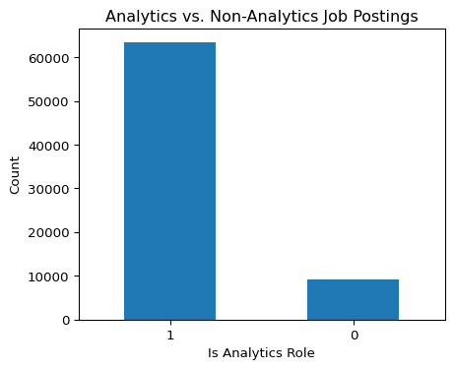

Salary Distribution
This section examines the distribution of annual salary midpoints for postings with annual salary information.
salary_data = df_eda["annual_salary_mid"].dropna()
salary_data.describe()
count 23693.000000
mean 123371.352172
std 46041.497947
min 11148.000000
25% 90000.000000
50% 120000.000000
75% 150000.000000
max 800000.000000
Name: annual_salary_mid, dtype: float64
salary_data.plot(kind="hist", bins=30)
plt.title("Distribution of Annual Salary Midpoints")
plt.xlabel("Annual Salary Midpoint")
plt.ylabel("Frequency")
plt.show()
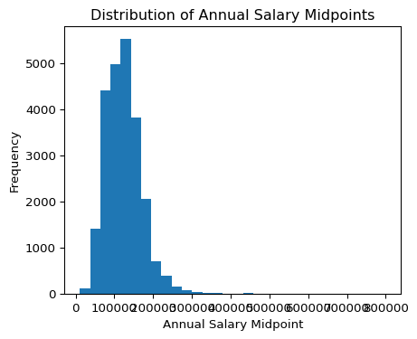

Remote Work Patterns
This section summarizes the work arrangement categories available in the dataset.
remote_counts = df_eda["remote_type"].value_counts(dropna=False)
remote_counts
remote_type
[None] 56570
Remote 12497
Hybrid Remote 2260
Not Remote 1127
NaN 44
Name: count, dtype: int64
remote_counts.plot(kind="bar")
plt.title("Remote Work Arrangement Distribution")
plt.xlabel("Remote Type")
plt.ylabel("Count")
plt.xticks(rotation=45)
plt.show()
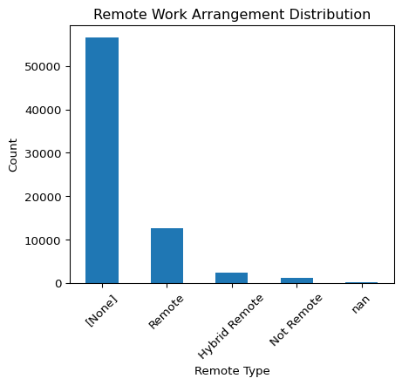

Education Requirements
This section shows the most common education levels requested in the postings.
education_counts = df_eda["education_level"].value_counts(dropna=False).head(10)
education_counts
education_level
[\n "Bachelor's degree"\n] 29969
[\n "No Education Listed"\n] 22110
[\n "Bachelor's degree",\n "Master's degree"\n] 10501
[\n "Associate degree",\n "Bachelor's degree"\n] 1972
[\n "Master's degree"\n] 1623
[\n "High school or GED"\n] 1541
[\n "High school or GED",\n "Bachelor's degree"\n] 1408
[\n "Bachelor's degree",\n "Master's degree",\n "Ph.D. or professional degree"\n] 853
[\n "Associate degree"\n] 786
[\n "Associate degree",\n "Bachelor's degree",\n "Master's degree"\n] 267
Name: count, dtype: int64
education_counts.plot(kind="bar")
plt.title("Top Education Levels in Job Postings")
plt.xlabel("Education Level")
plt.ylabel("Count")
plt.xticks(rotation=45, ha="right")
plt.show()
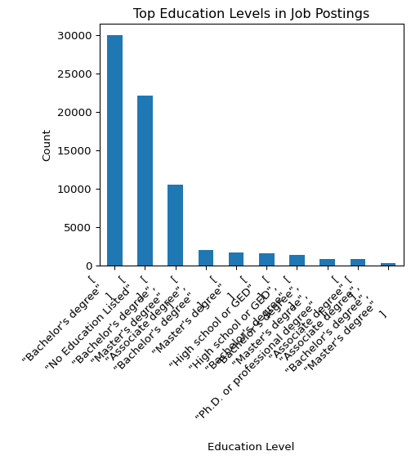

Experience Requirements
This section summarizes years of experience requested across postings.
df_eda[["min_experience", "max_experience"]].describe()
 | min_experience | max_experience
count | 49352.000000 | 8430.000000
mean | 5.486444 | 3.773903
std | 3.322241 | 2.576739
min | 0.000000 | 0.000000
25% | 3.000000 | 2.000000
50% | 5.000000 | 3.000000
75% | 8.000000 | 5.000000
max | 15.000000 | 14.000000

Skill Count Distribution
This section examines how many skills are listed across job postings using the constructed skill count variable.
df_eda["total_skill_count"].describe()
count 72498.000000
mean 3.997572
std 0.098513
min 0.000000
25% 4.000000
50% 4.000000
75% 4.000000
max 4.000000
Name: total_skill_count, dtype: float64
df_eda["total_skill_count"].dropna().plot(kind="hist", bins=30)
plt.title("Distribution of Total Skill Counts")
plt.xlabel("Total Skill Count")
plt.ylabel("Frequency")
plt.show()
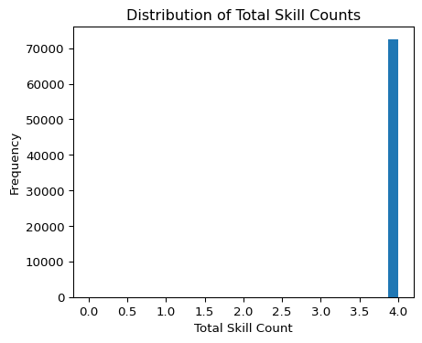

Top Occupation Groups
This section highlights the most common occupation groups in the cleaned dataset.
top_occ_groups = df_eda["occupation_group"].value_counts().head(10)
top_occ_groups
occupation_group
Data Analysis and Mathematics 30057
Business Intelligence 29445
Network and Systems Engineering 8212
Business Analysis 4326
Health IT Professionals 261
Marketing Specialists 153
Name: count, dtype: int64
top_occ_groups.plot(kind="bar")
plt.title("Top Occupation Groups")
plt.xlabel("Occupation Group")
plt.ylabel("Count")
plt.xticks(rotation=45, ha="right")
plt.show()
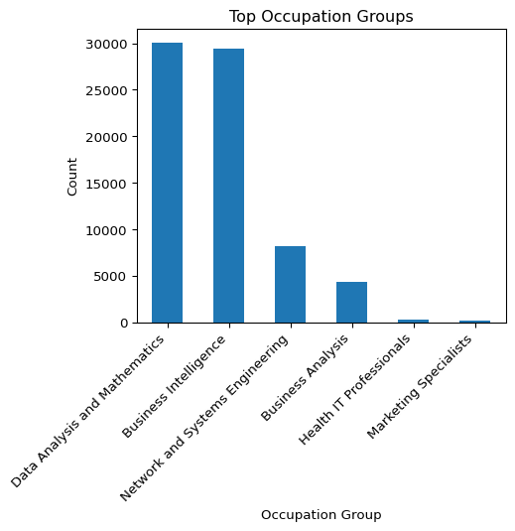

Key Takeaways
The exploratory analysis provides a first view of how analytics-related roles compare with the rest of the dataset. It also highlights salary availability, remote work patterns, education requirements, experience ranges, and variation in skill counts. These results help identify which variables are useful for skill comparisons, clustering, regression, and classification in the next sections.

Modeling Methods
This page presents the main modeling methods used in the project. The goal is to identify patterns in analytics-related job postings and evaluate which factors help explain role groupings and salary differences. The methods include KMeans clustering, salary regression, and role classification.

Load Cleaned Data
import pandas as pd
import numpy as np
import matplotlib.pyplot as plt
from sklearn.model_selection import train_test_split
from sklearn.compose import ColumnTransformer
from sklearn.pipeline import Pipeline
from sklearn.preprocessing import OneHotEncoder, StandardScaler
from sklearn.impute import SimpleImputer
from sklearn.cluster import KMeans
from sklearn.decomposition import PCA
from sklearn.metrics import (
silhouette_score,
mean_squared_error,
r2_score,
accuracy_score,
f1_score,
confusion_matrix,
ConfusionMatrixDisplay
)
from sklearn.linear_model import LinearRegression, LogisticRegression
df_ml = pd.read_csv("data/lightcast_cleaned.csv")
df_ml.shape
(72498, 28)

Feature Selection Rationale
The selected variables reflect the main dimensions emphasized in the project: skills, experience, education, location, work arrangement, and occupational grouping. For salary analysis, numeric variables are first inspected to see how strongly they relate to annual salary.
salary_corr = df_ml[
["annual_salary_mid", "salary_mid", "min_experience", "max_experience",
"skills_all_count", "skills_specialized_count", "skills_common_count",
"skills_software_count", "total_skill_count"]
].corr(numeric_only=True)["annual_salary_mid"].sort_values(ascending=False)
salary_corr
annual_salary_mid 1.000000
salary_mid 1.000000
max_experience 0.533913
min_experience 0.493927
skills_all_count NaN
skills_specialized_count NaN
skills_common_count NaN
skills_software_count NaN
total_skill_count NaN
Name: annual_salary_mid, dtype: float64

KMeans Clustering
KMeans clustering is used to identify natural groupings of job postings based on numeric job characteristics. The clustering results are then compared with SOC labels to evaluate whether the clusters align with occupational categories.
cluster_vars = [
"salary_mid",
"min_experience",
"max_experience",
"skills_all_count",
"skills_specialized_count",
"skills_common_count",
"skills_software_count",
"total_skill_count"
]
kmeans_df = df_ml[cluster_vars + ["soc_label"]].dropna().copy()
kmeans_df.shape
(3938, 9)
X_cluster = kmeans_df[cluster_vars]
scaler = StandardScaler()
X_cluster_scaled = scaler.fit_transform(X_cluster)
silhouette_scores = {}
for k in range(2, 7):
km = KMeans(n_clusters=k, random_state=42, n_init=10)
labels = km.fit_predict(X_cluster_scaled)
silhouette_scores[k] = silhouette_score(X_cluster_scaled, labels)
silhouette_scores
{2: 0.5101550739478664,
3: 0.40775021539751205,
4: 0.3805335881063199,
5: 0.4096460317452402,
6: 0.419437401417407}
best_k = max(silhouette_scores, key=silhouette_scores.get)
best_k
2
kmeans = KMeans(n_clusters=best_k, random_state=42, n_init=10)
kmeans_df["cluster"] = kmeans.fit_predict(X_cluster_scaled)
kmeans_df["cluster"].value_counts().sort_index()
cluster
0 2673
1 1265
Name: count, dtype: int64
pca = PCA(n_components=2)
cluster_pca = pca.fit_transform(X_cluster_scaled)
plot_df = pd.DataFrame({
"PC1": cluster_pca[:, 0],
"PC2": cluster_pca[:, 1],
"cluster": kmeans_df["cluster"]
})
plt.figure(figsize=(8, 6))
for c in sorted(plot_df["cluster"].unique()):
subset = plot_df[plot_df["cluster"] == c]
plt.scatter(subset["PC1"], subset["PC2"], label=f"Cluster {c}", alpha=0.5)
plt.title("KMeans Clusters of Job Postings")
plt.xlabel("Principal Component 1")
plt.ylabel("Principal Component 2")
plt.legend()
plt.show()
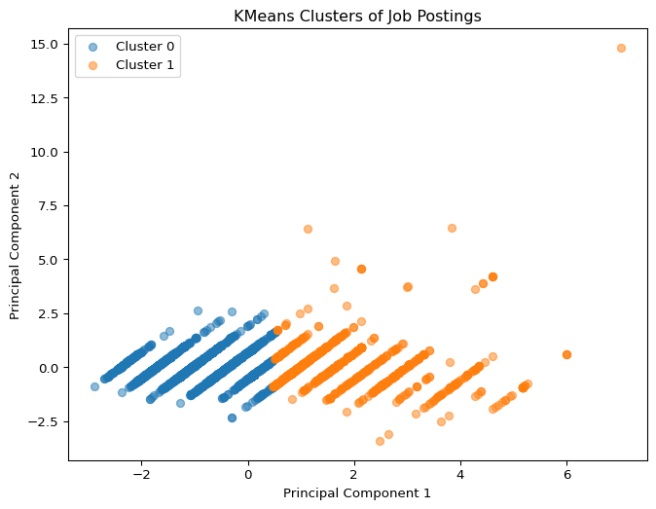
top_soc = kmeans_df["soc_label"].value_counts().head(8).index
cluster_soc_table = pd.crosstab(kmeans_df["cluster"], kmeans_df["soc_label"])[top_soc]
cluster_soc_table
soc_label | Mathematical Science Occupations
cluster
0 | 2673
1 | 1265

Regression Model
A regression model is used to estimate annual salary midpoint based on experience, skill counts, remote arrangement, education, location, and occupation group.
salary_df = df_ml[df_ml["annual_salary_mid"].notna()].copy()
salary_df.shape
(23693, 28)
reg_features = [
"total_skill_count",
"min_experience",
"max_experience",
"remote_type",
"state",
"education_level",
"occupation_group"
]
X_reg = salary_df[reg_features]
y_reg = salary_df["annual_salary_mid"]
numeric_features = ["total_skill_count", "min_experience", "max_experience"]
categorical_features = ["remote_type", "state", "education_level", "occupation_group"]
numeric_transformer = Pipeline([
("imputer", SimpleImputer(strategy="median")),
("scaler", StandardScaler())
])
categorical_transformer = Pipeline([
("imputer", SimpleImputer(strategy="most_frequent")),
("onehot", OneHotEncoder(handle_unknown="ignore"))
])
preprocessor = ColumnTransformer([
("num", numeric_transformer, numeric_features),
("cat", categorical_transformer, categorical_features)
])
reg_model = Pipeline([
("preprocessor", preprocessor),
("model", LinearRegression())
])
X_train_reg, X_test_reg, y_train_reg, y_test_reg = train_test_split(
X_reg, y_reg, test_size=0.20, random_state=42
)
reg_model.fit(X_train_reg, y_train_reg)
reg_pred = reg_model.predict(X_test_reg)
rmse = np.sqrt(mean_squared_error(y_test_reg, reg_pred))
r2 = r2_score(y_test_reg, reg_pred)
pd.DataFrame({
"Metric": ["RMSE", "R2"],
"Value": [rmse, r2]
})
 | Metric | Value
0 | RMSE | 38660.265468
1 | R2 | 0.323131

Classification Model
A classification model is used to predict whether a posting belongs to an analytics-related role using structured job-posting features.
class_features = [
"total_skill_count",
"min_experience",
"max_experience",
"remote_type",
"state",
"education_level",
"occupation_group",
"sector_label"
]
X_clf = df_ml[class_features]
y_clf = df_ml["is_analytics_role"]
numeric_features_clf = ["total_skill_count", "min_experience", "max_experience"]
categorical_features_clf = ["remote_type", "state", "education_level", "occupation_group", "sector_label"]
preprocessor_clf = ColumnTransformer([
("num", Pipeline([
("imputer", SimpleImputer(strategy="median")),
("scaler", StandardScaler())
]), numeric_features_clf),
("cat", Pipeline([
("imputer", SimpleImputer(strategy="most_frequent")),
("onehot", OneHotEncoder(handle_unknown="ignore"))
]), categorical_features_clf)
])
clf_model = Pipeline([
("preprocessor", preprocessor_clf),
("model", LogisticRegression(max_iter=1000))
])
X_train_clf, X_test_clf, y_train_clf, y_test_clf = train_test_split(
X_clf, y_clf, test_size=0.20, random_state=42, stratify=y_clf
)
clf_model.fit(X_train_clf, y_train_clf)
clf_pred = clf_model.predict(X_test_clf)
acc = accuracy_score(y_test_clf, clf_pred)
f1 = f1_score(y_test_clf, clf_pred)
pd.DataFrame({
"Metric": ["Accuracy", "F1 Score"],
"Value": [acc, f1]
})
 | Metric | Value
0 | Accuracy | 0.987034
1 | F1 Score | 0.992636
cm = confusion_matrix(y_test_clf, clf_pred)
disp = ConfusionMatrixDisplay(confusion_matrix=cm)
disp.plot()
plt.title("Confusion Matrix: Analytics Role Classification")
plt.show()
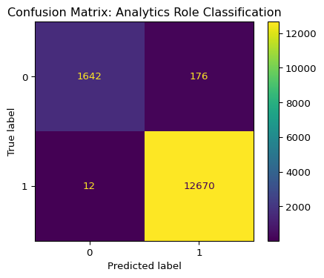

Interpretation for Job Seekers
The clustering results show whether job postings naturally group into distinct types and whether those groups resemble official occupational classifications. The regression model evaluates which job characteristics are associated with salary outcomes, while the classification model identifies which structured features best distinguish analytics-related roles. Together, these methods help translate labor market data into practical guidance for students and job seekers.

NLP Methods
This section is included as an optional extension of the project. The main analysis in this project focuses on structured exploratory analysis, skill patterns, clustering, regression, and classification. Because the required evaluation is already addressed through those methods, natural language processing is treated as a secondary component in the current version of the project.

Skill Gap Analysis
This page examines which skills appear most often in analytics-related job postings and what those patterns suggest for students preparing for business analytics, data science, and machine learning careers. The goal is to compare market demand with the types of skills that job seekers may need to strengthen.

Load Cleaned Data
import pandas as pd
import matplotlib.pyplot as plt
df_skills = pd.read_csv("data/lightcast_cleaned.csv")
df_skills.shape
(72498, 28)

Focus on Analytics-Related Roles
This section limits the analysis to postings identified as analytics-related in the data cleaning stage.
analytics_df = df_skills[df_skills["is_analytics_role"] == 1].copy()
analytics_df.shape
(63406, 28)

Most Common Specialized Skills
This section identifies the most frequent specialized skills appearing in analytics-related roles.
specialized = (
analytics_df["skills_specialized"]
.dropna()
.astype(str)
.str.split(";")
.explode()
.str.strip()
)
top_specialized = specialized.value_counts().head(15)
top_specialized
skills_specialized
[] 823
[\n "User Experience (UX) Design",\n "Project Management",\n "Cyber Security",\n "Technical Support",\n "Data Analysis"\n] 376
[\n "Pivot Tables And Charts",\n "Continuous Improvement Process",\n "Performance Management",\n "Utilization Management",\n "Data Management",\n "Data Architecture",\n "Finance",\n "Data Manipulation",\n "Python (Programming Language)",\n "Statistics",\n "Call Center Experience",\n "Visual Basic For Applications",\n "SQL (Programming Language)",\n "Excel Macros",\n "Service Level",\n "Workforce Management",\n "Kronos (Timekeeping Software)",\n "Descriptive Analytics",\n "Tableau (Business Intelligence Software)"\n] 301
[\n "Cloud Computing",\n "Enterprise Resource Planning",\n "Workflow Management",\n "Gap Analysis",\n "Durable Goods",\n "Agile Methodology",\n "Business Process Reengineering",\n "OneStream (CPM Software)",\n "Integrated Business Planning",\n "Data Engineering",\n "Functional Specification",\n "Finance",\n "Standard Operating Procedure",\n "Systems Development Life Cycle",\n "Data Integration",\n "Information Systems",\n "Test Planning",\n "Supply Chain",\n "User Acceptance Testing (UAT)",\n "SAP Applications",\n "Business Requirements",\n "Organizational Strategy",\n "Business To Business",\n "Technical Documentation",\n "Project Planning",\n "Anaplan",\n "Software As A Service (SaaS)",\n "Software Development",\n "Business Planning",\n "Business Strategies",\n "Computer Science"\n] 279
[\n "Data Analysis"\n] 265
[\n "Emergency Response"\n] 151
[\n "SAP Applications"\n] 118
[\n "Microsoft Access",\n "Data Warehousing",\n "Finance",\n "Self Service Technologies",\n "Dashboard",\n "Primary Care",\n "Managed Care",\n "Statistics",\n "Preventive Care",\n "Organizational Strategy",\n "SQL (Programming Language)",\n "SAS (Software)",\n "Chronic Diseases",\n "Ad Hoc Reporting",\n "Economics",\n "QlikView (Data Analytics Software)",\n "Tableau (Business Intelligence Software)",\n "Computer Science",\n "User Information"\n] 112
[\n "Sales Process",\n "Statistics",\n "Marketing Analytics",\n "Digital Marketing",\n "Predictive Analytics",\n "Google Analytics",\n "Python (Programming Language)",\n "Analytics",\n "Data Analysis",\n "Marketing",\n "Project Management",\n "SQL (Programming Language)",\n "SAS (Software)",\n "Data Structures",\n "Economics",\n "Project Implementation",\n "R (Programming Language)"\n] 100
[\n "Software Technical Review",\n "Finance",\n "Data Analysis",\n "Data Integrity",\n "Economics",\n "Computer Science"\n] 97
[\n "Financial Statements",\n "Oracle Cloud",\n "Solution Design",\n "Cash Management",\n "Interface Design",\n "Requirements Analysis",\n "Financial Management",\n "Functional Specification",\n "Software Documentation",\n "Accounts Payable",\n "Test Planning",\n "Accounts Receivable",\n "Financial Data",\n "Business Requirements",\n "Systems Integration",\n "Data Migration",\n "Fixed Asset",\n "Oracle Fusion Middleware",\n "General Ledger",\n "Economics",\n "Accounting"\n] 94
[\n "Microsoft Access",\n "Process Improvement",\n "Informatics",\n "Algorithms",\n "Dashboard",\n "Data Analysis",\n "Formal Learning",\n "Process Modeling",\n "Project Stakeholders",\n "Data Visualization",\n "Business Strategies",\n "Business Process Modeling"\n] 89
[\n "Gap Analysis",\n "Full Life Cycle Implementation",\n "Business Process",\n "Business Requirements",\n "Oracle Human Capital Management (HCM)",\n "Contract Review",\n "Human Capital",\n "Public Service"\n] 87
[\n "Oracle Cloud",\n "Account Reconciliation",\n "Corporate Reporting",\n "Agile Methodology",\n "Financial Close",\n "Process Improvement",\n "Oracle Hyperion Financial Management",\n "Software Deployment",\n "Finance",\n "Consolidation",\n "Business Process",\n "Waterfall Methodology",\n "Cloud Services",\n "Development Testing",\n "Calculations",\n "Sales Proposals",\n "Financial Data",\n "Request For Proposal",\n "Business Requirements",\n "Prototyping",\n "Project Management",\n "Oracle Hyperion",\n "Technology Solutions",\n "Financial Consolidations",\n "Data Transformation",\n "Technology Strategies",\n "NextGen Enterprise Practice Management",\n "Quality Management",\n "Extract Transform Load (ETL)",\n "System Deployment",\n "Business Development",\n "Auditing"\n] 86
[\n "Salesforce",\n "Python (Programming Language)",\n "Data Extraction",\n "Data Analysis",\n "SQL (Programming Language)",\n "Customer Relationship Management"\n] 82
Name: count, dtype: int64
top_specialized.plot(kind="bar")
plt.title("Top Specialized Skills in Analytics-Related Roles")
plt.xlabel("Skill")
plt.ylabel("Frequency")
plt.xticks(rotation=45, ha="right")
plt.show()
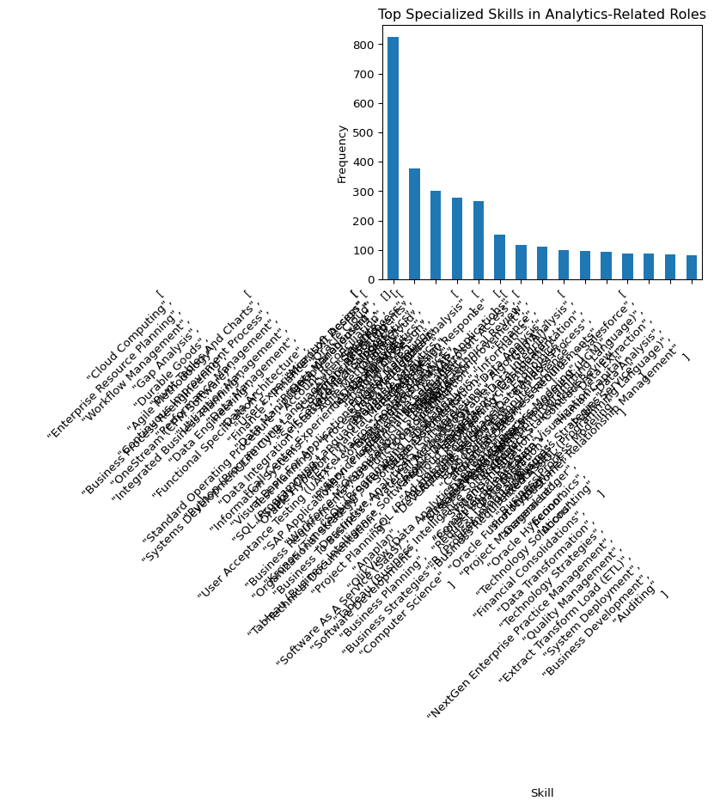

Most Common Software Skills
This section highlights the software tools that appear most often in analytics-related job postings.
software = (
analytics_df["skills_software"]
.dropna()
.astype(str)
.str.split(";")
.explode()
.str.strip()
)
top_software = software.value_counts().head(15)
top_software
skills_software
[] 8438
[\n "SAP Applications"\n] 1007
[\n "Oracle Cloud"\n] 802
[\n "Microsoft Office"\n] 736
[\n "Dashboard"\n] 479
[\n "SQL (Programming Language)"\n] 412
[\n "Oracle Cloud",\n "Oracle Human Capital Management (HCM)"\n] 337
[\n "Microsoft Excel"\n] 318
[\n "OneStream (CPM Software)",\n "SAP Applications",\n "Anaplan"\n] 279
[\n "Python (Programming Language)",\n "Visual Basic For Applications",\n "SQL (Programming Language)",\n "Kronos (Timekeeping Software)",\n "Tableau (Business Intelligence Software)"\n] 270
[\n "Oracle Human Capital Management (HCM)"\n] 243
[\n "SAP SuccessFactors",\n "SAP Applications"\n] 207
[\n "Microsoft PowerPoint",\n "Microsoft Excel"\n] 206
[\n "Power BI"\n] 205
[\n "Oracle E-Business Suite"\n] 203
Name: count, dtype: int64
top_software.plot(kind="bar")
plt.title("Top Software Skills in Analytics-Related Roles")
plt.xlabel("Software Skill")
plt.ylabel("Frequency")
plt.xticks(rotation=45, ha="right")
plt.show()
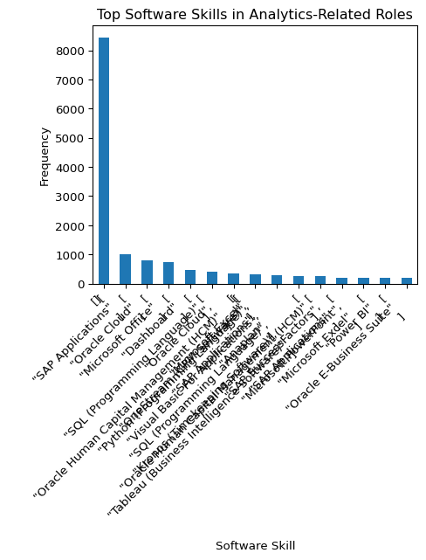

Most Common Common Skills
This section shows broader workplace and transferable skills that appear across analytics-related roles.
common_skills = (
analytics_df["skills_common"]
.dropna()
.astype(str)
.str.split(";")
.explode()
.str.strip()
)
top_common = common_skills.value_counts().head(15)
top_common
skills_common
[] 5433
[\n "Communication"\n] 582
[\n "Consulting"\n] 558
[\n "Management"\n] 532
[\n "Troubleshooting (Problem Solving)"\n] 296
[\n "Planning",\n "Analytical Skills",\n "Operations",\n "Writing",\n "Information Gathering"\n] 279
[\n "Business Objectives",\n "Customer Service",\n "Presentations",\n "Forecasting",\n "Communication",\n "Empathy",\n "Planning",\n "Ability To Meet Deadlines",\n "Patience",\n "Time Management",\n "Leadership",\n "Operations",\n "Business Administration",\n "Innovation",\n "Team Performance Management"\n] 270
[\n "Customer Service",\n "Problem Solving"\n] 243
[\n "Operations"\n] 241
[\n "Sales"\n] 211
[\n "Management",\n "Consulting"\n] 200
[\n "Information Technology",\n "Management",\n "Communication",\n "Presentations",\n "Planning",\n "Influencing Skills",\n "Quality Assurance",\n "Consulting",\n "Relationship Building",\n "Natural Sciences"\n] 185
[\n "Planning"\n] 180
[\n "Consulting",\n "Sales"\n] 138
[\n "Research"\n] 120
Name: count, dtype: int64
top_common.plot(kind="bar")
plt.title("Top Common Skills in Analytics-Related Roles")
plt.xlabel("Common Skill")
plt.ylabel("Frequency")
plt.xticks(rotation=45, ha="right")
plt.show()
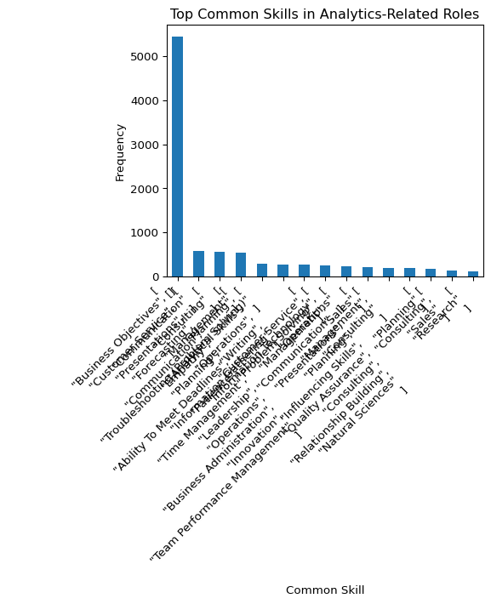

Skill Counts by Role Type
This section compares the average total number of listed skills between analytics-related and non-analytics roles.
skill_count_summary = (
df_skills.groupby("is_analytics_role")["total_skill_count"]
.mean()
.reset_index()
)
skill_count_summary
 | is_analytics_role | total_skill_count
0 | 0 | 3.980642
1 | 1 | 4.000000
skill_count_summary.plot(
x="is_analytics_role",
y="total_skill_count",
kind="bar",
legend=False
)
plt.title("Average Total Skill Count by Role Type")
plt.xlabel("Is Analytics Role")
plt.ylabel("Average Total Skill Count")
plt.xticks(rotation=0)
plt.show()
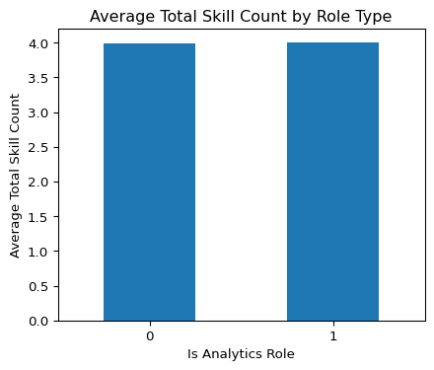

Practical Interpretation
The results on this page highlight which skills appear most often in analytics-related job postings. Technical tools and specialized skills help show what employers expect from candidates, while common skills reveal the broader workplace capabilities that still matter across roles. These patterns can help students identify where the strongest market demand exists and which areas may require additional preparation.

