NetMAS Tutorial - basics
2010/7/1 AIST
NetMAS is the abbreviation of Network-based Multi-Agent Simulator. This document describes the basic usage of NetMAS:
- Prepare the required libraries.
- Run and quit NetMAS.
- Load a network model
- Run a simulation.

This document is for Microsoft Windows users, but should also be useful for Mac users and Linux users.

The latest version of the document
The latest version of this document and sample files could be acquired from:
http://sequoia.a01.aist.go.jp/~shnsk/NetMAS/
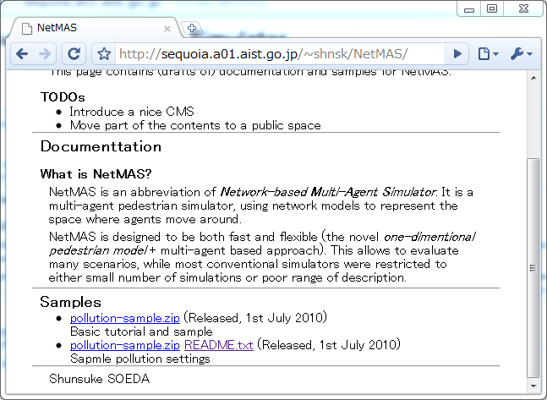

Setting up the environment
Java Runtime Environment and Java3D are required to run NetMAS.
- Java Platform, Standard Edition
Version JDK 6 Update 20 and above
URL http://java.sun.com/javase/downloads/index.jsp
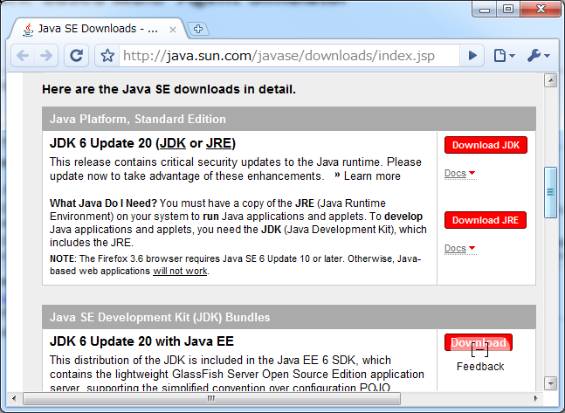
- Java3D
Version 1.5.2 and above
URL https://java3d.dev.java.net/binary-builds.html
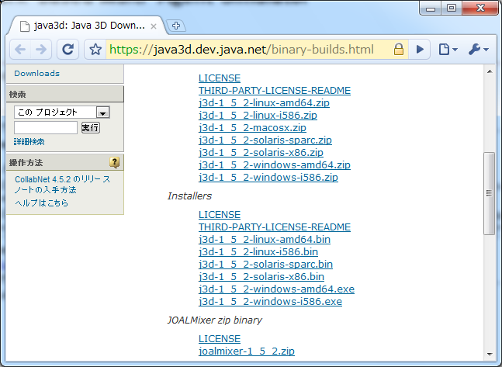
Download the libraries from the links, and follow the instructions of each site to install the libraries.
- You must install JRE before Java 3D.
- You might already have a JRE installation. If NetMAS does not run, remove all the JRE installation and re-install the libraries.
Notes for developers:
Those who intend to later develop NetMAS should install the JDK version of Java platform, not the JRE version.

Run and Quit NetMAS
Double click on either “NetworkMapEditor.jar” or “run.bat” bundled with this document.
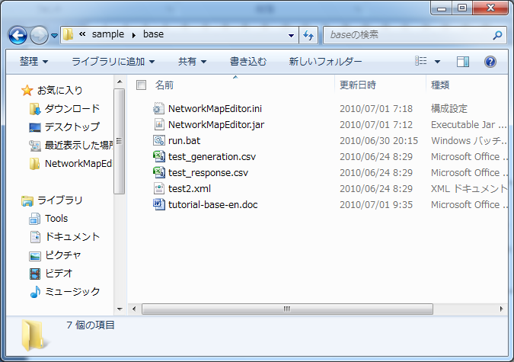
This will start NetMAS.
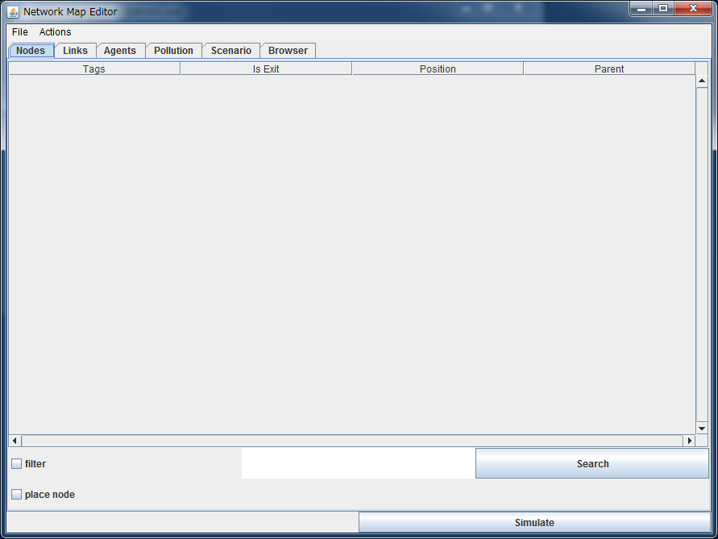
To quit NetMAS, select “Quit” from the “File” menu.
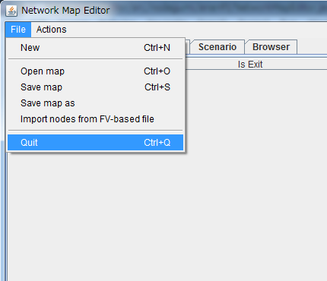
JAR executable and batch file:
The difference between using "run.bat" and "NetworkMapEditor.jar" is that when "run.bat" is used, a console will appear. Most debug messages will be shown in this console, so if you have any troubles, use "run.bat" and see what error messages are shown.

Load network model
To load a network model, select “Open MAP” from the “File” menu.
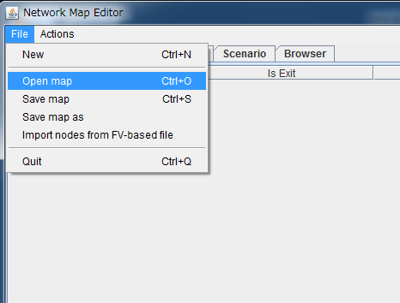
In this tutorial, open “test_model.xml”.
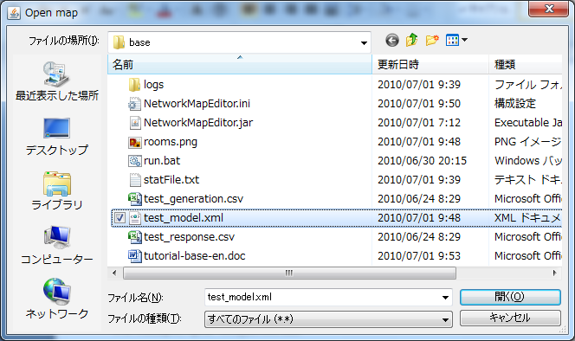
You can see that nodes of the network model are added to the nodes list:
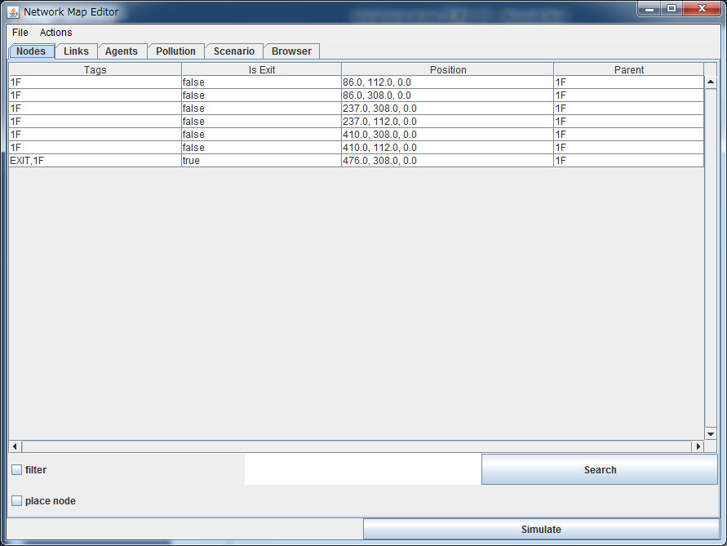
To check the network model (and to edit it), you can open the editor panel from the browser tab
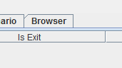
and you will get the “Object browser” window. In this window, right click on the “1F” and select show frame. This will show you the editor window.
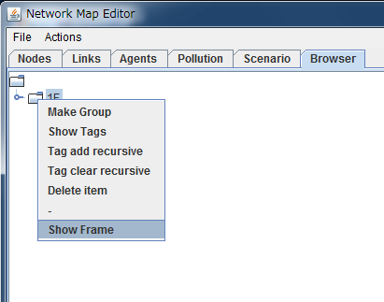→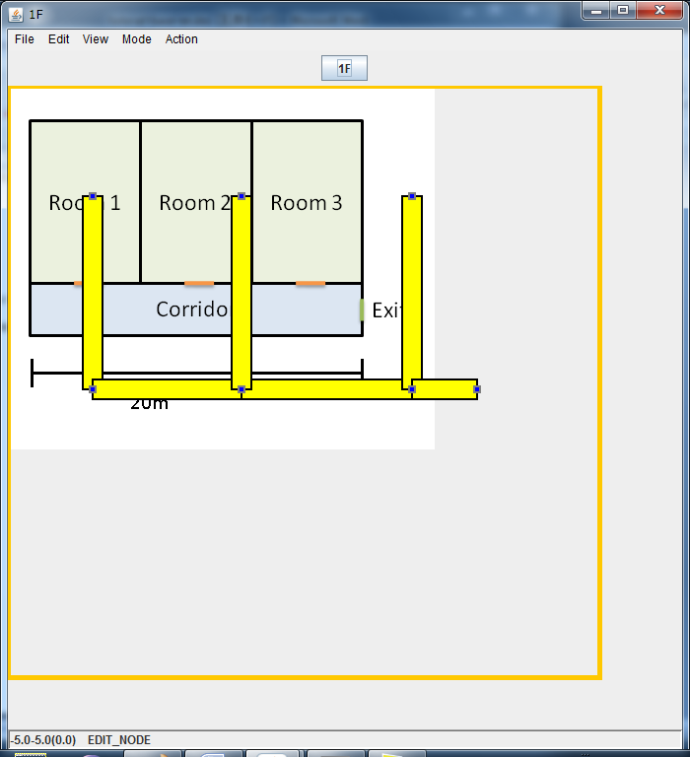
Other tabs:
There are 6 tabs in the main editor window, each used to edit and control the network model. One important tab is the “Scenario” tab, where you set the “response scenario” file and the “agent generation scenario”.

Running Simulation
To run a simulation, press the “Simulate” button in the editor.
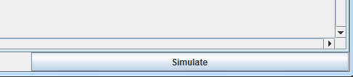
This will start the simulator. To run the simulation, press the “play” button.
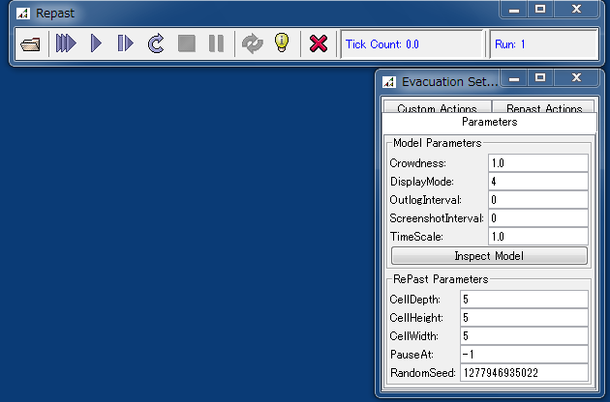
The simulator will start immediately.
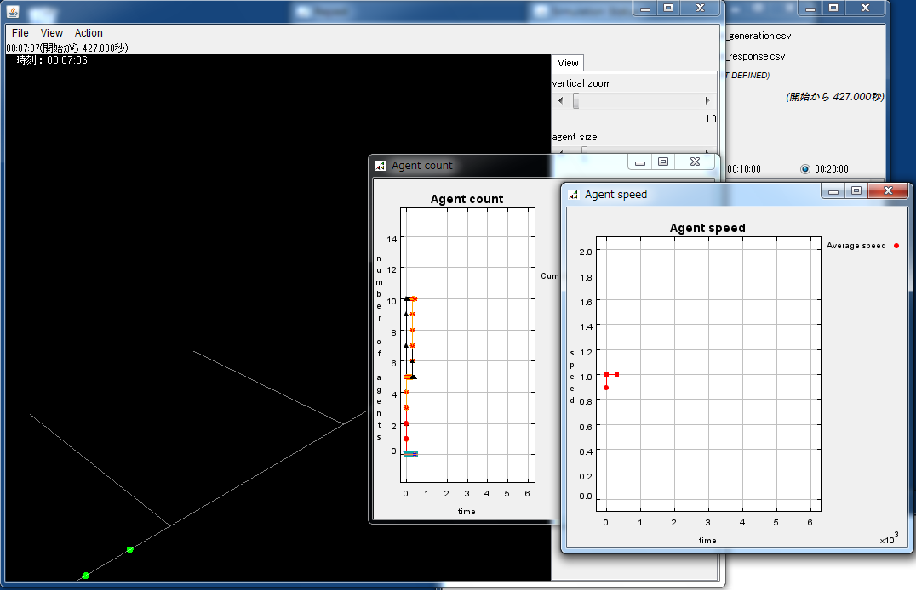
In this simulation, the agents will start from each room, wait in the corridor for 20 minutes, the head to the goal.

