**Bacteriological and eutrophication risk assessment of an Argentinian temperate shallow urban lagoon**

Melina Celeste Crettaz-Minaglia& Diamela Gianello

Melina Celeste Crettaz-Minaglia (MCCM): [crettaz.melina@uader.edu.ar](mailto:crettaz.melina@uader.edu.ar)

Diamela Gianello (DG): [gianellodiamela@comahue-conicet.gob.ar](mailto:gianellodiamela@comahue-conicet.gob.ar)

*Predictive models* were carried out with SigmaPlot 12.0® Software using TC and Chl-a as indicators of bacteriological and eutrophication risks respectively (Pinto et al., 2012) in functions of the temperature, and one-week cumulative rain as indicators of climate change according to the predictive scenarios (IPCC, 2007) for the study area.

TC concentration was deﬁned as the logarithm of the population size [z = log (N)] as a function of water temperature (WT, in ºC) in the range of temperatures observed plus 5 ℃ and of one-week cumulative rain (in mm) plus 50 mm by a projection of maximum climate change for the study area. Similarly, Chl-a concentration was defined as the algal biomass [z = Chl-a (µg.L-1)] as a function of WT and one-week cumulative rain. Therefore, MPN.100 mL-1 of TC or Chl-a (µg.L-1) was modeled using a 3D Paraboloid equation (**Eq. 2**) with 5 parameters (y0, a, b, c, and d).

$Z [ log( N) or Chl-a] = y_{0} + (a*x) + (b*y) + ({c*x^{2}}^{} )+ (d*y^{2})$**Eq. 2**

Where **z [log (N)]** is the decimal logarithmic of the bacterial count (MPN in 100 mL), **z [Chl-a]** is the Chl-a concentration (µg.L-1), **x** is the water temperature (in ºC), **y** is the one-week cumulative rain (in mm), **y0** is an initial value of bacterial count or Chl-a concentration, **a** is the reciprocal z (a = 1/abs(z)), **c** is reciprocal to the square z (c = 1/z2), **b** is the reciprocal predictive value (b = 1/abs (f)), and **d** is the reciprocal predictive value to the square (d = 1/f2) being **f** as predictive value.

Fitting was carried out for each water temperature and cumulative rain condition registered during the samplings by nonlinear regression, minimizing the sum of the squares of the deviations between the experimental and predicted values. The goodness-of-ﬁt was evaluated by two parameters: the coefﬁcient of determination (R2) and the root-mean-square error (RMSE) deﬁned as **Eq. 3** (Crettaz-Minaglia et al., 2017).

RMSE = $\sqrt{\frac{\sum_{i = 1}^{ n}{} {(field data}_{i}{}^{}- {predictive data}_{i}){}^{2}}{(n - k)}}$**Eq. 3**

Where **n** is the number of field data, and **k** is the number of parameters of the model. Lower RMSE values indicate a better ﬁt of the model to describe the data.

**Nonlinear Regression Thursday, June 24, 2021, 19:14:28**

Data Source: Data 1 in lagoon model

Equation: 3D; Paraboloid

f = y0+a*x+b*y+c*x^2+d*y^2

**R Rsqr Adj Rsqr Standard Error of Estimate**

0,8137 0,6622 0,5946 0,3778

**Coefficient Std. Error t P**

y0 2,2583 1,2481 1,8094 0,0854

a 0,0262 0,1335 0,1960 0,8466

b 0,0006 0,0135 0,0460 0,9638

c 0,0012 0,0033 0,3651 0,7188

d 8,9784E-005 0,0002 0,3698 0,7154

**Analysis of Variance:**

DF SS MS

Regression 5 285,5969 57,1194

Residual 20 2,8544 0,1427

Total 25 288,4513 11,5381

**Corrected for the mean of the observations:**

DF SS MS F P

Regression 4 5,5949 1,3987 9,8006 0,0001

Residual 20 2,8544 0,1427

Total 24 8,4493 0,3521

**Statistical Tests:**

Normality Test (Shapiro-Wilk) Passed (P = 0,6720)

W Statistic= 0,9711 Significance Level = <0,0001

Constant Variance Test Passed (P = 0,8584)

**Fit Equation Description:**

[Variables]

x = col(2)

y = col(5)

z = col(3)

reciprocal_z = 1/abs(z)

reciprocal_zsquare = 1/z^2

reciprocal_pred = 1/abs(f)

reciprocal_predsqr = 1/f^2

'Automatic Initial Parameter Estimates

F(q;r) = ape(q;r;2;0;1)

[Parameters]

y0 = F(x;z)[1] ''Auto {{previous: 2,2583}}

a = F(x;z)[2] ''Auto {{previous: 0,0261803}}

b = F(y;z)[2] ''Auto {{previous: 0,000622093}}

c = F(x;z)[3] ''Auto {{previous: 0,00121873}}

d = F(y;z)[3] ''Auto {{previous: 8,97843e-005}}

[Equation]

f = y0+a*x+b*y+c*x^2+d*y^2

fit f to z

''fit f to z with weight reciprocal_z

''fit f to z with weight reciprocal_zsquare

''fit f to z with weight reciprocal_pred

''fit f to z with weight reciprocal_predsqr

[Constraints]

[Options]

tolerance=0,0000000001

stepsize=1

iterations=200

Number of Iterations Performed = 13

**Nonlinear Regression Saturday, June 19, 2021, 20:06:44**

Data Source: Data 2 in lagoon model

Equation: 3D; Paraboloid

f = y0+a*x+b*y+c*x^2+d*y^2

R Rsqr Adj Rsqr Standard Error of Estimate

0,8129 0,6608 0,5639 63,2266

Coefficient Std. Error t P

y0 562,3987 240,6622 2,3369 0,0348

a -59,4709 25,2889 -2,3517 0,0339

b 2,2246 3,2805 0,6781 0,5087

c 1,7495 0,6260 2,7946 0,0143

d -0,0475 0,0753 -0,6314 0,5380

Analysis of Variance:

DF SS MS

Regression 5 430071,6613 86014,3323

Residual 14 55966,4274 3997,6020

Total 19 486038,0887 25580,9520

Corrected for the mean of the observations:

DF SS MS F P

Regression 4 109031,4585 27257,8646 6,8186 0,0029

Residual 14 55966,4274 3997,6020

Total 18 164997,8859 9166,5492

Statistical Tests:

Normality Test (Shapiro-Wilk) Passed (P = 0,6564)

W Statistic= 0,9642 Significance Level = <0,0001

Constant Variance Test Passed (P = 0,6674)

Fit Equation Description:

[Variables]

x = col(3)

y = col(13)

z = col(6)

reciprocal_z = 1/abs(z)

reciprocal_zsquare = 1/z^2

reciprocal_pred = 1/abs(f)

reciprocal_predsqr = 1/f^2

'Automatic Initial Parameter Estimates

F(q;r) = ape(q;r;2;0;1)

[Parameters]

y0 = F(x;z)[1] ''Auto {{previous: 562,399}}

a = F(x;z)[2] ''Auto {{previous: -59,4709}}

b = F(y;z)[2] ''Auto {{previous: 2,22461}}

c = F(x;z)[3] ''Auto {{previous: 1,74949}}

d = F(y;z)[3] ''Auto {{previous: -0,0475388}}

[Equation]

f = y0+a*x+b*y+c*x^2+d*y^2

fit f to z

''fit f to z with weight reciprocal_z

''fit f to z with weight reciprocal_zsquare

''fit f to z with weight reciprocal_pred

''fit f to z with weight reciprocal_predsqr

[Constraints]

[Options]

tolerance=0,0000000001

stepsize=1

iterations=200

Number of Iterations Performed = 13

**Table 3. Predictive risk model parameters (a is the reciprocal z (a = 1/abs(z)), b is the reciprocal predictive value (b = 1/abs (f)), c is reciprocal to the square z (c = 1/z2), and d is the reciprocal predictive value to the square (d = 1/f2), and y0 is an initial value of bacterial count or Chl-a concentration) , standard errors, coefficient of determination (R2), and root-mean-square error (RMSE) applied to field data of the Lagoon of the Parque Unzué (2015-2019). BPRM: bacteriological predictive risk model, and EPRM: eutrophication predictive risk model.**

| **Model** | **BPRM** | **EPRM** |
| --- | --- | --- |
| **a** | 0.0262 ± 0.1335 | - 59.47 ± 25.29 |
| **b** | 0.0006 ± 0.0135 | 2.225 ± 3.280 |
| **c** | 0.0012 ± 0.0033 | 1.749 ± 0.6260 |
| **d** | 8.978-5 ± 0.0002 | -0.0475 ± 0.0753 |
| **y0** | 2.258 ± 1.248 | 562.4 ± 240.7 |
| **R2** | 0.66 | 0.66 |
| **RMSE** | 0.37 | 28.6 |

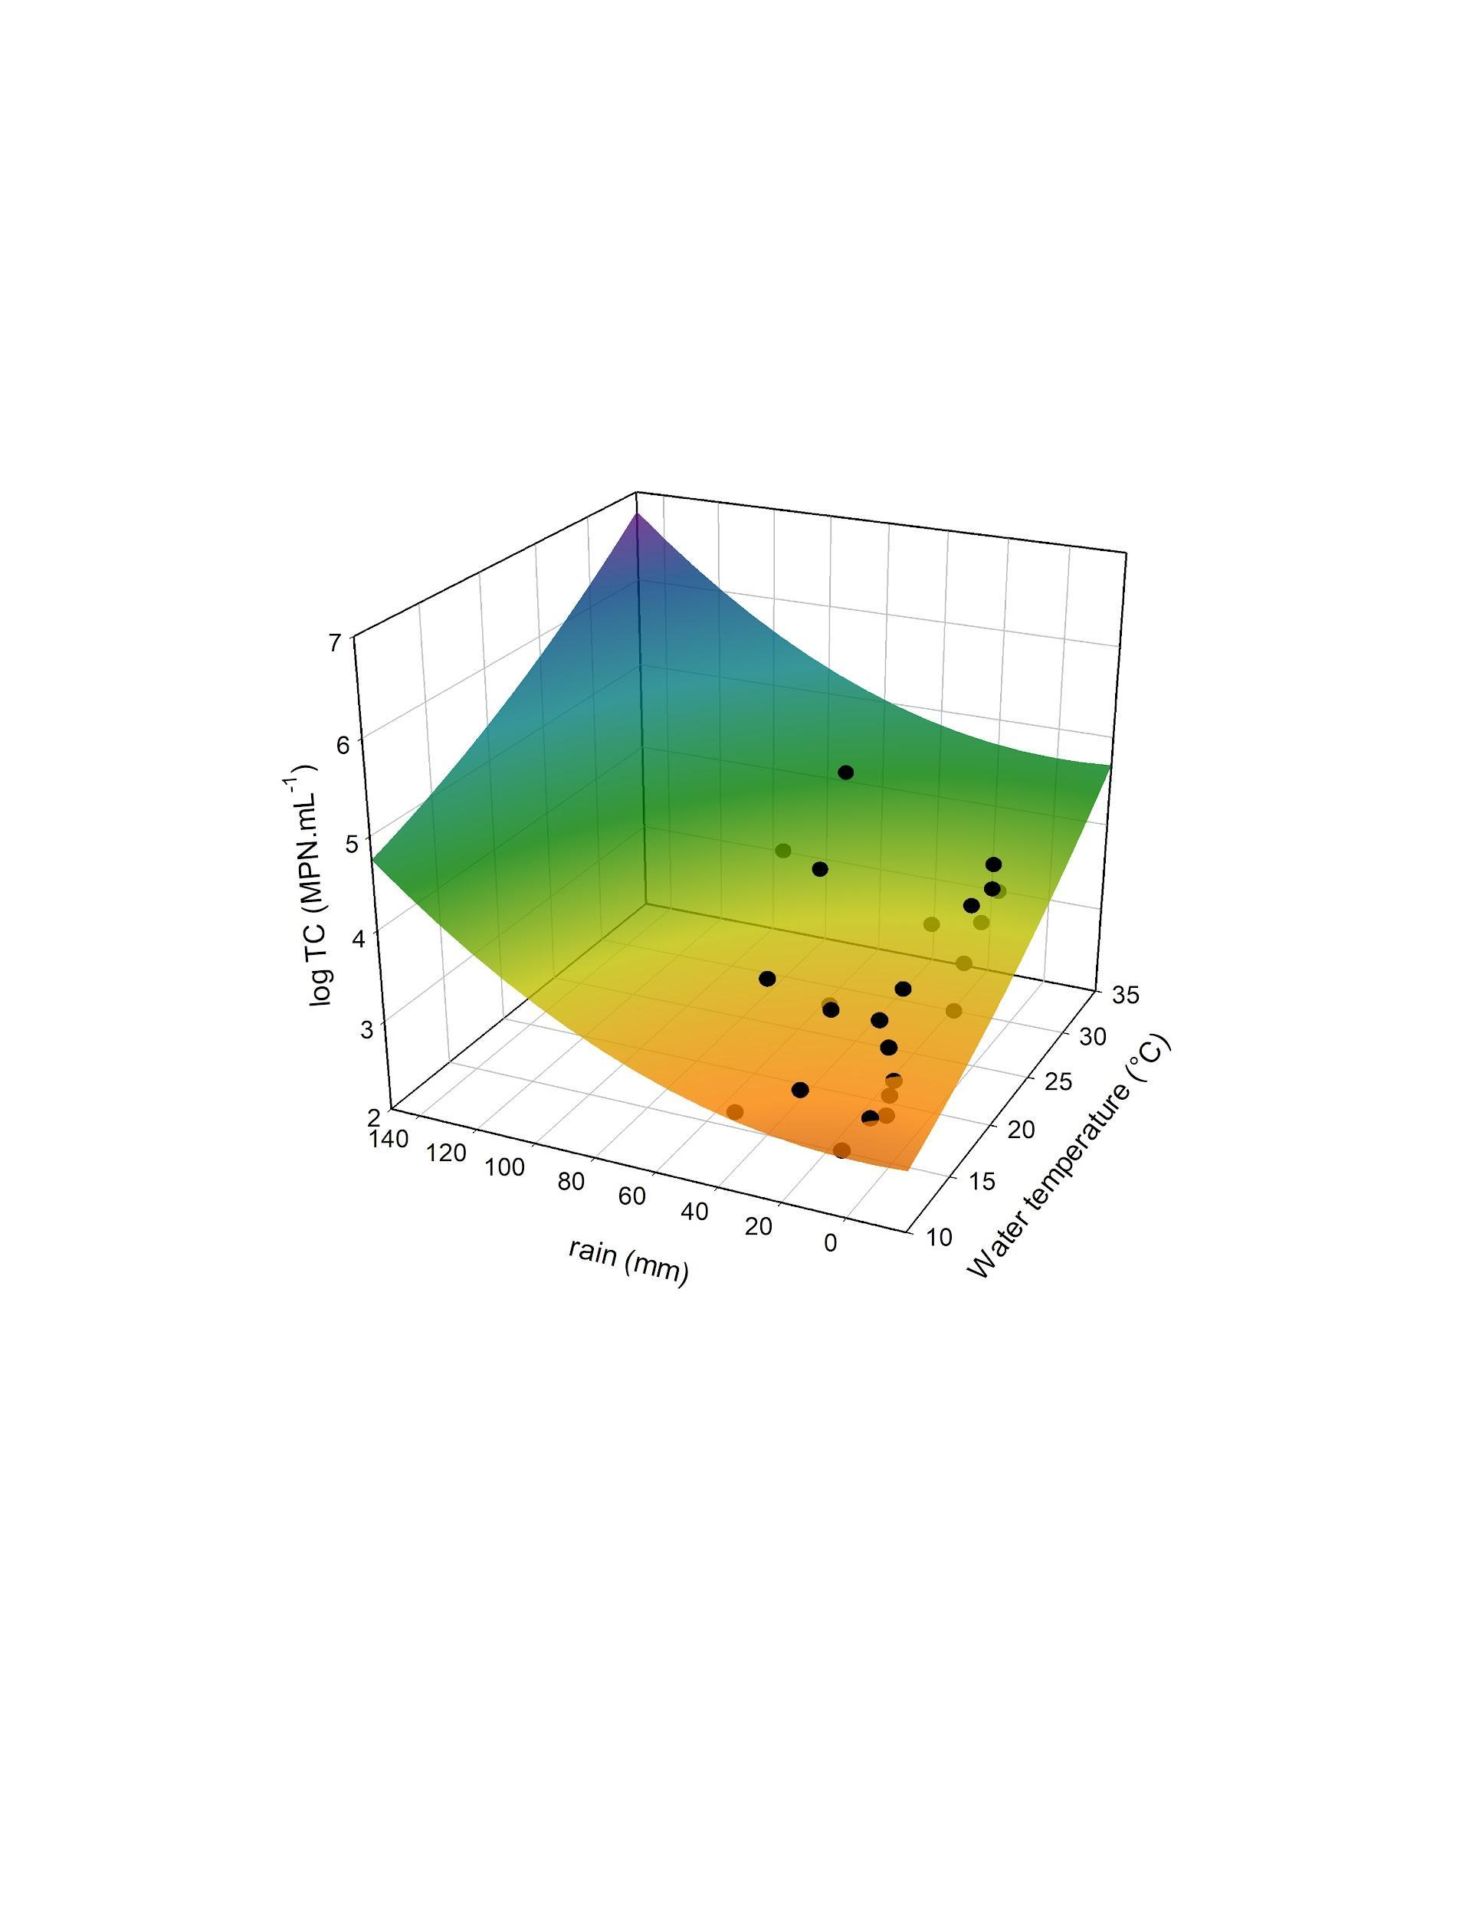

**Figure 8. Predictive bacteriological risk model under climate change scenarios in the lagoon of the Parque Unzué. Black points are the field data and color paraboloid is the predictive data.**

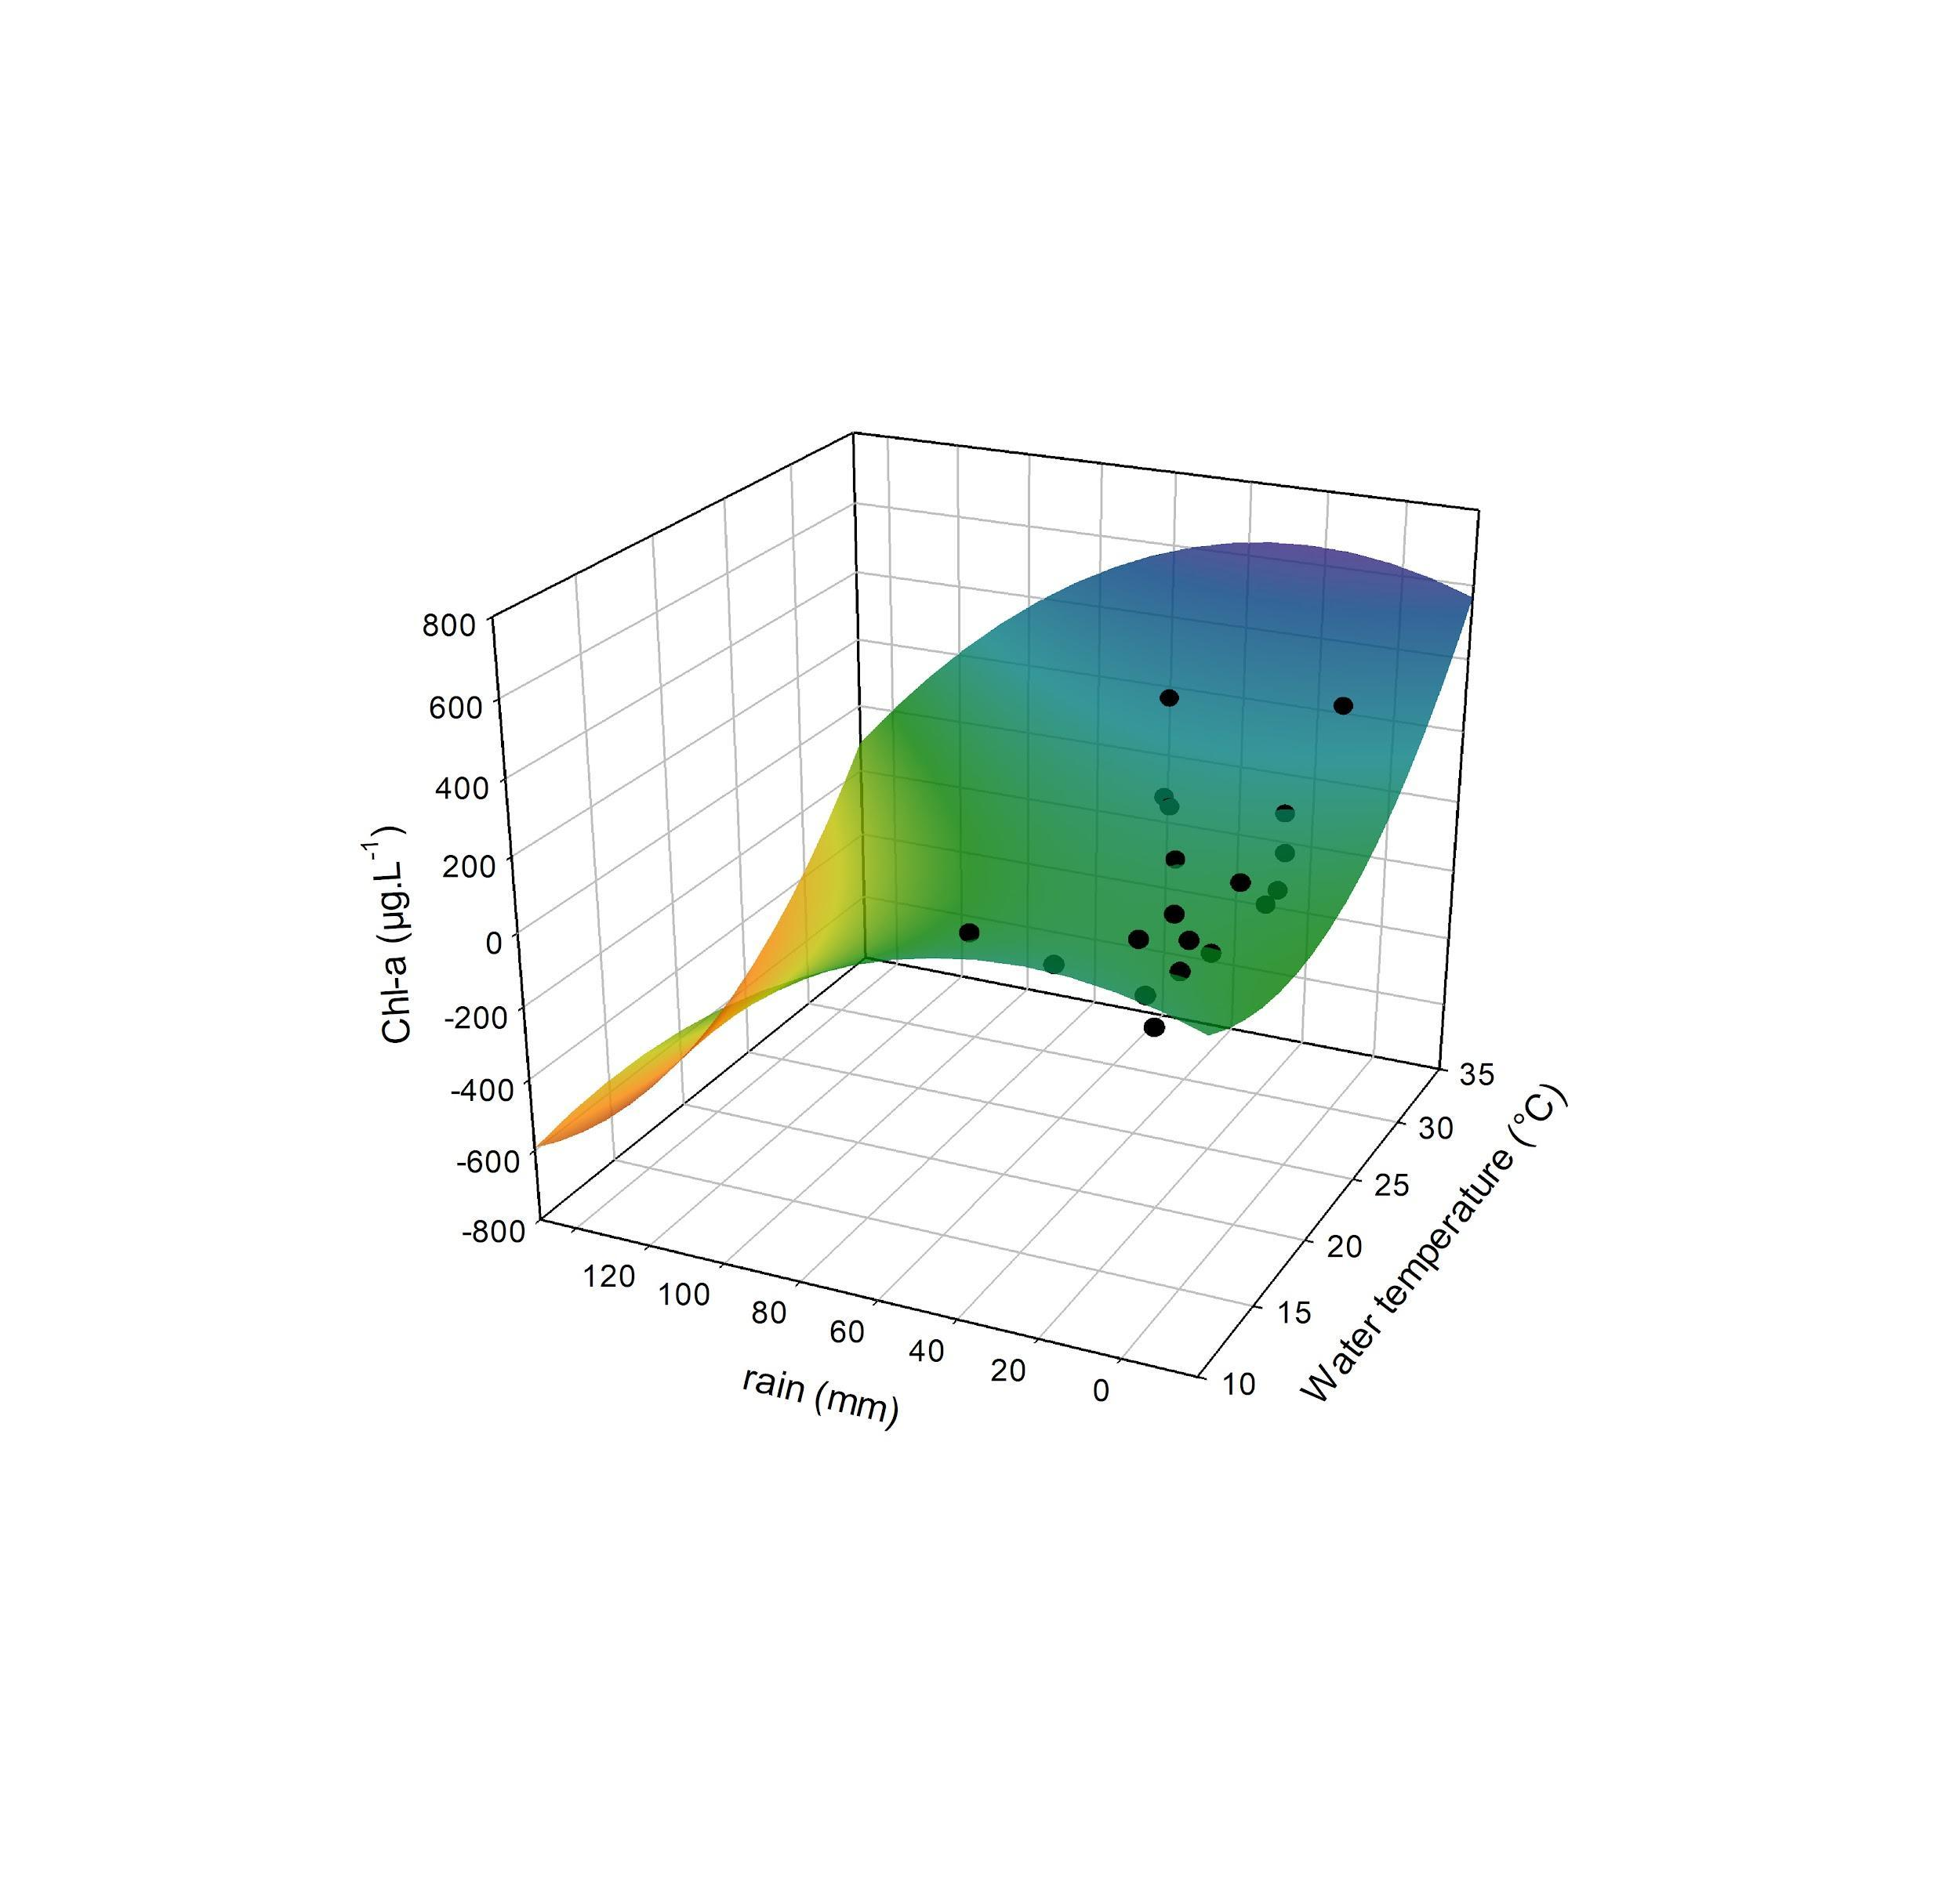

**Figure 9. Predictive eutrophication risk model under climate change scenarios in the lagoon of the Parque Unzué. Black points are the field data and color paraboloid is the predictive data.**