**Bhaktapur Multiple Campus**

**Dudhpati, Bhaktapur**

Department of Science and Technology (CSIT)

**Project Report**

**May 25, 2019**

This is to certify that the C project entitled

**On Date Converter**

is the bona fide record of C project work done by

**Name: Rabi Prajapati**

**Symbol No: 20253**

Of CSIT (1st Sem.) during the year 2075-76.

Submitted for the C project Viva-Voce examination held on ___________

**Project Supervisor Head of the Department**

**Intellectual Property Rights Agreements**

This report is submitted as the part requirement for the degree of CSIT at Tribhuvan University. It is the product of Rabi Prajapati, Arbin Shrestha, Krijal Khadka, Nikil Kayastha and Shishir Gc with their knowledge on the source code. The report may be freely copied and distributed as a sample for the projects.

Co-Oridinator Signature

**CONTENTS**

**Chapter 1: Introduction**

**Chapter 2: Requirement Analysis**

**Chapter 3: System Design**

**Chapter 4: Implementation and Testing**

**Chapter 5: Conclusion and Recommendations**

**Chapter 1: INTRODUCTION**

**1.1 Introduction:**

Date and Day representative of time period, plays a vital role in human beings. With every new sunrise and sunset day passes altering the date. From very past, people used to keep track of days and larger division of time with help of ancient roots. The natural units for timekeeping used by most historical societies were the day, the solar year and the lunation.

The Gregorian calendar was introduced as a refinement of the Julian calendar in 1582, and is now in worldwide use for secular purposes. Various medieval or ancient calendars remain in use for religious or social purposes. One of them is Hindu calendar.

Hindu calendar adopt a similar underlying concept for timekeeping, but differ in their relative emphasis to moon cycle or the sun cycle and the names of months and when they consider the New Year to start. The most studied Hindu calendars are Shalivahana Shaka and Vikram Samvat. In case of Nepal Vikram Samvat is studied.

**1.2 Problem Definition:**

Nepal follows Hindu calendar (Vikram Samavat) as its national calendar which differs from the standard Gregorian calendar. English language being recognized as the standard worldwide language, the standard calendar also holds an importance. Nowadays, most of the institutions and organizations perform their operations in standard format along with national format for international recognition. Date being a major factor of time schedules for performing operations, we have to keep track of standard calendar along with national calendar.

You might have been in a situation where you have to insert both English date and Nepali date and you end up with blank space in the English slot as you don’t recognize the respective English date. This often happens while filling forms for hospitals, registration etc. You might have memory of yourself asking teacher for the English date while writing letters during your school days. Sometimes you might receive a letter and when you retrieve the letter from the mail box you can’t get when was the letter actually sent, as the English date is written in it. So our project focuses on resolving these common problems.

**1.3 Objectives:**

* To be able to know about the respective English date for particular Nepali date.
* To be able to know the specific day of the particular date.
* To be able to know about the respective Nepali date for particular English date.
* To be able to know about total no. of days in the particular month.

**1.4 Scope and limitation**

* The project requires user interaction for performing its operation.
* It is the small project and is applicable for certain task only.
* The project’s functionality is valid only for certain range.
* The project could have been more attractive using graphics.
* The project could have additional features like adding notes and listing them.

**1.5 Report Organization**

The project is organized into five chapters. After this introductory chapter,

* Chapter 2: describes the requirement of the project.
* Chapter 3: focuses on the code and modules used in the project.
* Chapter 4: describes implementation and testing for betterment of project.
* Chapter 5: describes the contribution of the project and necessary improvements.

**Chapter 2: Requirement Analysis**

**2.1 Existing Work**

The project we have accomplished is just a simple date converter. We have moved one step ahead to present it in informative calendar form. One can input the valid date in English format (A.D) to convert it into Nepali format (B.S) and vice versa. She/he can identify the particular day for the input date. The information about the no. of days for particular month can be received. Once the data is input for first time, she/he can roam around the calendar with the help of particular keys. Within the program, they can simply exit from wherever they want with help of specific keys.

**2.2 Requirement Analysis**

**2.2.1 Functional Requirements**

Date Converter

System

User

Fig: Diagram for functional Requirements of Date converter

**2.2.2 Non-Functional Requirement**

* **Usability:** First the interface is created for the user where he/she chooses the conversion type. As soon as the conversion type is chosen, user-system interface is created where user inputs data and system process it to give the required output. Header file “windows.h” is used is intensively used in the program to manipulate the position of cursor. Similarly, “dos.h” is used for setting foreground and background color for better presentation.
* **Reliability:** The program checks for all possible errors of data that the user might unknowingly provide to the system and displays where the error occurred. So, The program retains the trust of the users with its functionality.
* **Performance:** The program is small and consists of simple codes and modules. As soon as the user inputs the data, the results are displayed within no time. The program also features in roaming around different dates smoothly in no time.
* **Supportability:** The program is supported in most of the operating system. There are multiple applications for accessing the codes of the program as well. The code is supported in most of them.

**Chapter 3: System Design**

**3.1 Interface Design**

Great emphasis was given to create an interactive user interface. Simple characters are displayed in attractive way for informative and better presentation. With the help of “windows.h” header file we could make use of the cursor movement function within it.

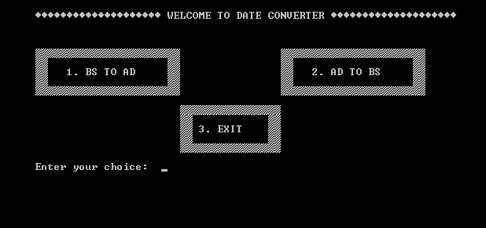

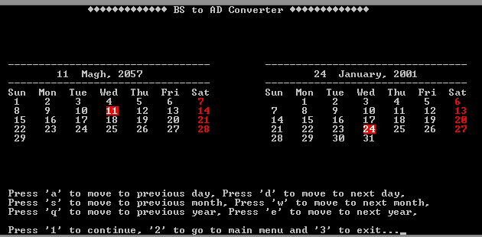

Fig: Program Interface

`**3.2 Input Output Design**

Standard input (scanf) and standard output (printf) are used in the program defined under header file “stdio.h”. The program allows the user to input particular year, month and date which the system uses to convert it into respective form desired by the user. Data input is controlled with error checking mechanism so that the data input by the user is valid. If any error occurs during input, the program detects it and redirects the page providing information about the problem to the user.

**3.3 Process Design**

No

Yes

Display Converted Date

Continue?

Display Input Date

Input Date

Choose Converter

Display main menu

Fig: Flowchart for Process Design

**Chapter 4: Implementation and Testing**

**4.1 Implementation**

The records of no. of days per months for several years were collected which are implemented for converting date from AD to BS and Bs to AD. Several functions are used for ease and simplicity of the program. Cursor movement function helped in manipulation of the cursor which is implemented for displaying date in more informative and interactive form. Similarly, Foreground and Background color function is used for separation of particular days for better presentation. Different characters are implemented for creating designs in the program for attractive view.

**4.2 Testing**

Testing was done by comparing the results provided by the program with the certified converter. Similarly, primary testing was also done by testing the data provided by colleagues. Some of the errors that were observed during testing phase were later recovered by restudying the program code. Multiple testing was done for correct presentation of the result to the user by changing the program code. Conversion test was also conducted which was successful.

**Chapter 5: Conclusion and Recommendation**

**5.1 Conclusion**

* We were able to get the respective English date for particular Nepali date.
* We could know the specific day of the particular date.
* We were able to get the respective Nepali date for particular English date.
* We could know about total no. of days in the particular month.
* We could know the relation of English months and Nepali months.

**5.2 Recommendations**

* The codes could be expanded to make it applicable for multiple tasks.
* The limited range of supported dates could be expanded.
* The project could have been more attractive using graphics.
* The project could have additional features like adding notes and listing them.

**Reference:**

<https://www.hamropatro.com/date-converter>

<https://www.codewithc.com/mini-project-in-c-calendar/>

<http://flipkarma.com/project/date-converter-in-c/>