1. Write a program to illustrate an Intelligent Agent with the below details.

Any control system can be viewed as an agent. A simple example of such a system is an automated taxi driving system. Write a program to design the following simple interface of traffic.

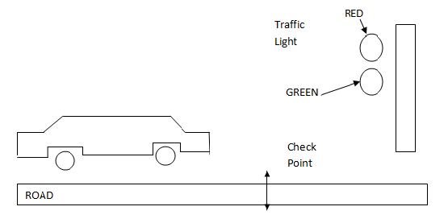

Here, the requirement is that, the signal of traffic light is on certain interval lets say (10 secs). This task will be done in sequence or simply in random order too. The condition is that, when the moving car reaches at check point, the program hast to check the current light of the traffic signal and perform the following rule.

IF Traffic_Light is GREEN THEN

“GO”

ELSE

“STOP” until the light changes to GREEN

**Ans:**

An agent can be anything that perceive its environment through sensors and act upon the environment through actuators (effectors). An agent should have PEAS (Performance, Environment, Actuators, Sensors) properties. Based on these properties, agents can be grouped together or can be differentiated from each other.

1. **Performance:** All the necessary results that an agent gives after processing comes under its performance.
2. **Environment:** All the surrounding things and conditions of an agent fall in this section. It basically consists of all the things under which the agents work.
3. **Actuators:** The devices, hardware or software through which the agent performs any actions or processes any information to produce a result are the actuators of the agent.
4. **Sensors:** The devices through which the agent observes and perceives its environment are the sensors of the agent.

**For e.g.,** let us take an example of a self-driven car. The PEAS description for this agent will be as follows:

The **performance** factors for a self-driven car will be the speed, safety while driving, time taken, comfort of user etc.

The road on which car is being driven, other cars present on the road, pedestrians, crossings, road signs, traffic signals, etc. all act as its **environment**.

All those devices through which the control of the car is handled, are the **actuators** of the car. For e.g., the steering, accelerator, breaks, horn, music system etc.

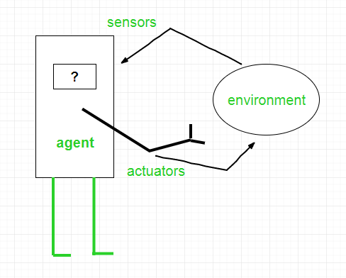 All those devices through which the car gets an estimate about its surroundings and it can draw certain perceptions out of it are its **sensors**. For e.g., camera, speedometer, GPS, odometer, sonar etc.

Fig: Structure of Agent

**Source code:**

#include <stdio.h>

#include <conio.h>

#include <graphics.h>

#include <dos.h>

int checkpoint=250; //320 for green light at checkpoint

void light(int,int);

int mid(int i) {

i=i/10;

i=i%10;

return i;

}

void car(int i, int midy ,int color,int k) {

setcolor(WHITE);

line(0, getmaxy()/2 + 37, getmaxx(), getmaxy()/2 + 37);

line(checkpoint+120,getmaxy()/2 + 37, checkpoint+120,getmaxy()-100);

setcolor(YELLOW);

setfillstyle(SOLID_FILL, YELLOW);

line(0 + i, midy + 23, 0 + i, midy);

line(0 + i, midy, 20 + i, midy);

line(20 + i, midy, 40 + i, midy - 20);

line(40 + i, midy - 20, 80 + i, midy - 20);

line(80 + i, midy - 20, 100 + i, midy);

line(100 + i, midy, 120 + i, midy);

line(120 + i, midy, 120 + i, midy + 23);

line(0 + i, midy + 23, 18 + i, midy + 23);

arc(30 + i, midy + 23, 0, 180, 12);

line(42 + i, midy + 23, 78 + i, midy + 23);

arc(90 + i, midy + 23, 0, 180, 12);

line(102 + i, midy + 23, 120 + i, midy + 23);

line(28 + i, midy, 43 + i, midy - 15);

line(43 + i, midy - 15, 57 + i, midy - 15);

line(57 + i, midy - 15, 57 + i, midy);

line(57 + i, midy, 28 + i, midy);

line(62 + i, midy - 15, 77 + i, midy - 15);

line(77 + i, midy - 15, 92 + i, midy);

line(92 + i, midy, 62 + i, midy);

line(62 + i, midy, 62 + i, midy - 15);

floodfill(5 + i, midy + 22, YELLOW);

setcolor(DARKGRAY);

if (i % 2 == 0)

setfillstyle(SLASH_FILL, DARKGRAY);

else

setfillstyle(BKSLASH_FILL, DARKGRAY);

circle(30 + i, midy + 25, 9);

circle(90 + i, midy + 25, 9);

floodfill(30 + i, midy + 25, DARKGRAY);

floodfill(90 + i, midy + 25, DARKGRAY);

light(k,color);

delay(100);

cleardevice();

}

void light(int i,int color) {

int x=525,y;

setcolor(DARKGRAY);

char str[5];

setfillstyle(SOLID_FILL, DARKGRAY);

rectangle(x-25, 5, x+25, 95);

floodfill(x, 50, DARKGRAY);

setcolor(BLACK);

setfillstyle(SOLID_FILL, BLACK);

circle(x,20 , 13);

floodfill(x, 20, BLACK);

circle(x, 80, 13);

floodfill(x, 80, BLACK);

if(color == LIGHTRED)

y = 20;

else

y = 80;

setcolor(BLACK);

setfillstyle(SOLID_FILL, BLACK);

circle(x, y, 13);

floodfill(x, y, BLACK);

setcolor(color);

setfillstyle(SOLID_FILL, color);

circle(x, y, 13);

floodfill(x, y, color);

setcolor(BLACK);

settextstyle(TRIPLEX_FONT, HORIZ_DIR, 1);

moveto(x-4, y-9);

sprintf(str, "%d",9-mid(i));

outtext(str);

}

int main()

{

int gdriver = DETECT, gmode, err;

int i,temp , l=0, t=0, k=0, color;

initgraph(&gdriver, &gmode, "C:/TURBOC3/BGI");

while(!kbhit()) {

cleardevice();

temp=0;

if(l%2==0) {

l=1;

color=LIGHTRED;

}

else {

l=0;

color=GREEN;

}

for (i = t; i<t+100+temp; i++, k++) {

if(i==checkpoint && color==LIGHTRED) {

temp=(100-mid(i)*10);

for(k=i;k<temp+i;k++)

car(i,getmaxy()/2,color,k);

l=0;

color=GREEN;

temp=100-temp;

}

else

car(i,getmaxy()/2,color,k);

}

t=i;

}

getch();

closegraph();

return 0;

}

**Output:**

1. Suppose the traffic light is turned **Red** when the car reaches the checkpoint.

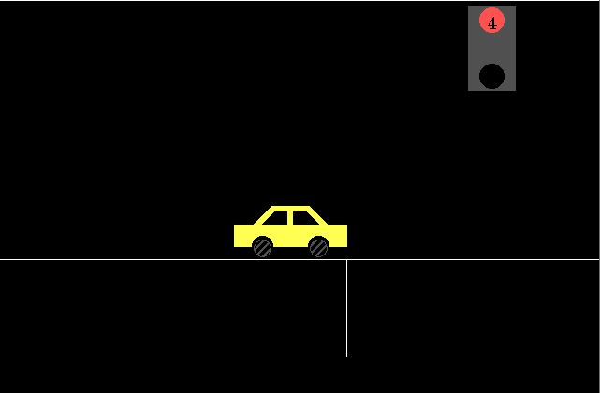

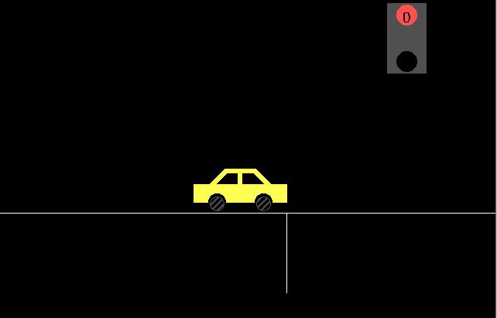

1. Suppose the traffic light is turned **Green** when car reaches the checkpoint

