Le

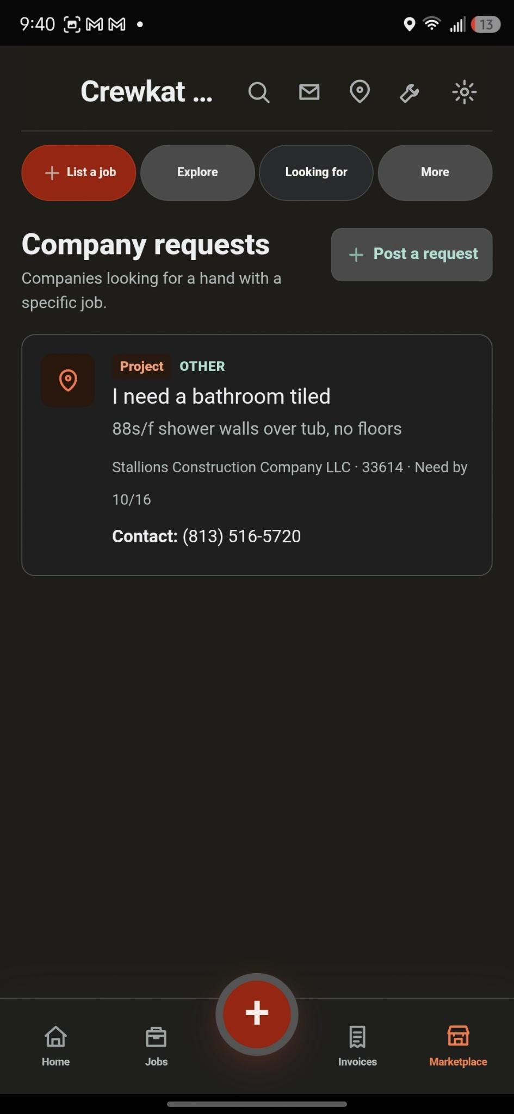
The “looking for” tab lets rename it to leads or something similar. (Screenshot above)

In the following screenshot. Change the all button with a small “sort by” icon next to projects.

Also there is a little bit of confusion between jobs and projects, can we come up with a solution to make them more differentiable make switch the theme colors when in project vs jobs. Open to ideas

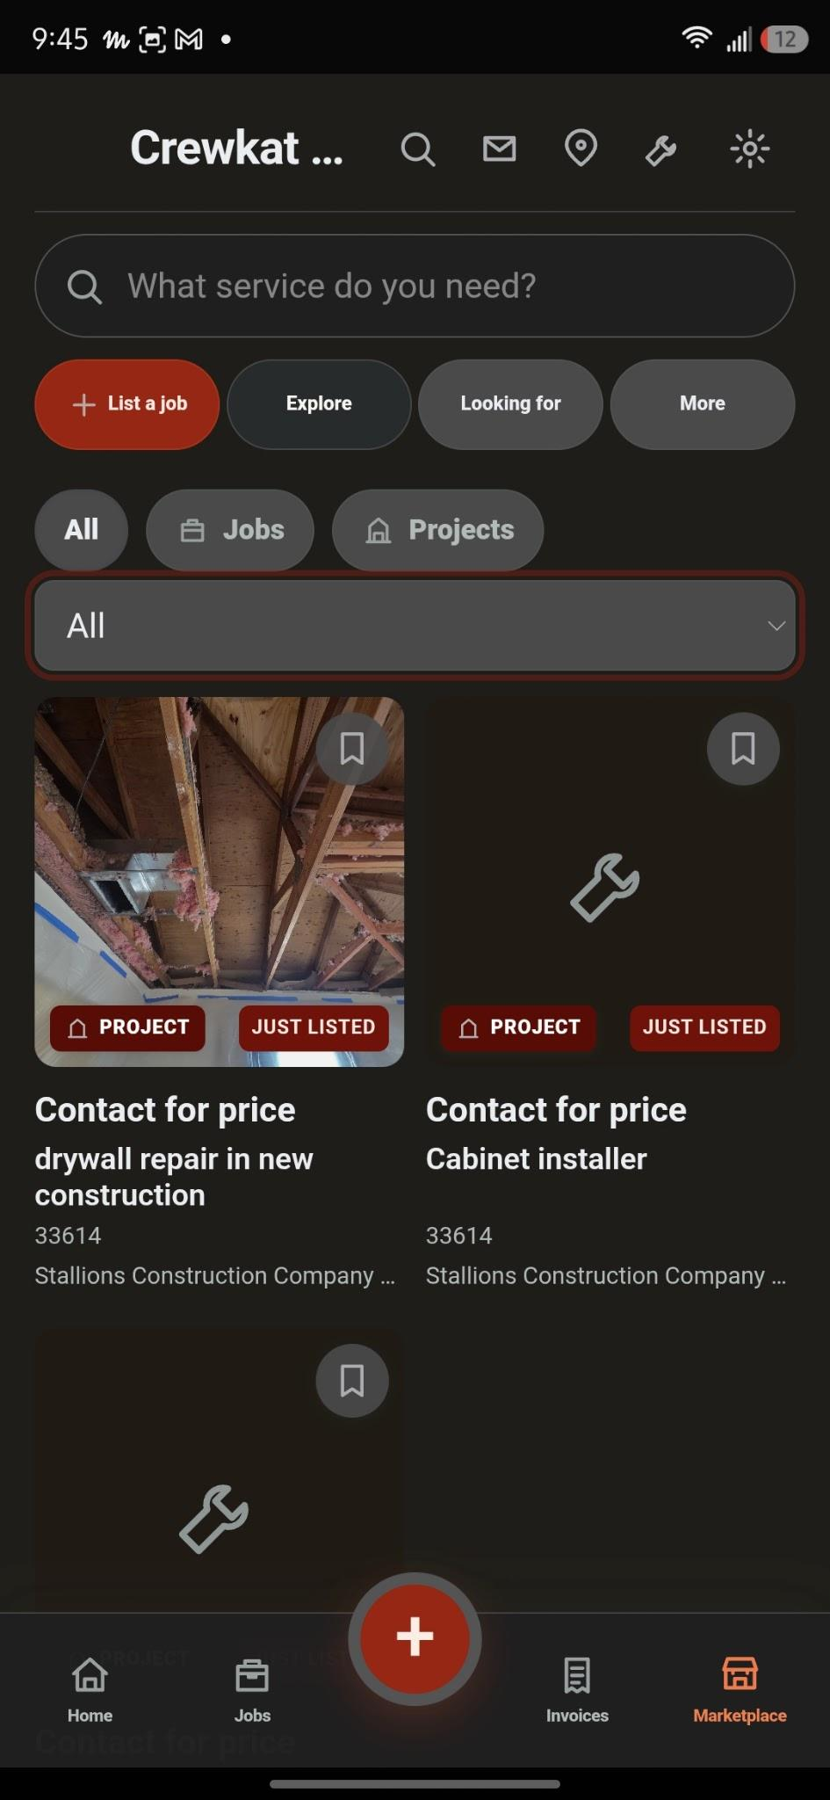

When tapping the more button or the sort by button I would like it to be a floating window with a little animation. Same as the other floating windows in the app

Since we have a search bar in the marketplace tab lets get rid of the magnifying glass icon up on the header.

The envelope icon in the marketplace should be inside the more option and when there is an unread message the more icon should have a tiny number with the amount of unread messages. Also not sure if yet in place but lets do push notifications when receiving messages and option to receive other notifications like when a client signs a document and when a client sees an invoice or estimate. Lets have the optional notifications in the notification dropdown in settings.

As seen below there is little difference in the theme colors. Let's fix that and change the header name to just settings. And the app settings to appearance or theme.

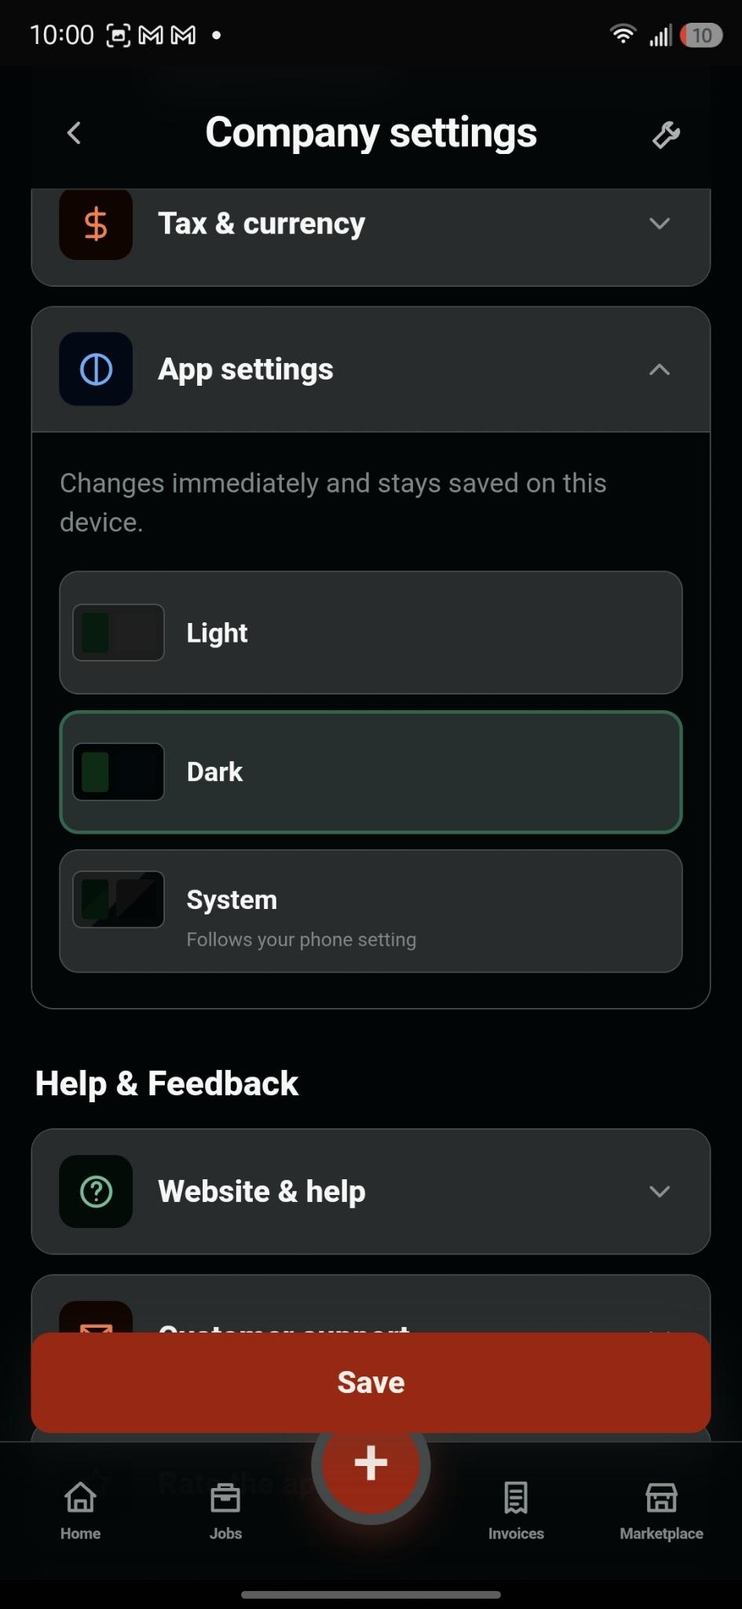

Please change the feeling. I need a little more animations through the app.

Inside marketplace again lets move the location icon from the main header yo tho options inside marketplace. Next to the more button and intead of it being a toggle lets do an animated floating window and maybe add a map to show location option like below in facebook

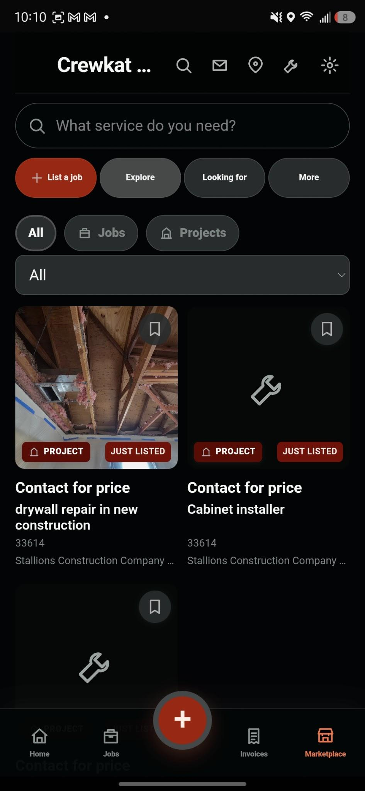

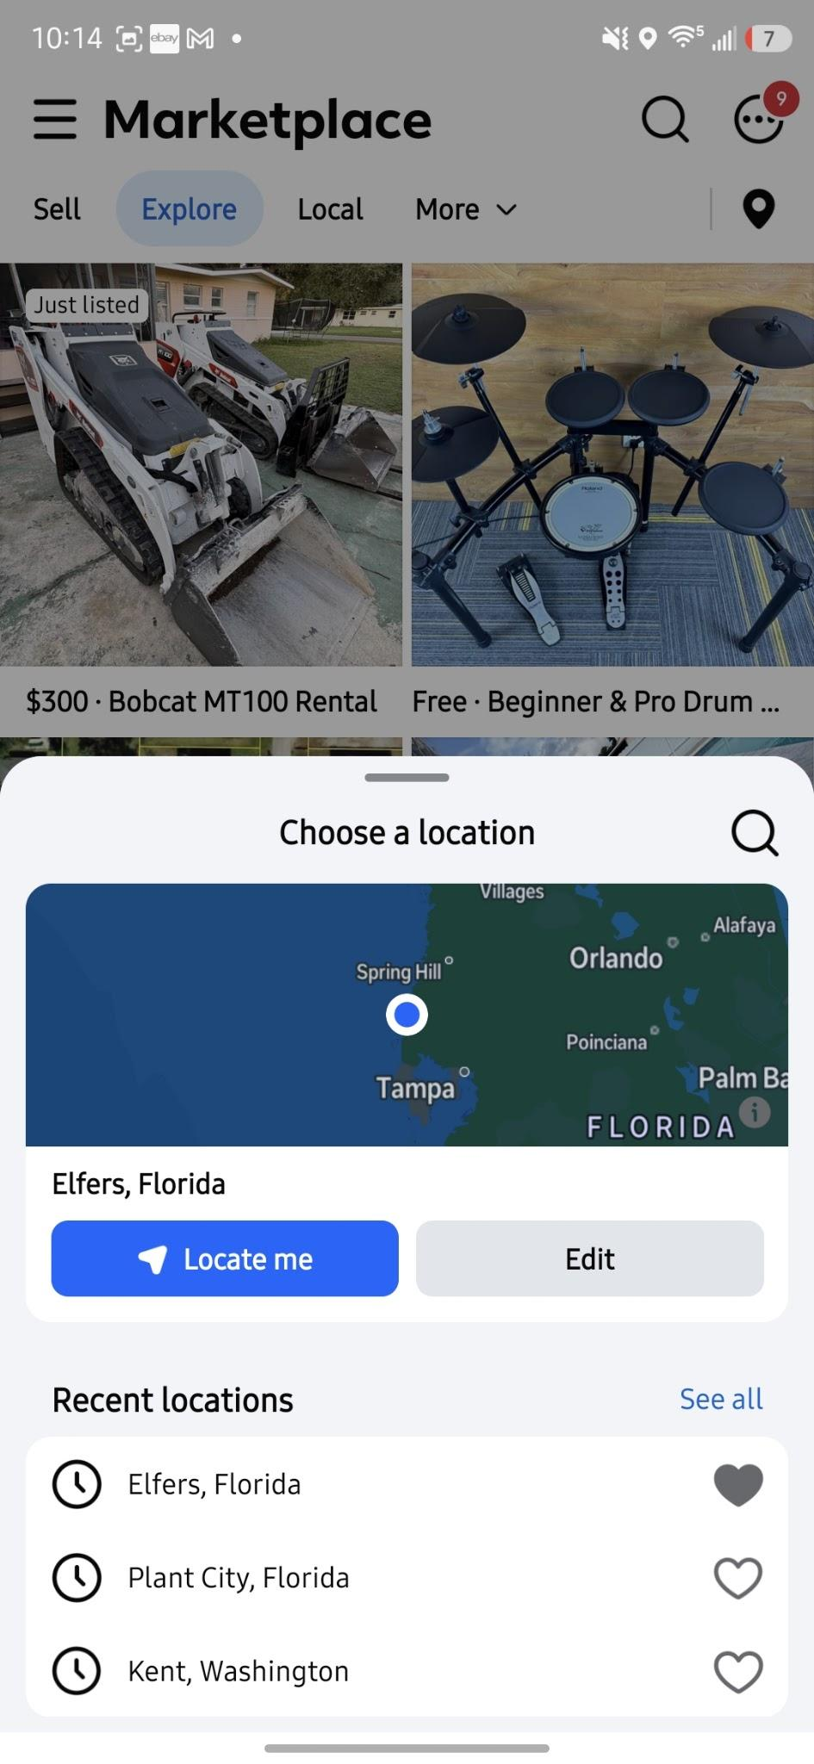

Also lets change to settings icon to a gear it looks like a light bulb

