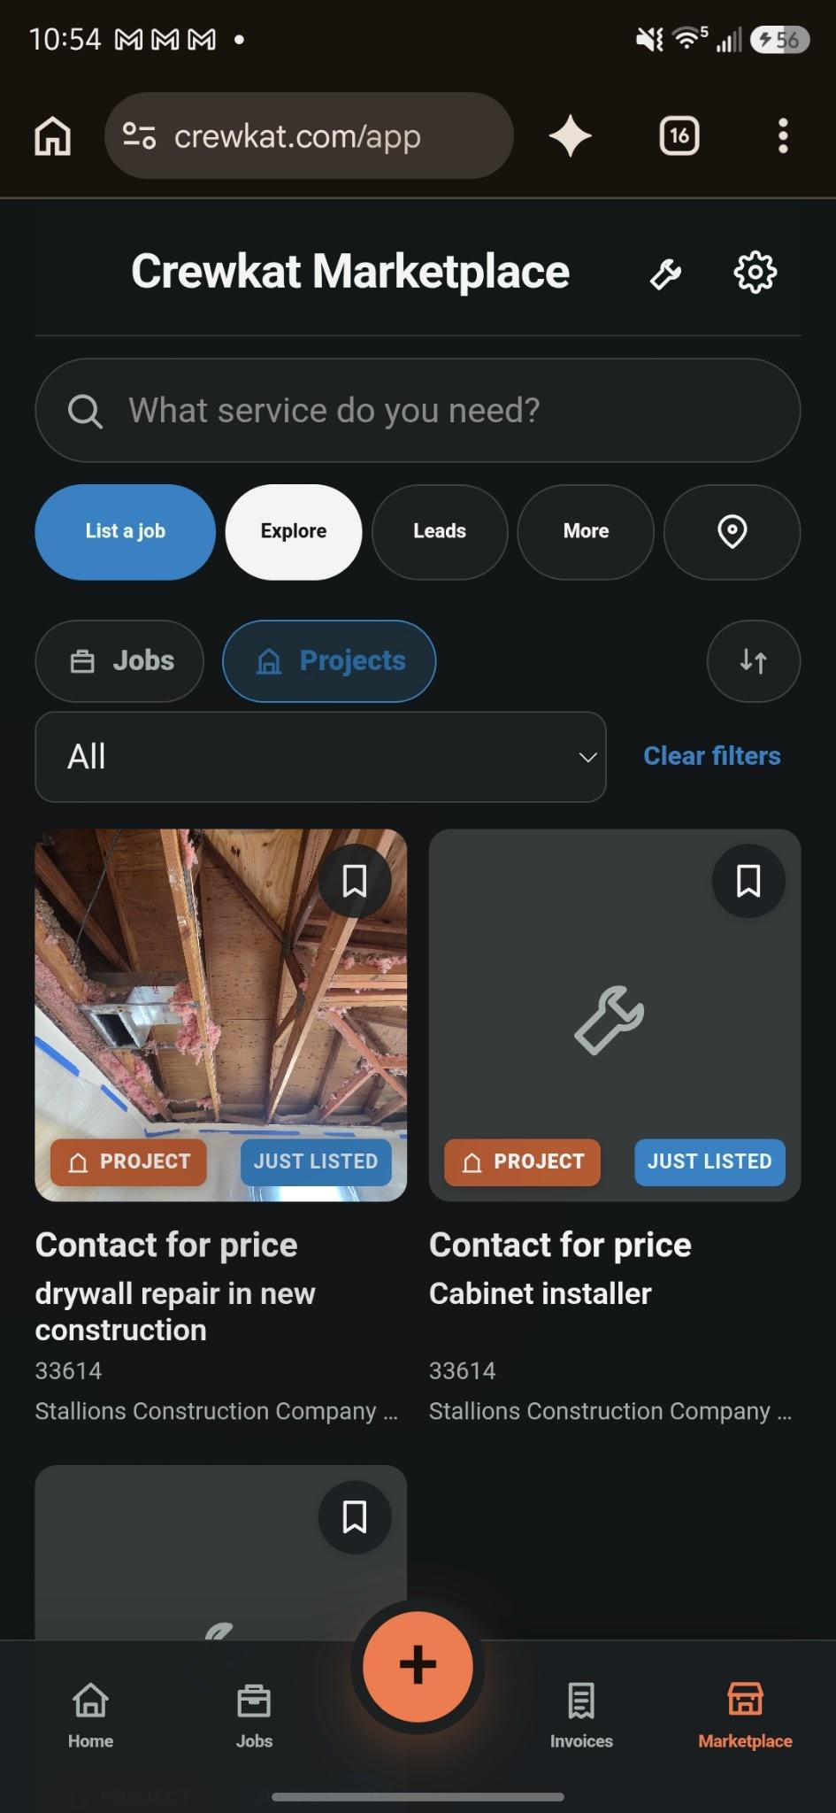
When im in projects the lista job should say list a project and the project icons over the listings should also be blue… see above.

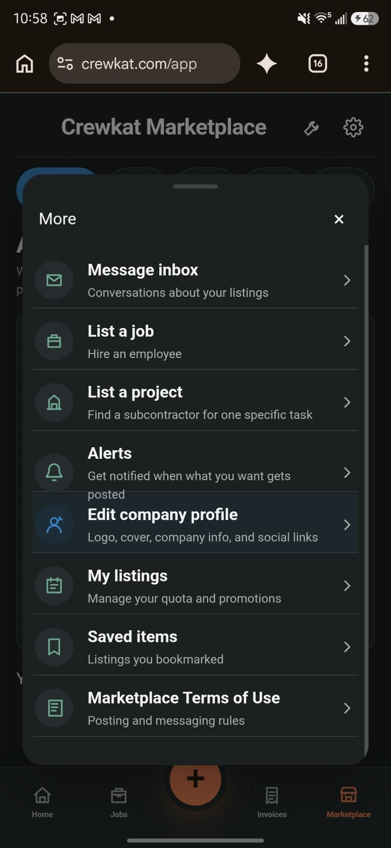
The alert buttons description extend past the box make it fit in

After tapping the save button in settings it sends me to a different page usually the page i came from but it should save and and say saved and stay within the settings tab and if i make a new change in settings change back to save.

