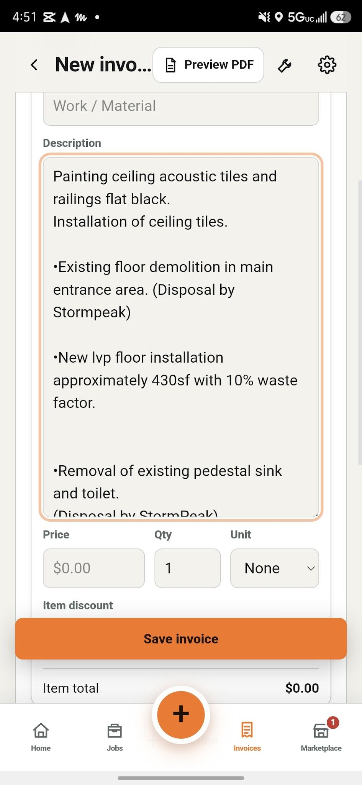In the invoice window. The description box is resizable by dragging the bottom right corner up or down and that is an awesome feature, but can we add a tiny icon to indicate that it is resizeable by dragging that icon. It must be tiny.

Also make it so that if im in the middle of creating an invoice but accidentally close the app, when it loads back up i still have the document in drafts.

Saving an invoice brings up this error when i type a lot of information in the description box. If only typing a few words it saves normally.
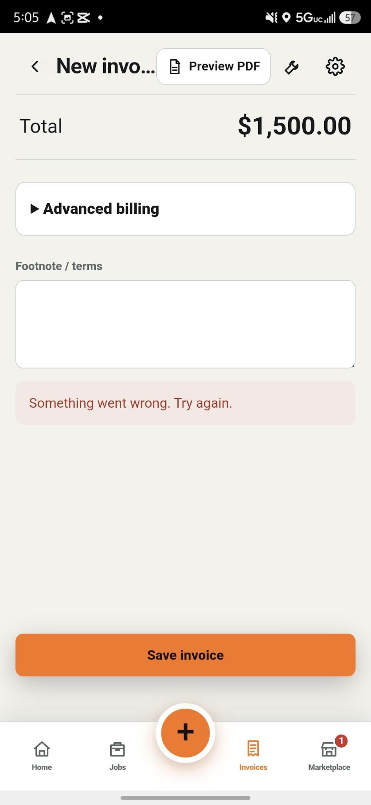

This next window when editing an invoice, it's too crowded. The save invoice button takes too much space. Can we place the button up on the header and say only save? And we can get rid of the gear and the wrench icon in this window. That way its just the headline, preview pdf and save. Lets make those buttons small.
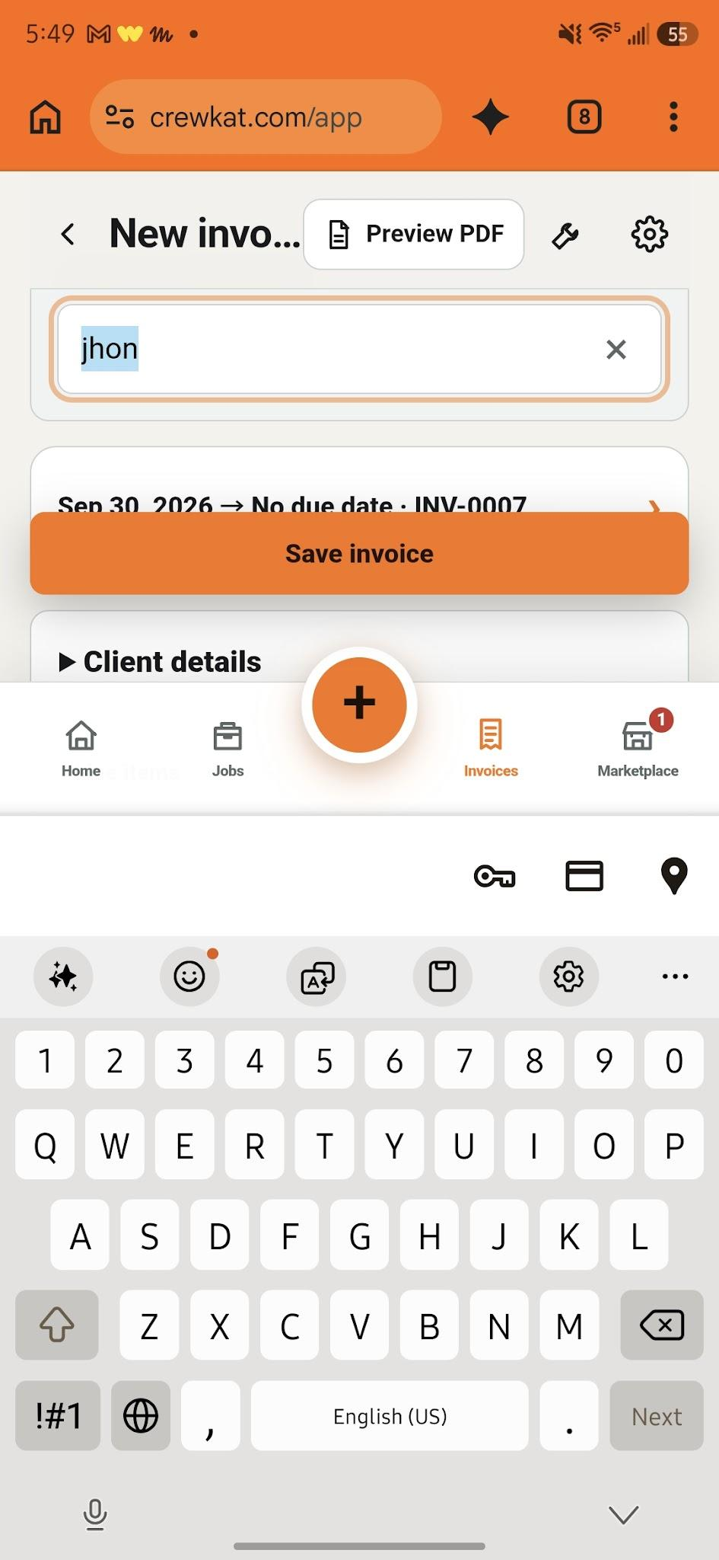

When going to edit an existing invoice the description tab does not appear on the window.
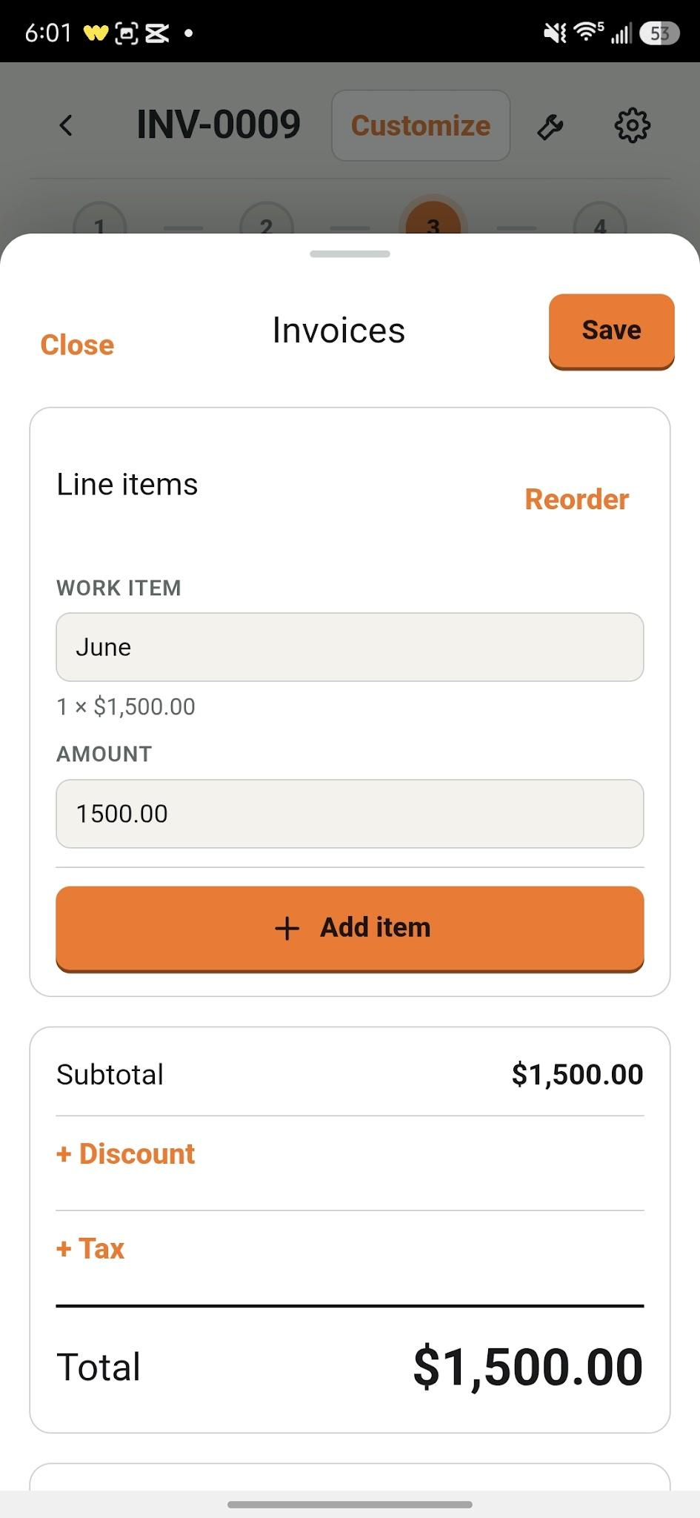

In this next screenshot the content inside the cards can be too close to the edge like the work automatic or the circle and created. Make these cards smaller also

And if i tap send or send pdf in the more menu in this window nothing happens in the mobile app. Only in the web app options come out.(see bellow)
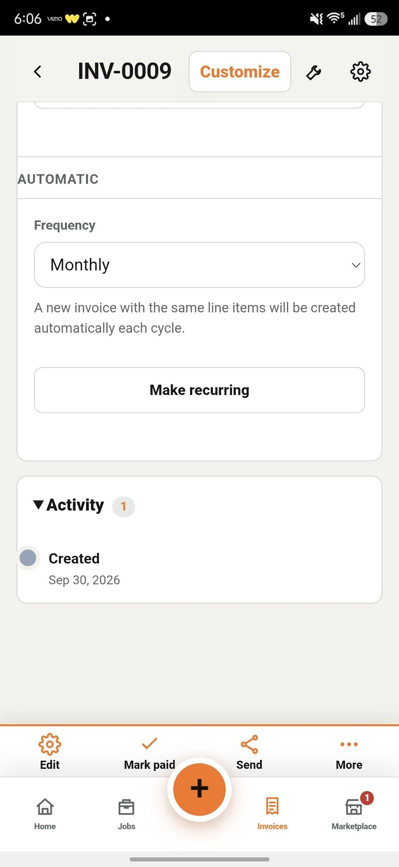

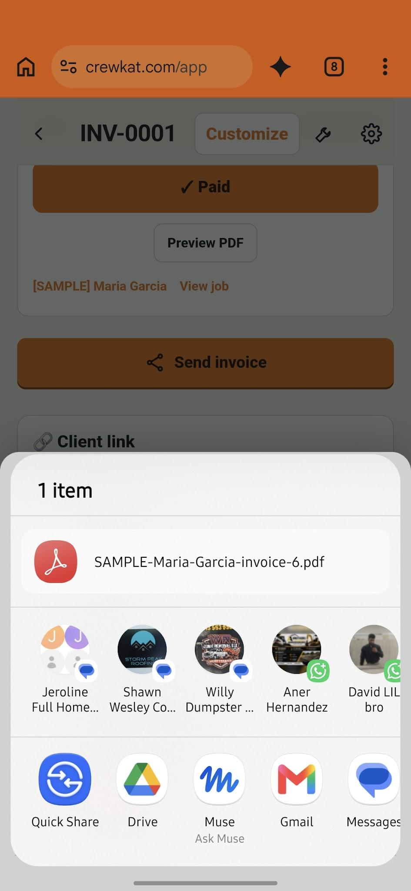

Also the phone “go back” button closes the the app i would like for it to send me back a window insetad and any work that was being done to be saved in drafts or saved if it was an existing document

See bellow. The client link send ls me here. The document is out of proportion, fix to show the actual pdf file not a render of it.

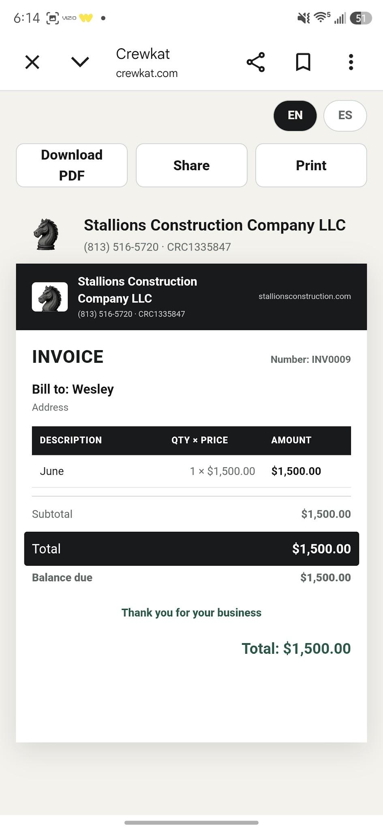

In this estimate cards the content of the cards also sit too close to the left edge

Lets say im viewing an invoice and i tap marketplace, i want to be able to see where i was when i tap invoices again. Now it's sending me to the home page of invoices.

When creating a contract the view document doesn't do anything and the card and buttons are all messed up please fix. 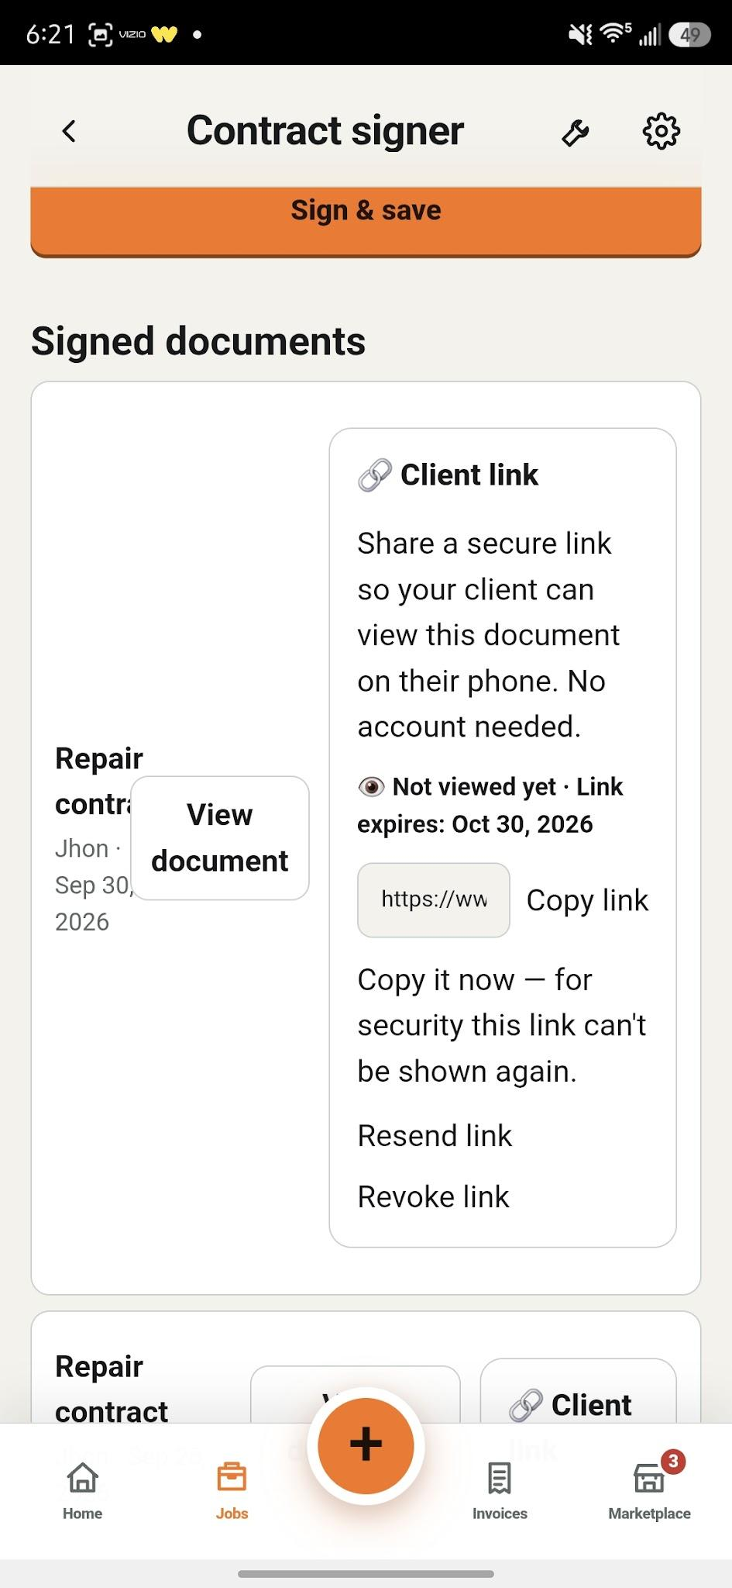

Payment notes have no save button. Replace the x for a small save button.
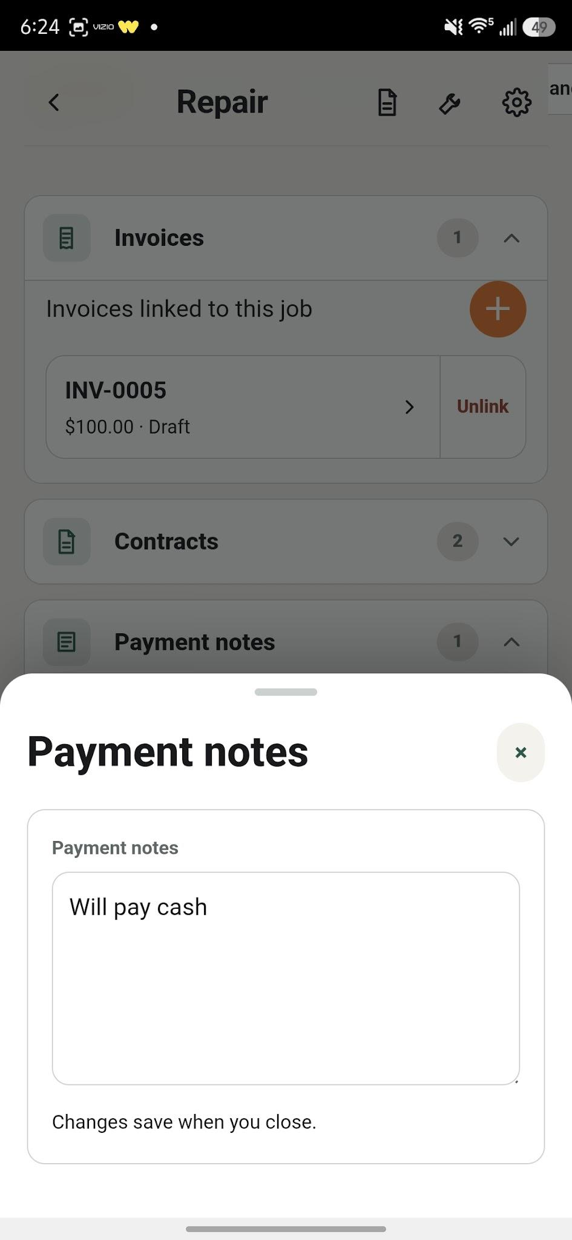

Lets add a camera icon on the camera orange button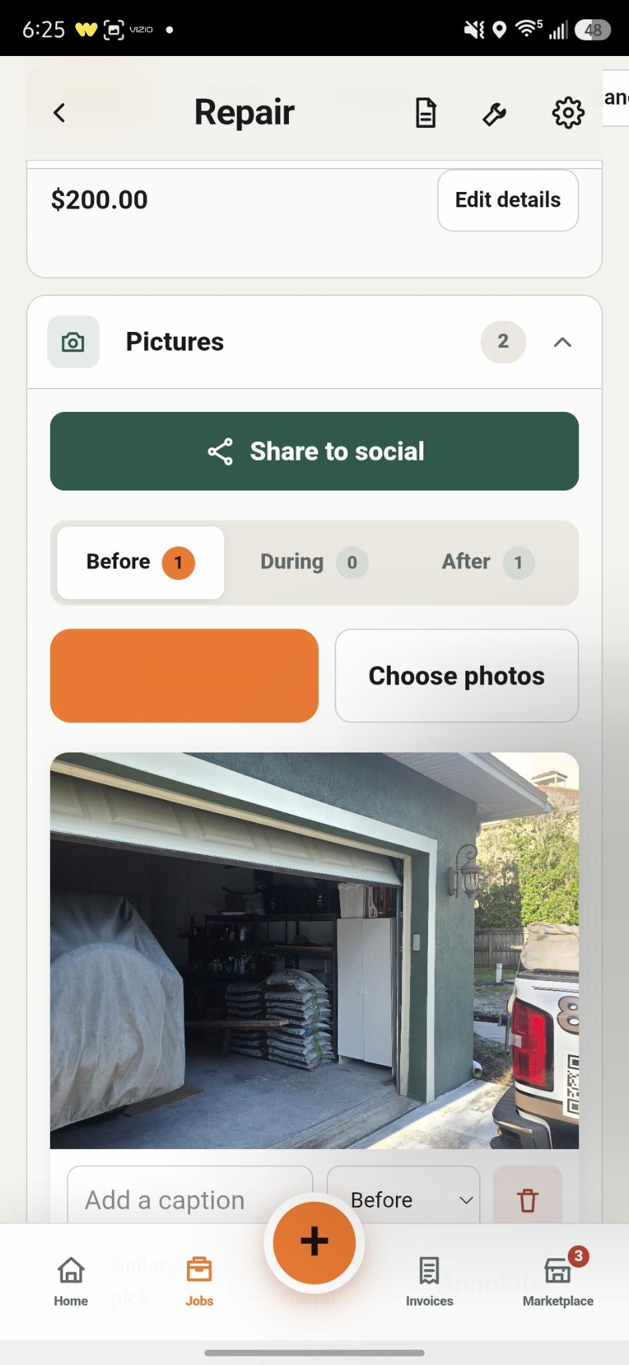

Same thing here replace x with save
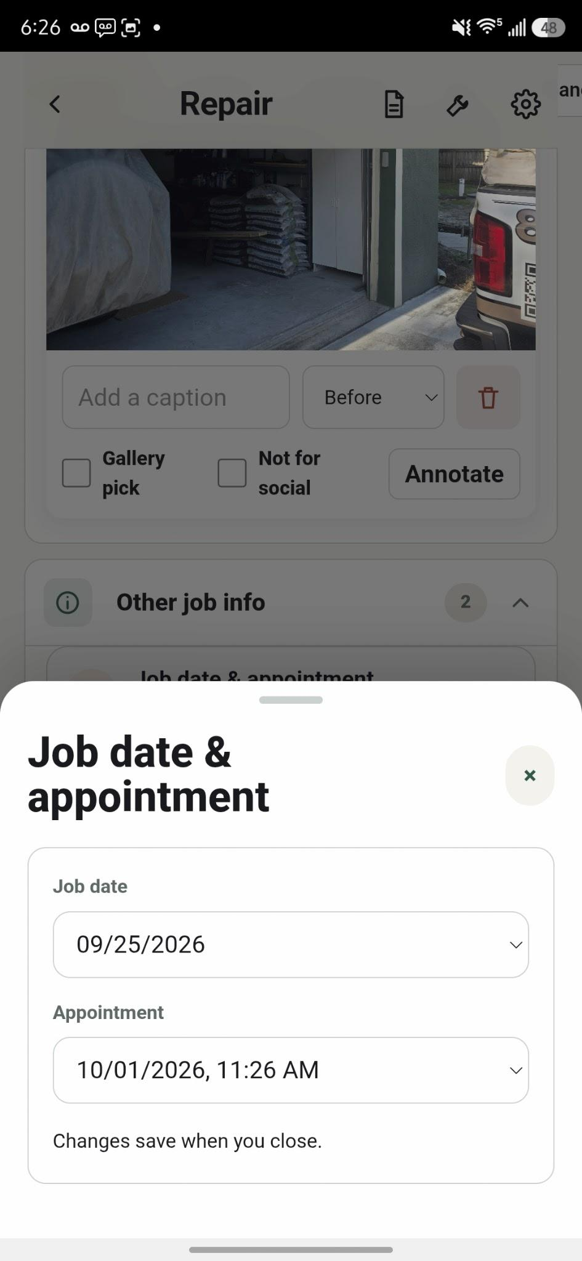

Make the cards more rectangular instead of so round
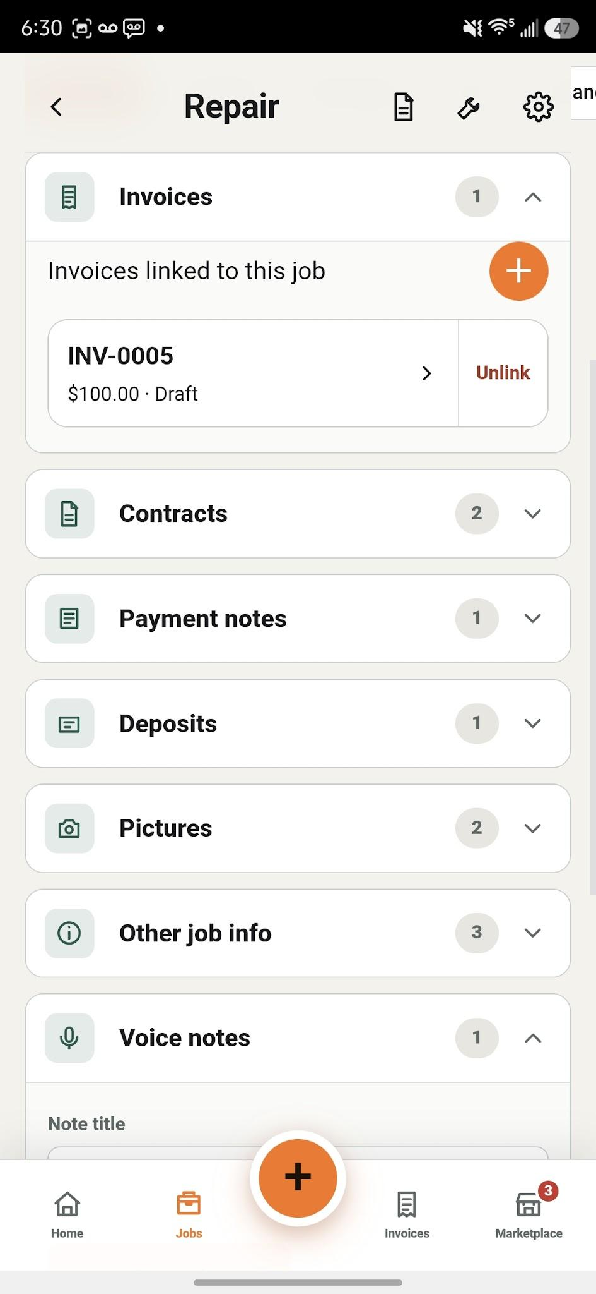

Images aren't showing in the proof packet

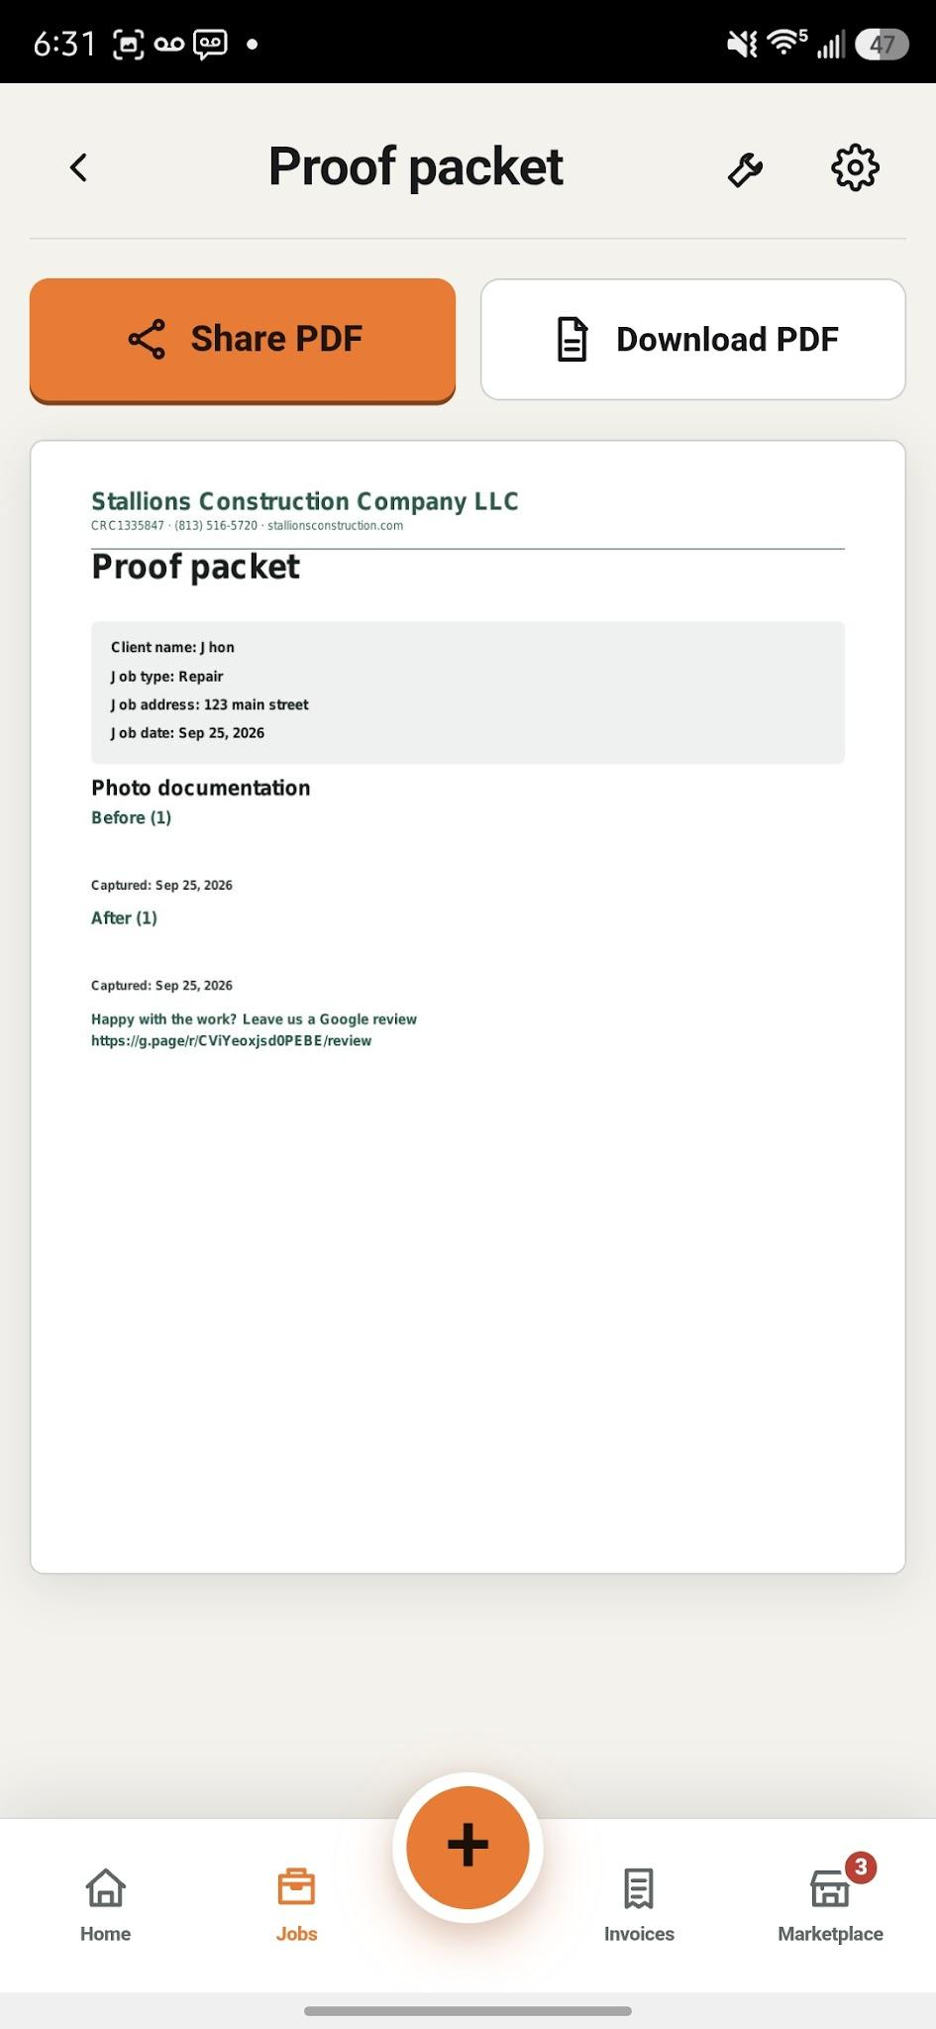

Content to close to borders, make the cards smaller and the buttons the same size but a lot smaller.
In the material prices tool
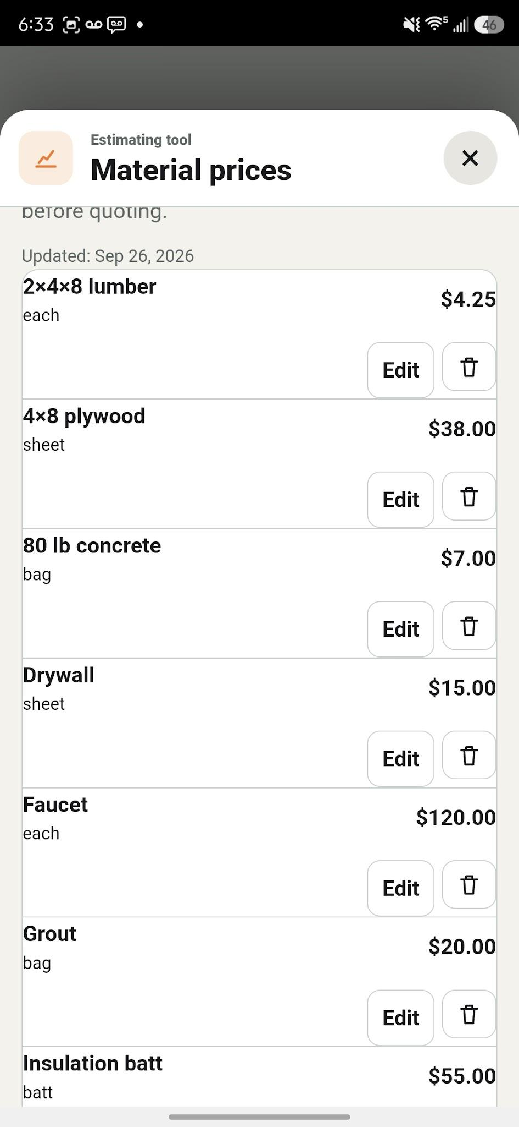

The copy button in the punchlist menu saves the numbers shown on the left (0/2) instead of the actual punch list content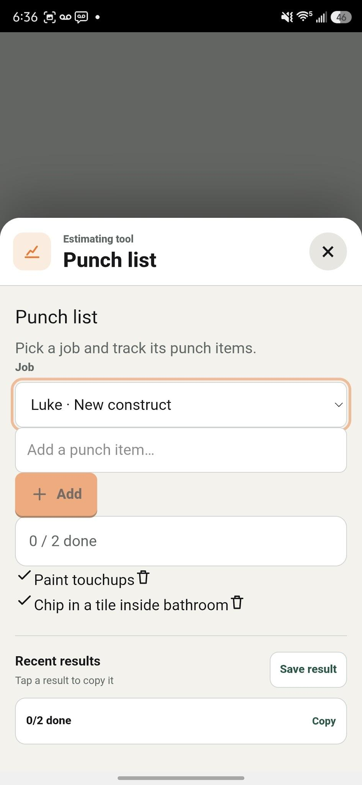

Add a camera icon to the camera button in the scanner tool.
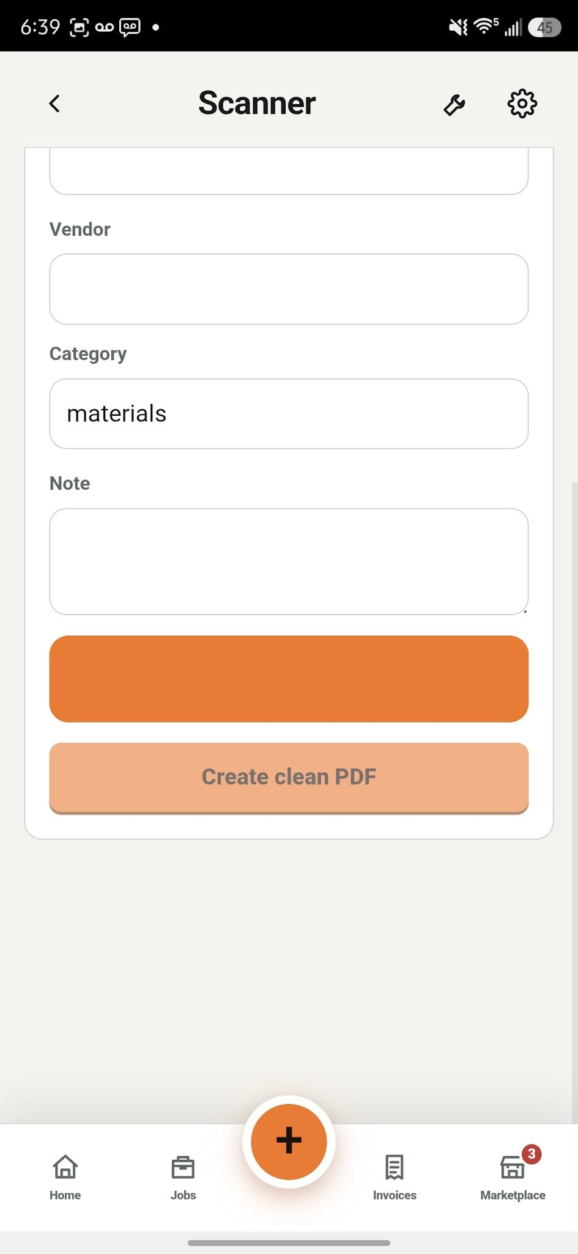

Also in the scanner tool. When I click on the camera, it opens the camera. And when I come back, the top menu is gone. And I cannot press back button, see screenshot below.
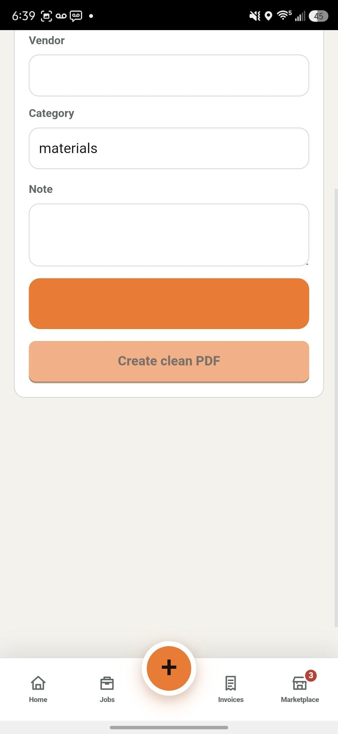

When I do take a picture of a document inside the scanner tool, it does nothing. And when I come back, the cards are out of promotion. The top header is gone, and nothing scans or happens.

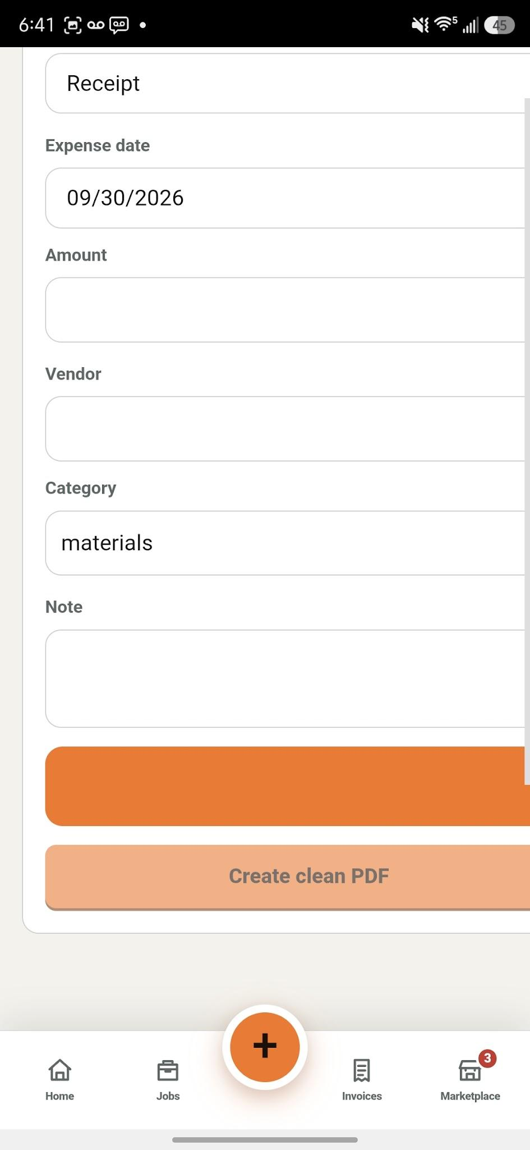

The settings gear icon is still the old one. In some windows
