In the new client page the button for picking a contact is there but i do not like the options to open chrome an the card option try again the actual contacts button if it doesn't work it is what it is.
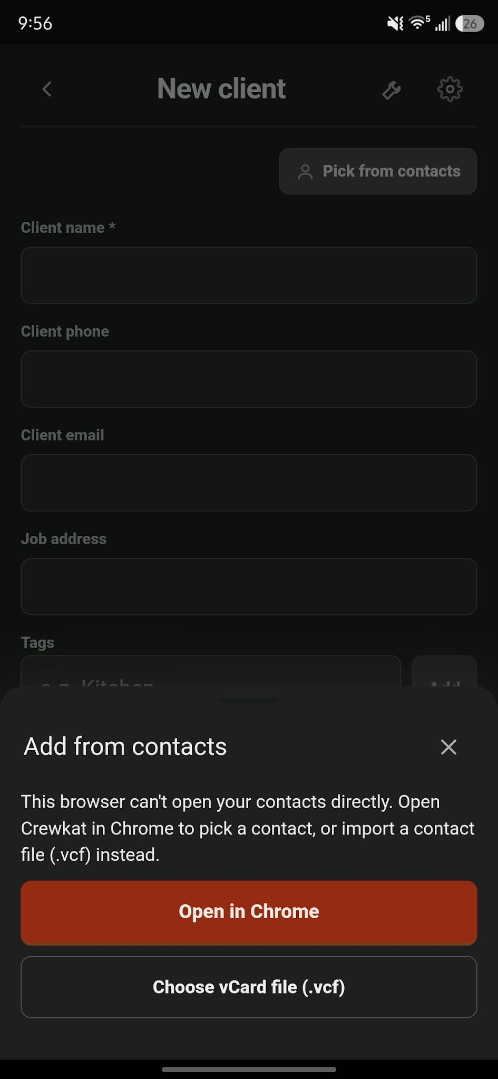

Document preview when sent through a link does not show the document
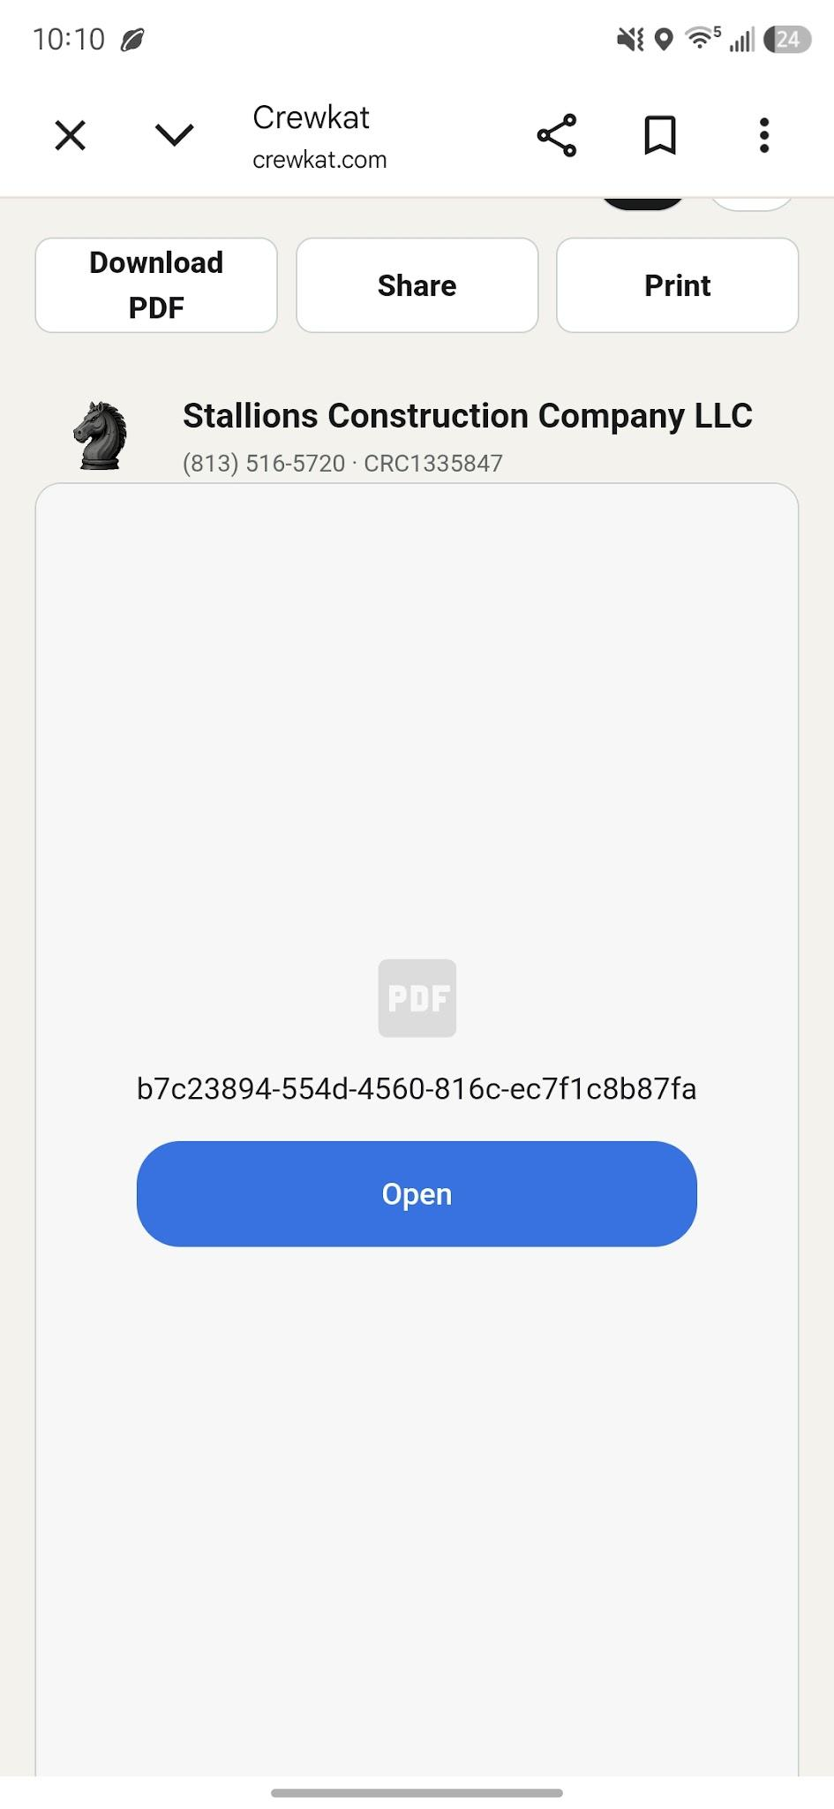

The send invoice button only downloads a pdf. I would like these options instead in a floating small window just like that.
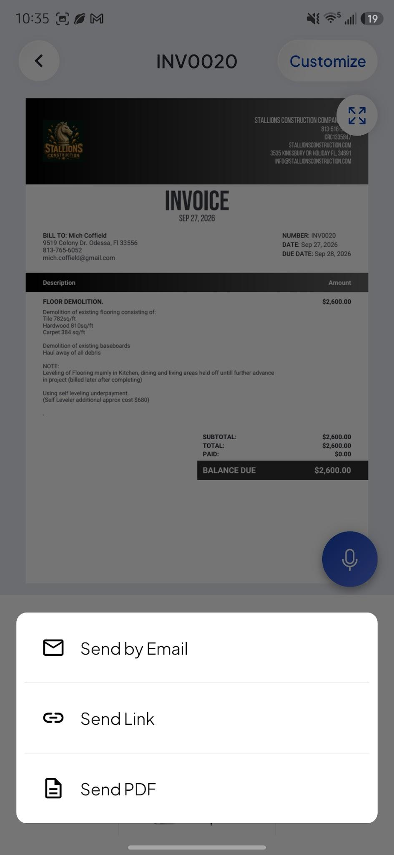

When im inside an invoice i would like the bottom master menuwith home jobs +sign etc to not show . Instead just the editing and other options menu for this invoice.
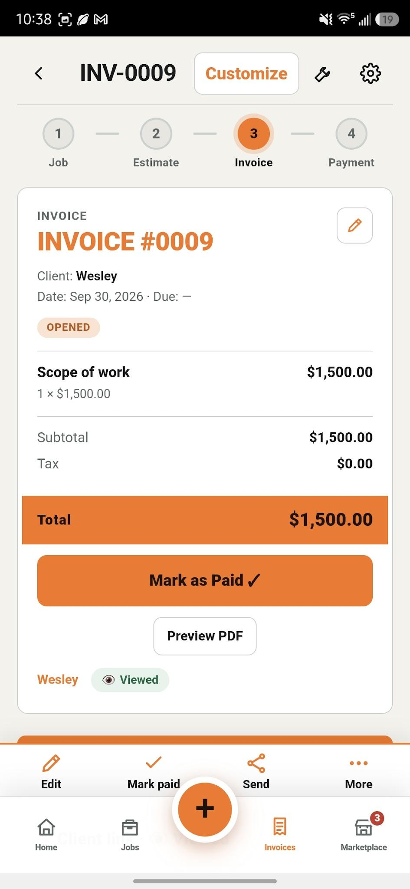

The words automatic and manual in the recurring setting should be separated from the edge.
