Explainable Research Charts — IM/2021/049
Visual figures for Chapter 5 / viva. Use these to explain phone distribution, ABSA results, feature scores, and ranking behaviour to your supervisor.

Figure A — Phone distribution by brand. Shows the corpus is Apple-heavy; mention this as a limitation and coverage fact.
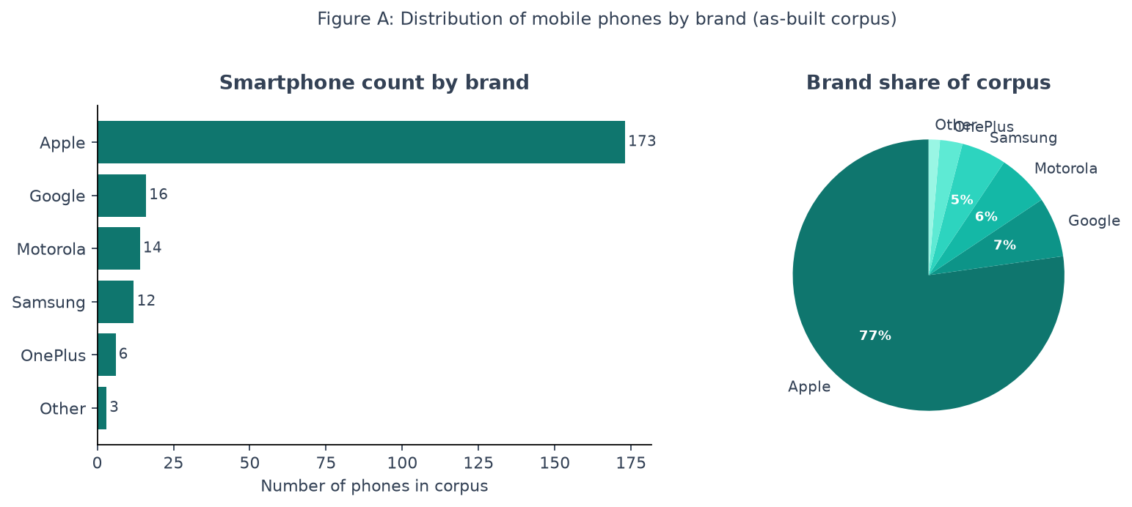
File: data/exports/analysis/charts/01_phone_brand_distribution.png

Figure B — Reviews per phone. Mean ≈ 15 kept reviews; not 200/phone — report honestly.
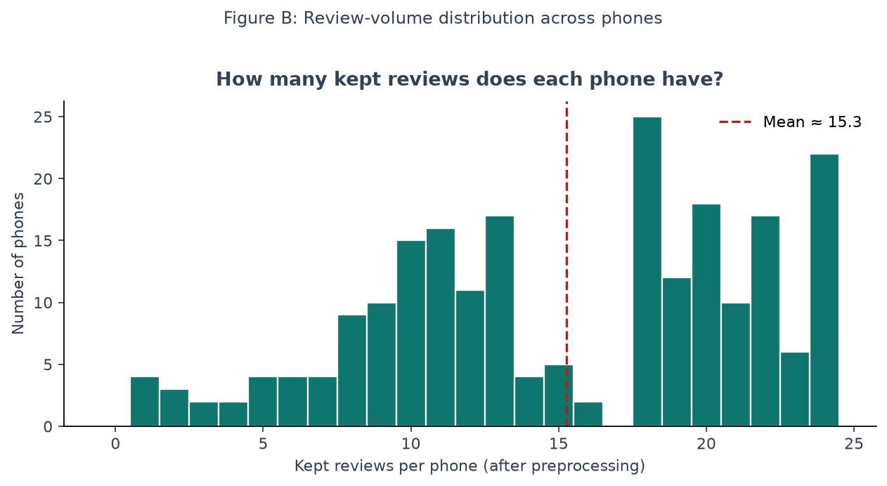
File: data/exports/analysis/charts/02_reviews_per_phone_hist.png

Figure C — Aspect & sentiment distribution. Battery is discussed most; all six features appear.
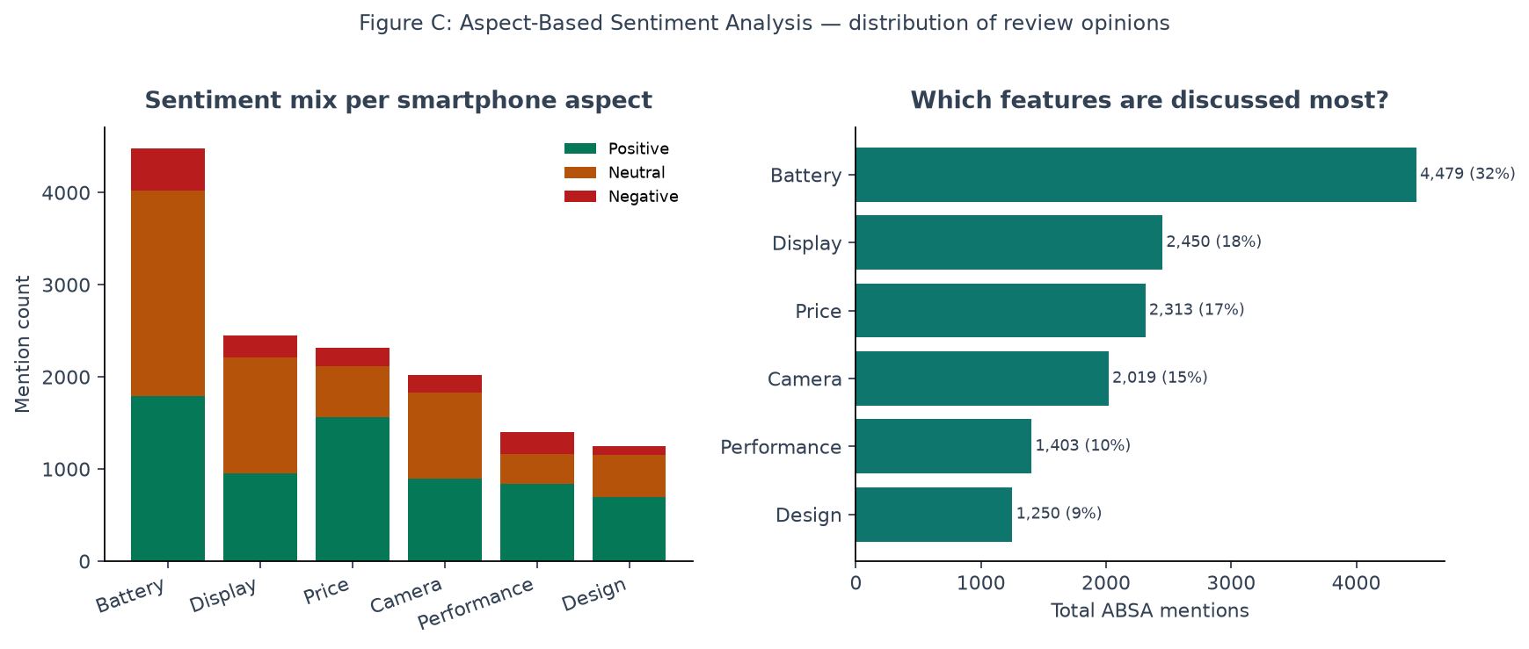
File: data/exports/analysis/charts/03_aspect_sentiment_distribution.png

Figure D — Overall sentiment mix across 13,914 aspect mentions.
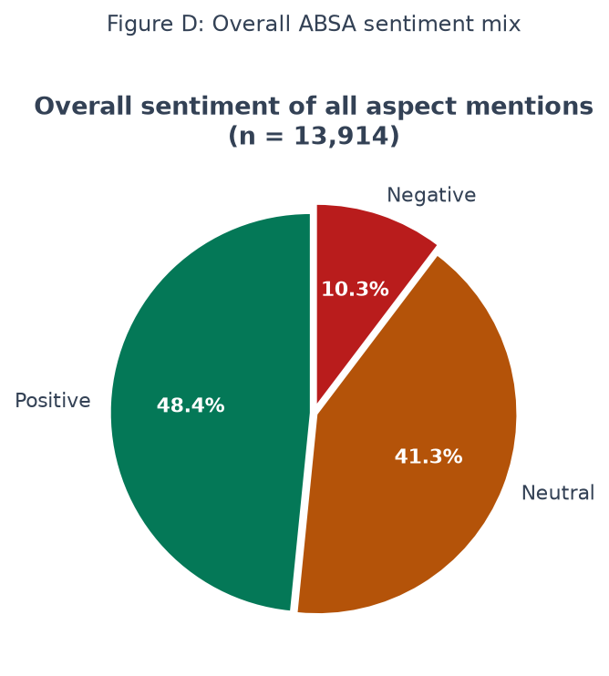
File: data/exports/analysis/charts/04_overall_sentiment_pie.png

Figure E — Explainable feature scores for two phones. Faded bars = lower confidence (fewer mentions).
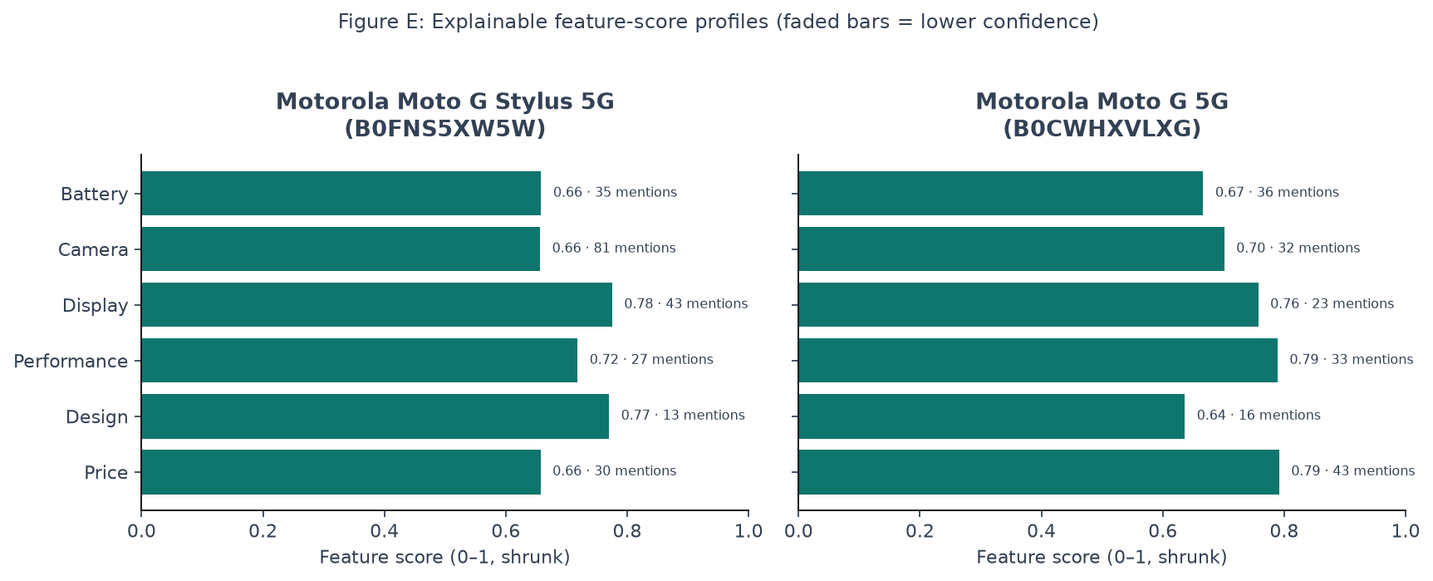
File: data/exports/analysis/charts/05_sample_phone_feature_scores.png

Figure F — ABSA vs Amazon stars by rating bucket (sanity check, not gold accuracy).
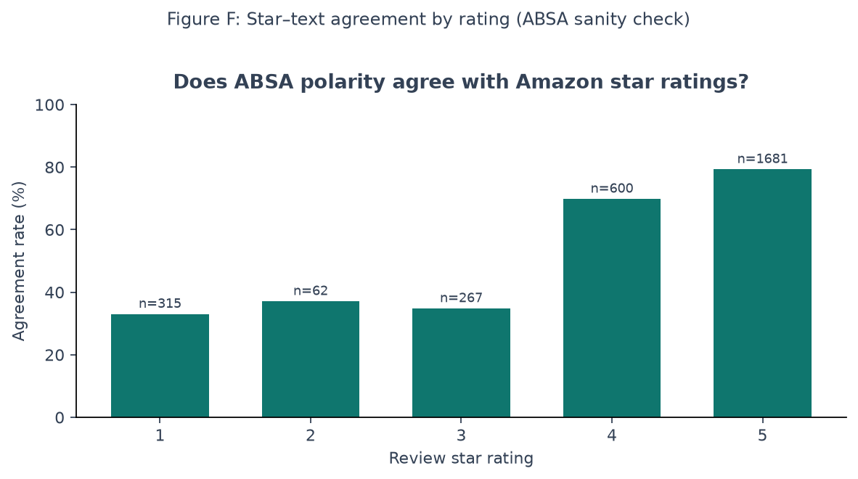
File: data/exports/analysis/charts/06_star_text_agreement_by_rating.png

Figure G — Changing user priorities changes the Top-1 recommendation.
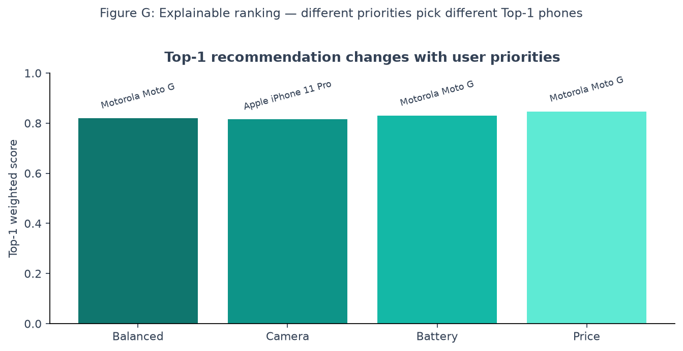
File: data/exports/analysis/charts/07_ranking_priority_top1.png

Figure H — Proposed method vs Amazon star baseline Top-5 (different lists).
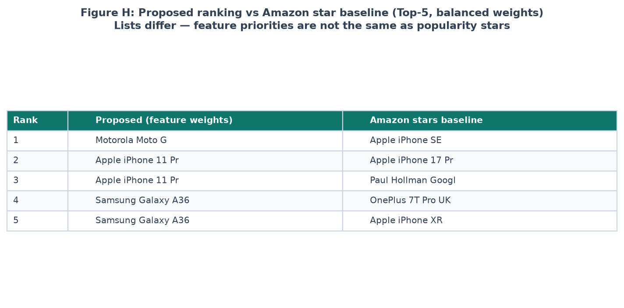
File: data/exports/analysis/charts/08_proposed_vs_baseline_table.png
Viva tip
Open this document (or the PNG folder) when asked: “Show me the data distribution”, “How do you know ABSA works?”, “Do user priorities matter?”, or “How is this better than star ratings?”

