SMARTPHONE RECOMMENDATION SYSTEM
Research Methodology, Docker Architecture and Simple Web Application Guide

Based on the supplied ABSA methodology and extended with recommendation, feedback and implementation details.

Main development environment | Cursor + Python
Deployment/runtime | Docker + Streamlit
Research data | Amazon Reviews'23 for current development; future permitted live source can use the same schema
Storage | SQLite + CSV/Parquet research outputs

Recommended implementation principle: process reviews offline, store feature scores, and keep the user-facing recommendation path fast.

1. Purpose and Final Research Goal
The goal is to build a simple smartphone recommendation research prototype that uses Amazon smartphone review text to create aspect-level feature scores and then recommends the Top 10 smartphones according to each user's requirements. After the Top 10 are shown, the user rates satisfaction from 1 to 5. That feedback is used to evaluate the recommendation system, not to automatically retrain it.
- Display smartphone products in a familiar e-commerce style using cards, search and filters.
- Use review-based Aspect-Based Sentiment Analysis (ABSA) for Battery, Camera, Display, Performance and Price.
- Convert review opinions into per-phone aspect scores.
- Collect user importance values (1-5) and calculate a deterministic weighted recommendation score.
- Return the Top 10 phones and collect a 1-5 satisfaction rating plus an optional comment.

2. Clear Research Methodology
The core ABSA stages below follow the supplied methodology document: data preprocessing, sentence segmentation, LLM aspect extraction, LLM sentiment classification, structured aspect-sentiment records, aspect score aggregation, and a smartphone feature score database. The recommendation and feedback stages are added as the application and evaluation layer.
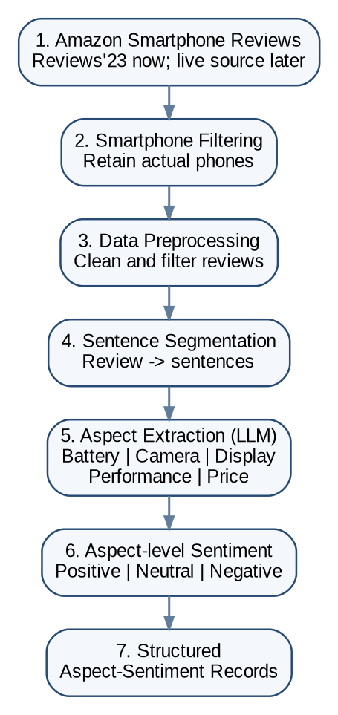 | 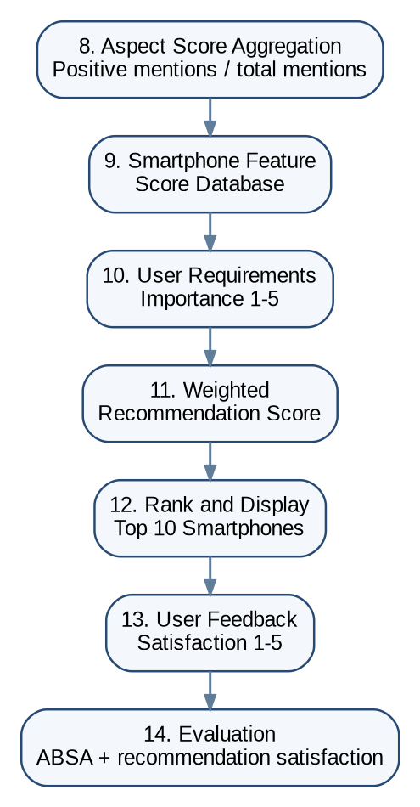
Figure 1. End-to-end research methodology (left: data and ABSA; right: recommendation and evaluation)

Phase | Input | Method | Output
1. Data acquisition | Amazon smartphone review data | Reviews'23 now; future permitted live collector uses same output schema | Raw review dataset
2. Product filtering | Cell Phones & Accessories metadata | Remove accessories; retain actual smartphones | Selected smartphone list
3. Preprocessing | Raw review text | Remove duplicates/empty/spam, HTML; normalize; English filtering | Clean reviews
4. Sentence segmentation | Clean review | Split each review into sentence-level units | Sentence dataset
5. Aspect extraction | Sentence | LLM chooses Battery/Camera/Display/Performance/Price | Aspect labels
6. Sentiment classification | Sentence + aspect | LLM predicts Positive/Neutral/Negative for each aspect | Aspect-sentiment records
7. Structured dataset | Validated LLM output | Store phone, review, sentence, aspect and sentiment | ABSA dataset
8. Aggregation | Aspect-sentiment records | Positive mentions / total aspect mentions | Feature scores 0-1
9. Recommendation | Feature scores + user weights | Weighted sum and descending ranking | Top 10 phones
10. Feedback & evaluation | Top 10 shown to user | 1-5 satisfaction + optional comment | Recommendation evaluation data

3. Preprocessing and ABSA Model Process

3.1 Raw data preservation
Keep the original review file unchanged. Every transformation must create a new output. This makes the research reproducible and allows you to compare raw and processed records.
data/raw/amazon_smartphone_reviews_RAW.csv
data/processed/amazon_smartphone_reviews_CLEAN.csv
data/processed/review_sentences.csv
data/results/aspect_sentiment_records.csv
data/results/smartphone_aspect_scores.csv

3.2 Cleaning rules
- Remove exact or near-duplicate review records using a documented rule.
- Remove missing and empty review text.
- Remove obvious HTML and normalize repeated whitespace.
- Filter to English if the research scope is English-language reviews.
- Use conservative spam/unusable-text rules and record the number of removed rows.
- Do not remove negations such as not, no, never, do not, because they change sentiment meaning.

3.3 Sentence segmentation
A review such as “Battery lasts two days. Display is amazing. Camera is poor.” becomes three sentence records. Preserve review_id, sentence_id, phone identifier and the original review relationship.

3.4 LLM aspect extraction and sentiment
Use a controlled aspect taxonomy: Battery, Camera, Display, Performance and Price. The LLM should not invent new research aspects. A sentence may contain more than one aspect; each aspect receives its own sentiment label.
Sentence | Aspect | Sentiment
The battery lasts two days. | Battery | Positive
The display is acceptable. | Display | Neutral
The camera is poor at night. | Camera | Negative
The camera is excellent but the battery is terrible. | Camera; Battery | Positive; Negative

3.5 Aspect score aggregation
Use the simple score already shown in the supplied methodology:
Aspect Score = Number of Positive Mentions / Total Mentions for that Aspect
Example: if 850 of 1,000 Battery mentions for a phone are Positive, Battery Score = 0.85. Keep the aggregation formula configurable so a different formula can be tested later without changing the whole application.

4. Recommended Technical Architecture
Use Cursor for development and Docker as the reproducible runtime. Google Colab is not required for this architecture unless you later fine-tune a GPU-heavy model. The same Docker image can run both the Streamlit application and offline research scripts.

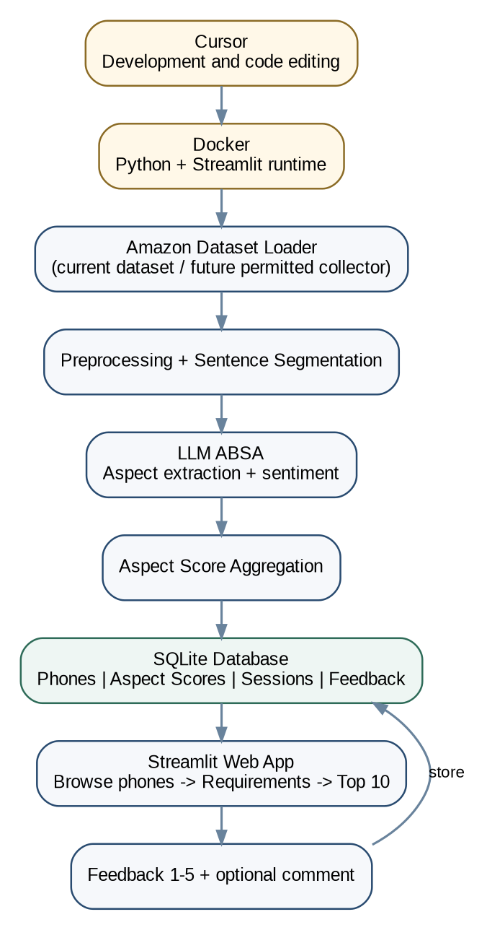
Figure 2. Proposed Docker-based system architecture

4.1 Why separate offline and online processing?
- Offline: dataset loading, cleaning, segmentation, LLM ABSA and aggregation can take minutes or hours.
- Online: user preference input, weighted ranking and Top 10 display should take seconds.
- The website reads precomputed feature scores from SQLite. It does not call the LLM for every visitor.

5. Cursor Project and Folder Structure
smartphone-recommender/
|-- app.py
|-- Dockerfile
|-- docker-compose.yml
|-- requirements.txt
|-- .env.example
|-- README.md
|
|-- config/
| |-- settings.py
| `-- aspects.py
|
|-- data/
| |-- raw/
| |-- interim/
| |-- processed/
| `-- results/
|
|-- database/
| `-- smartphone_recommender.db
|
|-- scripts/
| |-- init_db.py
| `-- run_pipeline.py
|
|-- src/
| |-- data_collection/amazon_dataset.py
| |-- data_collection/product_filter.py
| |-- data_collection/amazon_scraper.py # future adapter
| |-- preprocessing/cleaner.py
| |-- preprocessing/sentence_segmenter.py
| |-- absa/llm_provider.py
| |-- absa/absa_pipeline.py
| |-- absa/score_aggregator.py
| |-- recommendation/recommender.py
| |-- evaluation/metrics.py
| `-- database/db.py
|
|-- pages/
| |-- 1_Browse_Phones.py
| |-- 2_My_Requirements.py
| |-- 3_Recommendations.py
| |-- 4_Feedback.py
| `-- 5_Research_Admin.py
|
`-- tests/
|-- test_cleaner.py
|-- test_absa.py
`-- test_recommender.py

6. Simple Website Structure
The user-facing website should look like a simple smartphone store rather than a research dashboard. Keep the research/admin functions separate from normal users.
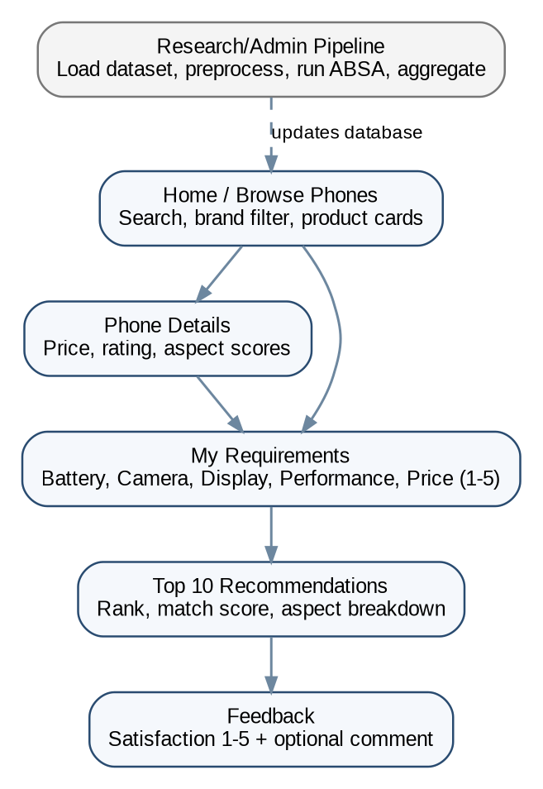
Figure 3. Website navigation and recommendation flow

Page | Purpose
Home / Browse Phones | Grid of all available phones, product image/placeholder, name, brand, price, rating, search and filters. Similar visual idea to an e-commerce catalogue, but simple.
Phone Details | Phone details plus review-derived Battery, Camera, Display, Performance and Price scores.
My Requirements | Five importance sliders from 1 to 5. Optional brand or budget filter can be used as a hard filter, but the research ranking should remain based on the documented aspect weights.
Recommendations | Top 10 phones with rank, overall match score and the five aspect scores. Show a short deterministic explanation of the strongest matches.
Feedback | Ask “How satisfied are you with these recommendations?” using 1-5 and an optional text comment.
Research/Admin | Load/inspect dataset, run preprocessing, run ABSA, aggregate scores and view research counts. This page is not required for ordinary users.

7. Recommendation Method
The recommendation stage should use deterministic Python mathematics rather than asking the LLM to choose phones.
For a user who gives importance values from 1 to 5, first normalize the weights:
Normalized Weight(a) = User Weight(a) / Sum of all User Weights
Then calculate each phone score:
Recommendation Score(phone) = Sum[Normalized Weight(a) x Phone Aspect Score(phone, a)]
Sort all eligible phones by this score in descending order and return the Top 10. If a phone has a missing aspect score, document and apply one consistent rule, such as excluding that phone from ranking until enough aspect evidence exists.

8. User Feedback and Research Evaluation

8.1 Feedback collected after Top 10
Rating | Meaning
1 | Very dissatisfied
2 | Dissatisfied
3 | Neutral
4 | Satisfied
5 | Very satisfied
Save the rating with the recommendation session. Also store the user's five input weights and the Top 10 results so the feedback can be traced to the actual recommendation shown.

8.2 Minimum feedback fields
- session_id and timestamp
- Battery, Camera, Display, Performance and Price weights
- Top 10 phone IDs and recommendation scores
- Satisfaction rating 1-5
- Optional comment

8.3 ABSA evaluation
Create a manually verified evaluation sample and compare the predicted aspect and sentiment labels with ground truth. Report at least Accuracy, Precision, Recall and F1-score. Where possible, report aspect extraction and sentiment classification separately.

8.4 Recommendation evaluation
Use the 1-5 feedback to report mean satisfaction, median, standard deviation and the percentage of users who selected 4 or 5. The feedback should evaluate the system; do not automatically retrain the ABSA or recommendation model from these ratings unless a separate learning methodology is introduced.

9. Simple Database Design
Table | Main fields
smartphones | id, parent_asin, name, brand, price, image_url, average_rating
reviews | id, smartphone_id, rating, review_text, verified_purchase, timestamp
aspect_sentiments | id, smartphone_id, review_id, sentence_id, sentence, aspect, sentiment
aspect_scores | smartphone_id, battery, camera, display, performance, price, updated_at
recommendation_sessions | session_id, five user weights, created_at
recommendation_results | session_id, smartphone_id, rank, recommendation_score
feedback | id, session_id, satisfaction_rating, comment, created_at

10. Docker + Cursor Setup

10.1 Development path
- Install Docker Desktop and Cursor.
- Create a folder named smartphone-recommender and open it in Cursor.
- Create the Python project files and requirements.
- Build the Docker image.
- Run Streamlit inside the container.
- Run the offline research pipeline through the same image when needed.
- Persist data and SQLite files through mounted local folders.

10.2 Minimal requirements.txt
streamlit
pandas
numpy
datasets
pyarrow
nltk
python-dotenv
pydantic
sqlalchemy
langdetect
pytest

10.3 Simple Dockerfile
FROM python:3.11-slim
WORKDIR /app
COPY requirements.txt .
RUN pip install --no-cache-dir -r requirements.txt
COPY . .
EXPOSE 8501
CMD ["streamlit", "run", "app.py", "--server.address=0.0.0.0", "--server.port=8501"]

10.4 Simple docker-compose.yml
services:
web:
build: .
ports:
- "8501:8501"
env_file:
- .env
volumes:
- ./data:/app/data
- ./database:/app/database

10.5 Main commands
# Build and start the website
docker compose up --build
# Open in browser
http://localhost:8501
# Run the offline research pipeline when required
docker compose run --rm web python scripts/run_pipeline.py
# Run tests
docker compose run --rm web pytest
# Stop the application
docker compose down

11. Recommended Implementation Order
Milestone | Build | Completion condition
Milestone 1 | Project + Docker | Streamlit opens at localhost:8501; SQLite initializes
Milestone 2 | Dataset loader | Amazon Reviews'23 metadata/reviews can be streamed; candidate phones are produced
Milestone 3 | Phone catalogue | Valid smartphones stored in database and displayed as cards
Milestone 4 | Preprocessing | RAW -> CLEAN dataset with before/after counts
Milestone 5 | Segmentation | Sentence dataset generated and linked to reviews
Milestone 6 | ABSA | Controlled aspect + sentiment outputs created; mock mode first, then real LLM
Milestone 7 | Aggregation | Five aspect scores generated per phone
Milestone 8 | Recommendation | Preference sliders produce ranked Top 10
Milestone 9 | Feedback | 1-5 rating stored with session and Top 10
Milestone 10 | Evaluation | ABSA metrics and recommendation satisfaction summary generated
Do not start with the full dataset or a paid LLM run. First make the entire pipeline work on a small sample. Then increase the number of phones and reviews gradually.

12. Concise Methodology Description for the Dissertation
Data acquisition and preparation. Smartphone review data are obtained from an Amazon review dataset for development and filtered to retain valid smartphone products. The raw data are preserved before preprocessing. Duplicate, empty, spam-like and non-English reviews are removed using documented rules, while HTML and unnecessary formatting are normalized. Clean reviews are then segmented into sentence-level records.
ABSA processing. Each sentence is processed using an LLM-based ABSA pipeline. Aspect extraction is restricted to five predefined smartphone aspects: Battery, Camera, Display, Performance and Price. For every identified aspect, the sentiment is classified as Positive, Neutral or Negative. The validated outputs are stored as structured aspect-sentiment records. Aspect scores are then aggregated for each smartphone using the proportion of positive mentions among all mentions of that aspect, producing a feature-score database.
Recommendation and evaluation. The web application collects user importance values from 1 to 5 for the five aspects. These values are normalized and combined with the stored smartphone aspect scores through a weighted-sum recommendation function. Smartphones are ranked by the resulting score and the Top 10 are displayed. After viewing the recommendations, the user provides a 1-5 satisfaction rating and may provide an optional comment. This feedback is stored with the recommendation session and is used to evaluate user satisfaction with the system.

13. Scope and Important Decisions
- Use Cursor + Docker as the main development environment; a separate Colab project is not required for the current LLM/API-based workflow.
- Use a small pilot dataset first. Increase scale only after all stages work correctly.
- Keep Amazon Reviews'23 and any future live data collector behind the same standardized data schema.
- If live Amazon collection is added later, confirm that the collection method is permitted and compliant with the relevant access terms. Do not make the research pipeline dependent on a fragile scraper.
- Do not call the LLM during every recommendation request. Precompute and store feature scores.
- Do not use the satisfaction rating to automatically retrain the system unless the research methodology is explicitly expanded to include online learning.

14. Final Build Checklist
☐ Docker project runs successfully in Cursor.
☐ Phone catalogue displays all selected smartphone models.
☐ Raw dataset is preserved unchanged.
☐ Cleaning statistics are saved.
☐ Sentence segmentation output is stored.
☐ LLM outputs are validated to the five controlled aspects and three sentiment classes.
☐ Aspect scores are generated for each smartphone.
☐ User can set five importance values from 1 to 5.
☐ Application returns Top 10 smartphones using deterministic weighted ranking.
☐ Feedback 1-5 and optional comment are saved with the recommendation session.
☐ ABSA metrics and satisfaction statistics can be exported for the dissertation.
Source alignment note: The ABSA sequence and five output aspects in this guide follow the supplied “MethodologyEven Better Version” document. Docker deployment, website structure, database design, recommendation-session storage and the 1-5 feedback/evaluation layer are implementation extensions proposed to complete the research prototype.

