**APPETIZERS**

Mexican Quiche

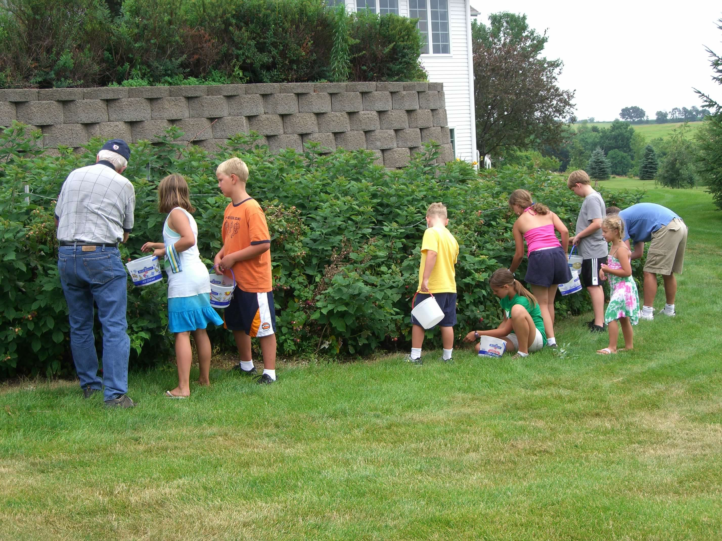

**Ingredients**

**½ C - butter**

**10 eggs**

**½ C – flour**

**1 tsp – baking powder**

**1 dash - salt**

**8-12 oz – canned mild green chili**

**2 C – cottage cheese**

**4 C – grated Monterey jack cheese**

**MAKES**

**12 lunch servings**

**24 appetizer servings**

**Directions**

Melt butter in a 9 x 13 “ baking pan. Set aside. In large bowl, beat eggs, add flour, baking powder, and salt. Mix well. Add melted butter, leaving pan buttered. Add chiles and cheese. Mix together and pour into baking pan.

Bake uncovered at 350° for 45 - 60 minutes. Test for doneness with a knife. Be sure quiche is set and knife blade comes out clean when inserted in center. Allow to cool slightly before removing from pan.

Can be frozen after baking. Reheat with foil cover.