**BeveraGEs**

Gløgg

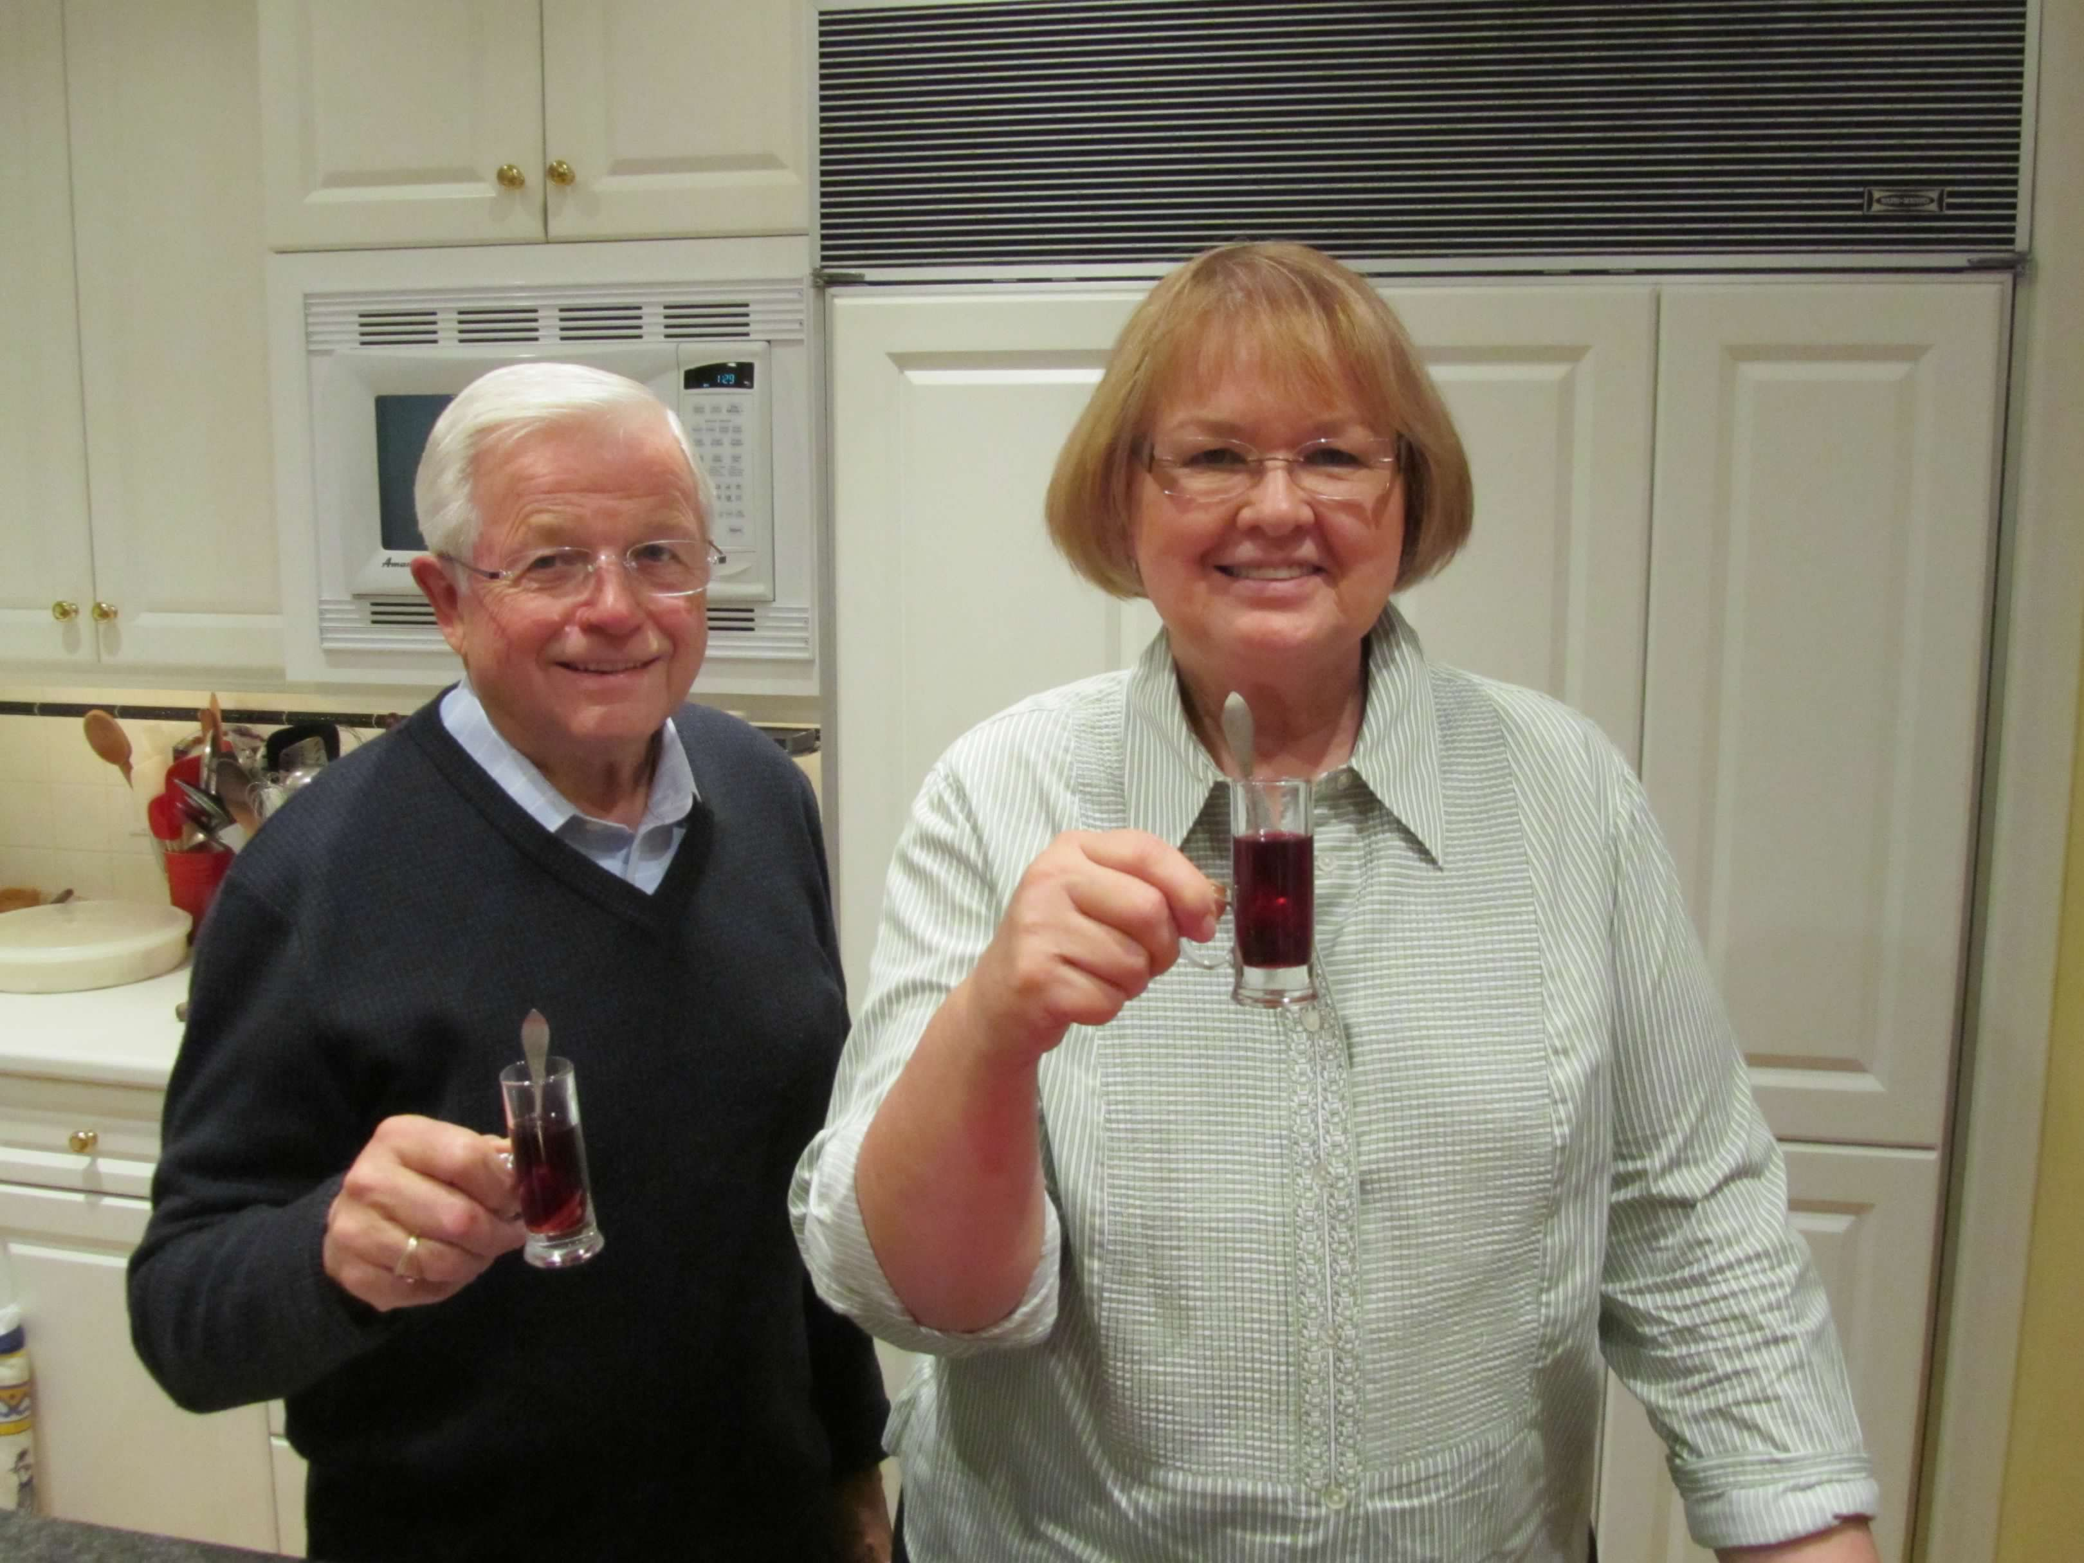

**Ingredients**

**750 mL – dry red wine**

**½ C – dried currants**

**½ C – gin (or aquavit)**

**½ C – bourbon**

**⅓ C – white sugar**

**orange peel**

**8 inches – cinnamon stick, pieces**

**6 cloves**

**2 cardamom pods, opened**

**¼ C – almond slivers, blanched**

**MAKES**

**8 servings**

**Directions**

In a large sauce pan, stir together wine, liquour, and sugar.

Make spice bag out of double thickness cheesecloth: place orange peel, cinnamon, cloves, cardamom, and some currants in the cloth. Bring up corners of cloth and tie with clean string.

Place spice bag into liquid and heat to simmer. Simmer, do not boil, uncovered for 10 minutes. Remove and discard spice bag.

To serve, place almonds and currants in small glasses, pour wine mixture over them in the glass and serve with a small spoon.