**BeveraGEs**

Hot Cranberry Cider

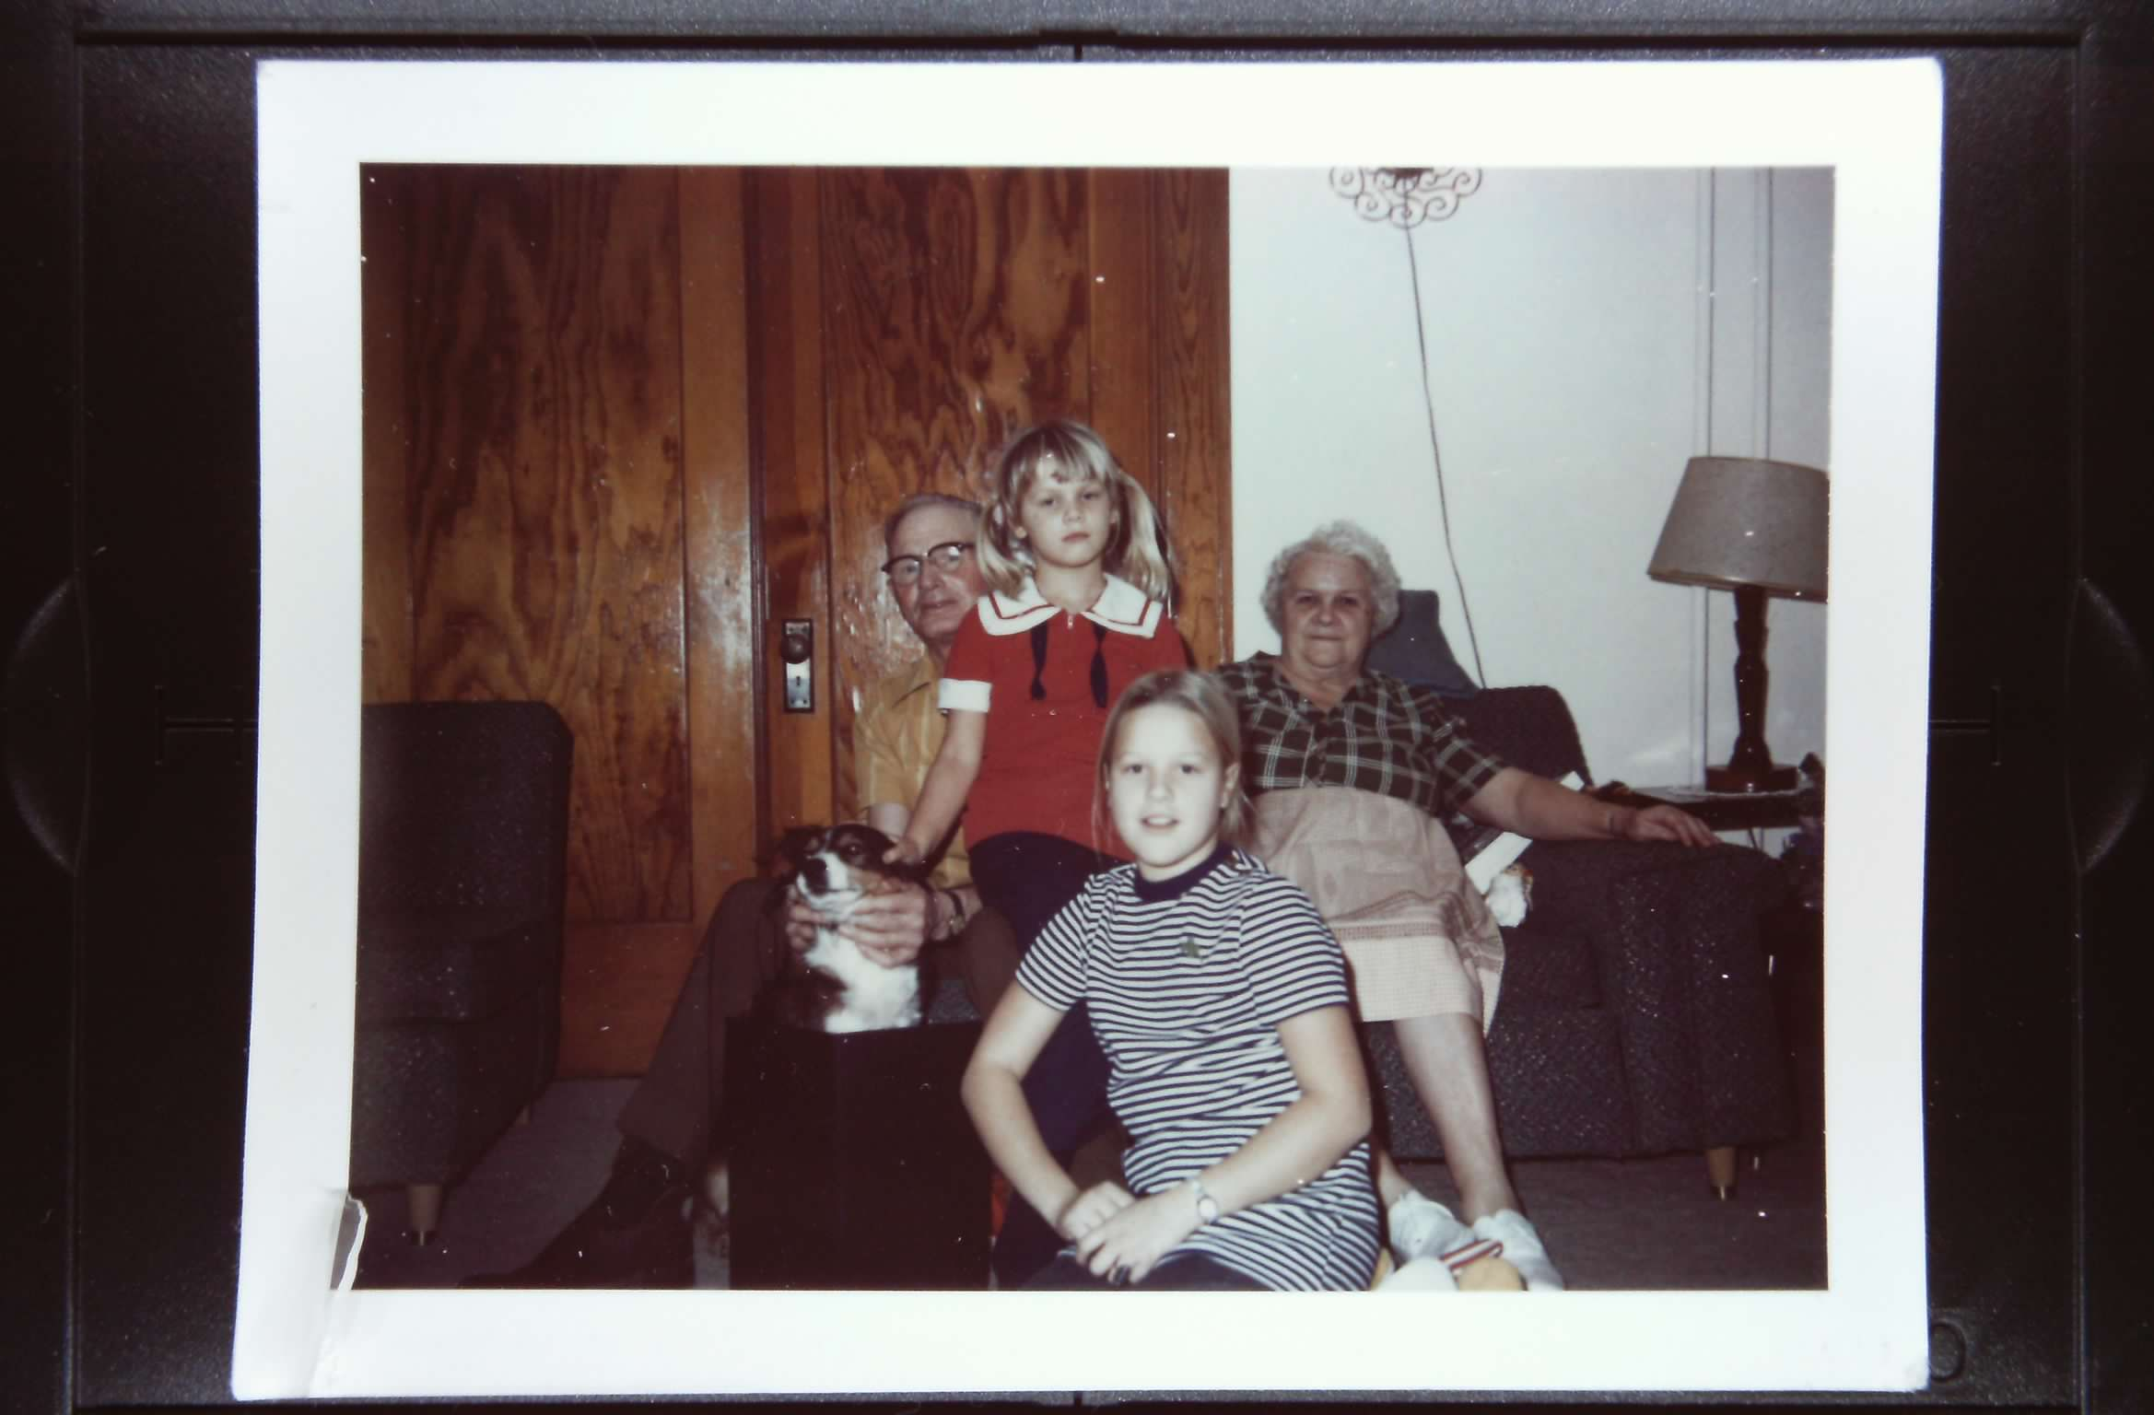

**Ingredients**

**1 gal – apple cider**

**2 ½ qt – cranberry juice**

**(3:2 apple: cranberry)**

**5 cinnamon sticks**

**MAKES**

**26 servings**

**Directions**

Pour apple cider and cranberry juice into coffee maker reservoir.

Place cinnamon sticks in basket of coffee maker and percolate. Serve hot.