**BeveraGEs**

Margaritas

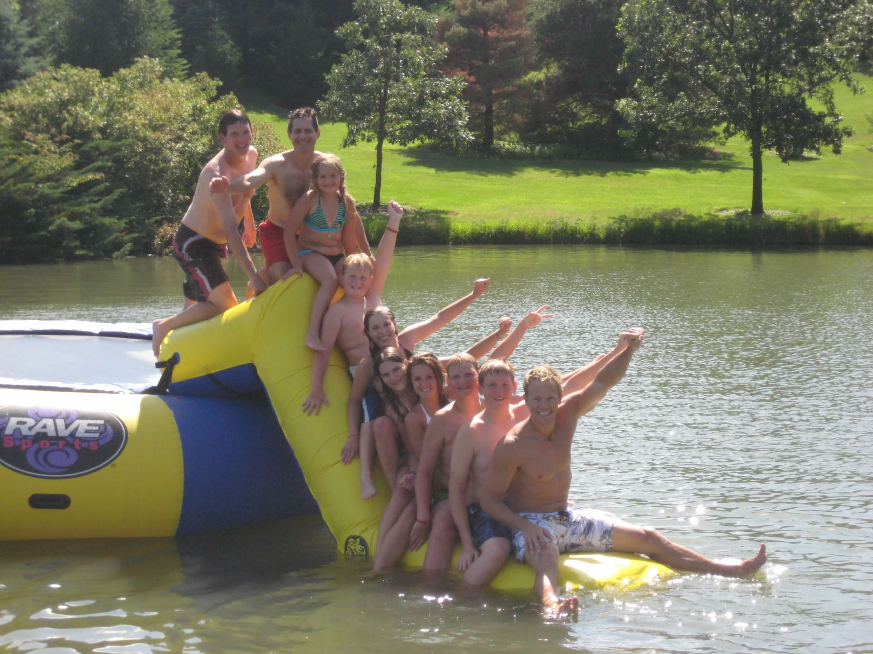

**Ingredients**

**1 can – Old Orchard lime mix**

**1 can – tequila**

**½ can – Triple Sec**

**1 lime**

**1 bag - ice**

**Optional: orange juice, Grand Marnier**

**MAKES**

**a party !**

**Directions**

Struggle to turn on Gma’s 30 year old blender and blend with ice.

Can make all ahead of time and serve over crushed ice with a splash of Grand Marnier as a topper.

Decorate with lime slices.