**Bread**

Aebleskiver

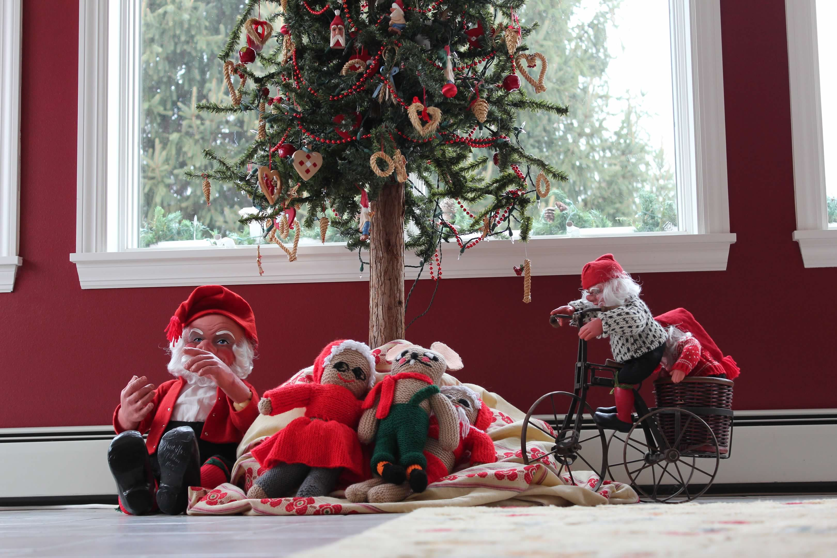

**History: From 1982 book *Delectably Danish: Recipes and Reflections* by Julie Jensen McDonald, which highlights Danish-American culture**

**Directions**

Heat aebleskiver pans on medium-low.

In small bowl, beat egg whites until stiffly beaten.

Mix flour, salt, sugar in medium bowl.

Beat together butttermilk and egg yolks in small bowl then mix into to flour mixture.

Add soda to flour/buttermilk mixture and then gently fold in beaten egg whites.

Grease holes of pan. Spoon batter into holes, half full. Cook over medium-low to low heat until half done and turn quickly with chop sticks.

Roll in sugar and serve with jam or applesauce.

**Ingredients**

**2 C - flour**

**½ tsp – salt**

**1 tsp – sugar**

**2 C – buttermilk**

**2 eggs, separated**

**1 tsp – baking soda**

**To grease: melted butter**

**To spread: jam**