**Bread**

Bread Dough

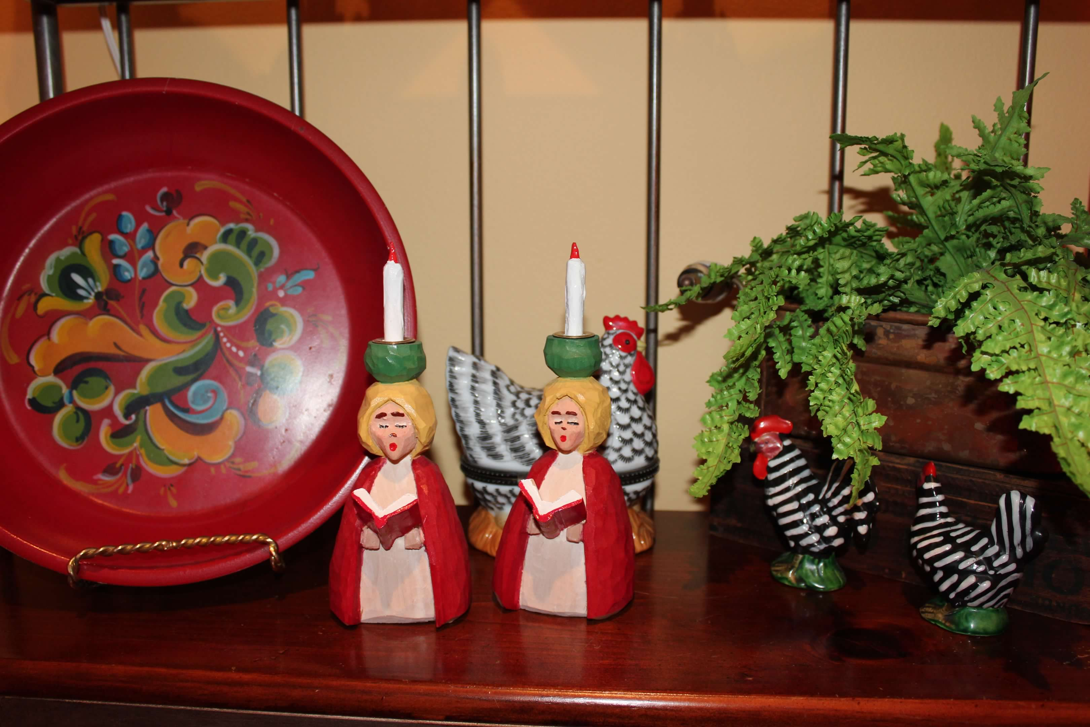

**Directions**

For breadmaker :

Put water, butter, sugar and salt in mixer. Top with bread flour then place yeast on top of flour.

Set breadmaker to Dough Setting.

When dough is complete, remove and make into 12 rolls or cinnamon rolls.

**Ingredients**

**1** ⅛ **C – water**

**2 T – butter, melted**

**2 T – sugar**

**1 tsp – salt**

**3 C – bread flour, King Arthur brand preferred**

**2 tsp – yeast, quick rise preferred**

**MAKES**

**12 rolls**