**Bread**

Gma & Gpa Pancakes

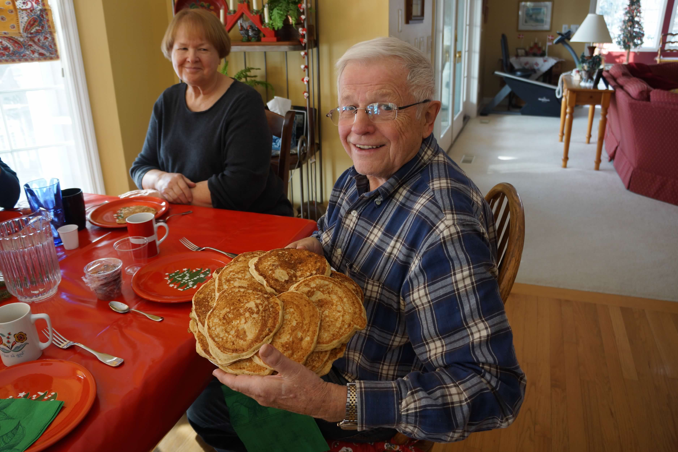

**Directions**

Mix eggs, buttermilk, oil and vanilla in small bowl.

In larger bowl, mix flour, baking powder, soda, salt and sugar.

Gradually add egg mixture to flour mixture and mix lightly with a whisk.

Grandpa thins the batter with some milk.

Grease griddle with canola oil between rounds of flipping pancakes.

Cook with love <3

**Ingredients**

**1 egg**

**1 C – buttermilk**

**2 T – oil**

**½ C – whole wheat flour**

**½ C – white flour**

**1 tsp – baking powder**

**½ tsp – baking soda**

**½ tsp – salt**

**1 T – sugar**

**1 tsp – vanilla**

**MAKES**

**One dozen pancakes**

**Bread**

Gma & Gpa Pancakes (x6)

**Tips: Gma says “this is the amount I make when all 13 of us are here together. It’s nice when I mix up all the dry ingredients and have it ready in a freezer ziplock bag to pull out.”**

**Directions**

Mix eggs, buttermilk, oil and vanilla in small bowl.

In larger bowl, mix flour, baking powder, soda, salt and sugar.

Gradually add egg mixture to flour mixture and mix lightly with a whisk.

Grandpa thins the batter with some milk.

Grease griddle with canola oil between rounds of flipping pancakes.

Cook with love <3

**Ingredients**

**6 eggs**

**6 C – buttermilk**

**¾ C – oil**

**1 ½ C – whole wheat flour**

**4 ½ C – white flour**

**2 T – baking powder**

**3 tsp – baking soda**

**3 tsp – salt**

**¼ C + 2 T – sugar**

**2 T – vanilla**

**MAKES**

**6 dozen pancakes**

