**Bread**

Mom’s Tea Rings (pt. 1)

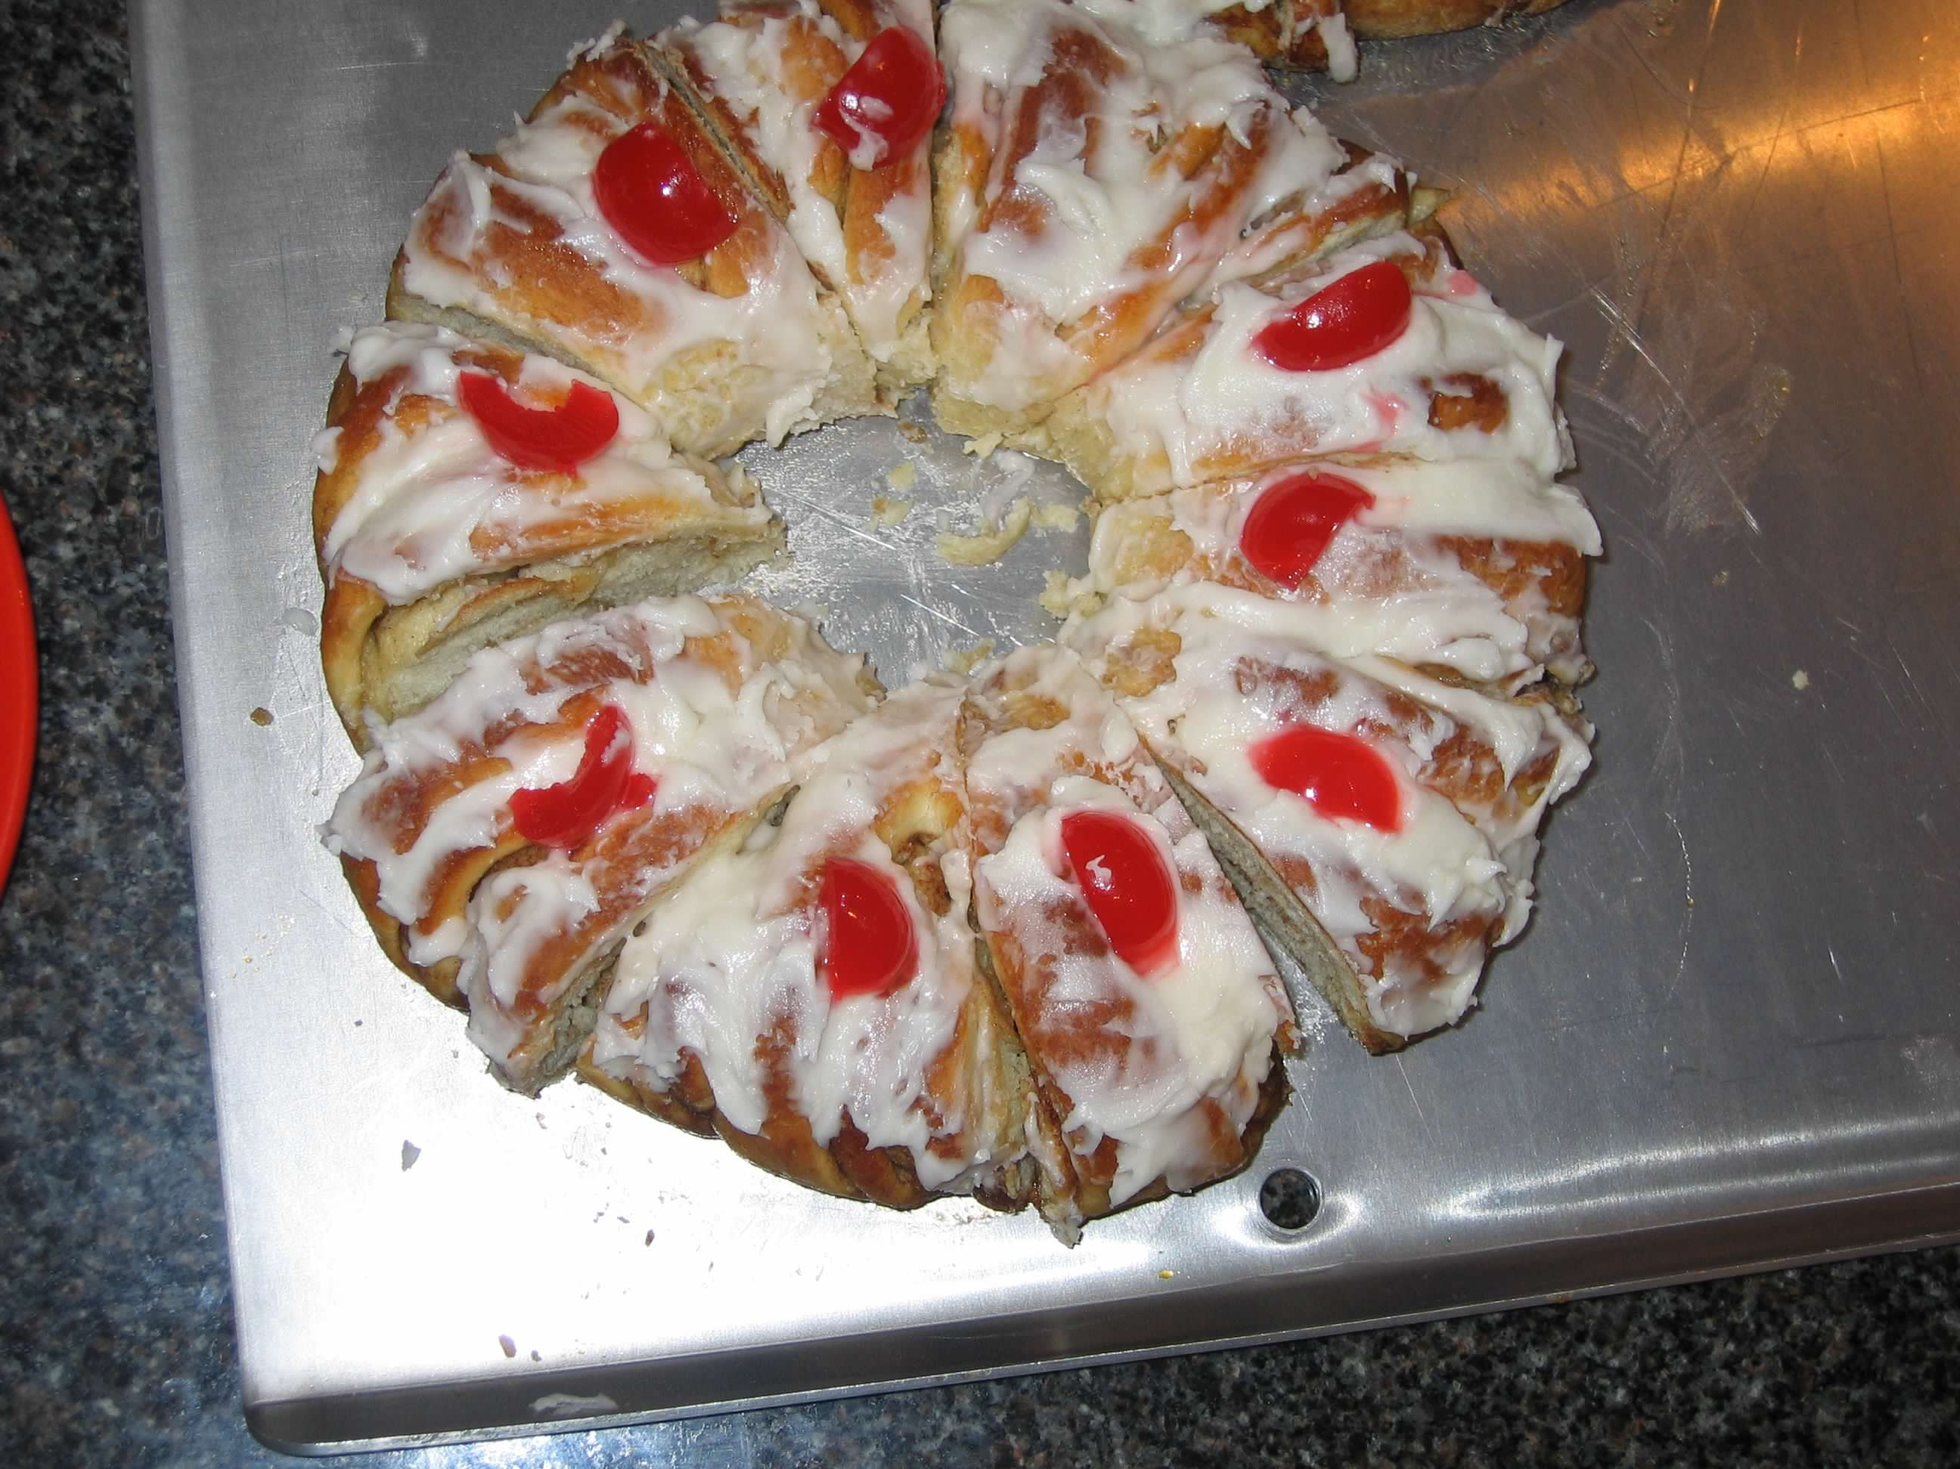

**Directions (pt.1)**

Dissolve yeast and 1 tsp sugar in warm water

Into the warm milk, add and mix the sugar, salt, beaten eggs, softened shortening and yeast. Mix in one half of the flour and beat till smooth. Gradually add remaining flour till easily handled. Turn out on floured board and knead till smooth, about 5 min. (Mom counts 300 strokes)

Put dough in greased pan. Cover and let rise in warm place until doubled (about 1 1/2 hours). Punch down, let rise again till almost doubled (about 30 min). Punch down again and divide into three equal parts. (Mom weighs them--about 16 oz. each)

Roll out dough into an oblong about 15x9". Spread with softened butter (~2 T), sprinkle to taste with brown sugar (1/3-1/2C) and cinnamon (~2 tsp).

**Ingredients**

**½ C – warm water**

**1 ½ C – warm milk**

**½ C – sugar**

**1 tsp – salt**

**2 eggs, slightly beaten**

**½ C – shortening, softened**

**2 packages – dry yeast**

**7-7½ C - flour**

**MAKES**

**Three tea rings**

**Bread**

Mom’s Tea Rings (pt. 2)

**Directions (pt.2)**

Roll up tightly beginning at the wide side, pinching edges to seal. Place sealed edge down, forming a ring, on a lightly greased cookie sheet. Pinch ends together. (Mom puts them in 9" round cake pans so that they are the right shape to put in her containers to freeze.)

With a scissor, cut 2/3 way through the ring at 1’’ intervals. Turn each of these cut sections on its side. Do same with remaining dough. Let rings rise until doubled, about 35-40 mins. Bake at 350° for 25-30 minutes. Let cool on rack. Lightly frost and decorate with chopped walnuts and maraschino cherries.

(Tea rings may be frozen before frosting. Then when ready to use them, simply remove them from freezer the night before, warm lightly in the oven or microwave, frost, decorate and enjoy. They are such a tradition with our family that even sleepy teenagers get up early at Gma's to be sure they get their share of the tea rings.)

**Ingredients**

**½ C – warm water**

**1 ½ C – warm milk**

**½ C – sugar**

**1 tsp – salt**

**2 eggs, slightly beaten**

**½ C – shortening, softened**

**2 packages – dry yeast**

**7-7½ C - flour**

**MAKES**

**Three tea rings**

