Grandma LaLa’s

Cookbook

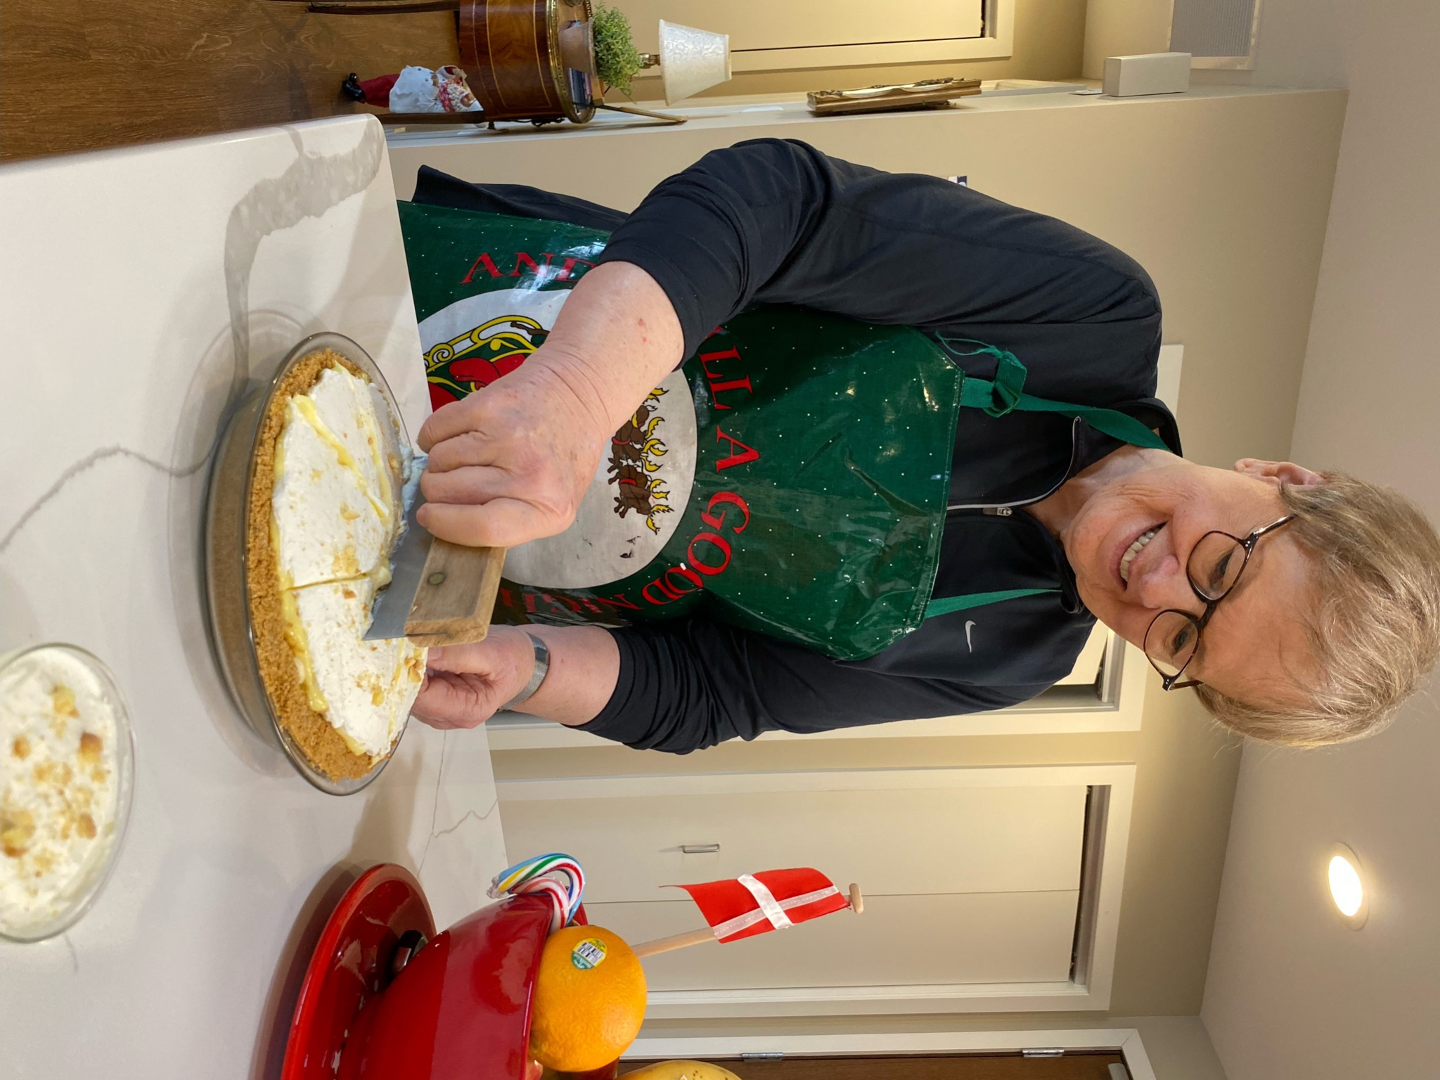

**Christmas 2023**

**This cookbook was made with lots of love for my incredibly wonderful grandchildren and great grandchildren. I hope you enjoy these recipes and make more memories with these dishes.**

**Love and hugs,**

**Grandma LaLa**