**Desserts**

Lefse

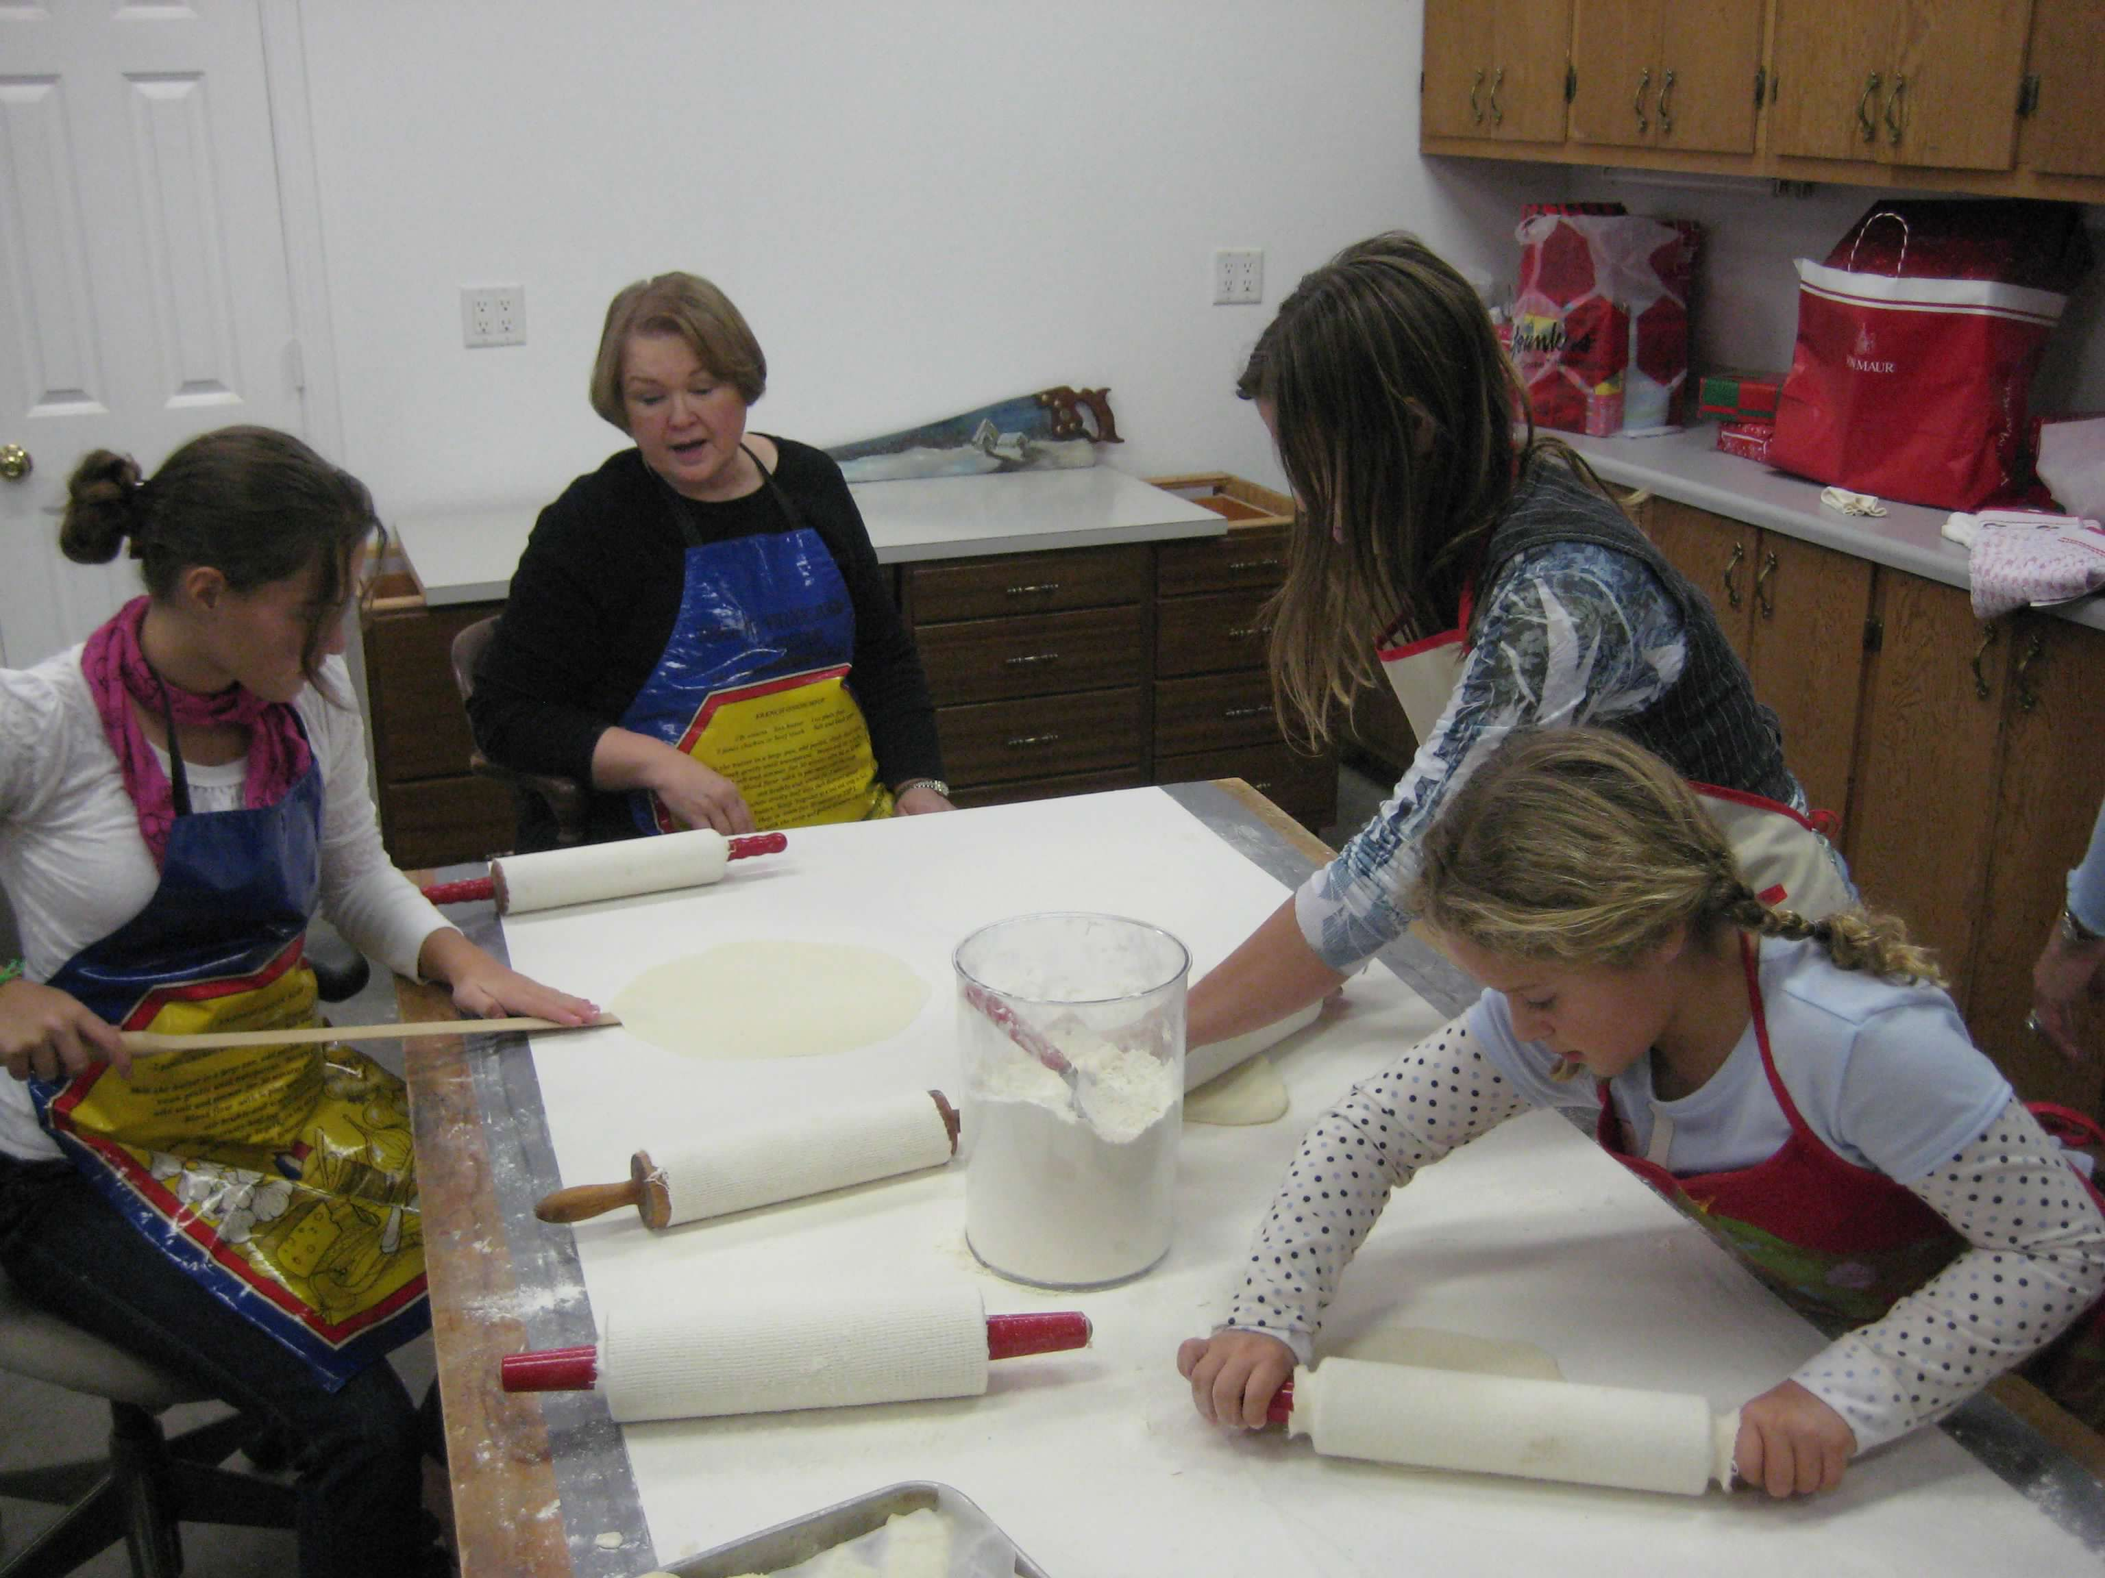

**Directions (pt.1)**

Boil potatoes in salted water until tender. Drain and put potatoes through ricer or Victorio strainer. In a big bowl, put the warm riced potatoes and add butter and cream. Mix with hands until completely smooth. Mixture should be like firm mashed potatoes. Put in covered pan or ziplock bags. Cool overnight or several hours until mixture is cool throughout.

Next day, measure 4 C (2 lbs / 32 oz) of mashed potato mixture into bowl of Kitchen Aid mixer. Add 2 C (10 oz) of flour and mix until smooth. Shape into a roll and put in ziplock bag. Form rolls with remaining potato mixture. Keep refrigerated until rolling out. If dough is not kept chilled, it will become sticky and hard to roll.

**Ingredients**

**10 lbs – Russet potatoes, peeled by the grandkids**

**1 C – butter**

**1 C – cream**

**6 C - flour**

**MAKES**

**50 servings**

**Desserts**

Lefse (cont.)

**Ingredients**

**10 lbs – Russet potatoes, peeled by the grandkids**

**1 C – butter**

**1 C – cream**

**6 C - flour**

**MAKES**

**50 servings**

**Directions (pt.2)**

For each lefse, measure out 3 oz. Roll out with lefse rolling pin on flour-covered surface to 12-14’’ diameter. The less flour used, the more tender the lefse will be.

Grill on flat griddle at ~450º until light brown on one side. Turn using Gpa’s Danish-upgraded Norwegian lefse stick.

Brush off excess flour on cooked lefse, room temp butter, and sugar (or cinnamon-sugar). Fold in edges, fold in half two times and cut in pieces with scissors.

If storing, store between wax paper sheets in freezer ziplock bag. Can refrigerate or freeze to use later. Can either heat again on griddle or wrap in slightly damp dishtowel and warm seconds in microwave.

**Note: Gma says “The 7 grandchildren here are amazingly great lefse makers. It is so impressive!!! They could start a lefse rolling business. Cool thing is they are already set to make pies using the same skills. They are pros!”**

