
Technical Specifications

Overview

This document outlines the high level architecture for the game, notable technical constraints of the platform and other software and hardware specific information related to its development.

Platform

The game will be initially exclusively developed for the Nintendo DS platform. Other handheld platforms such as the iPhone, Java Virtual Machine and Flash may be explored in the future.

Hardware Specifications

The Nintendo DS is a duel screen handheld mobile games console with a stylus touch screen. It has two CPUs and networking capabilities.
Component | Details
CPUs | ARM946E-S - 32-bit RISC, ARM7TDMI - 32-bit RISC
RAM | 4 MB
VRAM | 656 KB
Video Output | 2 Screens (1 Touch) – Resolution: 256x192
Networking | IEEE 802.11, Bluetooth, Wireless LAN
(WhatConsole, 2007)

Opportunities
The platform lends itself to a number of visual and gameplay opportunities. The split and touch screen environment will allow for unique and quirky gameplay technology to be developed. The hardware is designed to allow for multiple engine paradigms (Stang, 2006).

Limitations
T he Nintendo DS has very limited memory. The VRAM is especially small meaning assets must be carefully switched in and out as needed, not just all loaded in at once.

Middleware

Libnds

http://www.devkitpro.org/
The official Nintendo Nitro SDK is not available to homebrew developers. The low level libnds library has been created to allow unofficial game development. We will compile this library using the devkitPro tool chain’s devkitARM compiler.

PALib

http://www.palib.info/
As the libnds library is quite low level, the Programmers Arsenal library - or PALib - was created to make some common game functions such as sprite translation and rendering more straightforward. It also allows for background scrolling and transition effects. The PAGFX tool also streamlines and simplifies the way we can import graphics into a useable format.

Architecture
The game code will
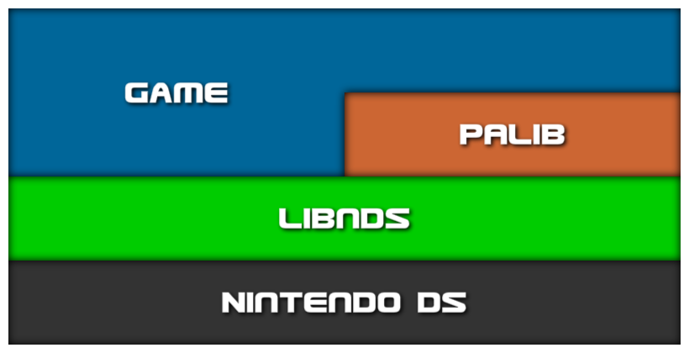

Software Requirements

The code we write will have to perform a number of tasks currently unavailable in the middleware libraries available for the Nintendo DS.

Projectile motion physics

The cartoon style ballistics of firing our protagonist around the environments must be modelled into a basic physics system. The system must be robust as it directly influences the gameplay experience and the player’s ability to progress in the level.

Radial, per-pixel and tri-point collision

Collision between the player and the environment must be modelled. Using triangle to point collision will allow us to set out the environment as a series of vertex buffers and check whether the player is on the ice or in the sea at all times.

2D vector rasterizer

The ice must be rendered dynamically and as such rasterizing the triangle strips in real time is the optimal solution, assuming we can achieve good performance with this method.

Water effects

Some kind of basic software shadier style effects must be created as a large majority of the screen will often be water and must therefore appear detailed.

State management

A state management system for the game, menus, and in-game interface must be built from scratch.

IDE

Visual C++ Express 2008

Our main development environment will be the Visual C++ IDE. Although we won’t use the compiler, the code completion and other developer functions will be useful for rapid, robust development.

Bibliography

Stang, B. (2006). The Book of Games. New York: gameXplore.
WhatConsole. (2007, 9 17). Nintendo DS Specs. Retrieved 10 19, 2009, from WhatConsole.co.uk: http://www.whatconsole.co.uk/nds.php

