**Comparison of Circadian Rhythm in Persons with Mild Cognitive Impairment and Healthy Spouses**

Christina Reynolds, PhD, Neil Thomas, MD, Nora Mattek, MPH, Zachary Beattie, PhD, Jeffrey Kaye, MD

Abstract: The sleep-wake cycle in persons with Alzheimer’s disease can be profoundly disturbed. This study compares rest-activity rhythms in persons with early Alzheimer’s disease or other mild cognitive impairment and their cognitively healthy spouses. The rest-activity patterns of seven couples were assessed using Nokia Activite smartwatches. Persons with cognitive impairment showed lower interdaily stability and higher intradaily variability compared to their cognitively intact partners. This study shows that the circadian rhythms of persons with Alzheimer’s disease are disrupted.

INTRODUCTION

Alzheimer’s disease is associated with a wide range of sleep disturbances such as insomnia and sleep fragmentation. Circadian rhythm disturbances have been found in individuals with Alzheimer’s disease. Rest-activity rhythm disturbances take the form of fragmentation of the rhythm, weak coupling with zeitgeibers, and higher levels of activity at night. In this study we examined disturbance to the circadian rhythm1. Higher levels of sleep fragmentation were associated with a higher risk of incident Alzheimer’s disease and cognitive decline.2 This sleep fragmentation takes the form of increased time awake and number of nighttime awakenings.3 Associated with this poor sleep quality is daytime sleepiness and the propensity to fall asleep during the day.4 The combination of nighttime awakenings and daytime sleepiness may produce an overall more fragmented activity-rest cycle5.

Loss of a strong circadian rhythm is a prominent feature of Alzheimer’s disease6. The circadian rhythm is thought to be governed by the suprachiasmatic nucleus. The suprachiasmatic nucleus shows morphological changes with aging and these changes are even more pronounced in the case of Alzheimer’s disease. The pineal gland is also involved as it produces melatonin which plays a role in governing the circadian rhythm7.

This study seeks to investigate the rest-activity rhythm as a marker of circadian rhythm health in individuals with Alzheimer’s disease and healthy older adults. We hypothesize that the rest-activity rhythm will be altered in those with Alzheimer’s disease compared to the healthy control group.

METHODS

Control participants were seven healthy older adults with no neurological disease. Seven participants had been diagnosed with early Alzheimer’s disease or other mild cognitive impairment. All subjects were part of the EVALUATE-AD project. EVALUATE-AD is designed to follow the life patterns of dyads of persons with early dementia and their caregiver partners. Each couple’s home was outfitted with a platform of passive infrared sensors used to detect presence in each room of the home. Participants were also asked to continuously wear a Nokia Activite smartwatch. The smartwatch is a consumer grade actigraph which can be used to monitor the rest-activity patterns of the wearer.

Clinical Measures

Clinical data were collected to ascertain the cognitive status of the study participant and his or her spouse. Demographic information about the study participants is presented in Table 1.

Procedure

Rest-activity patterns were monitored in participants’ own homes. Participants were asked to wear the watch continuously over a period of several months. The EVALUATE-AD study is ongoing and participants have been enrolled for up to seven months. All participants gave written informed consent (IRB#). One week’s worth of data, from February 1, 2018 to February 7, 2018, was used to calculate the circadian rhythm variables presented. This week was chosen because data had been collected for that week for all seven of the participating study couples.

Adequate data was collected for four couples to calculate the IS and IV at a weekly resolution over a period of several months. Participants in the study complete a weekly health survey online in which they report any life events which occurred during the previous week, such visitors, illnesses, medication changes, and travel.

Circadian Rhythm Variables

Non-parametric circadian rhythm analysis was performed on that rest-activity data obtained from the Activite watches. The Activite watch expresses activity as an estimate of the number of steps taken. Three variable reflect raw activity levels: amplitude, the number of steps counted during the hour with the peak activity, L5, total activity during the least active five hours, and M10, activity during the most active ten hours. We also calculated relative amplitude, a proportional measure giving a ratio of activity during L5 and M10. Relative amplitude is calculated as

$RA= \frac{M10-L5}{M10+L5}$

The circadian rhythm variables also include interdaily stability (IS) and intradaily variability (IV). IS indicates the degree of resemblance between activity patterns on different days. A higher value indicates a more stable rhythm. Higher IS values are more typical of healthy older people. IV shows the degree of fragmentation of the circadian rhythm, the frequency of transitions between periods of rest and periods of activity. A lower value indicates a less fragmented rhythm. Fragmentation tends to increase with age.

The formula for IS is given by:

$$IS= \frac{n\sum_{h=}^{p}{{\left(\overline{x_{h}}-\overline{x}\right)}^{2}}}{p\sum_{i=1}^{n}{{\left(x_{i}-\overline{x}\right)}^{2}}}$$

and the formula for IV is given by

$$IV= \frac{n\sum_{i=2}^{n}{{\left(x_{i}-x_{i-1}\right)}^{2}}}{(n-1)\sum_{i=1}^{n}{{\left(x_{i}-\overline{x}\right)}^{2}}}$$

where n is the total number of data points, p is the number of data points per day (24 in this case), $\overline{x_{h}}$ are the hourly means, $\overline{x}$ is the mean of all data, and $x_{i}$ are the individual data points.

The Nokia Activite watch records step count values on a minute level. For this analysis, the data was summed at the hourly level, so each data point represents the number of steps taken in that hour.

RESULTS

The IS and IV were calculated for each of the fourteen participants in the study. The average IS for the persons with Alzheimer’s disease was 0.27 ± 0.08 and the average IS for the cognitively intact caregivers was 0.45 ± 0.10. This result shows that the day-to-day stability of the circadian rhythms was higher for the cognitively intact persons than for those with Alzheimer’s disease. The average IV for the persons with Alzheimer’s disease was 1.41 ± 0.25 and the average IV for the cognitively intact was 1.27 ± 0.38. The intradaily variability was lower for the cognitively intact persons than for those with Alzheimer’s disease. The values for the circadian rhythm parameters for those with Alzheimer’s disease are shown in Table 2. The same parameters for their cognitively healthy spouses are in Table 3. Figures 1 and 2 display bar graphs comparing the interdaily stability and intradaily variability for each of the couples in the study.

DISCUSSION

This study found that persons with early Alzheimer’s disease or other mild cognitive impairment had disturbed circadian rhythms when compared with their cognitively intact spouses. The cognitively impaired group had a more fragmented daily pattern, with higher variability in rest-activity patterns and lower stability between days. The differences between persons with Alzheimer’s disease and healthy older adults reflect not only differences in activity level, but the fact that the rest-activity rhythm is less predictable across the day for those with Alzheimer’s disease.

This study also shows the utility of an inexpensive consumer grade smartwatch for an actigraphy study of this population. One strength of the Nokia Activite is that it is powered by a cell battery, providing six months’ worth of power, making the Activite very useful for long-term studies.

The limitations of this study include the small sample size assessed, with data from only seven couples collected. Another limitation of the study is the fact that the healthy controls were spouses of the Alzheimer’s disease patients, meaning the sleep disturbances experienced by the persons with Alzheimer’s disease could easily affect the rest-activity patterns of their cognitively healthy caregivers. There are also demographic differences between the caregiver and patient groups. The patients tend to be older than the caregivers by about seven years and are more likely to be male than the caregivers. A future study could include an actigraphic study of healthy controls who do not live with persons with cognitive impairment.

Table 1. Participant Demographics

|  |  |  |  |
| --- | --- | --- | --- |
| Variable | Caregiver | Patient | p-value |
|  | n = 7 | n = 7 |  |
| Age, years | 67.7 (8.2) | 74.9 (6.9) | 0.1 |
| Gender (% female) | 86% | 14% | 0.03 |
| Education, yrs | 16.4 (2.7) | 17.4 (3.7) | 0.58 |
| MMSE | 29.7 (0.8) | 24.6 (5.8) | 0.05 |
| GDS | 1.3 (1.1) | 1.6 (1.0) | 0.62 |

* MMSE = Mini-Mental State Exam, GDS = Geriatric Depression Scale

* Mean and standard of percentage

Table 2. Non-parametric Circadian Rhythm Parameters of Alzheimer’s Patients

|  |  |  |  |  |  |
| --- | --- | --- | --- | --- | --- |
| Interdaily Stability | Intradaily Variability | L5 | M10 | Amplitude | Relative Amplitude |
| 0.246 | 1.796 | 0 | 251.44 | 55.714 | 1 |
| 0.326 | 1.329 | 0 | 7986 | 1714 | 1 |
| 0.32 | 1.464 | 0 | 766.28 | 152 | 1 |
| 0.201 | 1.546 | 124 | 2832.6 | 642 | 0.91 |
| 0.164 | 0.98 | 0 | 2514.3 | 780 | 1 |
| 0.247 | 1.4524 | 5 | 8287.36 | 1810 | 0.99 |
| 0.375 | 1.336 | 0 | 1259.68 | 1259 | 1 |

Table 3. Non-parametric Circadian Rhythm Parameters of Healthy Caregivers

|  |  |  |  |  |  |
| --- | --- | --- | --- | --- | --- |
| Interdaily Stability | Intradaily Variability | L5 | M10 | Amplitude | Relative Amplitude |
| 0.483 | 1.12 | 0 | 1614 | 256.143 | 1 |
| 0.462 | 1.287 | 0 | 6122 | 1598 | 1 |
| 0.361 | 1.8149 | 0 | 6374 | 1926 | 1 |
| 0.328 | 1.389 | 1 | 4759.57 | 819.43 | 0.99 |
| 0.348 | 1.553 | 0 | 2302.54 | 329 | 1 |
| 0.597 | 1.107 | 0 | 1859.9 | 266 | 1 |
| 0.55 | 0.62 | 15 | 2643 | 337 | 0.988 |

1. van Someren, E.J., et al. Circadian rest—activity rhythm disturbances in alzheimer's disease*.* *Biological psychiatry*. **40**,(4), 259-270 (1996).

2. Lim, A.S., M. Kowgier, L. Yu, A.S. Buchman, and D.A. Bennett. Sleep fragmentation and the risk of incident Alzheimer's disease and cognitive decline in older persons*.* *Sleep*. **36**,(7), 1027-1032 (2013).

3. Vitiello, M.V., P.N. Prinz, D.E. Williams, M.S. Frommlet, and R.K. Ries. Sleep disturbances in patients with mild-stage Alzheimer's disease*.* *Journal of gerontology*. **45**,(4), M131-M138 (1990).

4. Bonanni, E., et al. Daytime sleepiness in mild and moderate Alzheimer's disease and its relationship with cognitive impairment*.* *Journal of sleep research*. **14**,(3), 311-317 (2005).

5. Ancoli-Israel, S., M. Klauber, J. Gillin, S. Campbell, and C. Hofstetter. Sleep in non-institutionalized Alzheimer’s disease patients*.* *Aging Clinical and Experimental Research*. **6**,(6), 451-458 (1994).

6. Witting, W., I. Kwa, P. Eikelenboom, M. Mirmiran, and D. Swaab. Alterations in the circadian rest-activity rhythm in aging and Alzheimer's disease*.* *Biological psychiatry*. **27**,(6), 563-572 (1990).

7. Wu, Y.H. and D.F. Swaab. The human pineal gland and melatonin in aging and Alzheimer's disease*.* *Journal of pineal research*. **38**,(3), 145-152 (2005).

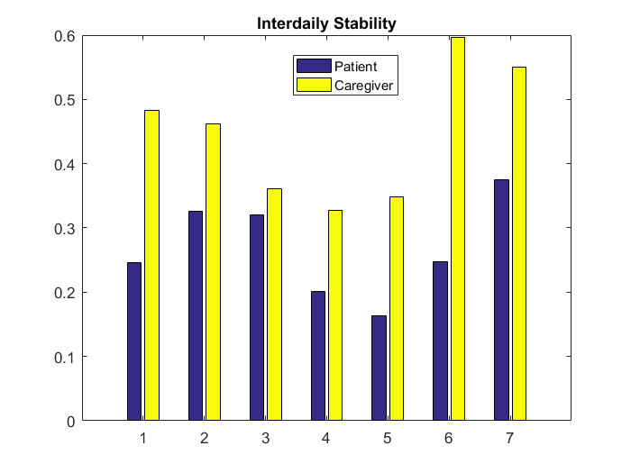

Figure 1: Bar graph showing interdaily stability of each of the couples in the study

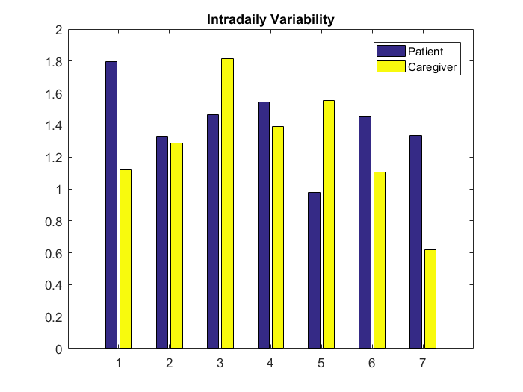

Figure 2: Bar graph showing intradaily variability for each of the couples in the study