Charles Fearn

Homework 1 Write-Up

CSCI 444

September 22, 2023

Introduction

For this homework assignment, the students in our class were given the task of taking the Enneagram personality test and store our answers in a CSV file. In this R project I have taken that data from all the students, read it into an R script, and have manipulated it (made it usable) in order to be able to create visualizations of all of the class’s answers. Here is my attempt at making all this data easier to read/visualize.

Looking at my won data

This is my data. The answers I gave for the personality test.

**Question**: For geom_bar, what is the default for the stat argument?

**Answer**: Bin is the default for the stat argument in geom_bar.

**Question**: What should stat be if you want the heights of the bars to represent values in the data? .

**Answe**r: To make to heights of the bars to represent values in the data, we can use stat = 'identity'.

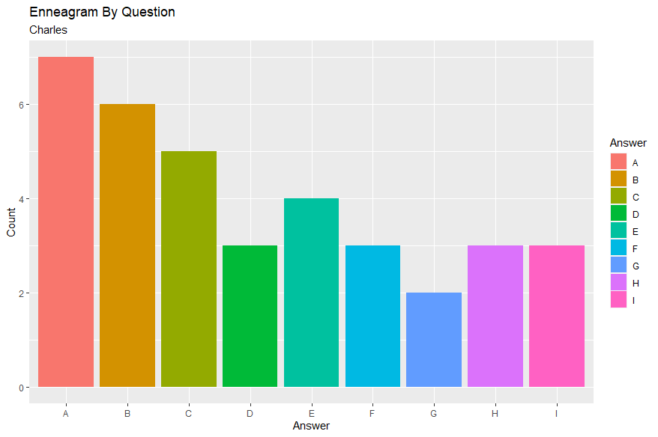(insert graph)

# Question: What is your personality type?

Answer: As you can see from the graph above, I answered A for more questions than the other answers. This tells me, according to The Enneagram Institute, where our homework PDF came from, that I have a type 9, The Peacemaker.

# Question: What are characteristics of this personality type (be sure to reference the site you use and verify your answer is in your own words)?

Answer: Surprisingly, I kind of agree with it. It says that Peacemakers are easygoing, trusting, and can pretty much get along with most people. I think this is accurate. I’m not much of a conflict causer and drama just drives me off. I like things to run smoothly. Honestly, just like it says on the PDF, I try to be optimistic and supportive.

# Do you agree with this description?

# Answer: I sure do. I mean, there are tons of personality tests that you can take online, and who really knows how accurate they really are. I feel like this test got pretty close. I guess you could compare these tests to horoscopes and how people say that when you read your horoscope, you pretty much always agree with it. It’s almost like you are digging to much into it to make it relatable, but I think Peacemaker is a good description of me, so we’ll go with it.

Class Data

What is the file with dirty data? What is the issue?

The file with the dirty data is:

* Heskett. How the answers were typed into the excel file does not match the structure of any other file or the instructions given on how to fill in their data. I will manually change some of their data in order to get it in the correct format. Just by taking a quick look at the data, it seems like they have all their answers but there is a column B and C (when the file is opened in excel, it’s at the top of the file when opened in RStudio
* The updated counts are: A= 3, B=5, C=3, D=4, E=2, F=4, G=6, H=4, I=5

Question: What personality type is the most common in the class? If there is a tie, list all.

Answer: The most common personality type in the class is type 9.

Question: What are traits of this personality type (include the reference to the website you used to answer this question).

Answer: Type 9 is the peacemaker. They are generally easy-going and get along with most people.

Question: Is this your personality type?

Answer: Yes, this the personality type I got when I took the test.



Question: Hmm… notice there is one answer that is strange. What is the strange answer?

Answer: Heskett has two choices for an answer. Both letter I. they also had some weird data that was entered incorrectly at the top that I took out. I think they were just giving the sums of all their answers, but it caused problems with the visualizations.

Question: For which answers, A-I only, do some students have 0 entries (Give last names)?

Answer: Mobley and Parman has zero answers where they answered F, Crews didn’t answer G for any. Nishida didn’t have any E’s for answers.

**Bad Data**

* Freeny answered Question 28 with a D. I Changed D to an E and the counts updated to D =2 and E=7. This did not cause their Personality Type to change.
* McAnally answered Question 11 with an F. I changed F to G and the counts update to F =5 and G=2. This did not cause their Personality Type to change.
* Nishida answered Question 11 with an F. I changed F to G and the counts update to F =3 and G=7. This did not cause their Personality Type to change.
* Heskett, on row 20 (question 19) put ‘II’ ( two letter I’s) so I deleted one since ‘I’ is one of the two choices. Once I knew the answers were valid, I moved on the sums of each letter. They had this at the top of the next two Columns, so I checked to make sure their total number of letters is correct. In the data, the person typed in that they have one question where they answered E, but It looks like there are two answer E’s. They also put that they answered 6 questions with ‘I’ when they only answered 5. So I updated these answers.
* A= 3, B=5, C=3, D=4, E=2, F=4, G=6, H=4, I=5
* Ragan answered Question 5 with a G, I changed G to a E. Th­­­ey answered Question 7 with an H. I Changed it to D. They answered Question 8 with an I and I changed it to an F. The counts update to D =6, E = 5­­, F=2, G = 0, H = 5, I = 4. Their Personality Type did change from Type 5 to a tie between Type 9 and Type 1. I’ll Change it to Type 1.
* Subedi answered Question 8 with an E and I changed it to an F. The updated counts are E =6 and F = 5. This causes the Personality Type to change. It’s a three-way tie between Type 9, Type 6, and Type 4. I’m going to assign them Type 6.
* Summerville answered Question 28 with answer D. I’m changing it to E and the updated counts are D = 1 and E = 3. This did not cause their Personality Type to change.
* Vandygriff had more than 25 answers that were incorrect. Therefore, I removed the file.

**Question**: Which seven questions have evenly split answers in the class (we have an odd number of students nowso look for those questions that are almost exactly split? What is the question text for each? How did you answer these questions?

**Answer:**

3, 6, 7 and 5 have, pretty much, evenly split answers. After taking out the file belonging to Vandygriff, we now have an odd number of students. So, this is as even as they can get.

Question 3’s statements are,’ I have typically been diplomatic, charming, and ambitious.’ And ‘ I have typically been direct, formal, and idealistic.’ I answered number 3 with C, the first statement.

Question 5’s statements are, ‘I have been a hospitable person and have enjoyed welcoming new friends into my life.’ And ‘I have been a private person and have not mixed much with others. ‘I answered this with E, the second statement.

Question 6’s statements are, ‘Generally, it's been easy to "get a rise" out of me.’ And ‘Generally, it's been difficult to "get a rise" out of me.’ I answered this with A, the second statement.

Questions 14’s statements are, ‘I have not been able to speak up for myself very well.’ And ‘I have been outspoken—I've said what others wished they had the nerve to say.’ I answered E, the second statement.

Questions 17’s statements are, ‘My reluctance to get too involved has gotten me into trouble with people.’ And ‘My eagerness to have people depend on me has gotten me into trouble with them.’ I answered F, the second statement.

Question 22’s statements are, ‘I've typically been interested in asking tough questions and maintaining my independence.’ And ‘I've typically been interested in maintaining my stability and peace of mind.’ I answered A, the second statement.

Question 23’s statements are, ‘I’ve been too hard-nosed and skeptical.’ And ‘ I've been too soft-hearted and sentimental.’ I answered this with B, the first statement.