STRETCH: A FRAMEWORK TO TRANSITION TO TEXT-BASED CODING AFTER GRAPHICAL LEARNING TOOLS

A Master’s Thesis Presented to the Faculty of
the Department of Computer Science
Villanova University

In Partial Fulfillment
of the Requirements for the Degree of
Master of Science
in
Computer Science
by
Christopher Hallberg

April, 2013 (of completed thesis)
Under the Direction of
Vijay Gehlot, PhD

Table of Contents
Table of Contents ii
Abstract 1
1. Introduction 2
1.1. Problem Statement 2
1.2. Importance of Study 3
2. Literature Review 5
2.1. Importance of K-12 Computer Science Education 5
2.2. Importance of teaching to non-programmers 6
2.3. Success of Visual Programming Languages 7
3. Approach and Implementation of Study 9
3.1. The Base Language 9
3.2. The Target Language 11
4. The Stretch Framework 15
4.1. The Stretch Environment 15
4.2. The Stages 16
4.2.1. Text-based Scratch 16
4.2.2. Variables 18
4.2.3. From Sprites to Classes and Objects 19
4.2.4. Block Replacements 19
4.2.5. A Bigger Picture 20
4.2.6. Intermediate Steps 21
4.3. The Stretch Backend 22
4.4. Feasibility of Technology 22
4.4.1. Creating a Javascript library for Scratch 23
4.4.2. Javascript and .sb files 25
5. Conclusion 26
6. Future Work 27
6.1. Complete implementation of the interface 27
6.2. Study effectiveness in classroom environment 28
6.3. Steps After Study 29
7. Bibliography 30
8. Definition of Terms 32

Abstract
Visual programming languages are useful and effective tools when it comes to teaching and learning how to program. However, these languages create capable programmers isolated by the limited power and lack of professional acceptance of these learning tools. Due to their graphical and often syntax-free nature they make the next step of learning a textual language more difficult. Rather than do away with graphical languages, it would be far better to provide these capable programmers with a bridge or a proverbial Rosetta Stone to guide them into a textual language.
In the following pages, I present my attempts at creating such a bridge by connecting the popular visual language Scratch with the rising textual language Javascript. This will be done with a series of transitional steps, removing the isolating elements of visual programming languages while maintaining all the non-functional properties of the highly successful Scratch language and its associated development environment.

1. Introduction

Problem Statement
There is no denying the usefulness, effectiveness, and acceptance of visual programming languages as a method to teach programming¹¹. The only shortcoming to teaching programming using a visual programming language is the entrapment: being an expert in a visual programming language makes learning another language very difficult.
Building on J. Good’s investigation of visual languages^{8a}, Jon Oberlander stated that “it has already been amply shown that ‘graphicality’ in itself is not sufficient to alleviate novice programmer difficulties: we need to provide novices with further scaffolding if we are to support them as they learn to program.”¹⁴ Without this scaffolding, the isolation caused by becoming an expert almost negates the usefulness of the graphical language in the first place. By systematically progressing from a visual language to a textual language, all the negative effects of teaching using visual languages can be effectively eliminated.
This work focuses on one viable approach to solving this problem: the design of an intermediate language or program that helps users transition from a visual programming language to a textual programming language. This involves identifying two compatible and non-functionally similar languages to serve as the visual base and textual target for the program. After these languages have been chosen, the next step is to create an environment and set of incremental steps that walk the user or student from fluency in the base language to fluency in the target language while maintaining the non-functional properties of both.

1.2. Importance of Study
Computing and computational thinking have been identified as important skills for K-12 education. Computers, and, specifically, programming provide the key to engaging students in developing their computational mindset. In the hours after his State of the Union address this year, President Obama joined several journalists in an online video chat, where he answered questions on many topics, including science, engineering, and computer programming. President Obama responded favorably to several mentions and direct questions on computer programming being added to the mandatory high school curriculum. According to President Obama, “Not only does it prepare young people, who may choose not to go to a four-year college to be job ready, it also engages kids ... given how pervasive computers and the Internet is now and how integral it is into our economy and how fascinated kids are with it, I want to make sure that they know how to actually produce stuff using computers and not simply consume stuff.”²⁴
On the particular subject of math and science, the President discussed his academic attitude when it comes to handling his daughters. “Math and science [are] part of your overall educational experience,” he says. “We don’t want you to be intimidated by it.”²⁴ Using programming as an outlet for interactive teaching and as an immediate application of math and science, students are more hands-on with their lessons and perceive the satisfaction of applying the concepts that they’ve learned.
On the other side of personal development are the unparalleled opportunities available to people with knowledge of programming. Countries today can only thrive by embracing and generating innovative technology. As such, software programming is one of the fastest growing industries with a higher initial salary point and lower entry-level education². Securing knowledge of a professionally applicable programming language secures a promising future not only for the individual, but for all of us.
The rest of this report is structured as follows. In the following section, I present a review of existing literature on related subjects to provide further incentive for undertaking this study and demonstrating its applicable place in education. Following this in section three, I will outline my approach to creating the bridge I’ve put forth. Finally I will conclude and provide direction for future work in this area.

Literature Review
I begin with a review of recent studies within the broad subjects to which my paper contributes. First I’ll emphasize the importance of teaching computer science as a skill. I’ll bring to light how it is an important skill for even people without a career or future in programming, especially in early education. Finally, I’ll demonstrate with previous research why visual programming languages are the most effective and increasingly the most commonly used means for teaching programming.

2.1. Importance of K-12 Computer Science Education
The 2010 report to the President on K-12 education in science, technology, engineering, and math (STEM) begins with the impressive claim “the success of the United States in the 21st century—its wealth and welfare—will depend on the ideas and skills of its population. As the world becomes increasingly technological, the value of these national assets will be determined in no small measure by the effectiveness of science, technology, engineering, and mathematics (STEM) education in the United States. STEM education will determine whether the United States will remain a leader among nations."⁹
When it comes to choosing their careers, four out of five STEM students chose their course of study in high school or earlier. Only one in five choose during middle school¹³. Considering that 68 percent of students choose their course based on what they find stimulating, challenging, and interesting, it seems imperative that students are exposed to wider fields earlier in their educational careers. “We especially need to reach the pre-college audience, including teachers, parents, and students”²⁵.

2.2. Importance of teaching to non-programmers
Even when students do not plan on using computing skills directly in their lives, the concepts on which computer science is based are beneficial to students of many fields. There is an urge to use technology to engage and more effectively teach math to students. Conrad Wolfram²⁶ sees computers as the solution to a lack of engagement, interest, and effectiveness in teaching math. He puts forth that using computers for the actual computing is not only more useful and engaging, but it shifts focus to the more important parts of mathematics: conceptualizing, problem application, and verification. Many computer science concepts naturally follow because of their simple, elegant explanations for advanced mathematical concepts, e.g. recursion for calculus.
There is little doubt that this is the age of the Internet. Millions of hours of video, billions of hours of audio, and trillions of words full of fun and knowledge await some five billion users around the world. However, in order to be successful in a world as wired and connected as ours, we need not only to consume, but to create. As Mitch Resnick put it, “It’s as if they can ‘read’ but not ‘write’.”¹⁷ The real tool here isn’t the ability to produce, but it’s the ability to exhibit “computational thinking”, a model of thought processes that has far-reaching benefits.
Steve Jobs once said, “Everybody in this country should learn how to program a computer, because it teaches you to think.”³ To think computationally is to understand how to break a larger, more complex program down to simpler, more basic steps. Jeannette Wing’s very interesting 2006 article “Computational Thinking” goes on to praise this cognitive ability as fundamental, not just in computer science, but in every field. People often think computer science or programming is a niche skill (or worse, a talent) but Wing patiently explains, “computational thinking is a way humans solve problems; it is not trying to get humans to think like computers. Computers are dull and boring; humans are clever and imaginative. We humans make computers exciting.”²⁵ Being able to think in the abstractions of the computational model grounds us in truths outside normal reasoning because it plants us in a mathematical field. All the branches of knowledge and science that grow from this field are low hanging fruit for those standing in it.

2.3. Success of Visual Programming Languages
Learning another language and another way of thinking at the same time can be a rather daunting task, but this is the challenge presented to students learning programming for the first time. In order to develop fluency: the ability to think in the semantics of programming and the syntax of a programming language requires the adoption of an entirely new mindset. This creates a problem of languages having a “high ceiling” (large range of power resulting in a huge potential in possible programs) and a “high floor” (hard to step onto, difficult to learn). Visual programming languages were created to allow the student to express their syntax more naturally, tactilely, and intuitively, resulting in a desirable “low floor”. The environment created by visual languages encourages educational play, one of the most powerful ways to learn¹².
One study showed that the use of a visual programming language, on even an infrequent basis, allowed many computer science concepts to be taught and discovered by users who have never programmed before. One study of an urban youth program showed that all the students were utilizing sequential coding, demonstrating a grasp on computational thinking¹¹. On top of that, 88% of their projects demonstrated parallel operations, an advanced computer science idea. More than half of the students were using looping code, and one out of every four was using conditional statements; all this from a program that ran once every two to three months.
As mentioned before, the only downside to the success of visual programming languages is the entrapment in a syntax that is not professionally viable. This makes learning a textual language an essential step in securing a future in computing. In my experience, this is an intimidating ordeal that could potentially destroy a student’s interest and passion for computing. The experience of being completely lost has left students feeling like victims of a “bait and switch”: presented with a fun, easy, creative outlet that led to a thorn bush of syntactic and technical confusion. Throughout the rest of this thesis, I will explain the details of Stretch, the transition program I have developed to facilitate students’ progress beyond this daunting step.

Approach and Implementation of Study
In this section, I focus on the details of Stretch. I will start with the planning and design phases. This involves the choice of a base language, analysis of that language to determine a strong target language, and defense of that choice.

3.1. The Base Language
When designing Stretch, building upon a strong base is essential. Stretch needed to start with a visual programming language that was not only instrumental in teaching computational thinking, but also fostered a passion for coding that would fuel a desire to take on the next step. The language needed to be powerful enough to bring its users to a level where they are ready to advance to less restrained programming environments.
Several visual programming languages meet these criteria. I’ve ruled out a few common visual language types for various reasons. Dataflow languages are languages that have their logic structured into a flowchart style layout. They are among the earliest attempts at visual programming languages¹⁰. VVVV is an example of one such language. It describes itself as a “hybrid graphical/textual programming environment”²². Code written in VVVV is laid out in nodes instead of separate files or scopes. While visual in this regard, the actual logic is written in textual Java, putting it outside the realm of the visual in my mind. In either case, the flow chart interface is not an interface conducive with teaching outside of a strict computer science environment, where logic graphs and flows are most common.
A study by J. Good has analyzed dataflow languages and has concluded that they are less than beneficial. She discovered that novices had “great difficulty in understanding data-flow representations”⁸.
The second type of visual programming eliminated from candidacy will be referred to as macro languages. Macro languages are languages that allow a user to assign properties to objects. These properties can be as simple as “background” to make them react to the position of the level and player or as complex as “physics” to make the objects simulate gravity and collisions, normally quite a challenge to create well in code. The purest example of this is the game studio Construct 2 by Scirra¹⁸. Without any direct logic manipulation you can create a full game with advanced physics and graphics. It is a powerful creation tool, but not a tool for teaching coding or a programming mindset. GameMaker is a strong second example, but without textual coding using the environment’s unique scripting language the scope of this environment is quite limited and, again, not educationally engaging⁵.
The exclusion of the previous categories narrows down the larger choice of visual languages to block-based environments, from which there are two strong candidates: the 3D Alice and MIT’s Scratch.
Alice is a visual programming language that allows users to create interactive 3D systems. This is accomplished by arranging nesting code chunks (resembling draggable rectangles) and pre-programmed macros (“Let mouse move any object”¹) into a desired order. Originally conceived in 1995, Alice was designed for rapid prototyping for virtual reality systems¹⁵. It was later revised by Matthew Conway into a learning system targeted to 19-year old students, your usual college freshman. It was designed to teach object-orientation and basic programming constructs. Alice has even integrated different syntaxes into its interface, allowing it to be friendlier to new users or look more like Java, in an attempt to “bridge” the gap between itself and Java⁴.
Scratch is a visual programming environment developed at the MIT Media Lab. Color blocks can be snapped together to influence the behavior inside of the stage, which updates live with every code update. First developed in 2003, “the original design of Scratch was motivated by the needs and interests of young people (ages 8 to 16)”¹². Scratch’s interface naturally teaches objects, basic variable types through shapes (strings, numbers, Booleans), and parallel operations. Since its release, it has grown into a highly successful programming environment^{19b} and was ranked 29th in March 2013 on the TIOBE list, the highest ranked visual programing language²¹. On top of its features as a language, Scratch has an impressive acceptance in the target audience. In my own experience running an urban youth camp, middle school children find immediate satisfaction using Scratch and embrace it passionately.
After determining the base language for Stretch, I needed to find a target language that encourages the beneficial environment and social learning my base language is so famous for.

3.2. The Target Language
Having selected Scratch as the base language for my tool, I focused on selecting a language that had many of the features of Scratch. Many teachers I’ve had and worked with like to move students to Processing, another coding environment from MIT. Processing is an extremely useful IDE for Java that has a library of functions and templates that make coding in Java much more appealing to artists. It sets up most of the initial work for you by defining a window and global classes, which can be a chore for experienced programmers and a confusing guessing game for beginners.
Unfortunately, in my experience it’s a steep jump to Processing, as it would be to switch immediately to a full-fledged text-based language. Processing is very helpful to programmers by taking care of a lot of the technical things for them. Its helpfulness is an inspiration to the design of Stretch, but this aid is a downside to programmers coming from Scratch. The environment uses a very specific control flow to simplify the experience for its users. This very strict flow, however, is completely different from the usual flow found in Scratch programs. In particular, the lack of easy concurrency is going to leave many Scratchers lost and seeking back to their roots. Open source is an excellent strong point for sharing, but even with an export feature, getting the finished product out there is less than ideal.
The only other strong candidate was Python, another language rising in popularity which has some adoption as a teaching tool itself. The simplistic nature of Python is its clear strength. However, for my thesis, this strong suit is a negative point. By removing many common constructs of other languages, Python leaves users at another learning obstacle to overcome. Becoming an expert in Python still leaves a lot of learning to be done in order to learn most other languages; that, combined with a code flow and structure that can be radically different from our basis in Scratch. Python is an interpreted language, however, so its simple syntax would make it an excellent language to learn, but it does not serve well as the target language of our transition.
I needed to focus on the positive qualities of Scratch in order to pick a language that is not only a natural match for this language, but also one that is appealing to learn in this day and age. Scratch was designed to be social, so I needed a language that was easy to share. Programmers and users of my bridge not only needed to be able to share the finished product easily, but also need to share the code behind the project just as easily. This made me lean towards an interpreted language. Unlike more traditional compiled languages, programs written in an interpreted language are run as they are parsed. This means that you have one product that is code and program, as opposed to two separate products as you would have with code and its compiled binary. Another important part of being social is being relevant. While this was a minor point, I wanted to be sure my language choice was useful in this contemporary context.
Scratch is easy to approach. This led me to look for a language that is loosely typed. A language that is loosely typed handles variable types dynamically, changing them when necessary to avoid clashing in common operations. Most loosely typed languages have one variable type for all variables. This is a step back from the functionality of Scratch, which has different shapes for string and numbers, but I felt it was a necessary choice to make the transition as smooth as possible.
Finally, in order to successfully create an environment, I needed a language that I knew well enough to create a template and system for. I needed to understand the language at a level that would allow me to guide users gradually. As a former Scratch student and user, I know the language thoroughly. I would need to know the semantic effect each action is taking below the surface in order to match it accurately and feasibly to a final language.
I chose Javascript as the end point on the bridge because it matched my criteria perfectly. When it comes to getting started with the language, Javascript is unmatched. Javascript is a browser-based interpreted language. This means that Javascript does not require a compiler; its ideal environment for execution is a web browser. Web browsers are not only one of the most pervasive pieces of software in the world; they are becoming ever more powerful. In fact, the “web desktop” is still a rising trend: a suite of web pages that look to replace the functionality of your entire computer.²⁷ Browsers today are ubiquitous and powerful enough to accomplish this.
Any computer with a text editor and browser can be used as a tool to create programs in Javascript. The code for Javascript is written into an HTML file, which is the standard document format of the Internet. This means that code can be placed online to be run without download (by being visited in a browser as a page) or can be put on any machine with a web browser and run without installing any other software. Javascript also dominates social coding sites, being the most used language on GitHub^{6a} and in the top 10% on Sourceforge²⁰, two of the most widely used social coding sites.
The syntax of Javascript also made it very attractive. Variables are “duck-typed”, which means they are all declared the same and their type is determined automatically as they are used, even changing variable type as the program’s operations need. This is not the only way that Javascript is forgiving with its syntax; it also inserts semi-colons where you may have forgotten them and often provides easy to understand and line-specific errors. Since server-side Javascript is a relatively new technology, a majority of Javascript is available in open-source format, creating one of the largest collections of code samples imaginable: the Internet itself. In fact, 92.5% of pages use Javascript in some form²³ providing trillions of documents of working code to dive through⁷.

The Stretch Framework
This section focuses on the design of Stretch’s environment and architecture. It also includes a comprehensive look at the transitional steps the students will be brought through as they use Stretch, from the text-based version of Scratch to delving into the framework itself. Finally, I will talk about the technology that makes such an educational tool possible.

4.1. The Stretch Environment
Starting users out with a blank text-editing program can be rather intimidating. Due to this factor, software has been prototyped to add several useful layers over top of an HTML file. The project is saved as a regular, browser-compatible HTML file on the computer, but when viewed through this software, the interface comes to life with the familiar face of Scratch.
The first aid to the user is the layout of the software. When all facets are active the program will strongly resemble Scratch. A panel on the left will display the text equivalent of blocks (or text-block); the right will show the Stage (live-preview window) and a grid of Sprites, with the code in the middle; just like in Scratch. The key difference of course is that the panel is no longer the keeper of the code, the user is. Using the left panel as a reference, they can quickly look up the proper syntax of a text-block or status of a variable. The software will be highly customizable in terms of what information and parts of the interface can be seen, allowing users or teachers to adapt the interface to the educational goals of the day.

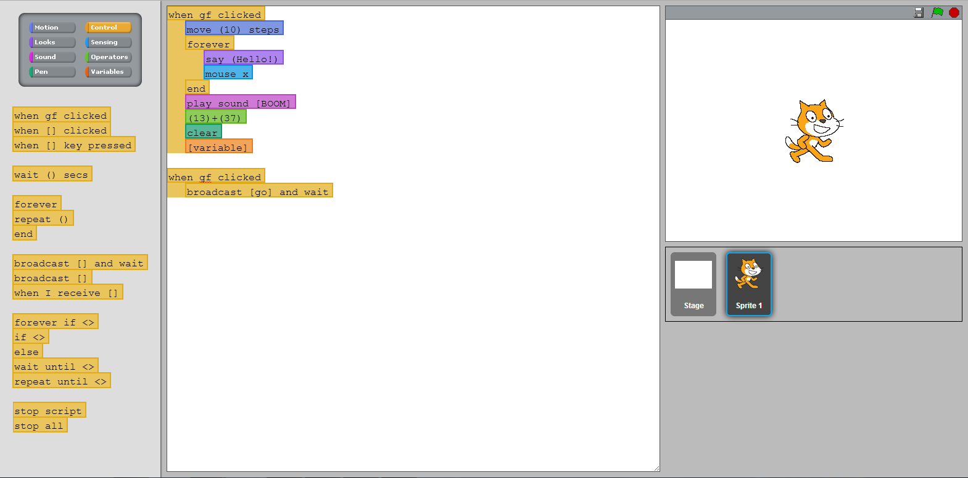
Screenshot of the Javascript prototype interface, rendered in Chrome.

4.2. The Stages
The program is designed to be used in place of the usual Scratch software and is designed to be an easy and intuitive transition. The program’s layout, color, and organization should allow the user to immediately understand its full use and functionality if they understand the Scratch interface. There are several major factors involved in how to present and progress the stages of transition, and a study will need to be done in the future to address these (see Future Work in Section 5 for more information).

4.2.1. Text-based Scratch
The first step of the bridge is to get the user typing. This step keeps all the syntax and wording identical to Scratch, but replaces drag-and-drop code editing with typed code editing. As you can see in the diagram, the interface is very similar in layout to that of Scratch, with a reference on the left where the blocks normally are and the Sprites and Stage broken up on the right for easy code organization. I believe this step will engage the advanced users by providing a faster method for producing code and allow all users to get used to fixing the most basic syntax (spelling, capitalization, proper term) and formatting (indentation, parentheses) errors. By color-coding the lines of text similar to the block colors in Scratch, the framework can provide immediate syntax feedback (a common feature in code writing applications, normally called “highlighting”) and help reinforce the connection to Scratch. This will be a very forgiving level of the bridging program, possibly ignoring capitalization issues.
The format of the blocks will be taken from the format used to embed Scratch block images into forum posts. The format is outlined in detail^{19a} on the language’s community wiki and is in wide practice among the forums.
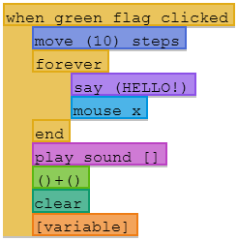
Example of syntax highlighting from the environment.

For translating from Javascript to the native .sb files compatible with Scratch, I will use similar technology found in a Python project called Kurt^{6b}. Kurt is a python script that converts from Scratch’s .sb files to plain text and back, allowing for typed Scratch file creation and editing. Looking through the announcement and support thread on the official Scratch forums, there are reactions I’d expected to find at this introductory level of transition^{19c}. Many users are excited: “Yesss! I've been waiting forever for this! Thank you!” ~ Magnie (username). Similar reviews can be found for the software that implemented Kurt into a graphical interface similar to Scratch and my vision of the final software, M3OW^{19d}.

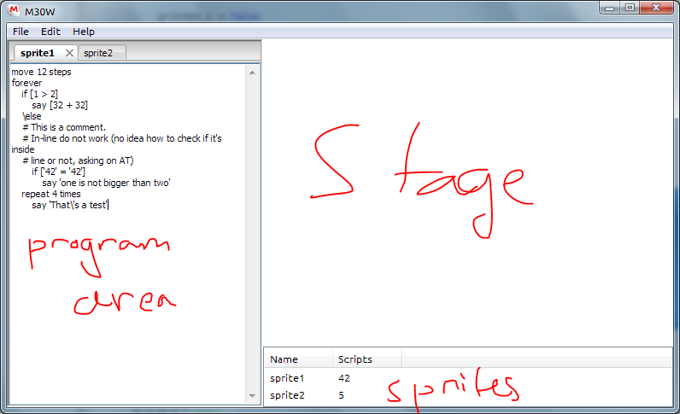
A development screenshot of M30W from its official development forum.

4.2.2. Variables
Adding variables in Scratch requires that the user navigate to the variables section, click on a button, and fill out a short form. In this step, the user would learn how to use the ‘var’ command to create new global variables. Again, I hope the ease compared to the previous method of declaring variables attracts the expert user. Up until this point, the user of my software was actually limited below the capabilities of Scratch: they could only access the base properties of Sprites.
The variables section of the reference has been repurposed as a variable reference. All the variables can be seen and copied and pasted from here if necessary. The value of each variable is displayed next to it and when new variables are declared in the code, they automatically appear here.

4.2.3. From Sprites to Classes and Objects
Scratch teaches about objects very naturally: by breaking up code organizationally and visually with Sprites. Besides the basic properties, a Sprite can also have its own user-defined variables that can only be changed in their own code. This step involves beginning to raise the curtain on the coding environment my software has created. Users are here taught how to use the “this” prefix to create their own Sprite specific variables, once again restoring the full capabilities of Scratch. This step also replaces the block that reads attributes of another Sprite with the object convention of using that Sprite’s name.
The largest change to this step is that the information panel that normally resides above each Sprite’s code is replaced with a Javascript object declaration. This provides the same information but instructs on the proper declaration of objects as well. Variables can be added specifically here as properties of the object, creating a secondary method for declaring private variables. Both methods for declaring “Sprite specific” variables introduced in this step are valid methods for doing so in Javascript.

4.2.4. Block Replacements
From here, the path of least resistance is to begin replacing Scratch blocks with their Javascript counterparts. As discussed earlier, the coding environment adds a library that connects remaining Scratch blocks to their proper functions behind the scenes. These functions are available for the user to type and utilize as well, since the goal is for them to be able to code outside of this environment. Parameters are a concept that would be taught here. It’s not a foreign concept because they have already been used and the users have been typing and looking at parameters for some time without realizing it.
Below is a table of a select number of blocks and their corresponding library and raw Javascript functions. Many of the functions can be included in our library to be made as easy as possible. With no limit on the number of function names available, there is no reason to include comparative functions not only at the top level, but every intermediate level between. Due to the first-order nature of Javascript, a function can be saved under many names without additional memory or unnecessary code.
turn 15 degrees | context.rotate(15deg)
length of (string) | String.length
when I receive [name] | function name (data)
forever if <conditional> | while (conditional)
repeat 10 | for(i=0;i<10;i++)

Creating a strict schedule of which blocks to replace when will require some hands on research. A better method might be to create an incentive for using more raw Javascript in a projects code. Given the social nature of the community, a simple percentage might be enough to create competition or prestige, but again, research will have to be conducted in this area.

4.2.5. A Bigger Picture
The next advanced step in transition is to start stripping away the environment’s rigid organization. Showing all the code in one page or file, the way it would be consolidated when run, would allow true freeform expression to come about. Sprites of identical types can actually share functions now, instead of having identical code locked in separate Sprites. Shared functions can be a further lesson in parameters and returns.
This consolidation would also reveal the universal Sprite object that contains all the basic properties. A stricter use of object names and ‘this’ will be required. From here, the user can be introduced to the other universal objects of Javascript including Math and document. The user will be freer than ever to try different types of applications.
The final reveal will be the full HTML document that the environment had been hiding the whole time. From here, the user can experiment by making a copy of this template in another editing program and seeing if they can get something to appear in a browser. All the seeds have been sown and this final stage introduces the largest incentive of exploration and sharing.

4.2.6. Intermediate Steps
The steps outlined above can be refined into more specific and atomic steps. These steps will be determined by research and of course by each teacher’s goal for a curriculum. Hiding the reference panel could be one of these more granular steps, forcing users to find answers in the real world. A step that can be taken after full text usage has been adopted is to turn off the line coloring that invokes the familiar confines of Scratch. Highlighting that the user is more likely to come across in the real world or even no highlighting at all can be a simple, challenging replacement for an early step. An interesting step would be to hide the live preview window in the environment and force the students to open their work in a browser instead. Saving the code and switching to a browser to refresh and review your work is a very common workflow for web developers. This could feasibly be done at any stage of the transition since the code will be exported to an HTML document.
Additional intermediate steps in the replacement category could be used to teach coding ideas. For example, the Scratch block  could be replaced with or(p1, p2) before moving the correct format of p1 || p2 to teach parameters.

4.3. The Stretch Backend
In order to allow these layers to function, a translator is needed to transform the text version of Scratch into valid HTML and Javascript. Thanks to the graphical innovation of the canvas element, it is completely feasible to translate all the intricate visuals possible in Scratch accurately and easily into Javascript. The saving process for a file is actually quite simple. When save is hit:
for each Sprite:
attribute each Scratch command with the JS library
place code into a Sprite class
add this code to a JS file of all the Sprite code
save the Javascript code file

if no HTML shim has been created
write new HTML shim that contains the Sprite code
import the JS library
else
update the embedded Sprite code
save as an index.html file in a project folder

display in web engine representing the environment stage
or
open the folder in a browser (depending on settings)

The resulting HTML file will be easily shared to a web site using standard development programs such as an FTP client, or to friends using conventional social media methods. Including the code of the Scratch functionality library in the file or pulling it from the Internet as an external resource will simplify the delivery of the final project by keeping it limited to one file.

4.4. Feasibility of Technology
In order to build a proper, usable prototype, research was undertaken into the feasibility of the technology necessary for the more advanced and crucial aspects of the environment.

4.4.1. Creating a Javascript library for Scratch
As discussed earlier, much of the graphicality of the products of Scratch will need to be reproduced in Javascript, in the form of a library of functions working behind the scenes. Heavy reliance on the canvas element allows us to create graphics, but the translation from one type of code to use the functions of another seems to be the larger problem. Not only is this technique possible, but it also at work in commercial products today.
A beautiful merging of aforementioned technologies, Processing.js is a Javascript port of the Java-based Processing language¹⁶. It is a library of Javascript functions that replicate the graphical and structural elements that make Processing so useful. More than this, however, it has a parser built in that attributes code to the functions of the library.
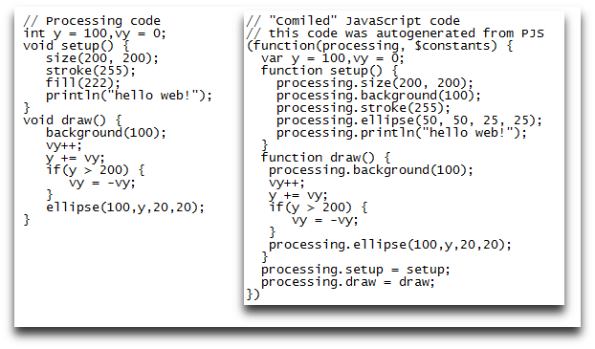
Side-by-side comparison of Processing code and automatically attributed code via Processing.js
This allows expert users of Processing to write code in their native tongue, with all the benefits and integration of Javascript. This functionality is identical to what I desire for my product. Below is an example of the library in action.
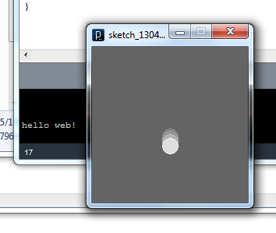
Execution of the above code in Processing

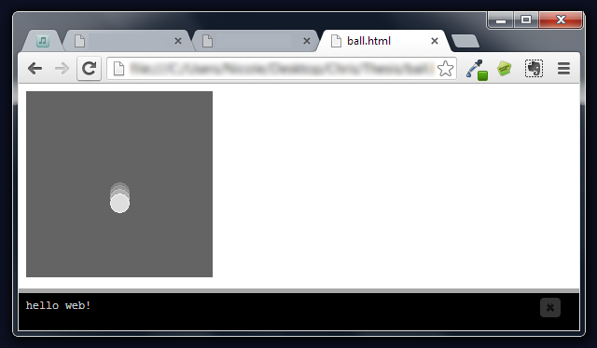
Execution of the same code, automatically attributed by Processing.js

4.4.2. Javascript and .sb files
In order to allow the users of my product to continue to contribute and learn from the Scratch community, it was very important to me from the beginning that users are able to import and save from Scratch’s native file type: .sb files. Several readers were found (footnote), but I could not get any library to successfully write to Scratch file. However, my prototype is in Javascript, other languages such as Python^{19c} have very popular libraries.

5. Conclusion
In the above paper, I presented a problem that many computer science students face in their early years of education in the subject. I analyzed the context of the problem, present in previous research in order to determine a scientifically backed solution to the problem. I then detailed a solution to this problem and presented the research put into the framework Stretch, our implemented version of this solution.
The development of a transition framework from graphical languages to textual ones continues to be a useful endeavor. It follows the research of the past into the successful fields of K-12 computer education, non-programmer computer education, and of course the proud tradition of graphical languages themselves.
The creation of a final product, including the bridging software and a lesson plan to guide the user, is still a ways off. The research necessary to create a truly successful program will provide students and teachers alike with a smooth transition into the real world. In order to create a framework that encourages discovery outside the realm of school, we must provide students with the ultimate empowerment of dual fluency and the further mental grasp and abstraction that it brings. The details below outline the work yet to be done in order to give users the chance to be both pioneer and ambassador to their peers and to place before them an open field of knowledge waiting at their fingertips.

6. Future Work
I have presented the design and progress of the Stretch framework, demonstrating the feasibility and continuing accomplishment of a transitional environment that brings a low learning curve to the daunting step into textual programming that is presented to many students. The current implementation is being developed and tested to ensure it is comprehensive enough to be brought to full fruition via a large-scale study and developmental response. There are several phases of work left to be done, and I will be presenting their details in this section.

6.1. Complete implementation of the interface
Even at its highest level of completion, the web-based prototype will not serve every function of the design. However, having a web-based version of the software will be highly beneficial to teachers and students alike. Teachers could use the tool in their classrooms without installing anything, with quick access to the Scratch community just a tab away. Students could access the tool from home as well, encouraging educational play on their own time. Not having to install anything means that they can switch from Scratch to Stretch and back as they desire.
Beyond this, however, development of a full product will be beneficial to the users and could act as a viral encourager to help more users bridge the gap. The key feature that was not able to be included in the web-based interface is the ability to save projects into a native Scratch file. The ability to do so not only keeps the user’s ties to this thriving and helpful community open, but it will allow word to spread about the tool. Perhaps more people in the Scratch community will try it themselves as word spreads about it through the forums.
Development will have to involve an environment capable of rendering modern HTML on the fly. Implementing the rendering engine Webkit has been considered. If it becomes possible to save Scratch files directly from the web page, this secondary approach may be abandoned all together.

6.2. Study effectiveness in classroom environment
Once a fully functioning prototype is complete, a study will have to take place to prove the effectiveness of the system. Since Scratch is being used widely in middle schools now, a controlled study could be conducted by asking teachers of certain classes to use the bridging software to transition the students to Javascript. The remaining classes could then be taught Javascript traditionally as part of a control group.
The key points of the study, in order of importance, are as follows:
- Success of teaching textual programming versus traditional methods
- Speed of teaching; are more or less intermediate steps required?
- Does the software keep coding fun the way Scratch software does?
- Impression of the scope of each language; what you can and cannot do with Scratch and Javascript.

By using subjective questionnaires before and after the use of Stretch, the subjects’ responses to the software and the idea of programming as both an appealing and enjoyable skill will be recorded. Being on hand for the weeks of teaching Javascript will make it possible to teach and, more importantly, debug the software. If it is clear that the students need certain features, those features could be implemented and tested immediately. It will have to be ensured that the software doesn’t cater too specifically to the desires of the study, to keep the effective audience of this framework broad.

6.3. Steps After Study
The main purpose of the study is to hone Stretch’s steps and their presentation. By ascertaining which steps gave subjects the most trouble, it can be determined which steps need to be broken up. If any section turns out to be too trivial to be given the attention of a full step, it can be combined with another step. The steps will again be evaluated to see how the interface can be adapted to facilitate and emphasize the lesson.

I extend to you my deepest thanks for your time and interest in Stretch and the improvement of K-12 computer science education nation-wide.

7. Bibliography
- Alice website. “A Demonstration of Alice”. http://www.alice.org/index.php?page=what_is_alice/what_is_alice. Accessed March 5, 2013.

- Bureau of Labor Statistics. “Selected Occupational Projections Data”. http://data.bls.gov/oep/noeted/empoptd.jsp. Accessed April 1, 2013.

- CodeOrg. “Teach”. http://www.code.org/teach. Accessed on March 6, 2013.

- Dann, W. and Cosgrove, D., Slater, D., Culyba, D. (2011). “Mediated Transfer: Alice 3 to Java”. In Carnegie Mellon and Conference ’11, Month 1–2, 2010. ACM.

- GameMaker website. “GameMaker: Studio™ | Yoyo Games”. http://www.yoyogames.com/gamemaker/studio. Accessed March 14, 2013.

- GitHub Inc.
  - Language stats. “Top Languages”. https://github.com/languages. Accessed March 14, 2013.
  - Kurt. “kurt by blob8108”. http://github.com/blob8108/kurt. Accessed March 23, 2013.

- Google, index size. “How Search Works”. http://www.google.com/insidesearch/howsearchworks/thestory. Accessed April 2, 2013.

- Good, J.
  - (1996). “The `right' tool for the task: An investigation of external representations, program abstractions and task requirements”. In Gray, W.D. and Boehm-Davis, D.A., (eds.), Empirical Studies of Programmers: Sixth Workshop, pages 77--98. Ablex Publishing Corporation.
  - Good, J. and Brna, P. (January 1996). Scaffolding for recursion: Can visual languages help? In IEE Colloquium on Thinking with Diagrams, pages 7/1--7/3. IEE.
  - Good, J. and Brna, P. (1996). “Novice difficulties with recursion: Do graphical representations hold the solution?” In Proceedings of the European Conference on AI in Education, Lisbon, Portugal, September 30 -- October 2, 1996.

- Holdren, John P. and The President’s Council of Advisors on Science and Technology (2010). “Report to the President: Prepare and Inspire: K-12 Education in Science, Technology, Engineering, and Math (STEM) for America’s Future.” http://www.whitehouse.gov/sites/default/files/microsites/ostp/pcast-stem-ed-final.pdf.

- Johnston, Wesley M. (2004). “Advances in Dataflow Programming Languages”. In University of Ulster, ACM Computing Surveys, Vol. 36, No. 1, March 2004, pages 1–34.

- Maloney, J., Peppler, K., Kafai, Y., Resnick, M., and Rusk, N. (2008). “Programming by Choice: Urban Youth Learning Programming with Scratch”.

- Maloney, J., Resnick, M., Rusk, N., Silverman, B., and Eastmond, E. (2010). “The Scratch programming language and environment”. In ACM Trans. Comput. Educ. 10, 4. Article 16.

- Microsoft. (2011). “Microsoft Releases National Survey Findings on How to Inspire the Next Generation of Doctors, Scientists, Software Developers and Engineers”. September 7, 2011. http://www.microsoft.com/en-us/news/press/2011/sep11/09-07MSSTEMSurveyPR.aspx. Accessed April 20, 2013.

- Oberlander, Jon and Brna, P. and Cox, R. and Good, J. (1999). “The GRIP Project, or The Match-Mismatch Conjecture and Learning to Use Data-Flow Visual Programming Languages.” University of Edinburgh & CBLU, The University of Leeds. April 1997--September 1999. Accessed at http://homepages.inf.ed.ac.uk/pbrna/grip.html on March 28, 2013.

- Pausch, P. and the Alice Team. (1995). “A Brief Architectural Overview of Alice, a Rapid Prototyping System for Virtual Reality”. In the May 1995 issue of IEEE Computer Graphics and Applications.

- Processing.js website. “Processing.js, a port of the Processing Visualization Language”. http://processingjs.org. Accessed April 8, 2013.

- Resnick, Mitch. (2009). “Scratch: Programming for all”. In November 2009 issue of Communications of the ACM. ACM 52, 11.

- Scirra website. “Create Games with Construct 2”. https://www.scirra.com/construct2. Accessed March 13, 2013.

- Scratch Website.
  - Block format. http://wiki.scratch.mit.edu/wiki/Block_Plugin/Syntax. Accessed April 9, 2013.
  - Community. http://scratch.mit.edu/. Accessed February 20, 2013.
  - Forums 1. http://scratch.mit.edu/forums/viewtopic.php?id=92843. Accessed April 3, 2013.
  - Forums 2. http://scratch.mit.edu/forums/viewtopic.php?id=106225. Accessed April 4, 2013.

- Sourceforge language index. “The Transparent Language Popularity Index”. http://lang-index.sourceforge.net. Accessed March 13, 2013.

- TIOBE. “TIOBE Programming Community Index for March 2013”. http://www.tiobe.com/index.php/content/paperinfo/tpci/index.html. Accessed March 5, 2013.

- VVVV project website. “vvvv - a multipurpose toolkit”. http://vvvv.org. Accessed March 13, 2013.

- W³ Tech, Javascript Survey. “Usage of JavaScript for websites”. http://w3techs.com/technologies/details/cp-javascript/all/all. Accessed March 15, 2013.

- Whitehouse Website. “Watch: President Obama Answers Your Questions in a Google+ Hangout”. (2013). http://www.whitehouse.gov/blog/2013/02/14/watch-president-obama-answers-your-questions-google-hangout. Accessed on March 6, 2013.

- Wing, J. “Computational thinking”. In the March 2006 edition of Communications of the ACM. ACM 49, 3 , 33–35.

- Wolfram, Conrad. (2010). “Teaching kids real math with computers”. TED website. http://www.ted.com/talks/conrad_wolfram_teaching_kids_real_math_with_computers.html. Filmed July 2010, posted November 2010.

- xOS web desktop website. http://xos.xproduct.net. Accessed April 25, 2013.

8. Definition of Terms
Non-functional property – A property of a programming language that has nothing to do with its syntax or semantics. A non-functional property is an attribute of a language that describes or refers to the environment in which it lives or creates, the types of programs that tend to be born of it, the communities that surround it, and/or the behavior it inspires. An example would be the open nature of HTML projects because they live on the Internet.
Sprite – A Sprite is an object in the Scratch environment. Each Sprite has its own set of instructions, only visible when the Sprite has been selected in the Scratch environment. They all have an x and y position, a direction, and rotation behavior by default. These values can only be changed by the Sprites own scripts.
Stage – The stage is the area in which the Sprites perform their scripts. They are not permitted to leave the bounds of the stage. The stage also serves as a permanent Sprite for the background and often global scripts. Changes made in the code of a Sprite are immediately changed in the stage’s execution of the program. See figure 1 below.
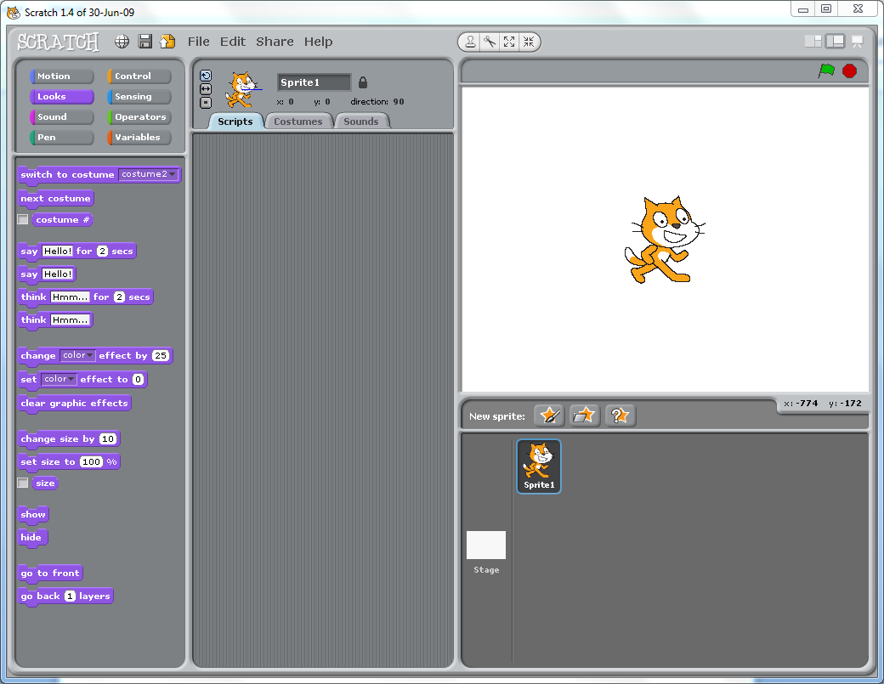
The Stage in the Scratch environment

non-functional properties – the properties and benefits of a language that are not directly related to its syntax or semantics. This corresponds to the context, social environment and encouraged behavior associated with a programming language.
The stage is the area in which the Sprites perform their scripts. It is a preview window to the current state and execution of the program. Sprites are bound within the stage. The stage also serves as a permanent Sprite for the background and often global scripts. Changes made in the code of a Sprite are immediately changed in the stage’s execution of the program.
A Sprite is an object in the Scratch environment. Each Sprite has its own set of instructions, only visible when the Sprite has been selected in the Scratch environment. They all have an x and y position, a direction, and rotation behavior by default. These values can only be changed by the Sprites own scripts.

