**Heuristic Analysis**

The following are the three heuristic evaluation functions:

1. Move_Count_Heuristic: Weighted difference between the number of moves for each player. The opponent’s moves are weighted with a multiplier that is randomly sampled between 1.0 and 2.0 ten times and the average is returned.
2. Opposite_Opponent_Heuristic: Weighted distance from the current proposed move and the move that would mirror the opponent’s last move. The distance is weighted with a multiplier that is randomly sampled between 5.0 and 50.0 ten times and the average is returned.
3. Composite_Heuristic: If the position for the move mirroring the opponent is blank, incentivize making this move with the Opposite_Opponent_Heuristic; otherwise, optimize for the greatest amount of moves with the Move_Count_Heuristic.

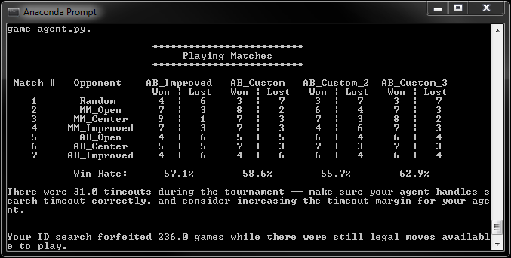

The Move_Count_Heuristic performed better than the baseline. And, although the Opposite_Opponent_Heuristic performed worse than the baseline, the games that it won/lost differed slightly from those with which the Move_Count_Heuristic had won/lost. Using this, my final evaluation function was comprised of both previous heuristics with some basic decision logic to select the appropriate heuristic to apply.

The results of combining the heuristics resulted in a 5-6% increase in win rate.