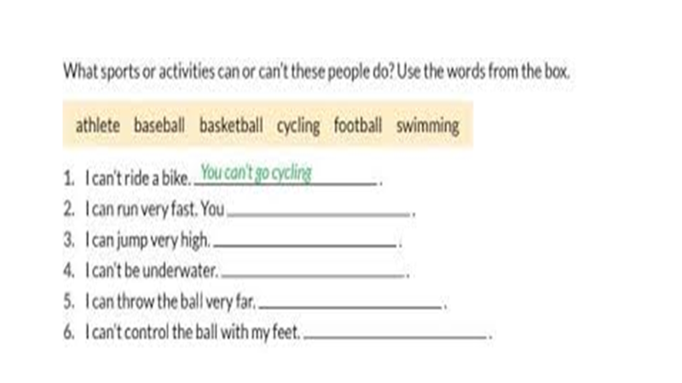

You can’t play football

You can play baseball

You can’t do swimming

You can play basketball

You can be an athelete