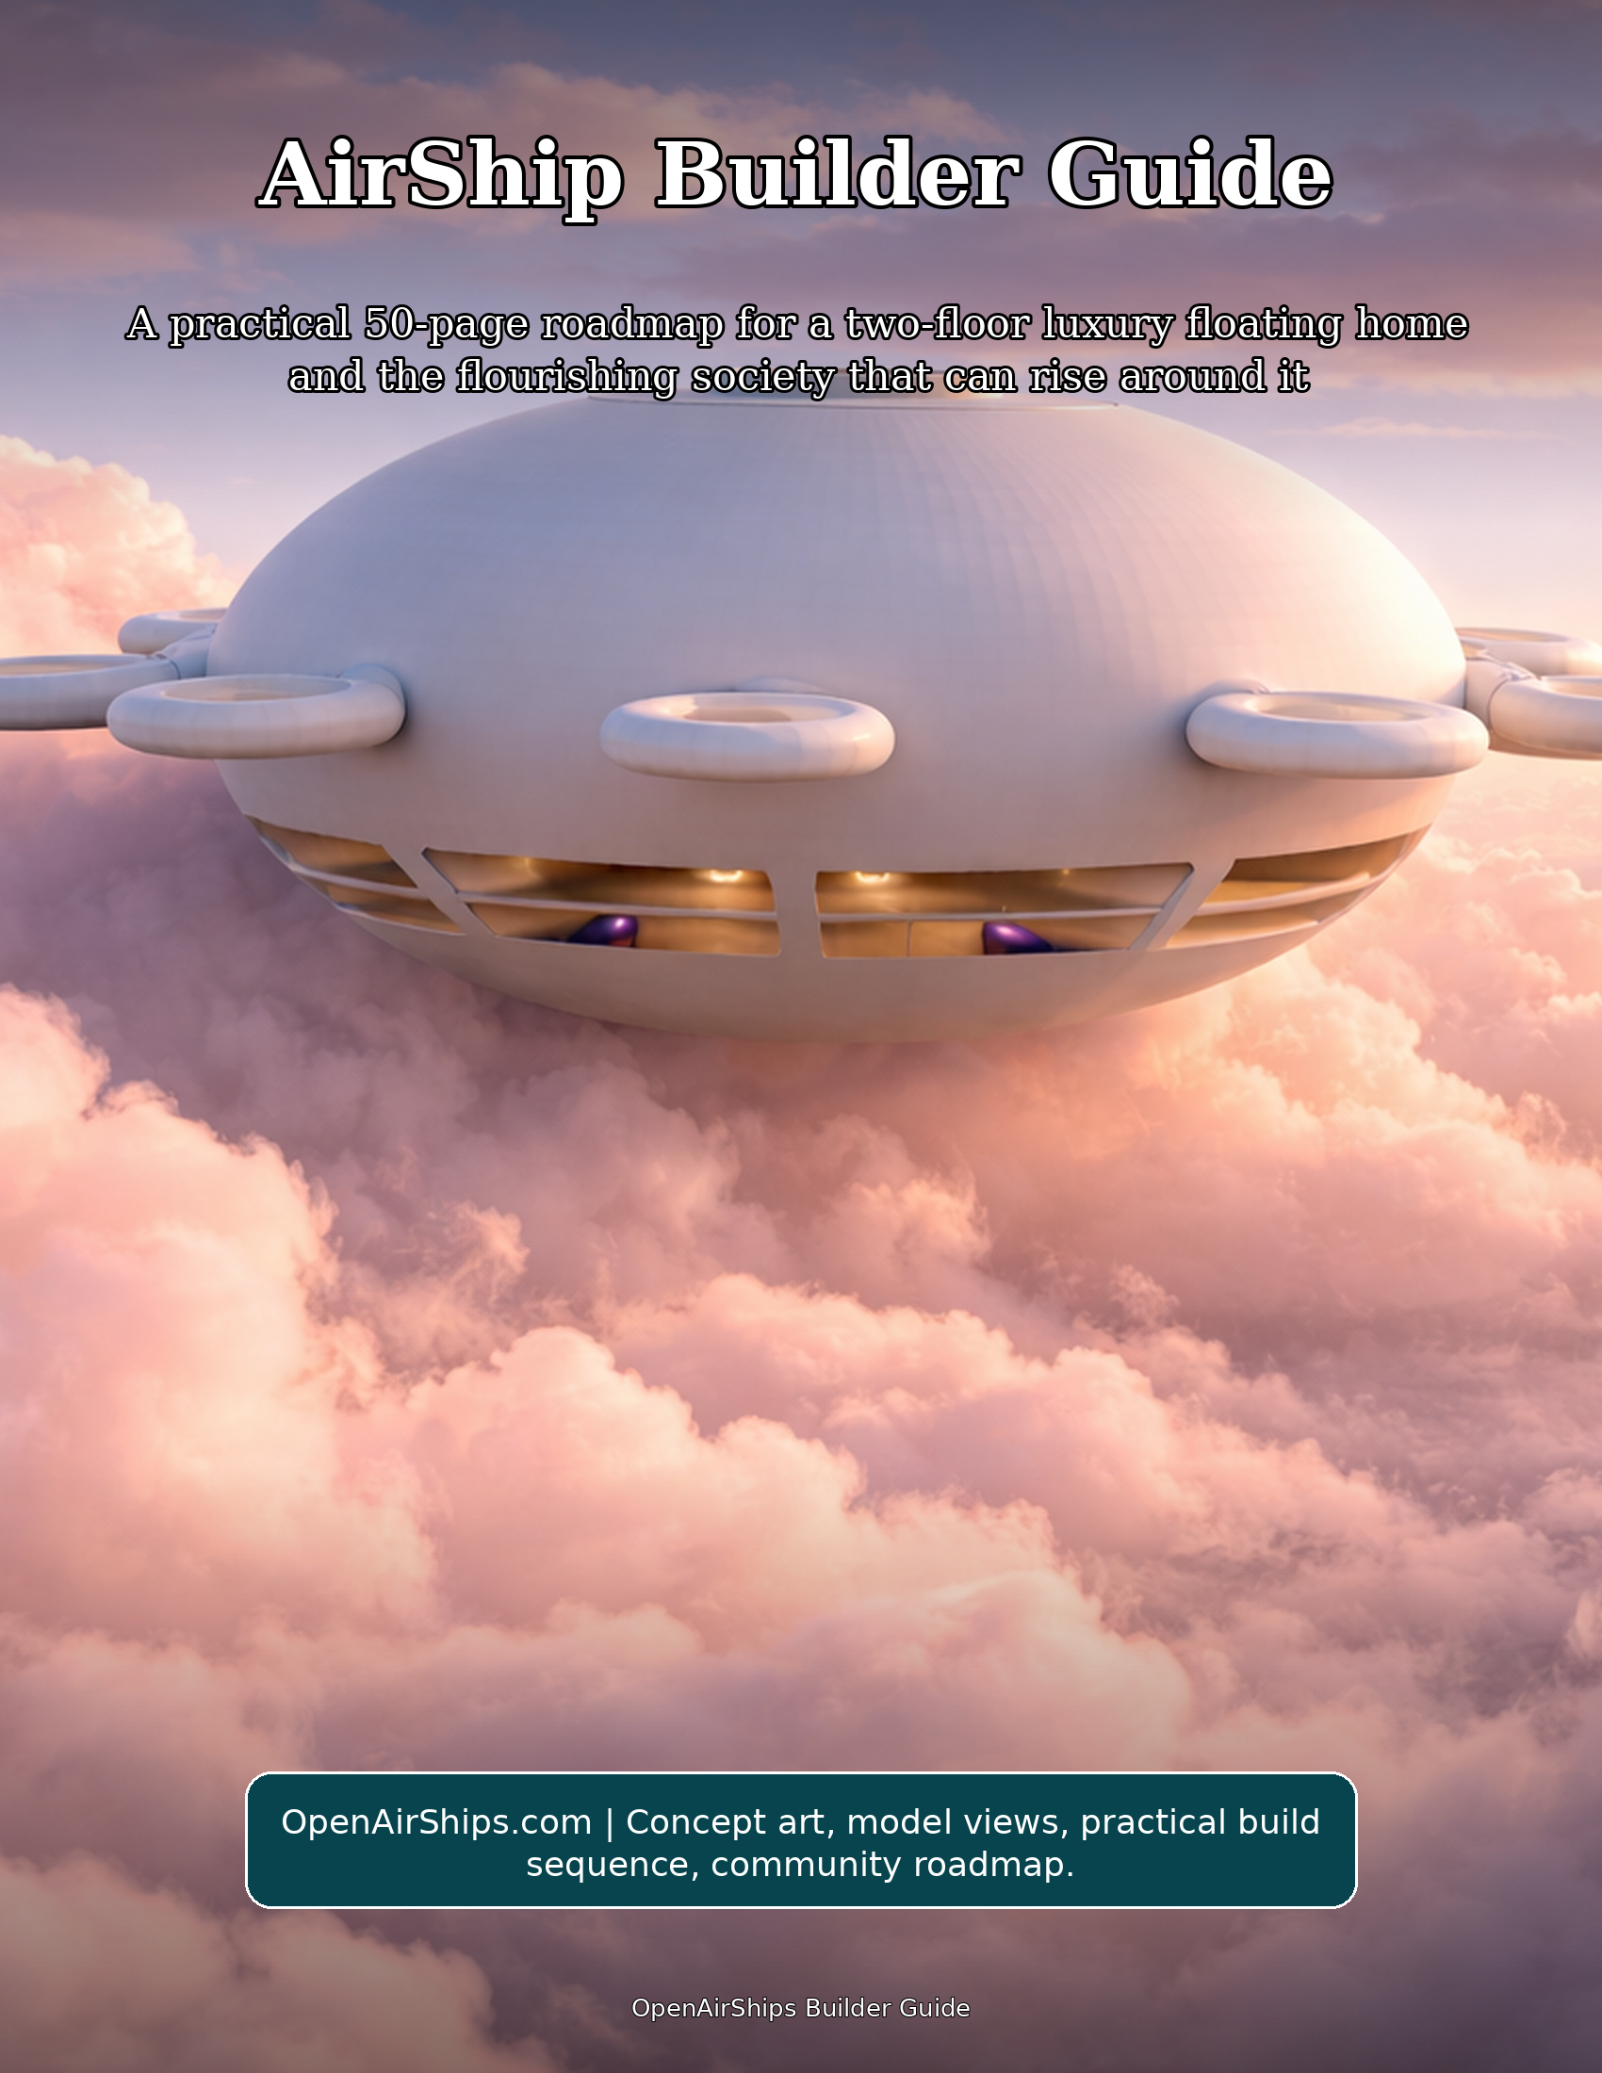

How to Read This Guide
This guide is written for a future AirShip builder who wants a practical path from vision to working prototype. The craft is treated as a round, low-profile, modular, two-floor luxury floating home, with its broad circular hull, upper sun-deck opening, eight perimeter assemblies, and visible two-floor interior band serving as the central design reference.
The pages are arranged as a builder journey. First, they define the spirit and geometry. Then they move into team formation, digital modeling, material research, interior planning, lift architecture, solar power, controls, community economics, food systems, and the flourishing society that can grow around a fleet of beautiful homes in the sky.
The guide stays practical by design. It focuses on constructive action, clear roles, prototyping discipline, open documentation, shared abundance, and graceful iteration. Whenever the work requires deep specialization, the practical step is to invite the right expert into the build circle and make their contribution part of the open design commons.

Workshop actions
• Print the reference-geometry pages and keep them in the workshop.
• Name a documentation steward responsible for keeping the reference atlas current.
• Create a shared build journal before any CAD changes are proposed.

The Promise of the AirShip Home
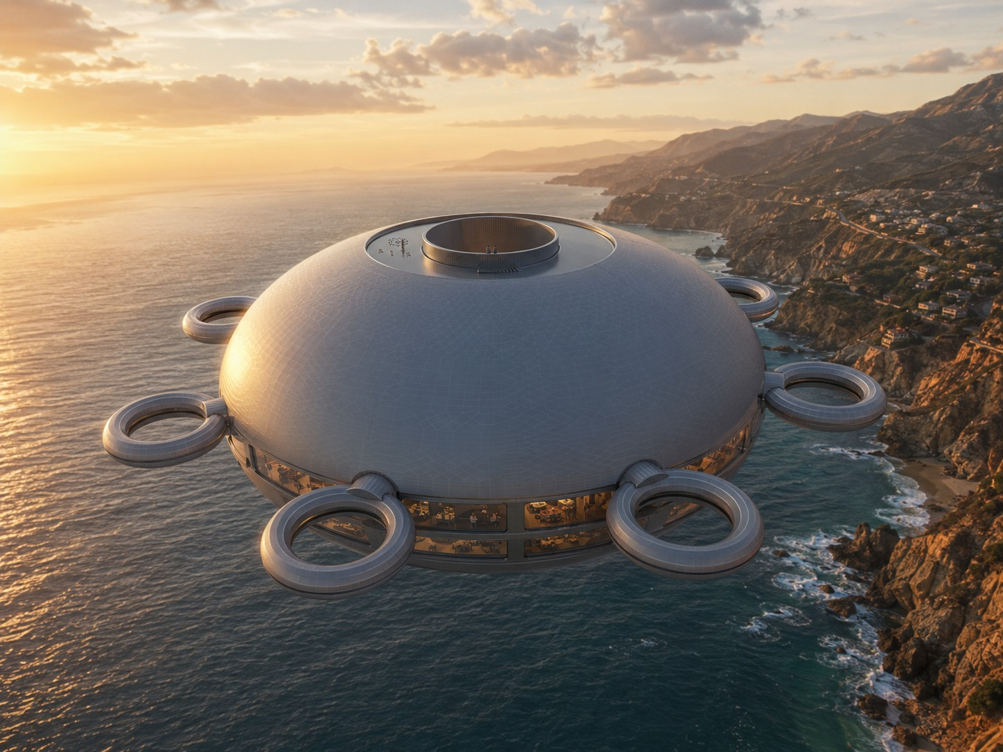
Hero concept view: the reference AirShip presented as a two-floor floating home.
“Build the home as if every curve is an invitation: to travel lightly, live beautifully, and help others rise with you.”
An AirShip home is more than a vehicle. It is a calm, solar-facing dwelling that carries household life into three-dimensional space. The supplied model already expresses a distinct promise: a broad circular hull, eight symmetrical docking and propulsion points, an upper sun-deck opening, and a visible two-floor interior band in the x-axis view.
The practical ambition is a floating home that feels luxurious because it is spacious, quiet, resource-aware, and community-connected. Luxury here does not mean excess. It means good light, generous air, open views, elegant circulation, durable materials, resilient power, and rooms designed for rest, study, cooking, growing, and gathering.
The social ambition is equally important. The AirShip becomes a node in a new culture of mobility and mutual aid: homes that can gather, separate, exchange resources, host guests, teach skills, grow food, print components, and share knowledge across a living network.

Reference Geometry and Modular Identity
The supplied model defines the project's reference geometry. The round plan, smooth dome, low vertical profile, two-floor side band, and eight perimeter assemblies form the visual and functional identity of the AirShip.
Design work begins with the existing envelope. Engineering, interiors, systems, service spaces, and finish details can be developed as coordinated layers inside a recognizable platform that can be studied, tested, fabricated, repaired, and celebrated as a coherent family of craft.
A shared reference model makes collaboration easier. Every contributor can work from a common origin, common axes, common modular wedge logic, and common reference views. This keeps design conversations focused on refinement, documentation, and elegant execution.

Foundation tasks
• Freeze the master hull mesh in a read-only archive.
• Create derivative layers only for internal systems, panels, furniture, utilities, and documentation.
• Use revision names that distinguish production work from exploratory sketches.

Reading the Supplied Views
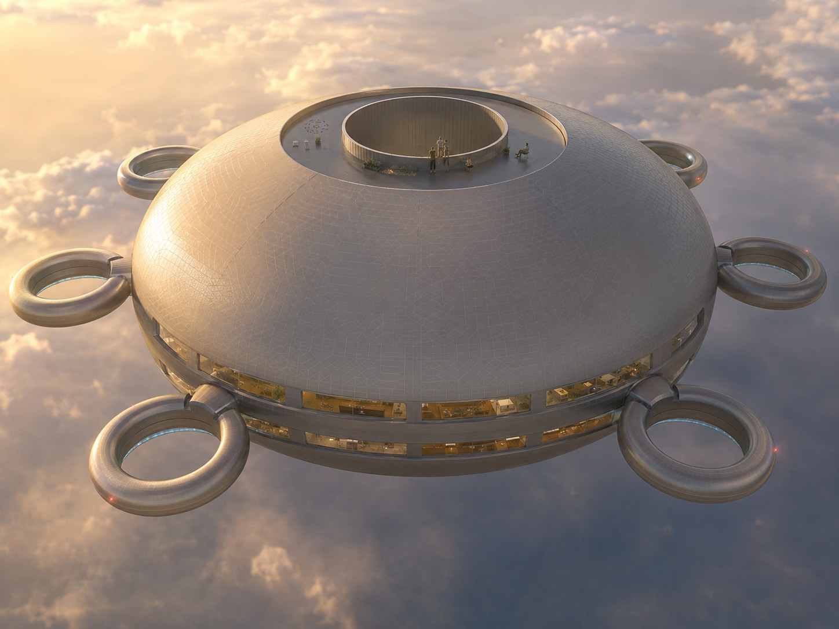
Reference view: central access ring, smooth upper hull, and perimeter modules.
The perspective view shows the craft as a smooth, broad, rounded body with a recessed upper zone and a central cylindrical access opening. The top views reveal radial symmetry and the ring modules around the circumference. The side view reveals the crucial two-floor band: upper living volume above, lower service and living volume below, with windows or bays distributed across the horizontal axis.
A builder should translate these views into a design atlas. Each view becomes a control drawing: top plan for module spacing, side view for floor separation, perspective view for character, and underside or alternate top view for access and maintenance interpretation. This atlas can be used in every design review.
The most practical first step is not cutting material. It is naming every visible feature. Once the features have names, builders can assign owners, create checklists, and develop prototypes without arguing about what the geometry means.

Geometry tasks
• Label the eight perimeter modules clockwise as P1 through P8.
• Label the upper access ring, recessed solar field, outer hull shell, two floor band, lower service zone, and interior stair core.
• Create a one-page visual glossary and include it in every build packet.

OpenAirShips Design Lineage
The OpenAirShips source documents describe a modular, open-source AirShip vision built around circular sections, low-cost iteration, solar power, 3D printing, mesh networking, and a society of mutual provision. The public OpenAirShips.com overview also frames the project around small modular open-source autonomous AirShips that can scale toward travel, housing, electricity, internet, clean water, and abundance.
The important builder lesson is that the AirShip is a platform, not a single product. A platform can host homes, workshops, gardens, sensors, routers, classrooms, guest spaces, water systems, and creative studios. That is why modularity matters: the same outer form can support many interior missions.
The practical path is to honor the source idea while making it buildable. Translate the vision into staged prototypes, documented subsystems, community review, and repeatable fabrication recipes that align with the reference geometry.

View-study tasks
• Create a source folder with the white paper, transcripts, screenshots, public site snapshots, and model files.
• Separate vision statements from engineering requirements so both can thrive.
• Turn each recurring idea into a build track: hull, lift, power, interior, controls, network, society.

The Builder Mindset
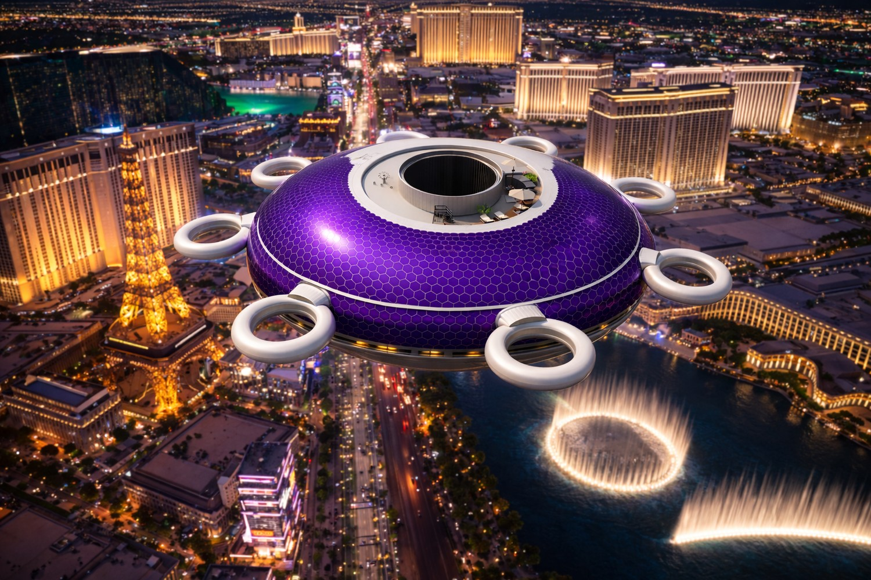
Concept lineage: OpenAirShips ideas translated into a practical build language.
A potential AirShip builder needs three virtues: patience with iteration, generosity with knowledge, and devotion to elegant execution. The work becomes joyful when each prototype is treated as a contribution to the shared future rather than a private secret.
The best builder mindset is both artistic and empirical. The model has a poetic presence, but the path to flight, comfort, and long service life is a careful sequence of drawings, simulations, small models, subsystem benches, full-scale mockups, and community reviews. Every stage should produce something useful: a diagram, a test result, a part library, a training note, or a better question.
The builder should also think like a host. This is a luxury floating home. People will sleep, cook, bathe, work, learn, welcome guests, and look out over changing horizons. The craft should make everyday life feel grounded even while it floats.

Source-library tasks
• Write a one-page builder oath centered on beauty, openness, comfort, and service.
• Choose a weekly design rhythm: review, prototype, document, publish.
• Make every meeting end with one visible improvement to the shared build library.

Phase 1: Assemble the Circle
Form the first build circle around clear roles rather than vague enthusiasm. The minimum circle includes a project steward, geometry steward, CAD lead, aeronautical advisor, materials advisor, electrical systems lead, interiors lead, controls lead, documentation lead, and community coordinator. Each person owns a track while still contributing to the whole.
In practice, this means treating the AirShip as both artifact and institution. The artifact is the AirShip home; the institution is the open community that keeps improving it. Each page of the build journal should therefore answer two questions: what did we make, and how does it help people live more freely, comfortably, and cooperatively?
A builder who follows this approach will always have a next action. The action may be a drawing, a phone call, a prototype, a meeting, a material sample, a render, a checklist, or a lesson. Small, visible steps create the trust required for a large and inspiring build.

Builder habits
• Publish role cards.
• Host a model walkthrough.
• Create an open decision log.

Phase 2: Create the Master CAD Atlas
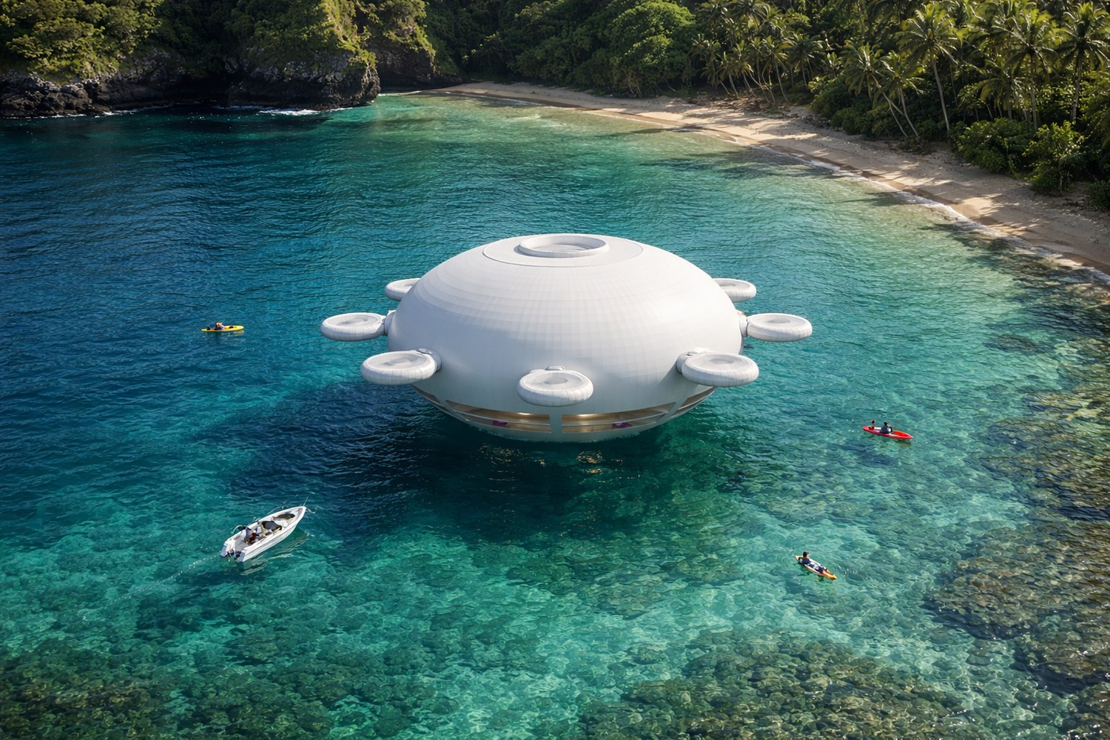
Workshop image: the builder mindset turns geometry, craft, and documentation into one habit.
The CAD atlas converts screenshots and model files into shared references. It should include top, side, perspective, section, interior, and module views. The key principle is that the exterior hull remains locked while internal structure and systems gain more definition.
Phase 2 technical focus: convert every supplied view into a controlled CAD reference. Use a common origin at the visual center of the craft, align the vertical axis through the central cylinder, and create locked reference planes for top, side, underside, and perspective views. Establish a naming scheme for hull shell, upper access ring, two-floor band, lower service bay, perimeter modules, and internal core so every contributor can attach work to the same coordinate system.
Build the atlas as a package rather than a single file: master mesh, simplified collision model, presentation model, fabrication model, section cuts, and exploded modules. Keep a revision register with author, date, purpose, affected subsystem, and export format. The public OpenAirShips plan calls for repeated global iterative open source revision, so the CAD archive should make comparison, rollback, remixing, and review effortless.

Circle launch tasks
• Archive original files.
• Define axes and origin.
• Create non-destructive layers.

Phase 3: Wedge-Based Modularity
The circular body naturally invites radial wedge modules. A wedge can hold structure, buoyancy volume, utilities, cabin zones, storage, or service access while sharing the same geometry with its neighbors. Repetition lowers complexity and makes the AirShip easier to teach, print, inspect, and repair.
Phase 3 technical focus: use the circular plan as a manufacturing advantage. Divide the craft into equal radial sectors, each with shared interface geometry for structure, utilities, buoyancy service, inspection access, and interior fit-out. The white paper emphasizes homogeneous circular sections because one tested wedge can inform the next seven, reducing the number of unique molds, tools, checks, and assembly procedures required for a full hull.
For each wedge, document hard points, wire chases, duct paths, panel seams, fastener families, service covers, and allowable interior attachments. A good module standard includes a drawing, a bill of materials, print orientation notes, joining details, access clearances, and a lightweight inspection checklist. Once the wedge interface is stable, the team can improve individual components without reopening the entire craft design.

CAD atlas tasks
• Divide the plan into equal sectors.
• Assign module interfaces.
• Prototype one wedge before multiplying it.

Phase 4: The Two-Floor Luxury Plan

CAD reference: top, side, and perspective views become the shared atlas.
The side view shows the AirShip as a two-floor floating home. The upper floor can celebrate light, views, cooking, dining, social space, and the sun-deck connection. The lower floor can host private suites, water systems, quiet workrooms, storage, and service corridors.
Phase 4 technical focus: treat the visible side band as the planning datum for two complete living levels. The upper deck can prioritize panoramic social space, galley, dining, work tables, and direct access to the sun-deck core. The lower deck can carry sleeping cabins, quiet rooms, storage, mechanical closets, water systems, sanitation, and service corridors arranged around the same central circulation spine.
Develop the interior as concentric zones. The central core carries stairs, vertical utilities, shared equipment, and the hatch sequence. The middle ring holds daily living functions. The outer ring captures the best views with long windows, built-in seating, cabinets, work surfaces, and balcony-like observation areas inside the fixed shell. Furniture should be modeled as structural mass early so weight distribution stays visible in every drawing.

Module tasks
• Draw floor plates inside the fixed envelope.
• Reserve a central vertical core.
• Keep windows aligned with the existing side band.

Phase 5: The Sun Deck as Civic Heart
The top access ring and recessed upper zone suggest a sun deck that is both private terrace and community interface. It can host gathering, solar maintenance paths, plant containers, meditation, stargazing, and graceful arrival from another AirShip.
Phase 5 technical focus: make the upper deck a real operating surface, not decorative space. The model shows a recessed top field and central opening; that geometry can organize solar service walkways, exterior seating, planter pockets, maintenance tie-downs, antenna masts, sensor housings, and weather-rated access panels while preserving the smooth body language of the craft.
Draw the deck in layers: drainage plane, walking surface, solar zones, access ring, hatch detail, handhold locations, lighting, data ports, and service panels. Keep the sun-deck specification practical: replaceable modules, clean cable routes, low-profile fixtures, and durable finishes. The result should feel like a terrace in the sky and function like an orderly roof plant room.

Interior planning tasks
• Map walking paths.
• Place furniture as removable modules.
• Preserve solar exposure.

Phase 6: Interior Circulation

Interior planning view: the visible side band supports the two-floor home concept.
A luxury floating home needs circulation that feels intuitive. The central vertical core can connect the sun deck, upper floor, lower floor, and bottom access point. Around it, radial corridors can serve rooms without breaking the smooth exterior.
Phase 6 technical focus: the central cylindrical opening becomes the vertical address of the AirShip. Use it to coordinate stair geometry, daylight, ventilation paths, utility risers, emergency egress drawings, equipment access, and the relationship between upper deck, main living floor, lower living floor, and underside service exit. The white paper specifically imagines a spiral stair connecting the sun deck, main interior, and lower exit.
Model circulation at human scale with simple clearances: shoulder width, handrail reach, step rhythm, landing intervals, luggage movement, appliance delivery, and maintenance access. Create a full-size mockup of three stair segments, a hatch ring, and one curved wall section. This single mockup will reveal proportions, hand feel, lighting opportunities, and where the AirShip begins to feel like a home instead of a shell.

Deck development tasks
• Design a central stair/elevator concept.
• Keep service runs near the core.
• Use curved interior walls to echo the hull.

Phase 7: Habitability and Comfort
The AirShip should feel serene. Comfort comes from daylight, acoustic softness, stable temperature, fresh air, generous storage, well-placed handholds, and rooms that can shift between travel, rest, and hosting.
Phase 7 technical focus: habitability depends on light, acoustics, temperature control, privacy, storage, and easy maintenance. Assign each cabin and shared room a comfort brief: seating count, sleeping count, expected noise level, daylight target, ventilation path, storage volume, power outlets, data ports, water access, and cleaning method. Luxury becomes measurable when each space is simple to occupy and simple to service.
Use the two-floor band for layered comfort. Put lively functions near shared view areas, quiet functions behind acoustic partitions, service equipment behind accessible panels, and storage where curved geometry would otherwise be wasted. The AirShip should read as advanced technology from outside and as an elegant apartment inside: warm surfaces, clear paths, hidden systems, and windows placed for long, cinematic horizons.

Circulation tasks
• Create a room-by-room comfort checklist.
• Mock up one cabin at full scale.
• Invite future residents to test layouts.

Phase 8: Materials Palette

Circulation study: the central core organizes deck access, stairs, and service routes.
The source vision emphasizes abundant materials, carbon-based structures, 3D printing, recyclability, and solar-facing surfaces. The builder path is to create a material library ranked by strength, weight, repairability, printability, finish quality, and availability.
Phase 8 technical focus: organize materials by job, not by fashion. The source documents discuss carbon for carbon fiber and graphene concepts, nitrogen as an inert buffer, hydrogen produced from water by electrolysis, photovoltaics, hemp-based printable materials, and reusable or recyclable construction stock. Build a matrix with columns for structural role, mass, repairability, recyclability, printability, conductivity, finish quality, and supply chain maturity.
Run material trials as small coupons before committing to assemblies. Each coupon should record weight, stiffness, surface finish, joining method, thermal behavior, fastening behavior, and finish compatibility. For printable components, include nozzle size, layer height, infill, fiber orientation, post-processing, and part marking. The AirShip project improves fastest when every material choice creates data that another builder can repeat.

Comfort tasks
• Build sample coupons.
• Record mass and finish notes.
• Select materials through transparent review.

Phase 9: Structural Rings and Frames
The exterior rings visible around the craft can be treated as functional modules: docking collars, propulsion housings, observation rings, service ports, or printable structural subassemblies. Their shared geometry makes them excellent candidates for early fabrication practice.
Phase 9 technical focus: the hull needs a disciplined hierarchy of rings, ribs, frames, panels, and service openings. Begin with major circular rings around the central core and perimeter belt, then connect them with radial frames that align to the wedge modules. This allows windows, cabins, buoyancy cells, utility runs, and exterior panels to reference the same structural grid instead of competing for space.
Produce three structural models: a clean visual model for form review, a simplified engineering model for loads and stiffness, and a fabrication model for joints and subassemblies. Label every frame by sector and elevation. Design joints so panels can be removed for inspection without disturbing finished interiors. The builder's goal is a beautiful shell that also behaves like a well-indexed kit of parts.

Material trials
• Model one perimeter ring in detail.
• Define its mechanical interface.
• Print display-scale and test-fit versions.

Phase 10: Lift Architecture

Materials study: structure, skin, energy, and interiors are chosen as coordinated systems.
At a conceptual level, the AirShip is organized around buoyant volume, compartmentalized lift cells, trim management, and a structural shell that keeps the home form coherent. The builder team should turn this into a professionally modeled lift architecture that fits inside the fixed hull.
Phase 10 technical focus: lift planning begins with the buoyant volume budget. The white paper centers lighter-than-air operation and describes hydrogen as abundant and obtainable from water through electrolysis, with lift managed by gas handling and internal buoyancy architecture. In the guide, treat lift cells, service corridors, sensors, valves, tanks, and access panels as reserved volumes in the CAD model from the first planning pass.
Create a lift ledger that tracks estimated mass by subsystem: shell, frames, windows, interiors, power, storage, propulsion, water, equipment, residents, supplies, and margin. Pair it with a volume ledger for buoyancy spaces. The ledger should be updated after every design change, render, mockup, or part sample so the craft remains a coordinated flying home rather than a collection of attractive rooms.

Frame development tasks
• Create a volume map.
• Assign lift compartments to wedges.
• Review with aerostatics specialists.

Phase 11: Solar Skin
The upper exterior is the natural solar field. Solar design should follow the existing curvature and recessed top geometry. The goal is a beautiful integrated skin, not a patchwork. Maintenance paths and replaceable panel zones can be planned as part of the surface system.
Phase 11 technical focus: the upper exterior is the natural solar field. The white paper imagines high-density photovoltaics over the exterior top apart from the sun deck, and the public plan emphasizes scaling with off-the-shelf components. Map solar coverage by curvature, shadow from the central ring, service walkways, module seams, cleaning access, cable routing, inverter placement, and replacement strategy.
Design solar skin as replaceable tiles rather than a single monolithic finish. Each tile should have a panel ID, electrical rating, connector type, mounting detail, seal detail, drainage path, inspection interval, and removal method. The recessed top geometry is ideal for an orderly photovoltaic garden: smooth from a distance, precise up close, and readable in the maintenance manual.

Lift planning tasks
• Map high-sun surfaces.
• Define panel tiles.
• Route wiring through repeatable channels.

Phase 12: Energy Storage and Distribution

Lift study: buoyancy volume, mass ledgers, and service access develop together.
A floating home needs a calm electrical backbone: generation, storage, distribution, monitoring, and graceful prioritization. The energy system should be modular by wedge so that improvements can be introduced without redesigning the whole craft.
Phase 12 technical focus: energy storage and distribution should be drawn as a house grid and a flight grid sharing a clear backbone. The source material points toward all-electric operation, graphene ultracapacitor ambitions, and modern storage improvements. Treat storage technology as a replaceable bay: define voltage architecture, cable trays, isolation points, thermal management, monitoring, access doors, and reserved expansion volume.
Build an energy one-line diagram early. Include solar input, charge controllers, storage modules, propulsion buses, cabin buses, lighting, galley loads, communications loads, pumps, sensors, computing, and shore or dock interface. Then create a physical routing drawing so cables, cooling, service panels, and furniture do not collide. A clean electrical architecture will make the AirShip easier to build, inspect, upgrade, and teach.

Solar skin tasks
• Draw a power one-line diagram.
• Create load categories.
• Prototype a bench-scale microgrid.

Phase 13: Propulsion and Station Keeping
The eight perimeter modules can express balanced movement in every direction while reinforcing the circular identity. The practical design goal is quiet, efficient, symmetric control that lets the AirShip maneuver gracefully and hold position as a home.
Phase 13 technical focus: propulsion in the source concept is arranged around perimeter thrusters, with discussion of efficient ducted or air-multiplier-like rings rather than traditional exposed propellers. The supplied model already expresses eight circular perimeter assemblies, so use them as the visual and functional basis for thrust, station keeping, low-speed maneuvering, and graceful hovering.
For each perimeter module, define thrust direction, duct diameter, motor bay, service hatch, cable route, sensor location, lighting, vibration isolation, and attachment interface. Create bench tests before flight prototypes: static thrust rig, acoustic reading, temperature run, power draw, duct insert variations, and control response. The rings should read as elegant architecture while behaving as precise maneuvering instruments.

Energy-system tasks
• Assign thrust modules to perimeter positions.
• Simulate symmetric control cases.
• Design removable service cartridges.

Phase 14: Autonomy and Navigation

Energy study: solar skin, storage bays, and distribution routes are planned as one system.
The AirShip should be designed as a calm, sensor-rich home with assisted navigation. Autonomy begins with awareness: position, attitude, altitude, weather data, nearby craft, energy state, and route intent. The first prototypes can focus on observation and stable control.
Phase 14 technical focus: autonomy starts with sensing the world in three dimensions. The transcripts emphasize that automated navigation in open air can be simpler than urban road driving because the vehicle can model airspace, maintain separation, and avoid obstacles with modern sensors. Build the stack around positioning, altitude, inertial data, lidar or depth sensing, cameras, wind estimates, route planning, and human override interfaces.
Create a simulation workflow before building large hardware. The public plan names 3D navigation and blockchain route peer verification; translate that into recorded test routes, sensor logs, digital twin playback, route signatures, and reviewable autonomy decisions. Begin with a small model carrying a phone or sensor pack, then graduate to larger prototypes as the navigation data becomes repeatable.

Propulsion tasks
• Create a sensor map.
• Build a simulator dashboard.
• Log every test in open format.

Phase 15: The Mesh Network Node
The AirShip can serve as a beautiful airborne communications node for a privacy-preserving community mesh. Practical builders should focus on lawful, cooperative, open protocols, local resilience, and service to residents, guests, educators, and neighboring craft.
Phase 15 technical focus: the AirShip can also be a network node. The white paper describes a peer-to-peer mesh using ultra-wideband radio concepts, encrypted traffic, frequency agility, blockchain incentives, and real-time data transfer. For a builder guide, convert this vision into hardware bays: radios, antennas, routing computers, storage modules, power conditioning, cooling, maintenance access, and externally documented interface standards.
The uploaded source also frames wireless design as a balance among data rate, distance, speed, number of users, and simultaneous streams. Use that tradeoff as the engineering worksheet for every network prototype. Record antenna placement, line-of-sight assumptions, link budget, packet loss, latency, power draw, enclosure temperature, and firmware version. Network design becomes practical when every flight produces measurable communications data.

Navigation tasks
• Prototype with permitted radios.
• Document network services.
• Create a resident-friendly connectivity panel.

Phase 16: Water, Air, and Living Systems

Autonomy study: sensing, route planning, and digital twin data support graceful navigation.
A floating home feels complete when essentials are abundant and elegant. Water capture, filtration, storage, efficient fixtures, fresh-air exchange, indoor planting, and maintenance access should be designed as visible signs of care.
Phase 16 technical focus: water, air, and living systems should be integrated like a small vessel and a high-end residence. Reserve service volume for potable water, filtration, pumps, greywater treatment, humidity control, ventilation, thermal recovery, air-quality sensors, and maintenance drains. The white paper's abundance language includes water, sewage treatment, electricity, and food, so each utility should have a visible pathway from source to use to recovery.
Create a utilities board before building rooms. Mount representative pumps, valves, tanks, filters, sensors, wiring, and controls on a test panel at human scale. Label every line and measure power draw, noise, service time, and replacement clearance. Then fold the tested layout back into the curved interior so everyday residents see beautiful rooms while maintainers see an intelligible machine.

Mesh-node tasks
• Create a resource loop diagram.
• Separate potable, grey, and garden water paths.
• Design systems as accessible furniture-like modules.

Phase 17: Food and Garden Modules
OpenAirShips imagines food abundance alongside mobility. The AirShip home can begin with compact gardens: herbs, greens, seed libraries, mushroom drawers, microgreens, and balcony planters on the sun deck. Larger fleet members can host farms and nurseries.
Phase 17 technical focus: food systems can begin small and become a signature capability. The source plan imagines AirShip FarmBots, permaculture food forests, hydroponic hemp farms, and local production of hemp-based filament. Inside the luxury home, start with compact grow cabinets, herb walls, seed storage, compost experiments, and a small nursery station connected to the water and lighting plan.
For community-scale work, separate residential gardens from production modules. A residential module is quiet, clean, and beautiful. A production module is optimized for tray access, nutrient delivery, robotics, harvesting, drying, seed saving, and fiber processing. Document both. The AirShip becomes more useful when it can host a dinner, teach horticulture, and support material production with the same design language.

Living-system tasks
• Design a galley garden wall.
• Create seed storage.
• Plan fleet-scale farm variants.

Phase 18: Waste as Resource

Living systems study: water, air, power, and comfort are integrated into the home.
A practical society treats outputs as inputs. Organic matter, packaging, worn parts, wash water, and fabrication scraps can be sorted into loops for composting, reuse, repair, recycling, and design improvement.
Phase 18 technical focus: treat every output stream as a design input. Track organic waste, greywater, packaging, print scraps, worn panels, filters, and maintenance parts. The white paper calls for reusable and recyclable materials so outdated designs can be melted down or repurposed; that idea becomes a workshop protocol when parts are labeled by material, revision, mass, and next use.
Build a circular-materials station into the workshop plan: sort bins, wash area, shredder or grinder space, filament testing, sample storage, and a digital inventory. Every failed prototype should still yield geometry lessons, mass data, material behavior, and reusable feedstock. This keeps the project lively and precise: nothing disappears into vague waste, and every experiment improves the next component.

Garden module tasks
• Create labeled resource stations.
• Design removable collection drawers.
• Track material return rates.

Phase 19: 3D Printing for Replication
The source vision places 3D printing at the center of growth. The practical starting point is a parts library for non-critical components: interior brackets, covers, handles, planters, ducts, templates, model sections, and educational kits.
Phase 19 technical focus: 3D printing is not merely a way to make parts; in the OpenAirShips vision it is the replication engine. The white paper imagines AirShip printers moving hot ends accurately through space, multiple printer nodes collaborating, and different materials being deposited together. Start with conventional printers for parts, then document the path toward larger robotic fabrication.
Create a print standard for every component: file name, material, layer orientation, infill, reinforcement, surface finish, tolerance, post-processing, test fit, part ID, and replacement interval. For multi-material ambitions, define which elements carry structure, conductivity, sealing, insulation, and finish. A printed AirShip becomes plausible when each part is boringly well documented and delightfully easy to improve.

Resource-loop tasks
• Start with small printed parts.
• Attach QR codes to part histories.
• Maintain parametric source files.

Phase 20: The AirShip Workshop

Resource loop study: materials, print scraps, water, and food systems feed future work.
Every serious build needs a workshop that feels like the future it serves: clean benches, model wall, print farm, materials library, electronics bench, documentation station, and a hospitality area where newcomers can understand the dream in minutes.
Phase 20 technical focus: the workshop is the first physical AirShip system. It should contain CAD stations, printer bays, material storage, assembly benches, coupon testing, electronics benches, photo documentation, packing, and a clean review table for finished parts. The OpenAirShips get-involved page names aeronautical, radio, materials, electrical, blockchain, Linux, encryption, video, and 3D-printing specialists; the room should welcome all of them.
Arrange the workshop around flow: idea, drawing, small print, test coupon, subsystem mockup, review, revision, publication. Put cameras and measurement tools where they are used, not hidden in drawers. A beautiful workshop culture produces beautiful craft because the same care given to a surface finish is given to filenames, labels, checklists, and the way people hand work to each other.

Replication tasks
• Create zones for CAD, print, assemble, test, document.
• Display the reference model prominently.
• Host weekly open studio hours.

Phase 21: Prototype Ladder
Move from small to large with grace. The ladder can include desk model, display model, module mockup, interior cabin mockup, sensor gondola, tethered demonstrator, autonomous demonstrator, one-room hull mockup, and full home integration model.
Phase 21 technical focus: prototype in a ladder. The transcript proposes beginning with very small craft, even a test model capable of carrying a phone for remote presence, before moving toward rideable scale. That ladder can be formalized as desktop geometry, buoyancy cell coupon, perimeter duct test, sensor gondola, room mockup, small autonomous demonstrator, one-sector module, and full-scale interior segment.
Each rung should answer one question cleanly. Does the duct make enough thrust? Does the window band feel spacious? Can the stair core be entered comfortably? Does a sensor package hold altitude? Does a printed bracket meet the interface drawing? Do not ask one prototype to prove everything. Let each object be a clear sentence in the larger engineering story.

Workshop setup tasks
• Define success for each rung.
• Limit each prototype to one main question.
• Publish lessons after each build.

Phase 22: Digital Twin

Workshop study: fabrication, testing, photography, and publication share one space.
A digital twin lets the AirShip evolve as a coordinated system. It can combine CAD, mass estimates, energy models, interior layouts, sensor data, maintenance logs, and community feedback into one living model.
Phase 22 technical focus: the digital twin is the living memory of the build. It should hold geometry, mass, components, wiring, plumbing, energy, sensor data, prototype results, maintenance records, and render-ready scenes. Because OpenAirShips emphasizes open-source iteration, the twin should be legible to new contributors: clean layers, obvious names, linked drawings, and change notes written for humans.
Use the digital twin to compare imagined performance with measured performance. After every print, weigh the part and update the mass ledger. After every bench test, attach power, heat, noise, and fit notes. After every render, record which geometry version produced it. Over time, the twin becomes more than a model; it becomes the shared operating language of the project.

Prototype tasks
• Choose a shared repository.
• Connect CAD views to requirements.
• Update the twin after every test.

Phase 23: Review Rituals
The project needs rituals that keep optimism organized. A weekly review can celebrate progress, compare prototypes, update requirements, invite critique as contribution, and keep decisions aligned with the reference atlas.
Phase 23 technical focus: reviews should be structured enough to improve quality and light enough to invite participation. Use four review modes: geometry review, systems review, fabrication review, and story review. Geometry checks the reference body. Systems checks power, lift, water, network, and controls. Fabrication checks whether parts can be made. Story checks whether drawings, images, and text help new builders understand the work.
Give every review a visible output: accepted drawing, open issue, changed dimension, new test, updated render, or clearer paragraph. The best review ritual makes decisions traceable without becoming theatrical. Publish short notes, mark owners, and close the loop. A contributor should be able to join months later and understand not only what was decided, but why the decision made the AirShip easier to build.

Digital twin tasks
• Open with the vision.
• Review geometry changes first.
• Close with published next steps.

Phase 24: Documentation as Infrastructure

Digital twin study: CAD, test data, and documentation remain synchronized.
Documentation is not paperwork; it is how the AirShip replicates. Every part, test, decision, material, and room concept should have a page that another builder can follow. Good documentation turns one workshop into a global classroom.
Phase 24 technical focus: documentation is infrastructure. The white paper depends on open replication, and the public site points people toward the plan, white paper, GitHub, and community discussion. Build the document system as if it were a subsystem of the craft: versioned folders, part numbers, diagrams, photos, test reports, meeting notes, source snapshots, contributor credits, and publication checklists.
Use a documentation template for each part and each subsystem. Include purpose, drawing, material, mass, interface, tool requirements, build steps, inspection points, revision history, and next experiments. Good documentation lets a builder in another city reproduce a bracket, improve a duct, translate a page, or spot a better route for a wire without needing to ask for private context.

Review tasks
• Use templates.
• Photograph every assembly.
• Write for a capable newcomer.

Phase 25: Open Source Governance
A strong build community needs fair ways to decide. Governance can include proposals, design review boards, resident councils, contributor credits, transparent budgets, and elected maintainers for core modules.
Phase 25 technical focus: open-source governance should make contribution simple and excellence visible. The OpenAirShips open-source page describes commitment to releasing designs and software for public improvement, and the GitHub repository provides a home for shared assets. Define contribution types: CAD, code, renders, tests, writing, outreach, materials research, supplier notes, and workshop lessons.
Create a lightweight governance map: maintainers, reviewers, release managers, issue labels, file standards, design proposals, accepted changes, and archived experiments. Pair freedom with clarity. A contributor should know where to submit a part, how to name it, what evidence supports it, who reviews it, how it becomes official, and where its story appears in the next public release.

Documentation tasks
• Create proposal formats.
• Publish voting records.
• Reward maintainers and teachers.

Phase 26: The Contribution Economy

Documentation study: drawings, photos, revision notes, and part records become infrastructure.
The source materials imagine rewards for useful contributions: transport, housing, printing, food, education, media, governance, storage, and network services. The practical version can start with credits, reputation, grants, bounties, and shared ownership pools.
Phase 26 technical focus: the contribution economy turns useful work into recognized value. The white paper lists many contribution categories: network data transfer, storage, node deployment, development, mapping, transportation, housing, 3D printing, water, electricity, food, seeds, education, governance proposals, voting, media, and exchange. Treat this list as an early service catalog for the AirShip civilization.
Build a ledger prototype before building a token. Record tasks, deliverables, reviewers, evidence, time, materials, and resulting benefit. A 3D printed bracket, a hydroponic tray, a mesh relay test, and a training video can all be logged in the same structure. This keeps the economy grounded in real outputs, real learning, and visible progress rather than abstract enthusiasm.

Governance tasks
• List contribution categories.
• Define evidence of work.
• Create a public gratitude ledger.

Phase 27: A Floating Neighborhood
One AirShip is a home. Many AirShips become a neighborhood. The circular form encourages docking clusters, shared sun decks, classroom gatherings, repair exchanges, garden swaps, music nights, and cooperative routing.
Phase 27 technical focus: a floating neighborhood needs spatial rules. Define docking distance, communication protocol, shared service windows, quiet hours, resource exchange points, guest arrival paths, emergency meeting points, and common cultural practices for meals, workshops, education, and maintenance. The AirShip is a home, but a fleet becomes a living district with its own geometry and rhythm.
Draw neighborhood diagrams at several scales: two AirShips visiting, eight AirShips in a circle, a workshop cluster, a garden cluster, a river or bay gathering, and an overland travel formation. Include data links, lighting, water exchange, cargo transfer, social spaces, and service access. A good fleet plan feels like a marina, a campus, and a constellation all at once.

Contribution-economy tasks
• Design gathering protocols.
• Create shared calendars.
• Map services across the fleet.

Phase 28: Luxury Without Waste
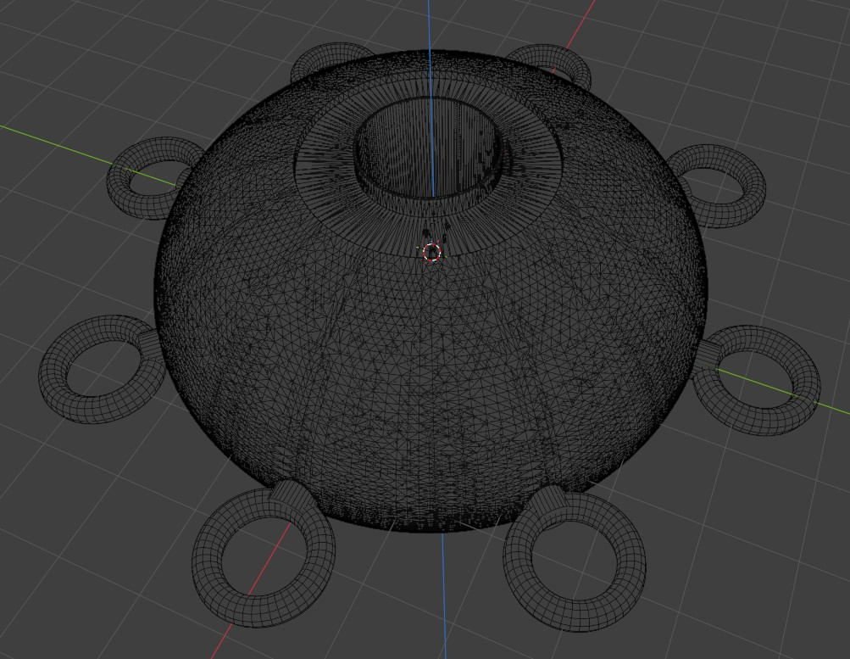
Contribution study: useful work is recorded, reviewed, credited, and improved.
Luxury in this society is beauty, time, health, movement, learning, and belonging. Interiors can use durable finishes, modular furniture, natural textures, excellent lighting, and quiet systems that make the home feel generous without burden.
Phase 28 technical focus: luxury without waste is a specification. Replace vague luxury with measurable qualities: excellent view lines, quiet sleeping rooms, durable surfaces, thoughtful storage, low-maintenance fixtures, warm lighting, efficient appliances, repairable furniture, and systems hidden behind elegant access panels. The craft should feel rich because every square meter performs beautifully.
Design interior modules as built-in furniture rather than loose objects fighting the curve. Window benches can hold storage. Curved walls can hide ducts. Stair landings can become reading shelves. Galley cabinets can double as structural partitions. The shell geometry is not a limitation; it is the design language that makes the home distinct from apartments, yachts, aircraft, and recreational vehicles.

Neighborhood tasks
• Design multi-use furniture.
• Choose repairable finishes.
• Use lighting scenes for daily rhythms.

Phase 29: Education Aboard
Each AirShip can be a school. Residents and guests can learn navigation, gardening, electronics, CAD, cooking, music, languages, repair, governance, and stewardship. Education makes the fleet self-renewing.
Phase 29 technical focus: education aboard should be hands-on and modular. Create lessons around buoyancy, solar power, CAD, 3D printing, water systems, mesh networking, gardening, open-source licensing, rendering, storytelling, and community operations. Each lesson should connect one visible feature of the AirShip to one skill a builder can practice immediately.
Turn every subsystem into a teaching station. A transparent utility panel can explain water flow. A removable solar tile can teach wiring and maintenance. A printed bracket can teach materials and tolerances. A mesh radio bay can teach decentralized networking. A living classroom helps the project recruit skilled contributors because newcomers learn by touching real parts.

Luxury-detail tasks
• Build a learning wall.
• Host skill circles.
• Create youth-friendly model kits.

Phase 30: Health and Wellbeing
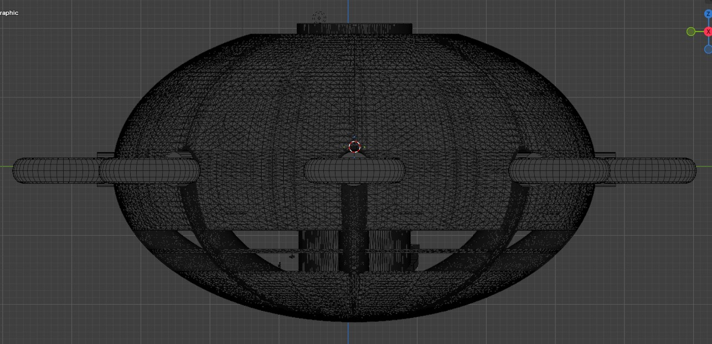
Luxury study: built-in furniture, warm light, views, and service access shape the interior.
The AirShip home should support sleep, movement, sunlight, fresh meals, quiet work, and community connection. Health is designed through routines as much as hardware: morning deck time, shared meals, creative work, garden care, and evening observation.
Phase 30 technical focus: health and wellbeing are layout decisions. Prioritize daylight, clean air, low noise, comfortable sleeping, gentle circulation, access to plants, places for exercise, social dining, quiet work, and views of land, water, and sky. The AirShip should allow a household to live slowly while the craft moves elegantly through space.
Create a wellbeing schedule for the design: morning light at breakfast, shaded work zones at midday, quiet evening cabins, night lighting that preserves calm, and fresh-air paths that do not disturb sleeping areas. Measure comfort with mockups and occupant notes. A home in the air succeeds when residents forget the complexity of the machine and remember the grace of the day.

Education tasks
• Plan wellness zones.
• Use circadian lighting.
• Create daily care rituals.

Phase 31: Art Direction
Reference OpenAirShips.com for additional art ideas, model lineage, and blueprint inspiration. The visual language should be optimistic: white hull, soft solar surfaces, warm interiors, luminous windows, green decks, and radial geometry.
Phase 31 technical focus: art direction must protect the recognizable model while improving finish, texture, color, light, and storytelling. Use the supplied renders as environment studies: coastline, clouds, desert, jungle, city, snow, valley, and water. The AirShip should keep its circular body, central top opening, perimeter rings, and two-floor side band while materials and lighting create variety.
Create an art bible with render angles, lens choices, daylight palettes, surface finishes, interior warmth, window glow, panel pattern, scale cues, and human presence. Include OpenAirShips.com as the reference hub for further art ideas, public assets, and technical context. The goal is a visual identity that makes the craft instantly recognizable across every image, blueprint, animation, and poster.

Wellbeing tasks
• Create a mood board.
• Render the same shape in multiple environments.
• Maintain visual continuity across all renders.

Phase 32: Blueprint Package
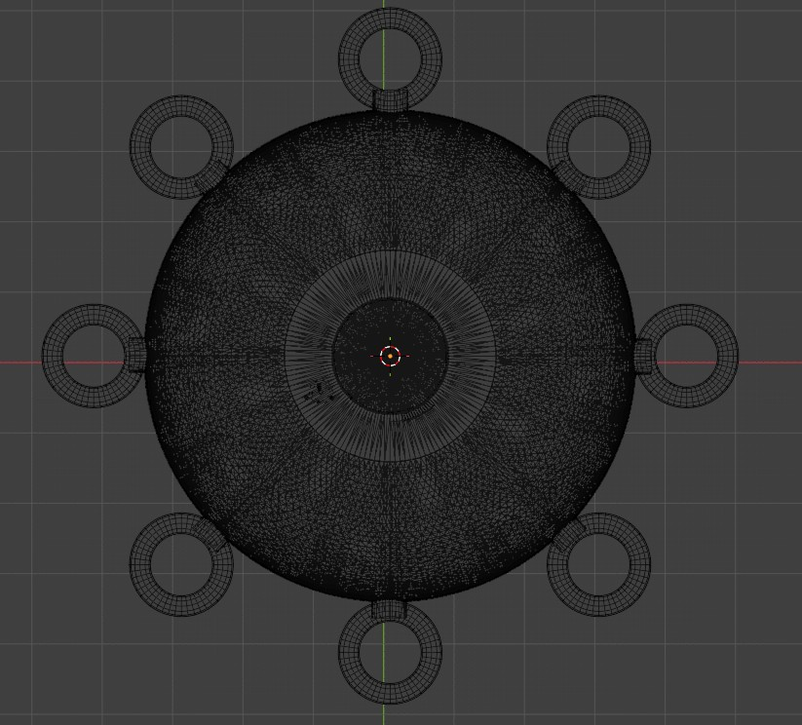
Health study: daylight, quiet rooms, clean air, and plants make the craft livable.
The blueprint package should be a growing set of views: locked exterior, plan, section, module, floor layout, access core, solar map, power map, network map, water loop, interior elevations, and fleet docking diagrams.
Phase 32 technical focus: the blueprint package should contain enough information to guide a serious builder from concept to prototype. Include general arrangement, top plan, side elevations, underside view, section cuts, wedge module drawing, central core drawing, floor layouts, utilities diagrams, energy one-line, mesh-node diagram, propulsion module diagram, materials matrix, and prototype ladder.
Make every blueprint page earn its place. Add scale bars, orientation markers, part labels, revision number, author, source file, and inspection notes. Separate presentation drawings from fabrication drawings. A presentation page sells the vision; a fabrication page tells a builder what to make, where it fits, how it connects, and what evidence proves it works.

Art-direction tasks
• Start with reference views.
• Add dimensions only after expert review.
• Version every sheet.

Phase 33: Full-Scale Interior Mockup
Before building a full craft, build rooms. A full-scale slice can test ceiling heights, window placement, stairs, furniture, storage, lighting, mechanical access, and emotional comfort inside the reference envelope.
Phase 33 technical focus: a full-scale interior mockup is the bridge between beautiful renders and livable architecture. Build one curved wall bay, one window band section, one floor transition, one storage module, one service panel, and one stair segment. Use inexpensive materials first, but match dimensions, sight lines, handle positions, lighting levels, and seating heights.
Run the mockup like a small apartment. Prepare a meal, sit with a laptop, store luggage, open panels, move through the stair, and host a conversation. Photograph every posture and every awkward reach. Then revise the CAD. This is where luxury becomes physical: a hand lands naturally, a cabinet opens cleanly, and a view frames the horizon.

Blueprint tasks
• Mock up one radial slice.
• Invite walkthroughs.
• Record resident feedback.

Phase 34: Model-Based Fabrication
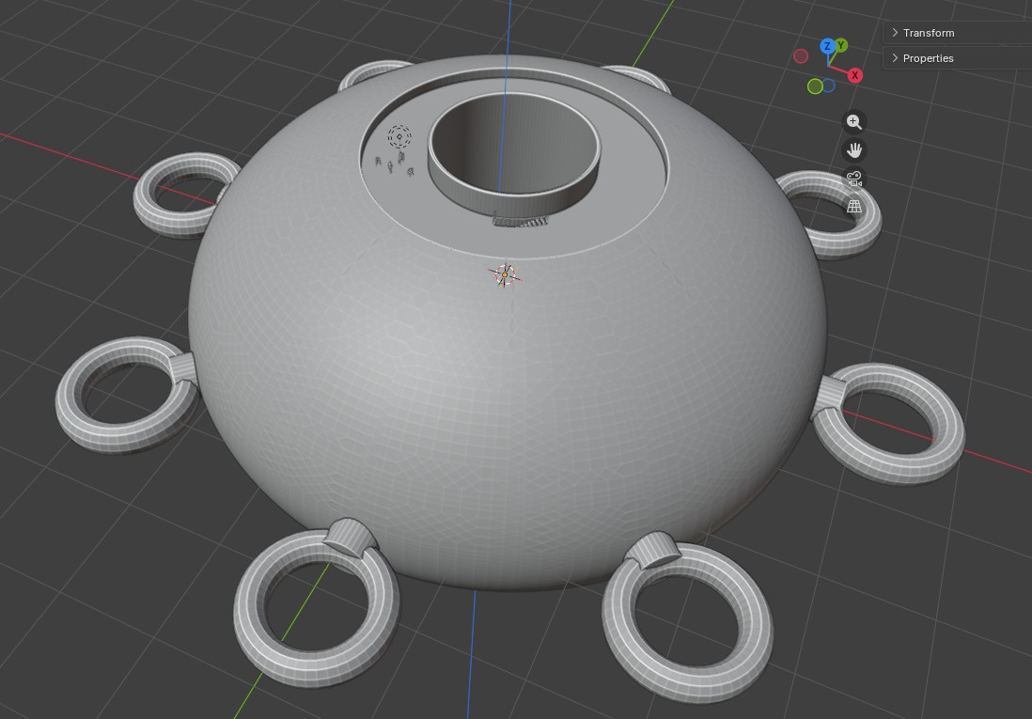
Blueprint study: controlled drawings translate the model into build packets.
Fabrication should flow from the digital twin to jigs, templates, molds, printed parts, and assembly instructions. A builder can begin with display-scale models, then move to full-scale interior components and non-flight exterior panels.
Phase 34 technical focus: model-based fabrication means the model is the source of truth. Parts should be generated from the controlled CAD atlas, exported in standard formats, labeled by revision, and checked against the physical part after fabrication. When the same geometry produces drawings, renders, prints, and inspection templates, the build becomes faster and more trustworthy.
Define fabrication packets for hull panels, ring modules, brackets, ducts, interior modules, and utility boards. Each packet should include model file, drawing PDF, print or fabrication settings, material, expected mass, tolerance, surface finish, assembly sequence, and photo checklist. A builder should be able to open one packet and know exactly how that part contributes to the whole craft.

Mockup tasks
• Create printable templates.
• Mark parts with orientation.
• Use assembly photos in the build manual.

Phase 35: Systems Integration Day
Choose regular integration days where teams connect their work: power with interiors, water with structure, controls with propulsion, solar with maintenance access, network with resident interface. Integration turns separate inventions into a home.
Phase 35 technical focus: systems integration day is a rehearsal for the complete AirShip. Bring power, controls, sensors, water, lighting, communications, and mechanical assemblies together on benches and mockups before they enter the hull. Integration should expose interface needs: connectors, access doors, labeling, mounting plates, software versions, calibration steps, and spare parts.
Write an integration script with start state, steps, expected readings, photos to capture, and sign-off criteria. Power the cabin lights, run a pump, boot the mesh node, spin a ducted fan on the bench, log sensor data, and update the digital twin. The day should end with fewer mysteries and a clearer bill of materials.

Fabrication tasks
• Bring physical parts to the same table.
• Review interfaces.
• Publish updated diagrams.

Phase 36: Community Workshop Curriculum
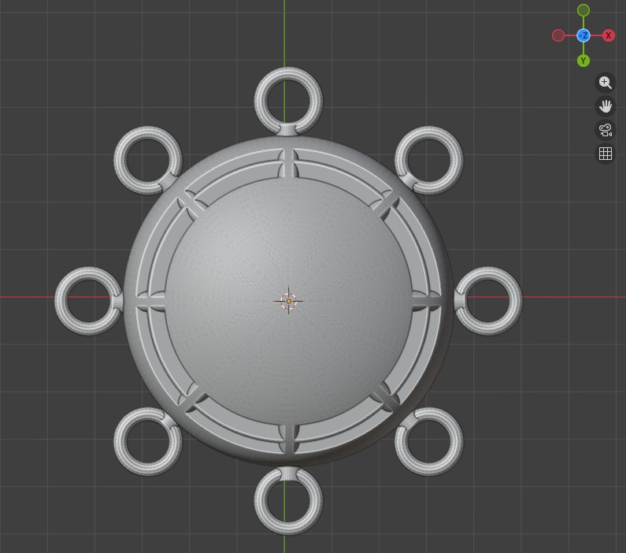
Fabrication study: model-based parts move from CAD to printed components.
A practical project invites people in. Build a curriculum that teaches the AirShip idea in one afternoon: model tour, modular wedges, solar skin, garden loop, mesh node, interior mockup, and contribution opportunities.
Phase 36 technical focus: the community workshop curriculum should be a builder pathway. Start with AirShip geometry and source history, then teach CAD basics, model naming, 3D printing, material coupons, solar tiles, simple circuits, mesh networking, interior mockups, rendering, documentation, and open-source contribution. Each class should produce a visible artifact for the shared library.
Organize workshops by skill level. Beginners label model features and assemble simple parts. Intermediate builders test brackets, document materials, and improve diagrams. Advanced contributors work on simulations, controls, radio hardware, energy systems, and structural analysis. The curriculum turns spectators into contributors by giving everyone a practical door into the project.

Integration tasks
• Create slides and handouts.
• Offer beginner tasks.
• Record sessions for remote builders.

Phase 37: Funding the Dream
Funding should match the ethos: transparent, milestone-based, community-owned where possible, and tied to visible prototypes. Supporters should see exactly what their contribution creates, from model refinement to room mockups to sensor benches.
Phase 37 technical focus: funding should be tied to milestones that produce durable assets. Fund a CAD cleanup, a model atlas, a perimeter duct prototype, a solar tile mockup, a full-scale window bay, a mesh-node bench test, a material coupon library, a documentary short, or a public blueprint release. Each milestone should leave behind files, photos, data, and a reusable lesson.
Create a funding board with budget, supplier list, owner, deliverable, publication date, and follow-up test. The OpenAirShips history includes an early crowdfunding attempt; the next version can make support tangible by showing exactly what a contribution builds. People support a dream more easily when the next artifact is specific, beautiful, and useful.

Curriculum tasks
• Publish milestone budgets.
• Show prototype photos.
• Offer contributor credits and open access.

Phase 38: Partnerships
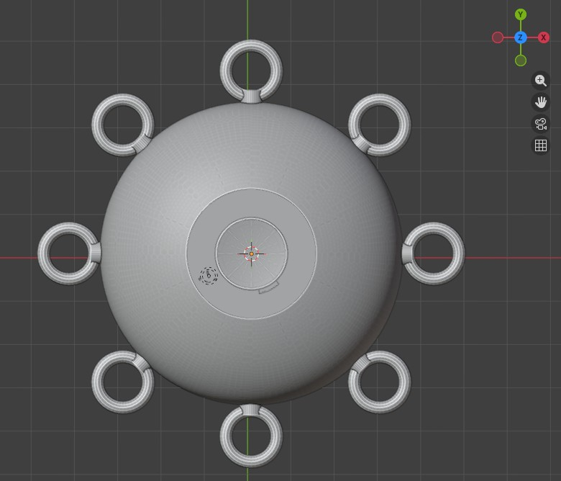
Fleet study: homes, workshops, gardens, relays, and classrooms share the same design family.
The AirShip needs friends: universities, makerspaces, aeronautical engineers, materials labs, solar designers, interior architects, permaculture teachers, open-source communities, and artists. Partnerships turn a single dream into a civilization-scale craft tradition.
Phase 38 technical focus: partnerships should map to missing capabilities. The public site lists specialist needs including aeronautical engineers, radio hardware engineers, materials scientists, electrical engineers, blockchain coders, Linux programmers, encryption experts, 3D printing experts, video production, and airspace consultants. Use that list as a practical recruiting map for labs, makerspaces, universities, suppliers, and independent builders.
Prepare partner packets rather than general pitches. A materials lab gets coupon requirements. A radio specialist gets mesh-node questions. A design school gets interior mockups and renders. A makerspace gets printable brackets. An electrical engineer gets the energy one-line. Clear packets respect expert time and turn outside interest into useful, credited contributions.

Funding tasks
• Create a partner map.
• Write invitation letters.
• Define shared deliverables.

Phase 39: Beautiful Interfaces
Residents should not need to understand every system to live well. The interface can show energy, water, air, garden, route, community messages, maintenance prompts, and learning opportunities in a warm, simple dashboard.
Phase 39 technical focus: interfaces make advanced systems livable. Residents should see calm dashboards for power, water, air quality, route, network status, maintenance reminders, cabin comfort, and community exchange. Technicians should see deeper diagnostic pages with sensor readings, logs, firmware versions, connector maps, and test routines. The same system can be graceful for residents and exact for builders.
Prototype interfaces with paper screens first, then clickable mockups, then live data from bench systems. Avoid visual clutter. Use clear states, large labels, plain language, and beautiful status views. The interface should feel like the instrument panel of a floating home, not a laboratory console, while still giving engineers the detail needed to keep improving every subsystem.

Partnership tasks
• Prototype a wall display.
• Use plain language.
• Add celebration signals for abundance.

Phase 40: Fleet Services
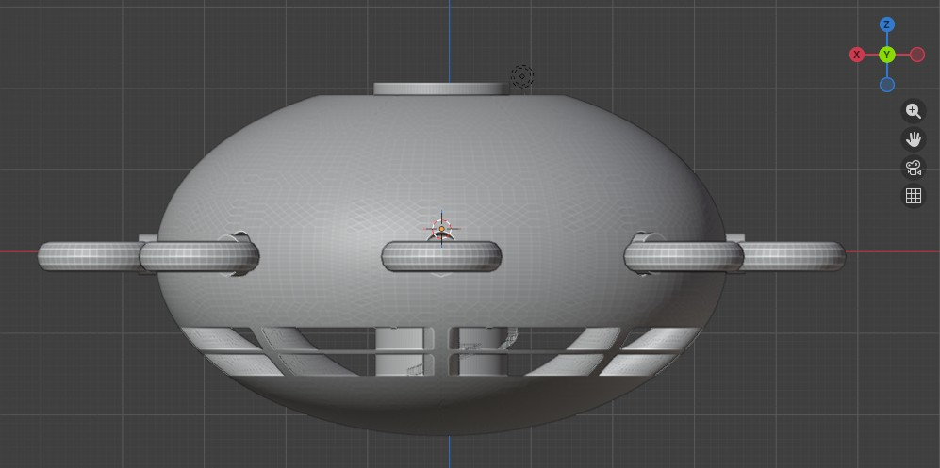
Research study: primary sources, public pages, and test data stay organized for future builders.
A society of AirShips can specialize. Some craft can be homes, some farms, some clinics, some classrooms, some fabrication shops, some guest houses, some theaters, some relay nodes, and some repair docks.
Phase 40 technical focus: fleet services turn individual homes into a network of capabilities. Define service roles: housing, guest hospitality, mobile workshop, garden module, print shop, water processing, energy support, communications relay, classroom, studio, clinic room, and cargo bay. The white paper's contribution list already contains many of these functions; the builder guide should assign spatial and technical requirements to each one.
Make fleet services modular. A workshop AirShip needs tool storage, benches, dust management, printers, parts library, and extra power. A garden AirShip needs trays, water, nutrients, lighting, harvesting, and seed storage. A relay AirShip needs antennas, routers, energy reserves, cooling, and diagnostics. Shared geometry lets different service craft feel like members of the same family.

Interface tasks
• Define service archetypes.
• Keep the common hull language.
• Create exchange protocols.

Phase 41: Docking and Hospitality
The perimeter rings suggest social architecture. They can become docking symbols, guest entry points, transfer ports, observation loops, or service nodes. Design them as places of welcome and graceful exchange.
Phase 41 technical focus: docking and hospitality are where engineering meets manners. Define how people arrive, where they step, what they hold, where luggage goes, how hosts greet guests, how service crews access panels, and how two craft exchange supplies. The white paper imagines traversal between AirShips through top and bottom access, so docking drawings should include vertical and horizontal arrival scenarios.
Build a hospitality storyboard. Show arrival lights, hatch opening, stair sequence, greeting area, shoe and bag storage, guest orientation, meal service, sleeping arrangements, and departure. Then make technical drawings for handholds, thresholds, lighting, signage, intercom, docking guides, and cargo handoff. A great AirShip makes arrival feel effortless because the choreography has been designed.

Fleet-service tasks
• Map guest arrival flows.
• Design signage.
• Create shared etiquette cards.

Phase 42: Stewardship Governance
A flourishing society is built through daily habits: open books, respectful meetings, shared learning, restorative conflict practices, resident councils, child-friendly participation, elder respect, and contribution paths for many abilities.
Phase 42 technical focus: stewardship governance keeps the project coherent as it grows. Define who maintains the master model, who approves releases, who reviews tests, who credits contributors, who archives old ideas, who publishes public updates, and who keeps the workshop safe, orderly, and welcoming. Governance should be visible in templates, calendars, labels, and release notes.
Create three recurring documents: the monthly release note, the open issues board, and the build journal digest. The release note shows what changed. The issue board shows what needs help. The digest tells the story of the work in plain language. Together they let the community scale without losing the practical beauty of the original craft.

Docking tasks
• Write a community charter.
• Create rotating steward roles.
• Celebrate useful work publicly.

Sources and Continuing Research
Core source documents used for this guide include the supplied OpenAirShips white paper, the supplied AirShip transcripts, and the four supplied model views. The public OpenAirShips.com page describes the goal as low-cost housing and transportation and the plan as small, modular, open-source, 3D-printable autonomous AirShips that scale using off-the-shelf components.
Recommended continuing research streams: OpenAirShips.com for project art, files, and community direction; the OpenAirShips GitHub for project repository material; public 3D model repositories for visual study; airship history archives for precedent; current lighter-than-air research for state-of-the-art design language; and professional aeronautical, materials, electrical, and habitat-design references for engineering development.
Keep source notes positive and useful. The goal of research is not to copy the past, but to gather enough wisdom to build a beautiful future with confidence and clarity.

Stewardship tasks
• Save source snapshots with dates.
• Credit every contributor.
• Update the blueprint package whenever a source improves the build.
Source foundation: supplied OpenAirShips white paper and video transcripts, supplied model screenshots and wireframes, and OpenAirShips.com for additional art ideas, blueprint context, and continuing technical research.

