Edit Video Tracking GUI (evt_gui)
User’s Manual

Outline
Introduction/Scope/Purpose
Document Version
Software Requirements
Analysis Requirements
Starting evt_gui
Loading a Dataset
XY traces
Active tracker path
X vs. t trace
Saving a Dataset
Browsing a Dataset
Selecting tracks
Switching units between pixels and microns
Plotting the radial vector
Attaching 3dfm magnet files to data
Editing Data
General Concepts
Active Plot
Removing a Track
Editing a track
Deleting points within an active track
Removing all points before or after a selected time
Removing Drift
Linear
Center-of-mass
Exporting data to the Matlab workspace
evt_gui Log messages
Helpful Hints
Troubleshooting
Conclusion
Changelog (for this Document)

Introduction/Scope/Purpose
The Edit Video Tracking GUI (evt_gui) is an user-interface constructed using Matlab that helps to quickly manage, browse, and edit video tracking data obtained from the CISMM Video Spot Tracker.

Document Version
1.0

Software Requirements
Matlab 6.5 or later.
CISMM 3dfmAnalysis Matlab toolkit (downloadable via CVS)
CISMM Video Spot Tracker version 4.03 or later
CISMM VRPNtoMatlab version 3.04 or later

Analysis Requirements
* - refers to the “root” filename for a given dataset.
Tracking file (*.vrpn.mat)- A tracking file (*.vrpn) is generated when log files are saved during a Video Spot Tracker session. Dragging and dropping a tracking file (*.vrpn) onto the VRPNtoMatlab icon will automatically generate a corresponding *.vrpn.mat file readable by Matlab and evt_gui in the same directory.
Intensity Projections (*.MIP.bmp)- Use mip or get_mips functions (located in 3dfmAnalysis toolkit) to generate intensity projections that will load automatically into evt_gui.

Starting evt_gui
At the Matlab prompt, type evt_gui↵ to bring up the evt_gui user interface…

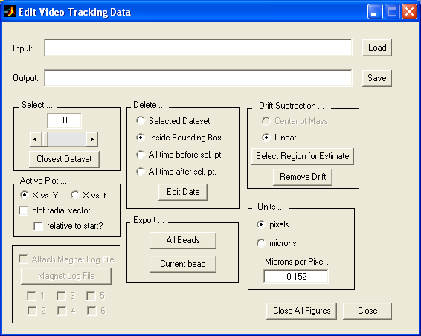

Loading a Dataset
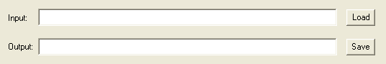

There are two ways to load a dataset into the user-interface.
- Typing a filename (including path) into the “Input” box and pressing “Load”.
- Pressing “Load” with an empty “Input” box will open an “Open File” dialog where you can navigate to the appropriate directory where a dataset can be selected.

After loading a dataset, two figures will appear on the screen...
- XY traces: The first figure contains a spatial representation of the data contained in the *.vrpn.mat file. If a MIP file is found in the same directory as the data, it will also load and display behind the spot_tracker data. Intensity projection images aid in determining the validity of video tracking information. The active tracker path is red, while inactive trackers are blue. | 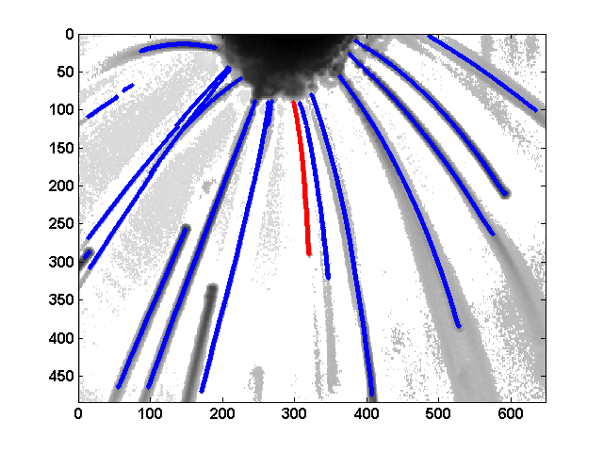
- XT trace: The second figure depicts a temporal representation of the data contained in the active tracker (displayed in red in the first figure). | 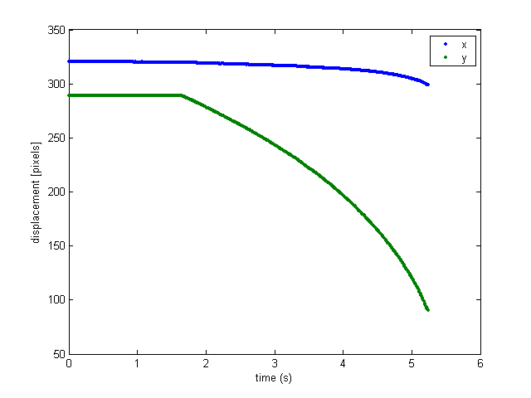

Saving a Dataset
When a dataset is loaded into evt_gui, a default filename is inserted into the “Output” box. This filename has the same root name as the input filename (*.vrpn.mat), but has been adjusted with an additional extension (*.vrpn.evt.mat) to convey that the data has been processed using evt_gui. Pressing the “Save” button will save the data as an “evt.mat“ file. This file contains not only the edited data, but has permanently inserted the correct timestamps as well The VRPN timestamps initially recorded in the vrpn file are recording the time the log entry was saved in the vrpn file. These are incorrect, and are replaced by evt_gui with the correct timestamps from the *.tstamp.txt file. If no *.tstamp.txt file is found, a frame rate of 120 frames/sec is assumed. If it is desirable to change this output filename, then change the text located inside the “Output” box before pressing the “Save” button.

Browsing a Dataset
- Selecting tracks: There are three ways to navigate through multiple trackers in a video_spot_tracker logfile.  - Select… textbox: To directly choose a specific tracker, type a number into the textbox and press enter.  - Select… slider: Use the slider to navigate from tracker to tracker. Note: Changing the active track from one track to another resets the zoom and position limits on the plotted figures.  - “Closest dataset”: Pressing this button activates the spatial plot, and waits for a single mouse click within the viewing area of that plot. Clicking on or near a tracked path will cause the closest path to become the active tracker. | 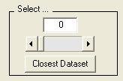
- Switching units between pixels and microns: To transform the units on the plot axes from pixels to microns and vice versa, click on the radio button containing the desired unit. This requires a calibration factor that defines the microns per pixel value. Enter this value into the textbox labeled “Microns per Pixel…” to adjust this parameter as desired. | 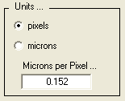
- Plotting the radial vector: Activating the “plot radial vector” checkbox will generate a third plot, where the radial displacement of a tracker in time will be shown. The radial displacement is useful when net displacements along a vector direction is desired. This plot is not used for any of the editing functions (this may be implemented later, but isn’t a priority). | 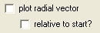
- Attaching 3DFM magnet files to tracking data: not yet fully implemented. | 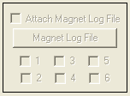

Editing Data

General Concepts
- Usually, editing data in evt_gui means strategically deleting points where the spot_tracker has obviously lost its way or where there is a user error in tracking (where the user mistakenly adds a new tracker or errantly moves an existing tracker, etc…)
- For most of these methods, one or two mouse-clicks are required in the active plot.

Active Plot  The “active plot” radio buttons define the plot where selecting datasets/points is desired. The points selected are assumed to be errant points based on either the XY position, or X/Y positions in time, t. | 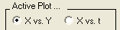
Removing a track  To remove an entire tracker from the dataset, select that tracker (making it active) and click on “Selected Dataset”, located within the “Delete…” box. Press the “Edit Data” button and that tracker will be removed. The ID numbers for all trackers with ID numbers greater than the deleted tracker will be shifted down by one. | 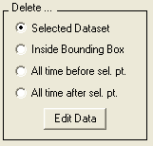

Editing a track  - Deleting points within a track. This method is most useful in removing errant points (where a tracker lost tracking and was later “fixed”) within a single track. Use Matlab tools (located in figure’s toolbar) to zoom to an appropriate scale if desired. Select the active plot based on which representation of the data you wish to edit. Inside the “Delete…” box select “Inside Bounding Box” and click on “Edit Data”. Position the crosshairs onto a corner of the region you wish to remove from the data. Click once. Now, position the crosshairs onto the opposite corner, thus defining a “box” where the data should be deleted. Click once more. The data within this region will be removed from the dataset. | 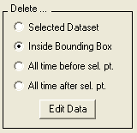
- Removing all points before or after a selected time. Note: This editing tool only works on the XY vs. time figure, as it is the only figure where time is explicitly displayed. As a result, evt_gui automatically chooses the XY vs. time figure as the active plot. Use Matlab tools (located in figure’s toolbar) to zoom to an appropriate scale if desired. Choose the appropriate “Delete…” tool based on the data you wish to remove. Click the “Edit Data” button and position the crosshairs to the appropriate time in the dataset and click once. All data before or after this time (depending on which option you chose) will be removed from all trackers in the entire dataset. | 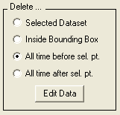
- Removing drift. If the entire duration of the dataset is appropriate for drift estimation, then simply press the “Remove Drift” button after selecting the desired drift removal algorithm. Otherwise, press the “Select Region for Estimate” button. The active plot will be set automatically to the XY vs. time figure. Click on opposing corners of a bounding box that defines the time duration of the dataset set aside for drift estimation (see Editing a Track for more detailed instructions on creating a bounding box). Click the “Remove Drift” button to remove the drift from all trackers in the dataset that exist during the drift duration.  - Linear. The linear method for drift estimation and removal fits the selected region in time for each tracker to a line and subtracts this line (velocity) for the entire duration of data taken for that tracker. If a particular tracker does not exist during the period of time set aside for drift estimation, no drift will be removed from that tracker. The drift velocities computed for each tracker will be reported in the log messages that display in the Matlab window. Additionally, if no data existed during the selected period of time for a particular tracker, that will be noted in the log messages as well.  - Center-of-mass. Not yet fully implemented. | 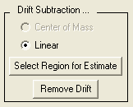

Exporting Data to the Matlab Workspace
It may sometimes be convenient to run additional analytical software on a specific tracker’s data. A simple way to do this quickly involves exporting a tracker’s data to the Matlab base workspace. Note: ‘beads’ are analogous to ‘trackers’.
- Pressing the “Current bead” button located within the “Export…” frame will create a variable in the Matlab base workspace with the name bead#, where # is the tracker ID number. This variable is a structure that contains three members: t, x, and, y, each easily accessed using the dot operator in Matlab.  - Pressing the “All beads” button will create a “beads” variable in the base workspace. This variable is an array of structures where each structure contains three members: t, x, and y, each easily accessed using the dot operator. | 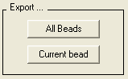

evt_gui Log Messages
Log messages are printed out to Matlab’s main window for most events that occur when working with a tracking dataset. The date and time are printed alongside the corresponding message. Sometimes, as in the case of drift removal, additional information is provided (such as average drift velocity for each tracker). Also, these messages are useful in determining what actions evt_gui has taken in response to a user’s request. At a later date messages may be saved as a means to trace what actions the user has taken when editing a spot_tracker file.

Helpful Hints
- Remember that the active tracker’s path is red while inactive trackers are blue. When deleting path points, ONLY ACTIVE TRACKER POINTS ARE DELETED. This is convenient in the case that the paths of two trackers cross one another.
- Choose your filenames wisely. Evt_gui prefers that the root filename for *.vrpn and *.vrpn.mat files be the same. This ensures that the timestamps will be loaded correctly. Also, when creating MIPs with the get_mips Matlab function, the filename automatically generated by get_mips is the filename that evt_gui looks for.
- Most objects on the evt_gui interface have tooltips (small yellowish text boxes that popup when you pause over an object). These tips provide information for what information you should enter, or perhaps the sequence in which to perform tasks.
- You can use the tools offered by default in Matlab on figures built by evt_gui. This is convenient when you want to zoom in on a section of a dataset and view or even edit it. Remember that when you select different trackers, the viewpoint is reset to its default value.

Troubleshooting
Evt_gui will not load, or several error messages appear in the Matlab window when trying to load evt_gui.

There are generally two reasons why this might happen.
- The path to the Matlab code for evt_gui or its dependencies is not set. To fix this, click on the “File” menu in the Matlab window and select “Set Path…”. “Add with subfolders” the 3dfmAnalysis folder wherever it may be located. Try running evt_gui again.
- The code for evt_gui may have been updated since your last CVS update. Update the code using TortoiseCVS or whatever tool is your preference, update the path in Matlab as described above, and try running evt_gui again.

After deleting a tracker or sections of a tracker’s path, the data I deleted doesn’t appear to be deleted. What’s wrong?

As far as I can tell, this happens due to a bug in Matlab. For some unknown reason, the figure does not update correctly immediately after the data has been removed. To get around this, change the active tracker value by clicking on the active tracker slider, and then return to the tracker you were working on. It sucks, but until a fix is found, this is what must be done.

I didn’t get an intensity projection when I loaded a dataset even though there’s one in the same directory as the data. What’s wrong?

Chances are, the filename for the MIP file is not what evt_gui is looking for. See the helpful hints section for more information.

Changelog (for this document)
2005-11-29 Jeremy Cribb <jcribb@email.unc.edu>
* Initial Version (1.0)

