Name: Daily Planner
Group members: Claire Stead, Arnau Cribillers Moncunill, Alex Escofet

APP REQUIREMENTS
- Store tasks with the add button. Tasks should contain: Title, description, level of importance, complete by date
- Color code for level of importance (ordered by importance): RED, YELLOW, BLUE -> Colorblind friendly:
  - Red (#ffcece) extremely urgent
  - Yellow (#ffebaf) medium urgency
  - Blue (#d4e6ff) low urgency
- Show daily tasks and weekly tasks, both lists should have the ability to be reordered. Background color of the task must be the color provided by the level of importance
  - Today tasks should display the title and description of the task
  - Weekly Tasks should display the Title, description, level of importance, complete by date
- Every task will have a box/button to mark the task as complete, add nice effects. The task can be unmarked and must be shown as it was before.
- The app must have some type of animation

DESIGN EXAMPLE
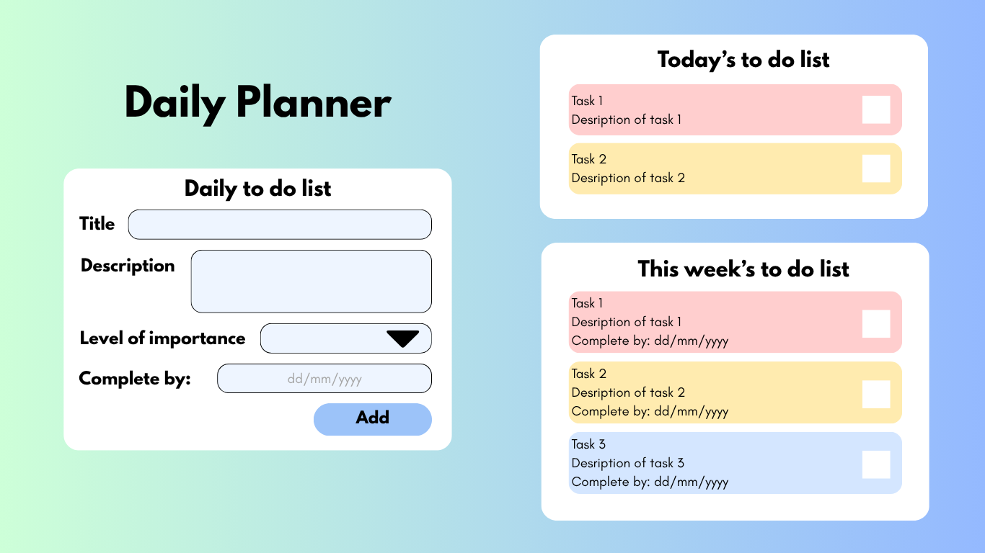

BONUS TASK
Try to create a more interactive app adding the calendar in https://vanilla-calendar.pro/
- When a day is picked, it should display all the tasks for that date.
- Follow the same requirements to display the tasks

DESIGN EXAMPLE
