Before you run this project, you need to do these steps first

1. you need to find the file 'additions' in the 'plugin' file, copy and paste all the file into ..\classENV\Build9\bin\debug\

2. find the 'irrKlang-1.5.0' file under the 'plugin' file, copy and paste those file into ..\classENV\

3. go to ..\classENV\envVar\ file find SetEnvironment9.bat, right click it and then add those line to it and then run it. 'setx IRRKLANG C:\Users\cricel\Desktop\classENV\irrKlang-1.5.0' (change to your own directory)



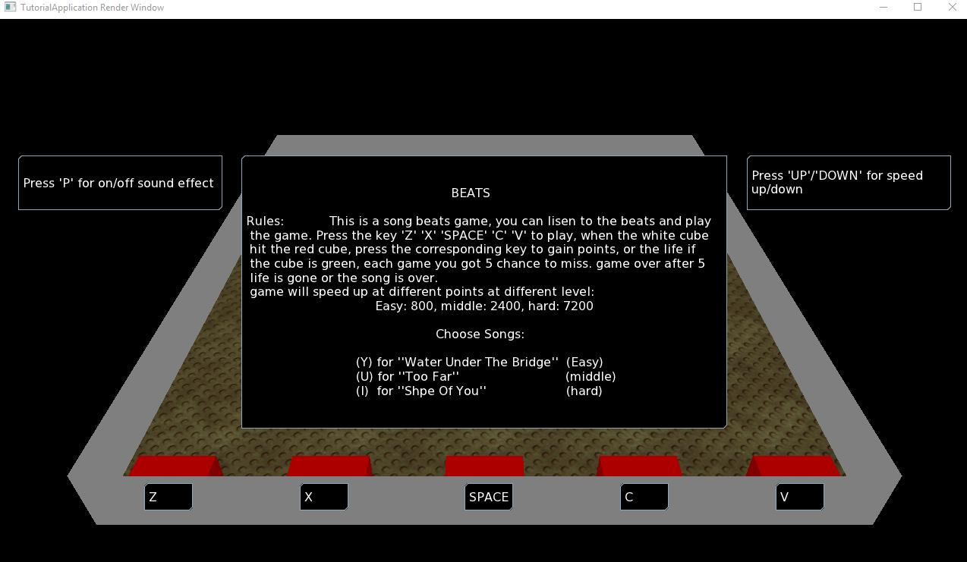

This is what I have for the final project, I was inspire by the mobile game “beat mp3 for YouTube” and want to build a Ogre version of this game, this is what it looks like, in the start page, you can see that the menu of this game and the introduction of how to play it.

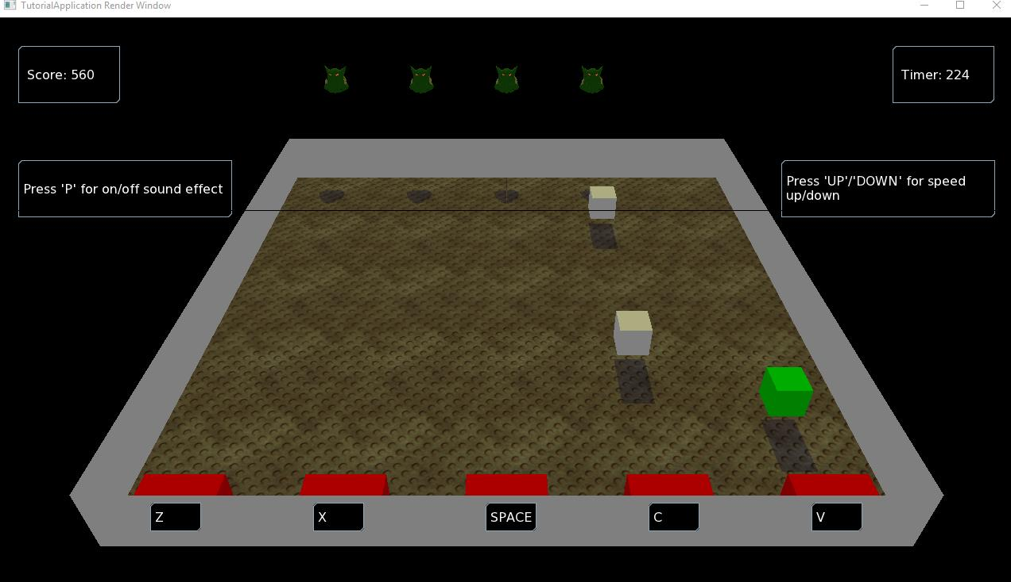

Its quit simply, all you need to do is press the right key when the white cube hit the red block, and the ogre head above is shows that how many key you can still miss that wont lose this game, you got 5 initial life. And the green cube can gain you one more life but without the points. And the top left is the score bar to keep in track how many point you get and the points calculate is different in different level game. The the top right place is where you can keep track of how many time is left, and when the time hits 0, the game will over. Also you can turn on/off by press the ‘P’ and press ‘up’ or ‘down’ to change the speed of this game.

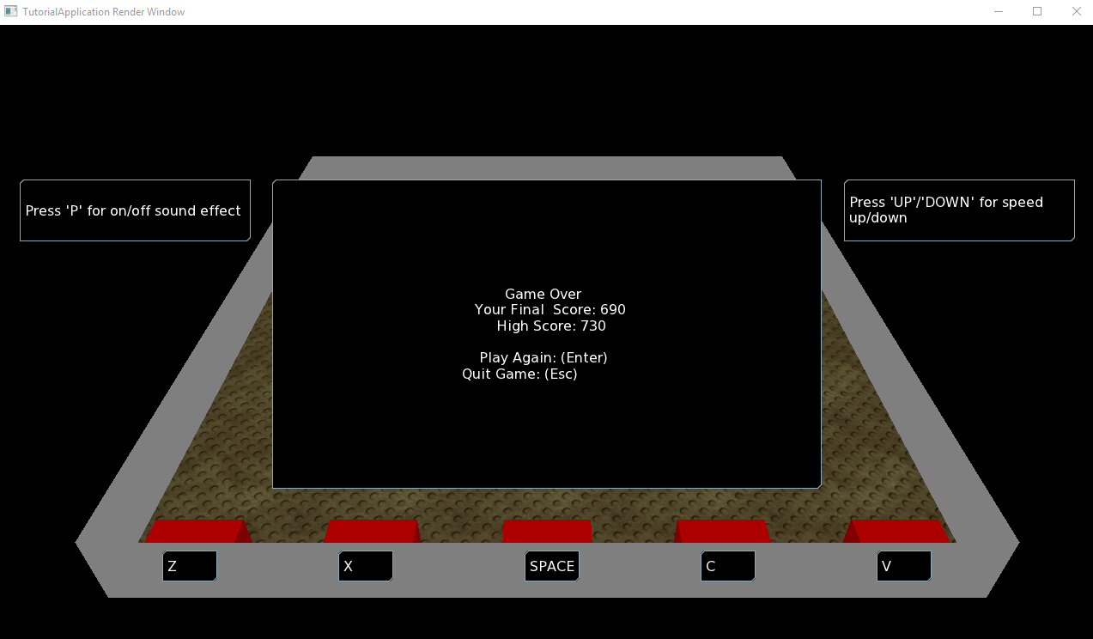

This is the page where the game is over, it will shows how many points you get so far and what is the highest score so far. you can press the return key to restart a game,