Kent State University, Department of Computer Science

Scientific Visualization: Prof. Ye Zhao

Project 1: DUE Sep 19 (Thursday) 2019 at 5pm
Starting from the application framework provided, implement some image operations for 2D drawing and image rendering. This will make you familiar with the 2D image processing and visualization, openGL and the fltk-based GUI we will use for more visualization projects in the future.
Assignments:
- On the main menu bar, add a menu item with title ‘Image Processing’ and create pull-down submenus with titles ‘Update’, ‘Average Smooth’, ‘Median Smooth’, ‘Gaussian Smooth’, ‘Edge Detect’, and ‘Undo’. Do this by using ‘fluid’, the FLTK GUI editor. Start with the file Gui.fl, and add the menu/submenu items and their callbacks as it was already done for ‘File’, ‘Read’, and ‘Write’. Writing out the code with ‘fluid’ will generate new versions of Gui.cpp and Gui.h. Add your new callback routines to the existing ‘Application’ class in ‘Application.h’ and ‘Application.cpp’.
We use .ppm (or .pgm) image format as described below. You can understand this by reading code in functions ReadFile() and WriteFile(). You may use irfanview (http://www.irfanview.com/) to transfer images in other formats to ppm images.
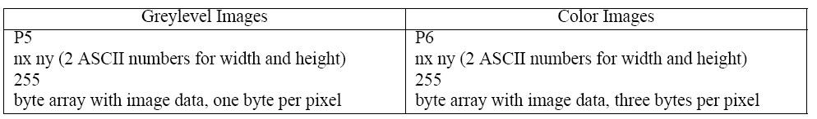
Please start from grey scale images for the following assignments. A color image can be transformed to a grey scale image. (You may use the average of 3 channels of a color image to represent the grey scale intensity.)
- Histogram: Compute the histogram of an image when you read it. Draw the histogram into the Editor window using OpenGL at the same time the image is drawn in the Display window.
Implement the following functions in the callback functions you created for the submenus:
- Update: Use the Editor window to edit the intensities of the loaded image. Note the transfer function of intensities should be drawn in this window together with the histogram. An array transFunc with 4 members, each an array of 256 integers, has already been defined. For this assignment you will only use transFunc[0], but we’ll need the other 3 members later. The values stored in the transFunc array can be used to translate the pixel values of the input image into the transformed new values: newPixelValue = transFunc[0][oldPixelValue]; Selecting the ‘Update’ menu item should transform the image and draw it into the displayWindow. It should also update the histogram in the transFuncEditor. For both, call the drawing methods of these windows.
- Average Smoothing: use 2D 3*3 averaging filter to create a new image from the original image.
- Median Smoothing: use 2D 3*3 median filter to create a new image from the original image.
- Gaussian Smoothing: use 2D 5*5 Gaussian filter to create a new image from the original image.
- Edge Detection: use 2D 3*3 Sobel kernel to create a new image from the original image for edge detection.
- Undo: You should always keep the previous version of the image when you perform an operation. Then you can fall back onto the previous image if the image processing operation was not satisfactory. Implement the ‘Undo’ operation such that the previous image is swapped back into the current image and is displayed. So you need two entities of type Image: curImage and oldImage to perform swapping operations upon ‘Undo’
Credits:

You will get bonus credit for the project if you can implement all the above assignments for color images, although only grey scale image is required.

Submission
We will use the Blackboard system for project submission.
Please submit your source codes in a zip file (NO exe files should be included in your submission package) and follow the submission deadline.

Warning
This homework is intended as an individual project. You are not permitted to work jointly on it with others

