*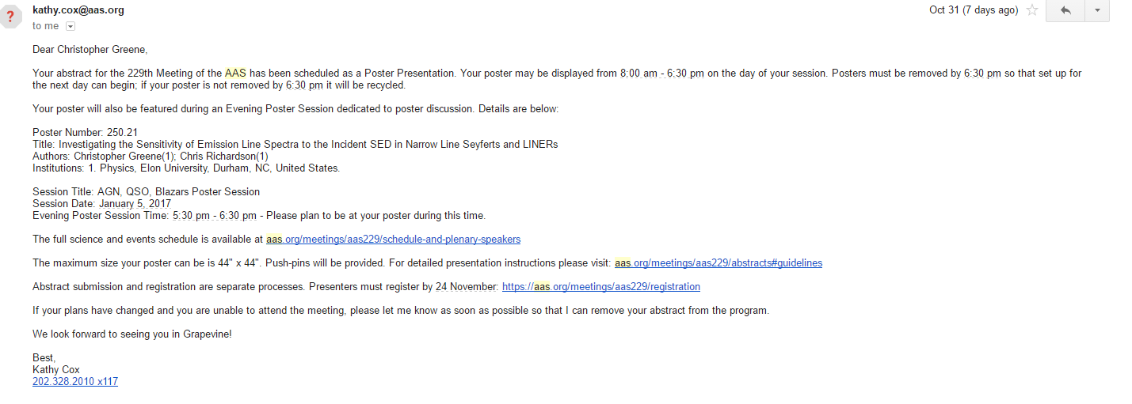*

*Investigating the Emission Spectra of Narrow Line Seyferts and Low-Ionization Nuclear Emission Region Galaxies through CLOUDY Simulations*

This research investigates photoionization models of the Narrow Line Region (NLR) of Seyfert galaxies and Low-Ionization Nuclear Emitting Region (LINER) galaxies with the use of the astrophysical code CLOUDY. Groves et al. 2004 attempted to resolve the apparent uniformity of emission line ratios in the NLR through introducing dusty, radiation pressure-dominated photoionization models of AGN. This model assumed a simple power law relation for the Spectral Energy Distribution (SED). Grupe et al. 2010 found a correlation between αuv and αx, and by constraining αuv as a function of αx we developed a photoionization model for the ionizing spectrum of a typical Seyfert Narrow Line Region. The incident SED is based upon the spectral indices αuv, αx, αox , and the blackbody accretion disk temperature Tbb . We set the value of αox based on the average of data collected in Grupe et al. 2010, and fix the value of αuv to αx based on their linear correlation. To check the validity of our model, simulations were run across a range of blackbody accretion disk temperatures and αx, while fixing the hydrogen density, ionization parameter, and elemental abundance of clouds in the NLR. The emission lines produced by these simulations were plotted using standard diagnostic diagrams and compared to emission line data obtained from the Sloan Digital Sky Survey. Our model produces emission lines without significant variation between simulations with αx = 1.42, 1.17, and 2.19, with Tbb ranging from 10­­4 K to 107 K, except with regard to [O I] λ6300/Hα, where our simulated spectra started to fall on the boundary between Seyferts and LINERs. This leads us to examine the ability of our photoionization model to create emission line spectra that are typical of LINERs, as debate still continues over the primary excitation mechanism for LINERs. To adjust our model to fit LINERs, we lower the value of the ionization parameter and discuss the preliminary results within the context of literature involving the nature of LINERs.