**Modeling Oscillations Techniques**

Authors:

Erin Murnane [emurnane@elon.edu](mailto:emurnane@elon.edu)

Christopher Greene [cgreene11@elon.edu](mailto:cgreene11@elon.edu)

Michael Imbimbo [mimbimbo@elon.edu](mailto:mimbimbo@elon.edu)

Physics 401A– Classical Mechanics – Fall 2016

This lab is a simple model of rectilinear motion of an object under a Newtonian system. Specifically, this experiment shows how to best approximate Newton’s second law of motion to a common, velocity dependent motion. Two perfect spheres of different sizes will be compared. Each will be thrown straight up and down in a rectilinear manner to a constant height of one meter. We will take the actual velocity over time plots collected by *Logger Pro* and numerically simulate each of the motion. We found that more than the force of gravity was acting on the system in both cases. Another force of drag was added to both systems to better our models. We discovered that the weight of the forces acting on an object in this particular rectilinear motion depends on the properties of the object and the type and direction of forces acting on it.

*Introduction:*

Two sphere like objects will be compared. A beach ball and a styrofoam ball with different dimensions (Table 1) will be thrown a vertical distance of one meter. The initial position and maximum height will be personally gauged by the participant. All measurements will be kept in International System of Units (SI).

|  |  |  |
| --- | --- | --- |
|  | Weight (grams) | Diameter (m) |
| Beach Ball | 0.0101 | 0.10 |
| Styrofoam Ball | 0.1056 | 0.45 |

*Table 1: Object Properties*

Preliminary Thoughts:

In an ideal case both the starting position and maximum height of both objects should be identical. Each object should travel a vertical distance of one meter. However, human error will make this difficult. Although the setting of the experiment will be the same, the force the participant exerts on each of the balls will be different to compensate for the different sizes. For instance, more force will be needed on the heavier beach ball to reach the correct height than the less heavy styrofoam ball.

To avoid human error, we will start collecting data immediately after the balls have left the participates hands so eliminate the differing driving force from the hand. Note that initial velocities will be different for each case.

*Experimental*

We used camera that captures at a frame rate of 120 frames per second. Logger Pro was used for its video analysis capabilities. Figure 1 shows how *Logger Pro* must define its reference frame according to the meter stick, and the user must manually plot points just after the ball leaves the participant's hand and just before he catches it. *Logger Pro* then records the time (seconds) versus the dependent variable, Y, in meters (Figure 2). The velocity is automatically calculating using built in numeric differentiation methods of seven points to get an average velocity for each point. 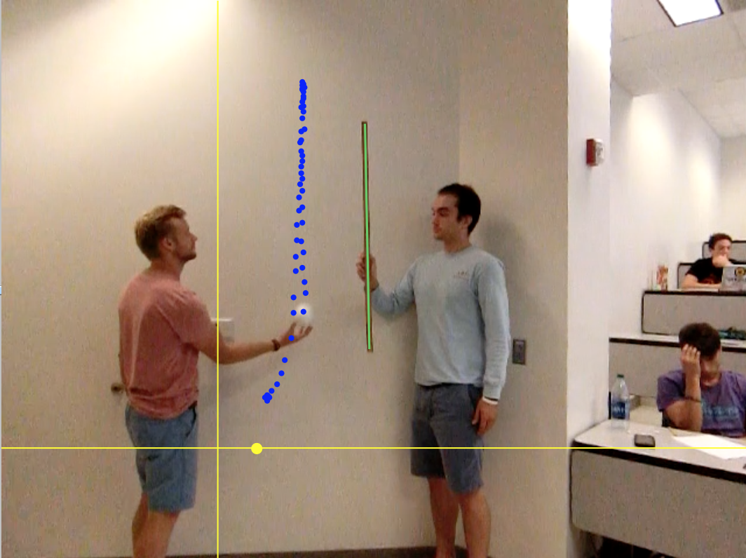

Once the list of time versus velocity points are collected, the data is saved in a comma separated variable (csv) file. *Mathematica* imports this file as an array and used in a coding file that approximates the rectilinear motion of the ball that expands on Newton’s second law.

*Figure 1: Video analysis window of Logger Pro*

*Figure 2: Logger Pro window to display how coordinates are captured and displayed from experimental video* 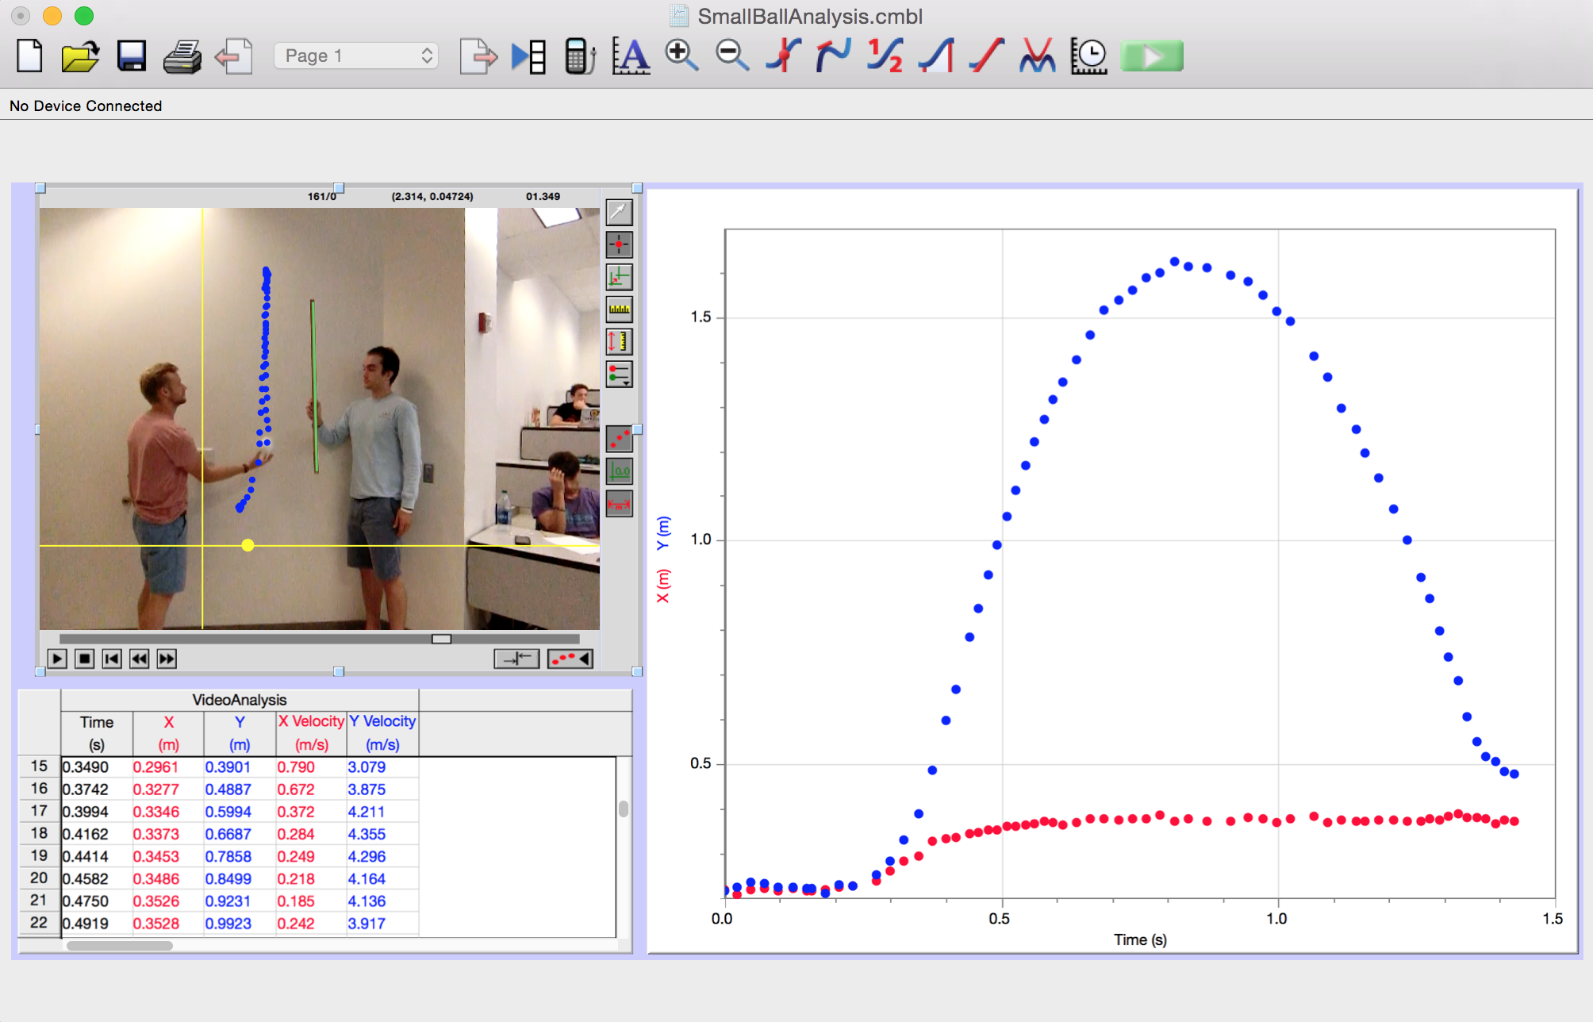

*Results and Discussions*

Newton’s second Law of Motion states, “The change of motion is proportional to the motive force impressed and is made in the direction of the line in which that force is impressed”. That is, if there is a change in motion present, otherwise known as acceleration, **a**, on a mass, **m**, a force of sum of forces must be present. This can be rewritten as the familiar equation for acceleration:

**a = ΣF / m (1.1)**

The Mathematical program we developed takes initial conditions of ball’s mass, starting position in meters, starting velocity in meters per second, starting time when ball has left the hand, and ending time just before ball reaches the hand again. The system loops through starting with the initial time, updating the change of motion from 1.1, which in turn updates the ball’s approximated velocity then position. The system evaluates every 0.01 seconds and stops when it reaches the ending time defined in the initial conditions.

Our free bottom diagram of the two cases had just one force acting on the two balls. We simply had the force of gravity and neglected all other forces. Below are our initial plots of the two balls. Figure 3 shows the styrofoam ball over a height (meters) versus time (seconds). The actual trajectory path from *Logger Pro’s* video analysis is in red, and our program’s approximated trajectory path is in blue. Figure 4 depicts the beach ball’s height (meters) versus time (seconds). Note that the purple trajectory path is from the Logger Pro’s video analysis and our programs approximated path is in blue again.

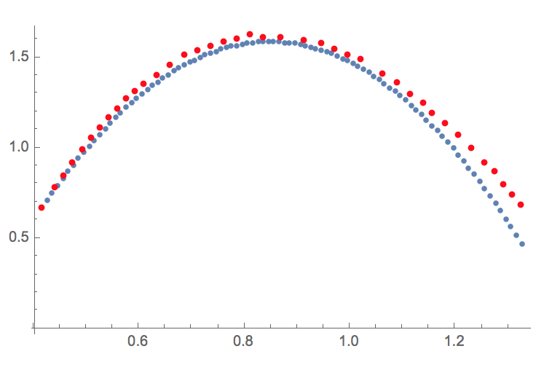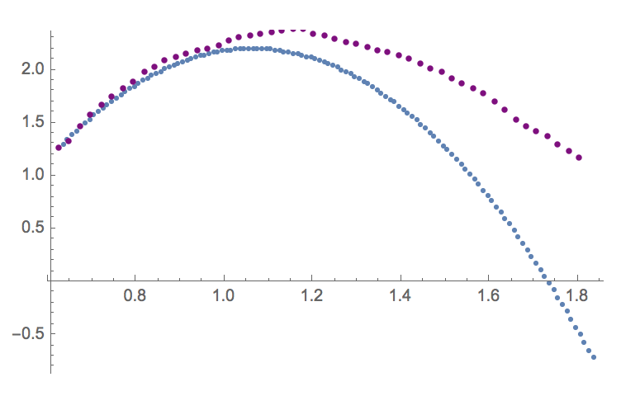

*Figure 3: Styrofoam balls’ approximated plot using force due to gravity Figure 4: Beach balls’ approximated plot using force due to gravity*

In both graphs, we see that our approximated values are fairly accurate to the actual trajectory path up until 1 second. After the one second mark we see that our approximated bath underestimates the actual data by a fairly significant amount. The beach ball approximate is much worse than the styrofoam ball.

Since it is fairly obvious we could better our model, it is safe to assume that their are other forces to be added in the model that we did not initially account for. Our group decided to explore drag forces on each of the balls. We explored the following two equations for drag from two different sources:

**Drag Force One and Two**

From Analytical Mechanics, …“for or spheres in air, approximate values for the constant sin the equation for *F(v)* are, in SI units, …” 1

**c1 = 1.55 x 10-4 * D (1.2)**

**c2 = 0.22 * D2 (1.3)**

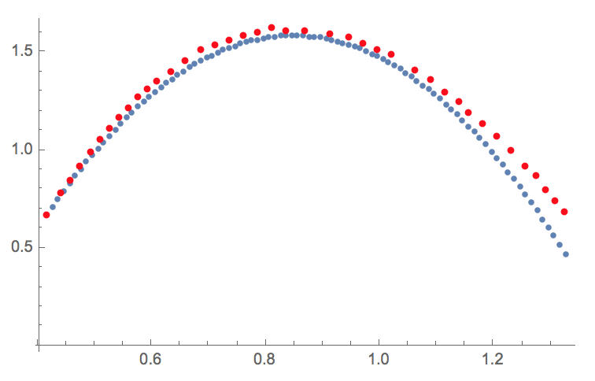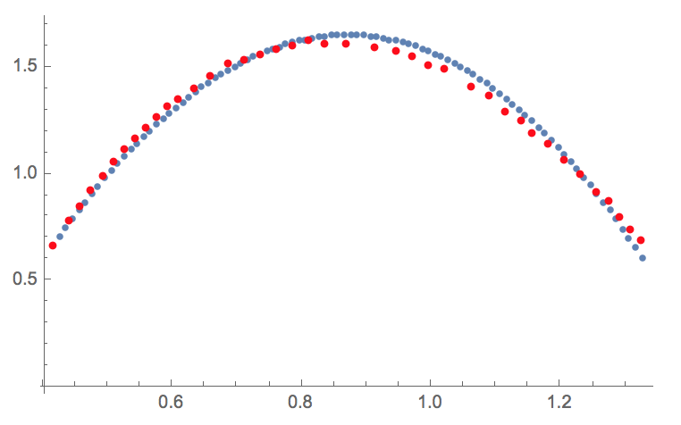*Figure 5: Styrofoam ball approximation accounting for drag force equation (1.2) Figure 6: Styrofoam ball plot using drag force equation (1.3)*

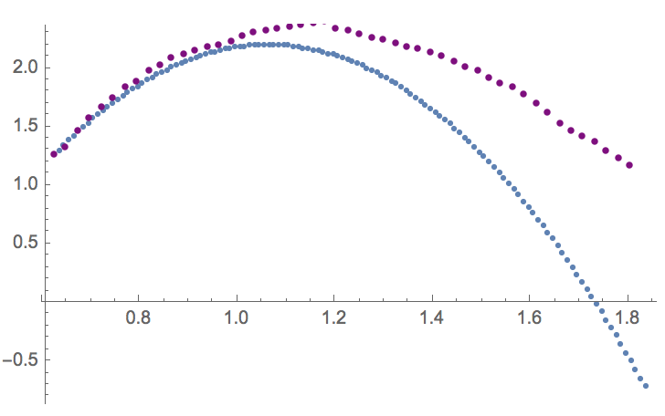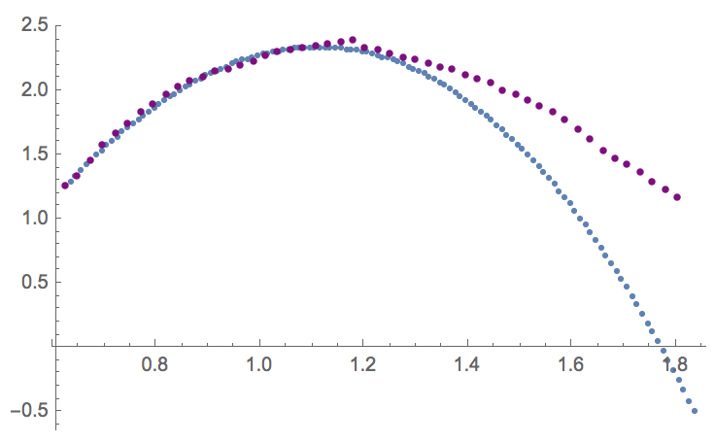

*Figure 7: Beach ball approximation accounting for drag force equation (1.2) Figure 8: Beach ball plot using drag force equation (1.3)*

**Drag Force Three**

Stokes Drag, the equation for viscous resistance, 2

**Fd = *-b*V where, (1.4)**

***b = 6𝝅ɳr***

***ɳ =* fluid viscous**

***r =* object radius**

***V =* object velocity**

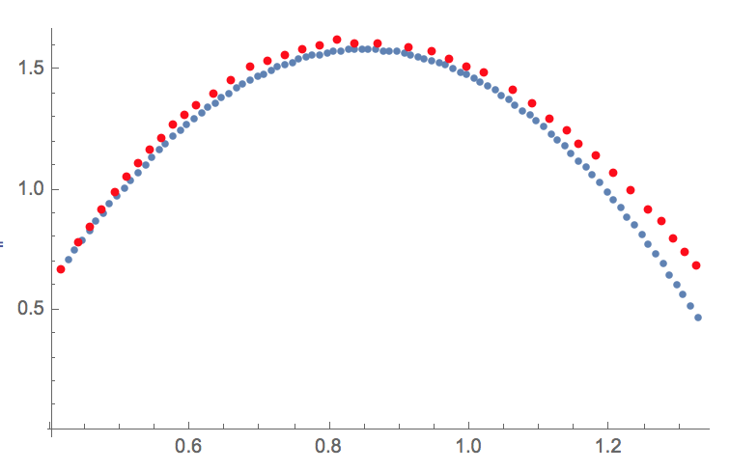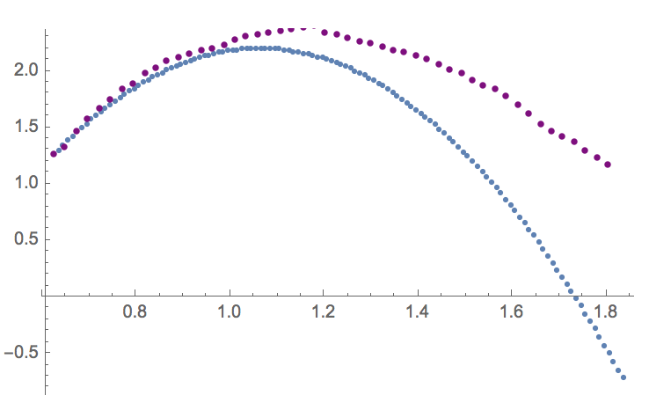

*Figure 9: Styrofoam ball approximation accounting for drag force equation (1.4) Figure 10: Beach ball plot using drag force equation (1.4)*

**Drag Force Four**

Quadratic Drag Equation,3

**where, (1.5)**

***ρ= 1.26 kg / m2* (mass density of air)**

***V =* (object velocity)**

***Cd = 0.5* (drag coefficient of a sphere)**

***A =* Cross-Sectional Area of the object**

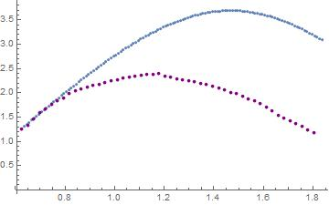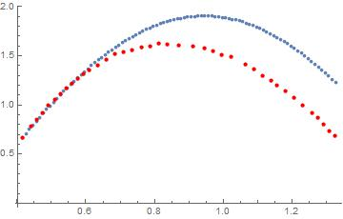

*Figure 11: Beach ball approximation accounting for drag equation (1.5) Figure 12: Beach ball plot using drag force equation (1.5)*

*Discussion*

**Force due to Gravity without drag:**

The styrofoam ball data seems considerably accurate when compared to the simulation. When comparing the beachball data to the simulation, we see accuracy diminish immensely. Although our simulations seem in favor of only one model and not both, drag must be taken into account.

**Force due to Gravity with Drag Force One:**

F(g) + F(v) = m dv/dt

F(g) is our constant force which does not depend on the velocity of the body. When dealing with spheres, approximate values for constants were found so that c1 = 0.000155 * D and c2 = 0.22 * D^2, where D is the diameter of the sphere.

Force of Drag One:

-mg - c1*v = m dv/dt ,

We then found acceleration by dividing Drag Force One by the inertia of the ball. Because air is a resisting fluid, we must take into account how the ball is deccelerated upon its ascension and descension due to the force of this resisting fluid.

c1 = 1.55*10-4 * D

When taking into account drag dealing with c1, it seems as if the amount of drag computed does not let either ball achieve its maximum ascension. The styrofoam ball simulation and data seem to be very accurate to one another, yet the beach ball data and simulation prove to be quite different. Due to the force of drag dealing with c1 only complimenting the styrofoam ball and not the beach ball, this drag force proves to be ineffective for varying cases

**Force due to Gravity with Drag Force Three:**

c3 = -6π D/2 * viscosity of air * velocity

Viscosity of air = 1.983*10-5

Force of Drag Three:

-mg - c3*v = m dv/dt

Drag Force Three depends on a different constant that now takes into account the viscosity of the air. Once again, the data and simulation from the styrofoam ball seem accurate to one another, but the beach ball data and simulation evidently differentiate. When taking account the viscosity of the air, the simulation of both balls prove to never reach their peak. This is most likely due to the value for air resistance that c3 takes into account. Both balls prove to decelerate upon their ascension and accelerate upon their descension too quickly. Once again, the styrofoam ball data and simulation seem to fit rather well, but the beach ball data and simulation differ far too drastically. Because this drag force only proves to be somewhat accurate for one model and not the other, this drag force proves to be ineffective for varying cases.

**Force due to Gravity with Drag Force Two:**

Drag Force Two deals with a different constant in which does not deal with the viscosity of air.

c2 = 0.22 * D2

Force of Drag Two:

-mg - c2*v = m dv/dt

Out of the three models for each balls, the simulations dealing this new constant provide the most accurate models for both the styrofoam and the beach ball. In both scenarios, from when the ball ascends to it's peak, the data and model match up satisfyingly well. Unlike the other two models dealing with c1 and c3, this new model allows both balls to reach the peak that was confirmed in the data found using Logger Pro. When taking into account only the styrofoam ball, the data points taken after the ball begins to descend seem to not be as neat as the data points taken during its ascension to its peak. I presume that if the data points taken after the ball reached it's peak were to be recorded without the clutter of our other data points, the data and model would match up precisely. In contrast, once the beach ball reached it's peak and began to fall downward, the data and model seemed to stray from one another.

*Conclusions*

It is very likely that some drag forces we used in our modeling were not the drag forces that matched the real-life situation. Further research into drag force four shows that it is utilized when dealing with objects moving at high velocities, which would account for the large overestimation of the data for that drag force. Another element of consideration is the magnitude of the drag force when we consider the situation we are trying to simulate. At the velocities and heights that we are trying to model, the force of drag is fairly small compared to the force of gravity, meaning that it is possible that some of our graphs don’t predict the data as accurately because the drag force is so small. This is especially true for the styrofoam ball. We also tested what happens when you change the sign of the drag force, and were unsure if the equations for drag force were dependent on direction.

*References*

1 Fowles; Cassiday; *Analytical Mechanics,* 7th Edition; Thomson Brooks/Cole; Belmont CA; 2005.

2 "Drag (physics)." *Wikipedia*. Wikimedia Foundation, n.d. Web. 04 Sept. 2016.

3 Hall, Nancy. "The Drag Equation." *NASA Glenn Research Center*. NASA, 05 May 2015. Web. 04 Sept. 2016.