1. The diagram shown below right depicts a region of space. The dashed curves indicate positions of equal potential energy for a test charge +q_{test} that is placed at various locations within this region. Three such locations (A, B, and C) are labeled.

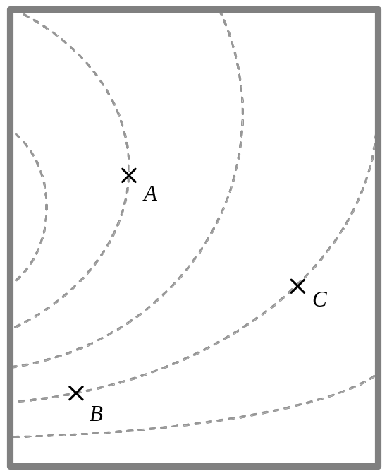It is known that the potential energy at location A is greater than that at locations B and C.

A. At each location, draw an arrow to indicate the direction in which the test charge +q_{test} would move when released from rest at that location. Explain your reasoning.

B. Rank the locations A, B, and C according to the magnitude of the force that would be exerted on the test charge +q_{test} at those locations, from greatest to smallest. Explain your reasoning.

C. If a particle were to follow a path that included locations A and C, at which location would it have greater speed? Explain.

2. Each of the four diagrams on this page represents a force field 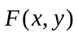 in the x-y plane

For each case, is it possible to draw a self-consistent set of equipotential contours for that situation?
If so: Draw a representative set of equipotential contours for that situation. Each drawing should clearly show (1) the correct shape of the contour lines, (2) the correct relative spacing of the contours, and (3) the regions that correspond to highest and lowest potential energy.

If not: Explain why, on the basis of the force field diagram, drawing such contours is impossible.

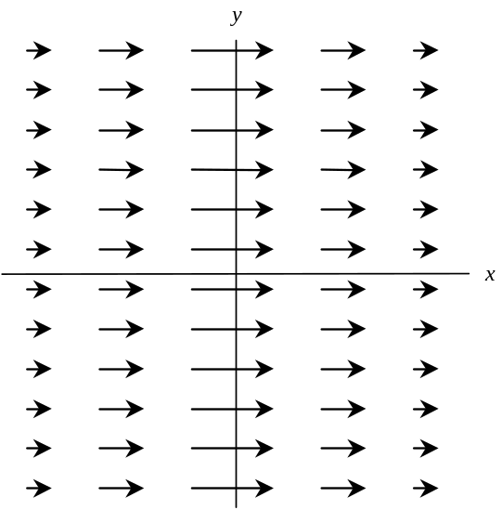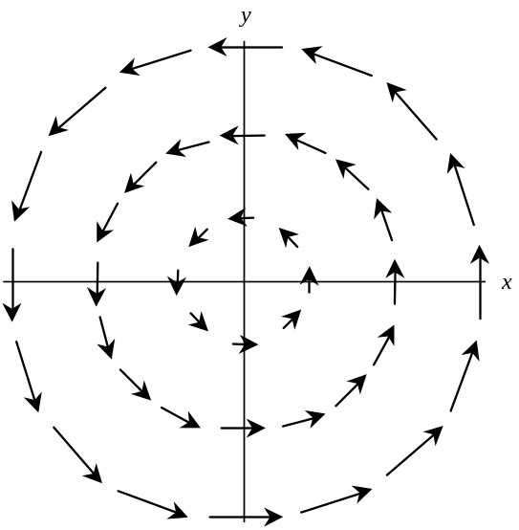

Case #1 Case #2

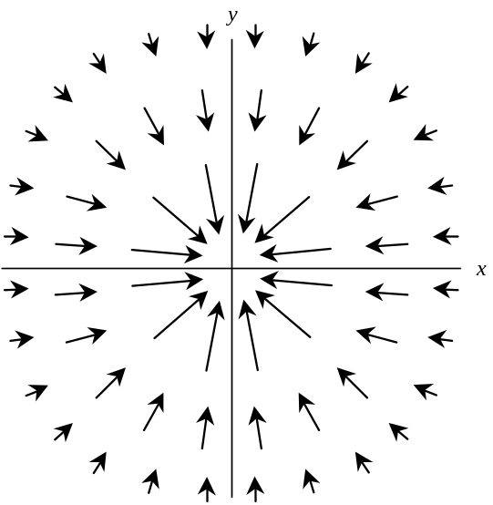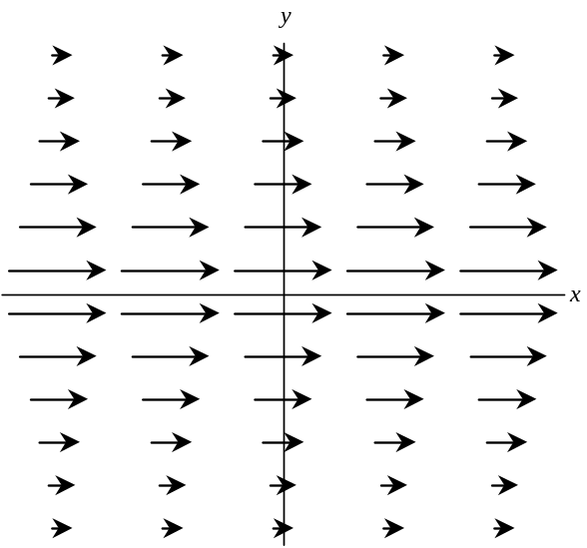

Case #3 Case #4
3. Recall that (i) potential energy functions can be defined only for conservative forces, and that (ii) a force is conservative if and only if the work done by that force along any closed path is zero.

For which vector fields in problem 2 can you identify a closed path over which 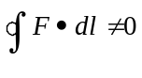?
For each such case, clearly indicate an appropriate path on the diagram. Explain your reasoning.

B. Explain how your answers in part A above should be consistent with those from problem 2.

Are your answers, in fact, consistent? If not, resolve the inconsistencies.

4. Consider the following statement:

“For a conservative force, the magnitude of the force is related to potential energy. The larger the potential energy, the larger the magnitude of the force.”

Do you agree or disagree with this statement? If you agree, state so explicitly. If you disagree, use your results (either from the tutorial or other parts of this tutorial homework) to provide at least three (3) specific counterexamples to the above statement. Explain your reasoning.

5. Consider the following statement:

“For a conservative force, the magnitude of the force is related to potential energy. For any equipotential contour line, the magnitude of the force must be the same at every point along that contour.”

Do you agree or disagree with this statement? If you agree, state so explicitly. If you disagree, use your results (either from the tutorial or other parts of this tutorial homework) to provide at least one specific counterexample to the above statement. Explain your reasoning.

