|  |
| --- |
| Difference Between NAAC & NBA Accreditation - Haq Se EngineerPREC LONIJai Shriram Engineering College (@JSREC09) / Twitter**JAI SHRIRAM ENGINEERING COLLEGE**  **TIRUPPUR – 638 660**  Approved by AICTE, New Delhi & Affiliated to Anna University, Chennai  Recognized by UGC & Accredited by NAAC and NBA (CSE and ECE) |

**DEPARTMENT OF**

**ELECTRONICS AND COMMUNICATION ENGINEERING**

**IBM - Naan Mudhalvan**

**Internet of Things**

**Group 3**

**Phase 5 - Project Submission**

**NAME : PRANESH R**

**NM ID :AU711221106022**

**YEAR : III**

**Project Objectives:**

A smart public restroom project involves designing and implementing advanced technologies features to enhance the functionality, hygiene, accessibility and efficiency of public restroom facilities.

This can include dirt detection, smell detection, monitoring the sweeper activity, depth detection . This aims to improve public restroom experiences and contribute to overall urban sanitation and sustainability.

**IOT sensors setup:**

**Odour sensor:**

Odour monitoring systems work by continuously detecting and quantifying the concentration of various odorants in the air. Advanced systems, like those developed by Oizom, utilise sensor-based technologies, artificial intelligence, and machine learning to monitor odour emissions in real time. The collected data can then be analysed to identify the source of the odour, track its dispersion, and develop effective strategies for mitigation.Explore Oizom’s advanced odour-monitoring solutions for a comprehensive approach to air quality management.

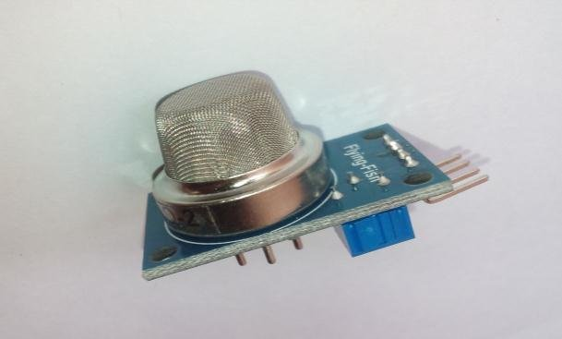

**Ultrasonic sensor:**

Ultrasonic sensors operate based on the principle of sound waves and their reflection. These sensors consist of a transmitter and a receiver. The transmitter emits ultrasonic waves, which are sound waves with frequencies higher than the upper audible limit of human hearing. The receiver then detects the reflected waves. The operation of ultrasonic sensors can be understood by considering the time it takes for the emitted sound wave to travel to an object and return to the sensor. By measuring this time interval, the distance to the object can be calculated using the speed of sound in air.

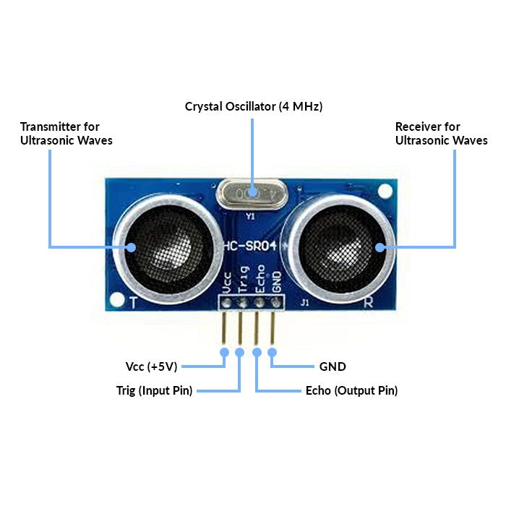

**Raspberry pi integration:**

Raspberry Pi is a series of small single-board computers developed in the United Kingdom by Raspberry Pi Ltd in association with Broadcom. The Raspberry Pi project originally leaned toward the promotion of teaching basic computer science in schools. The Raspberry Pi is a low cost, credit-card sized computer that plugs into a computer monitor or TV, and uses a standard keyboard and mouse. It is a capable little device that enables people of all ages to explore computing, and to learn how to program in languages like Scratch and Python.

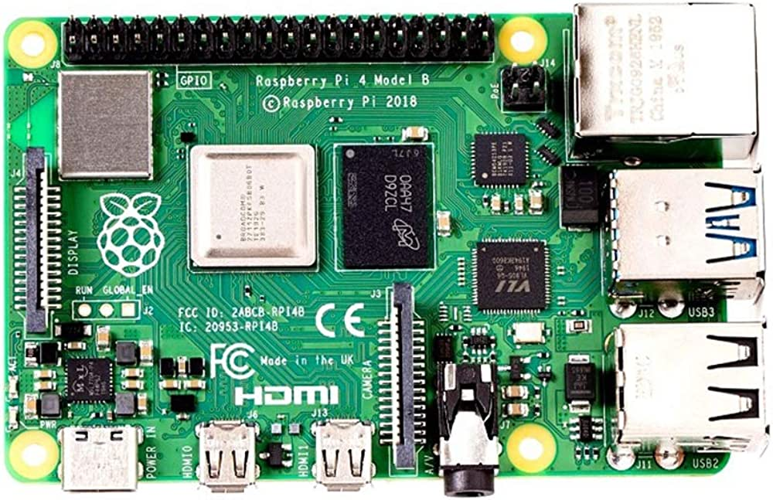

**Code Implementation:**

#include<ESP32Servo.h>

#define TRIGGERPIN 32

#define ECHOPIN 35

#define RED_LED 33

#define GREEN_LED 25

Servo servo_1;

long duration;

int pos, distance, i=0;

void setup()

{

servo_1.attach(18);

Serial.begin(115200);

pinMode(TRIGGERPIN, OUTPUT);

pinMode(ECHOPIN, INPUT);

pinMode(RED_LED, OUTPUT);

pinMode(GREEN_LED, OUTPUT);

Serial.println(" ");

Serial.println("Sensing the Height");

digitalWrite(RED_LED, HIGH);

digitalWrite(GREEN_LED, LOW);

pos = 0;

servo_1.write(pos);

}

void loop()

{

digitalWrite(TRIGGERPIN, LOW);

delayMicroseconds(3);

digitalWrite(TRIGGERPIN, HIGH);

delayMicroseconds(12); // it may be 10 us

digitalWrite(TRIGGERPIN, LOW);

// Reads the echoPin, returns the sound wave travel time in microseconds

duration = pulseIn(ECHOPIN, HIGH);

// Calculating the distance

distance = (duration/2) / 29.1;

// for Adult

if (distance >= 100 && distance <= 150)

{

i = 1;

if (pos != 180)

{

servo_1.write(180);

pos = 180;

i = 1;

}

}

// for Child

else if (distance >= 200 && distance <= 250)

{

i = 1;

if (pos != 0)

{

servo_1.write(0);

pos = 0;

i = 1;

}

}

else if (distance > 300 && i == 1)

{

digitalWrite(RED_LED, LOW);

digitalWrite(GREEN_LED, HIGH);

delay(5000);

digitalWrite(RED_LED, HIGH);

digitalWrite(GREEN_LED, LOW);

i = 0;

}

delay (500);

Serial.println(" ");

Serial.print("Free Level : ");

Serial.print(distance);

Serial.print(" ");

Serial.print("Position : ");

Serial.print(pos);

delay (500);

}

**Schematic diagrams:**

Raspberry pi

Microprocessor

Smell Sensor

Smell detection

T

O

I

L

E

T

User availabiltity

Ultrasonic

sensor

Mobile app

**Smell detection:**

* If any odour is present in the restroom, it is detected by the airquality sensor.
* It gives information to the arduino, then the arduino switch ON the fragrance in the restroom.
* The fragrance remove the odour and give fresh feel for next one.

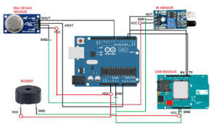

**User Detection:**

* In this feature the presence of the user is detected by Ultrasonic sensor.
* The Ultrasonic sensor detects the person at a specific distance from the door.
* If the user is present there is a red indication in the entrance and in the absence there is a green indication for showing the availability of the restroom.

**User experience:**

Smart restrooms are designed to optimize functionality and convenience, significantly impacting operational efficiency. Occupancy monitoring systems provide real-time data on restroom usage, enabling facility managers to allocate resources effectively and reduce waiting times.