## Section 2: Current Control

### Tr = 1ms:

Calculated response time of 9.5e-4, looks spot on

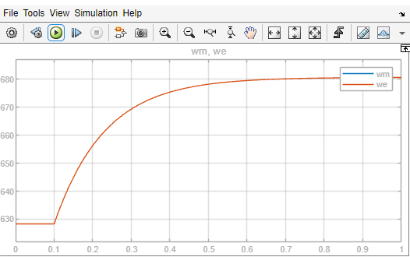

### Tr = 5ms

Part 7

