CSS Anim Plugin

10.10.2015

**Version 1.0**

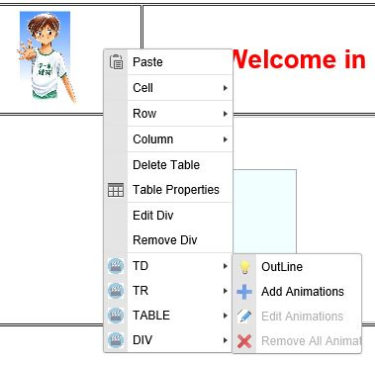 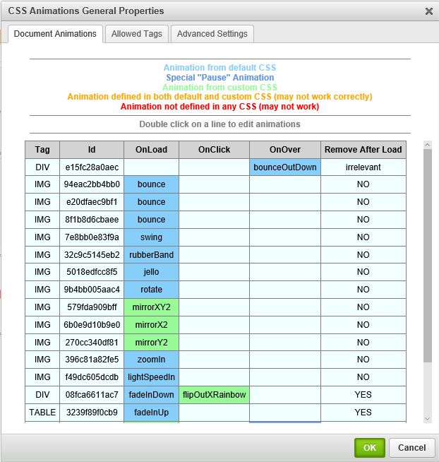

donate.gif

**Table of Contents**

[***Overview***](#h.gdlrsmpnqrhq)

[***The Plugin***](#h.56kfpodyq5td)

[***How it works***](#h.h9kecikiyzpd)

[***The Dialogs***](#h.mo4eo0gxtmbz)

[***CSS Animations “Context Menu”***](#h.buwz1tcz7y35)

[***CSS Animations “General Properties” Dialog***](#h.dlb01uutge0)

[***“Document Animations” Tab***](#h.cof126q0l6ad)

[***“Allowed Tags” Tab***](#h.srmvytidkc4a)

[***“Advanced Settings” Tab***](#h.kt4mu1xe9i3v)

[***CSS Animations “Edition Dialog”***](#h.mwpqc4rd3k6p)

[***Installation / Default Configuration***](#h.idazo6fc63xd)

[***Installation***](#h.mkqw3psby3y5)

[***Add-on Installation Instructions***](#h.z7t6i5ekao9l)

[***Specific configuration***](#h.lk4z0kx3iowa)

[***Known Issues***](#h.sk8fvwzi5fet)

[***Demo***](#h.yrd8qjg7k53y)

# Overview

CSS animations make it possible to animate transitions from one CSS style configuration to another.Animations consist of two components, a style describing the CSS animation and a set of keyframes that indicate the start and end states of the animation's style, as well as possible intermediate waypoints.

There are three key advantages to CSS animations over traditional script-driven animation techniques:

1. They're easy to use for simple animations; you can create them without even having to know JavaScript.
2. The animations run well, even under moderate system load. Simple animations can often perform poorly in JavaScript (unless they're well made). The rendering engine can use frame-skipping and other techniques to keep the performance as smooth as possible.
3. Letting the browser control the animation sequence lets the browser optimize performance and efficiency by, for example, reducing the update frequency of animations running in tabs that aren't currently visible.

## The Plugin

This “CKEditor” Plugin aims to ease Animations integration in your page. The goal is to allow to add/remove/Edit animations on elements on your page (“Div”, “Paragraph”, “Image”, …). Elements on which animations can be added are based on the “html tags”.

For every tag, you can add animations who will occurs “On Load” (when the page is loaded), “On Hover” (when the mouse hover the element and “On Click” (when the element is in “active” state.

After integration in “CKEditor”, the small icon  will be available in the top menu. This will allow to open the “Main Properties” Dialog.

The different Menus and dialogs are described in the following paragraph.

# How it works

Animation is a new CSS property that allows for animation of most HTML elements (such as div, h1 and span) without JavaScript or Flash.

All you need to get some CSS animation happening is to attach an animation to an element in the CSS:

/\* This is the animation code. \*/  
@-webkit-keyframes example {  
 from { transform: scale(2.0); }  
 to { transform: scale(1.0); }  
}  
  
/\* This is the element that we apply the animation to. \*/  
div {  
 -webkit-animation-name: example;  
 -webkit-animation-duration: 1s;  
 -webkit-animation-timing-function: ease; /\* ease is the default \*/  
 -webkit-animation-delay: 1s; /\* 0 is the default \*/  
 -webkit-animation-iteration-count: 2; /\* 1 is the default \*/  
 -webkit-animation-direction: alternate; /\* normal is the default \*/  
}

First, we have the animation code itself. This can appear anywhere in the CSS, as long as the element that you’re animating can find the relevant animation-name.

When assigning the animation to your element, you can also use the shorthand:

div {  
-webkit-animation: example 1s ease 1s 2 alternate;  
}

In our plugin, we have a “default css file : “**cssanim.css**” containing a lot of cool predefined animations (These css contains keyframe mostly coming from the css file proposed on “<https://daneden.github.io/animate.css/>” website).

We can also define a **Custom CSS** file (whose path can be defined in the plugin config file as well as in the dialog “advanced properties tab”.

As we can attach animation on elements via css (in the example before, we attached the animation to some “div” element, we can also attach animation on “css states” of the element such as “div:hover” or “div:active” …

In that case the attached animation will be launched when the specified element go from its “initial” state to the specific state (Hover, Click, …). So let’ have an example to understand what will happen.

#myDiv {  
-webkit-animation: myLoadAnimation 3s ease 1s 1 alternate;  
}

#myDiv:hover {  
-webkit-animation: myHoverAnimation 1s linear 0s 2 normal;  
}

So, what will happen when this page is loaded :

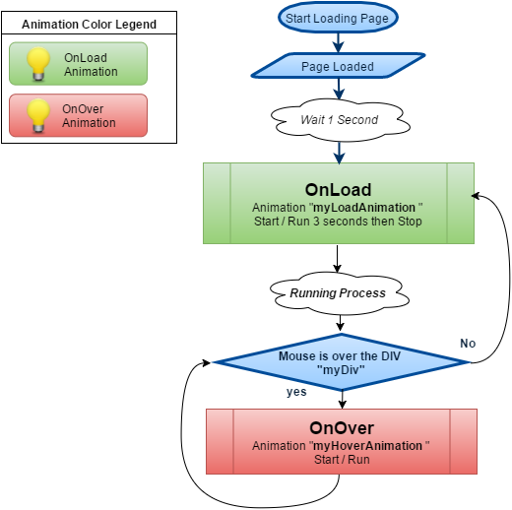

When the page is loaded, the “OnLoad” animation start after 1 second as described in the CSS frame, then this animation keep running 1 time for 3 seconds (as the animation iteration count is set to “1” and iteration time is set to 3 seconds). If the mouse hover the DIV, the “**OnOver**” animation start, and if the mouse goes out the div, the page go in the “Initial Load State”, so the “**OnLoad**” animation will be played again !.

In order to avoid the “OnLoad” animation to be played again, we need to remove this starting animation after completion, the plugin has a specific “**RemoveAfterLoad**” option who can be selected for the “OnLoad” animations, checking this option will add in the “CKEditor” generated page, a specific “javascript” piece of code to remove the animation attached on the element after completion.

So, in case of “Remove After Load” checked option, the process will be the following :

# graph1.png

# 

# 

# The Dialogs

## CSS Animations “Context Menu”

This menu will open when clicking on any area in the page, and will show a list of all the allowed elements (html tags) who are located under the mouse. For each element you’ll be able to :

* Outline the corresponding element (just to ease for is real location).
* Add or Edit animation attached to the element.
* Remove all animations attached to the element.

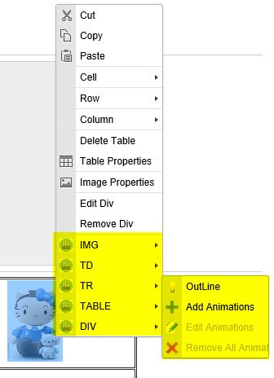

**Example:**

“right clicking” on an image (who is embedded in a “TD” / “TR” / “TABLE” / “DIV” ) will popup this menu.

You’ll be able for any embedded element to choose to “outline” (“highlight/locate”) it.

Or Add/Edit attached animations.

Or remove all attached animations.

Then, selecting “Add Animations” will open up the “[Css Animations Edition Dialog](#h.mwpqc4rd3k6p)” who will allow to manage the animations for this element.

The elements/tags displayed in the menu can be filtered via the “[General Properties / Allowed Tags Tab](#h.dlb01uutge0)” Dialog.

## 

## 

## CSS Animations “General Properties” Dialog

This dialog is the main CSS Animations Dialog (the one opened when clicking on the icon in the top level menu).

This dialog contains 3 tabs :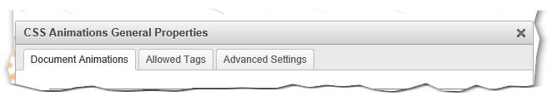

* “Document Animations” who display a summary of all available animations in the page.
* “Allowed Tags” who allows to filter the tags displayed in the Context menu.
* “Advanced Settings” who allow to manage “outline Box” parameters and “Custom CSS”

### **“Document Animations” Tab**

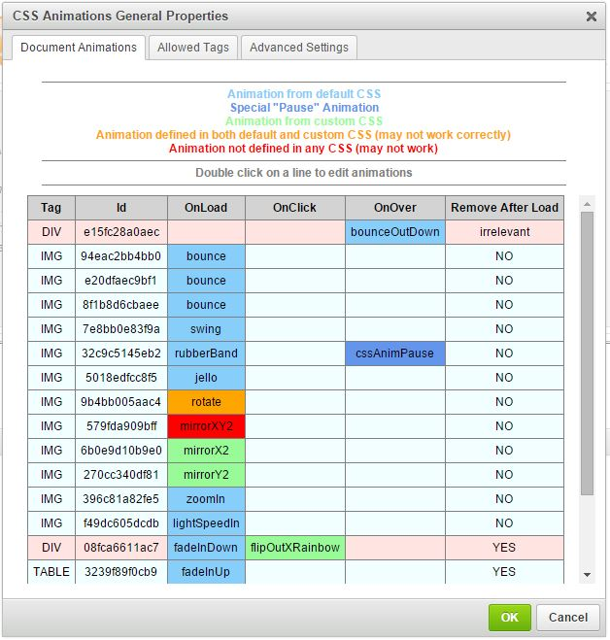

This dialog display a summary of all “defined” animations in the page. For each element a line give information about the type of element (html tag), it’s “id”, and the name for the animation who will occurs when loading the page “OnLoad Column”, when the mouse hover the element “OnOver” or when the element in “active state” (mouse hover + click).

The last column “Remove After Load” say if the “OnLoad” animation will be played only after the page is loaded and then removed or if this animation will be considered as the “Initial state” animation, in that case, the animation will play when the page is loaded and also when any other animation (OnOver or OnClick) is played (for example, if an element has both a Onload and a OnOver animation, the “OnLoad” animation will be played when the page is loaded, then if the mouse hover the element, the “OnLoad” animation will be played and when the mouse will leave the element, this one will return in it’s initial state, so the “OnLoad” animation will be played again). Refer to [How it works](#h.h9kecikiyzpd) for more information.

Other information given in this table are the different colors for the cells :

* “**Pink**” color means that animations are attached on this element, but it’s html tag has been disabled in the “allowed tags” tab.
* “**Light Blue**” color means that the animation attached to this element is defined in the default “cssanim.css” file.
* “**Green**” color means the element animation is defined in the “custom” css file (see “advanced setting tabs document”).
* “**Orange**” color means that the element animation is defined in both “default cssanim.css” file and in the “custom” css file, this may create problems and the animation played for this element can be either the one defined in the default css or the one defined in the custom css depending on how these files have been loaded by the navigator (as these load are asynchronous we cannot say exactly which one will be loaded the last !).
* “**Red**” color means that the corresponding animation is not defined in any css, so it will not be played (this can occur if an animation was previously defined in a custom ccc and if this css has been modified/removed).
* “**Dark Blue**” color means that the animation is a special animation “cssAnimPause” which means that the action on this element will pause the “OnLoad” animation (see [Edition Dialog](#h.mwpqc4rd3k6p)).

Hovering any line in the table will “Outline / Highlight” the corresponding element in the main windows :

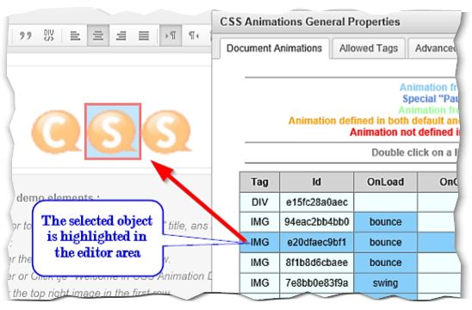

“Double Click” on any line will open the “[CSS Animations Edition Dialog](#h.mwpqc4rd3k6p)” and allow to modify animations for the element.

### **“Allowed Tags” Tab**

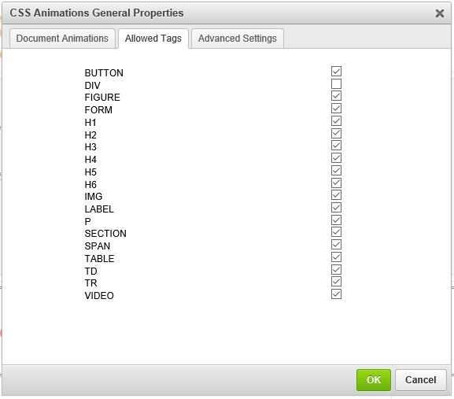

This tab allow to check/uncheck “Tags” who will be displayed in the [CSS Animations “Context Menu”](#h.buwz1tcz7y35).

### **“Advanced Settings” Tab**

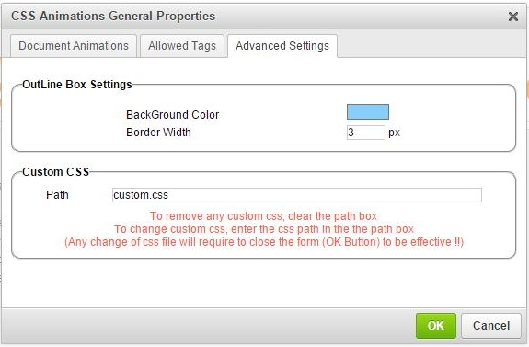

In this tab, we can change the aspect of the “Outline Box”, and define which “Custom” CSS file is used in addition of the default “cssanim.css” file.

## CSS Animations “Edition Dialog”

# 2015-10-20 14_44_35-CSS Animation Demo.jpg

This dialog contains :

* An image, preview area to play (test preview) the selected animation.
* Three Tabs dedicated to the “OnLoad”, “OnClick” and “OnOver” animations attached to the element.
* In “OnClick” and “OnOver” tabs, we have a special animation “**CssAnimPause**”, which is not really an animation, it can be selected if we like to pause the “OnLoad” animation.

Note that the “**Test It**” button will not be displayed if no animation is selected (**NONE**).

Also, the checking box “**Remove After Load**” will be available only in the “**OnLoad**” tab (see [How it works](#h.h9kecikiyzpd) for more info).

A value of “**iteration**” set to zero means “**infinite**”.

# Installation / Default Configuration

### Installation

This plugin does not need special process to be installed, just add it in your plugins when downloading your CKEditor distribution.

### **Add-on Installation Instructions**

If you want to add the plugin manually, you will need to:

1. Extract the downloaded plugin .zip into the plugins folder of your CKEditor installation. Example:
2. http://example.com/ckeditor/plugins/cssanim
3. Enable the plugin by using the [extraPlugins](http://docs.ckeditor.com/#!/api/CKEDITOR.config-cfg-extraPlugins) configuration setting. Example:
4. config.extraPlugins = cssanim;
5. Download and configure all its dependencies, too.

The plugin require “contextmenu” plugin and all its dependency to correctly work.

### Specific configuration

By default, the plugin configuration is the following :

**config.cssanim = {**

**// Can be overridden by config file**

**acceptedTags: allowedTagsDef,**

**// Can be overridden by config file**

**acceptedAnimations: allowedAnimsDef,**

**highlightBGColor: '#87CEFA', // Can be overridden by config file**

**highlightBorder: '3px', // Can be overridden by config file**

**highlightPadding: '3px', // Can be overridden by config file**

**customCssFilePath: “” // No custom CSS file defined**

**};**

**allowedTagsDef is a javascript array defined as :**

***allowedTagsDef = ['img', 'span', 'button', 'label', 'div', 'figure', 'form', 'h1', 'h2', 'h3', 'h4', 'h5', 'h6', 'p', 'section', 'video', 'table', 'tr', 'td'];***

**allowedAnimsDef is a javascript object defined as :**

***allowedAnimsDef = {};***

***allowedAnimsDef.BOUNCE = ['bounce', 'bounceIn', 'bounceInDown', 'bounceInLeft',***

***'bounceInRight', 'bounceInUp', 'bounceOut', 'bounceOutDown', 'bounceOutLeft', 'bounceOutRight', 'bounceOutUp'];***

***allowedAnimsDef.FADE = ['fadeIn', 'fadeInDown', 'fadeInDownBig', 'fadeInLeft',***

***'fadeInLeftBig', 'fadeInRight', 'fadeInRightBig', 'fadeInUp',***

***'fadeInUpBig', 'fadeOut', 'fadeOutDown', 'fadeOutDownBig',***

***'fadeOutLeft', 'fadeOutLeftBig', 'fadeOutRight', 'fadeOutRightBig',***

***'fadeOutUp', 'fadeOutUpBig'];***

***allowedAnimsDef.FLIP = ['flip', 'flipInX', 'flipInY', 'flipOutX', 'flipOutY'];***

***allowedAnimsDef.ROTATE = ['rotate', 'rotateIn', 'rotateInDownLeft', 'rotateInDownRight',***

***'rotateInUpLeft', 'rotateInUpRight', 'rotateOut', 'rotateOutDownLeft',***

***'rotateOutDownRight', 'rotateOutUpLeft', 'rotateOutUpRight',***

***'rotateRound'];***

***allowedAnimsDef.SLIDE = ['slideInDown', 'slideInLeft', 'slideInRight', 'slideInUp', 'slideOutDown',***

***'slideOutLeft', 'slideOutRight', 'slideOutUp'];***

***allowedAnimsDef.ZOOM = ['zoomIn', 'zoomInDown', 'zoomInLeft', 'zoomInRight', 'zoomInUp',***

***'zoomOut', 'zoomOutDown', 'zoomOutLeft', 'zoomOutRight', 'zoomOutUp'];***

***allowedAnimsDef.OTHER = ['flash', 'hinge', 'jello', 'lightSpeedIn', 'lightSpeedOut', 'pulse', 'rollIn',***

***'rollOut', 'rubberBand', 'shake', 'swing', 'tada', 'wobble'];***

If you like to define your own custom config file, just add in the CKEditor “config.js” file your custom values, as an example :

**config.cssanim = {**

**acceptedTags: *['img', 'span', ‘div’]*,**

**acceptedAnimations:** {***BOUNCE***:[***'bounce','bounceIn','bounceOut'***], ***ZOOM***:[***'zoomIn','zoomOut'***]}**,**

**highlightBGColor: '#FF0000', // Red Color**

**highlightBorder: '2px',**

**highlightPadding: '1px',**

**customCssFilePath: "***<path to your file>/<your file name>***.css”**

**};**

Notice that <path to your file> can be either local or something like “http://mySite/..”, located on the same domain as the CKEditor installation.

# Known Issues

No issues as today, just the fact that this plugin is using HTML5 features like input of type “color” or “number” who seems not be supported as now by “Edge / IE”, so rendering will not be as nice as in “Chrome”, “Firefox” or “Opera”.

# Demo

Want to play with it before installation, just go there <http://devlabnet.eu/softdev/cssanim/demo.php> and have fun !!