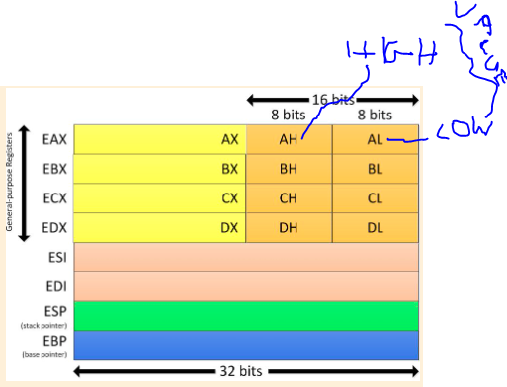

Everythink include ‘A’ is used to input/output, interrupt, arithmetic

Everythink include ‘B’ is used to base pointers for memory acces

Everythink include ‘C’ is used like counter register expamle. Loop counters

Everythink include ‘D’ is used to input/output, interrupt, arithmetic, is like data

