# Why it’s extremely difficult to buy a first home in Minnesota right now?

You want to buy a house of your own. You can’t find a lot in your price range. The housing market has been hot before, but several factors, including rising home prices, high demand and low inventory have conspired to make now an especially difficult time to get a foot in the door of home ownership. rise

## Insufficient funds

The first piece of buying a house, of course, is having the money to pay for it — the down payment, the mortgage, the taxes and the maintenance. But the cost of houses are rising fast, making affording each of those pieces that much farther out of reach.

## Median sale price for Twin Cities homes, *some time period*

*Show a bar chart of the median sale price for Twin Cities homes has been climbing in recent years. These figures are not adjusted for inflation.*

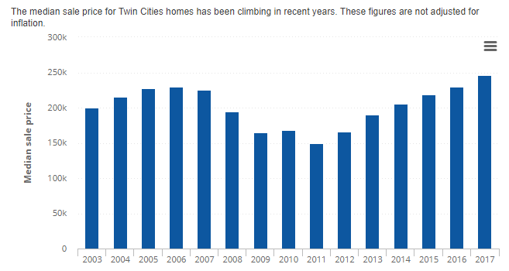

Bar chart and/or a map of homes in the median price range here

~~This bar chart should show house prices are rising faster: in the Twin Cities today, they’re more than four times greater than median household incomes,~~[~~according to the Minneapolis Fed.~~](https://www.minneapolisfed.org/publications/fedgazette/the-vanishing-starter-home)~~Home list prices are also outpacing growth in household income in Fargo-Moorhead and Rochester (and nationwide, for that matter) compared to just a few years ago.~~

## High demand, low inventory

People are less willing than they might have been a decade ago to look at more expensive homes, having watched the housing market implode during the financial crisis. That’s despite low interest rates for borrowing.

Economic researchers say; whereas a family of four with an annual household income of $100,000 might have looked at buying a $400,000 to $600,000 home before the housing crash, “today they’re going to be much more focused on that $200,000 to $250,000, maybe stretching to that $300,000 house.

### ~~Visual ideas~~

~~Use our data and query homes for sell in the above price ranges and year. Or we could make it interactive by including a dropbox that allows the user to enter a year, year range or price ranges and the map that returns the results. Thoughts?~~

In this environment, people with limited budgets are at a loss because there are other people swooping in and they have more flexibility with what they can afford.

All that adds up to even more interest in houses in the starter home segment of the market. But there aren’t necessarily a lot of them available.

We’ve seen high demand for homes before, but the short supply is more acute now.

### Active listings in the Twin Cities, *2013 - 2019*

The number of active listings in the Twin Cities (shown for December of each year) has declined in recent years. <https://www.zillow.com/research/data/> pull from Home Listings and Sales using the following query

### Perfect place to show 2 maps:

1. Map of listings in say 2003 or the earliest year we have
2. Map of listings in most current year we have