Satellite communication systems - the GPS location system

Lab Report

# Objectives:

* Understanding and using satellite communications and GPS applications
* Creating and using an API-Key in order to use Google Maps

# Introduction:

The satellite communication system refers, in telecommunications, to the use of artificial satellites to provide communication links between various points on Earth. Satellite communications play a vital role in the global telecommunications system.

The GPS is a global radio-navigation system which offers the possibility of offering the exact location of any point on the earth and the exact time.

# Method:

The application involves the use of Google Maps and it’s objective is to drop a pin at the specific location the user has provided. In order to do this, we will use Google’s Cloud API and create a new project and API Key, only usable by us.

An application programming interface key (API key) is a unique identifier used to authenticate a user, developer, or calling program to an API. However, they are typically used to authenticate a project with the API rather than a human user.

Different platforms may implement and use API keys in different ways. For example, Google provides the user with 12 free API Keys, after which more must be purchased.

Next, a request is made inside the index file which sends the user to a Google Maps application on the web.

Real life coordinates have been provided inside the javascript files, which then the application will use. Via the API, we are able to use a very complex and otherwise time-draining application.

In our specific case, we pointed the application towards the UTCN building. As we can see below the API responds to our code and moves the pin accordingly.

# Results:

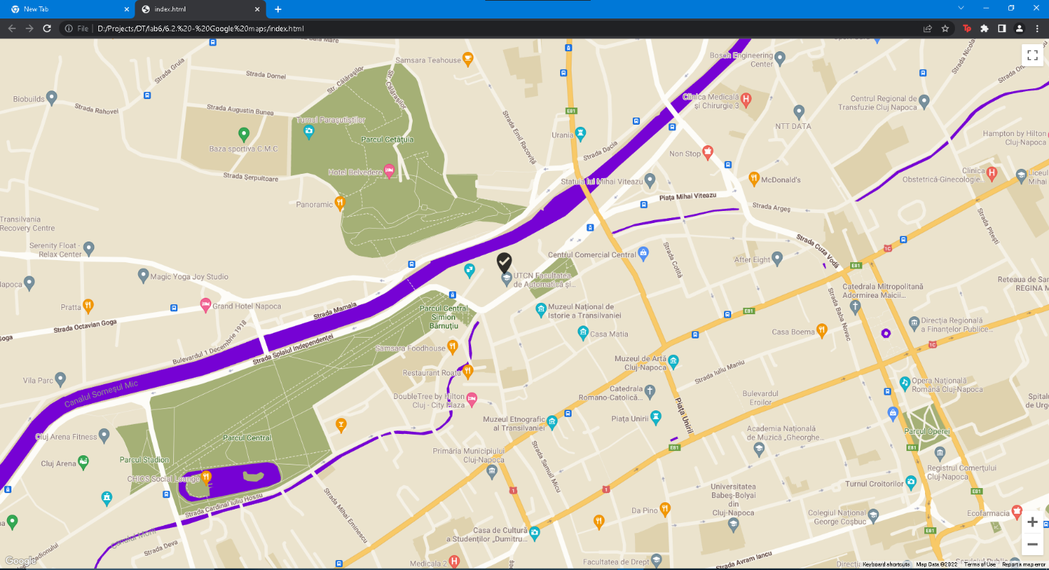

# Analysis:

Please answer to the following questions (*short as possible / one phrase*):

* What is GPS?

GPS stands for Global Positioning System and is a radio-navigation system that calculates the exact location of any point on earth and the exact time using satellites.

* What are the pros and cons of using satellite communication?

Pros: Their coverage is large and they are affordable compared to other means.

Con: Signals can be interfered with and the system needs to be adjusted for the time it takes for the signal to reach the Earth and back.