MBARONYE LOVEDAY
VUG/SEN/24/11860

ENTITIES AND ATTRIBUTES:
ENTITY | ATTRIBUTES | PRIMARY KEY
Department | DepartmentName | DepartmentName
Student | MatricNo, name | MatricNo
Lecturer | name | name
Course | courseCode, courseTitle | courseCode
Enrolement | session

UNNORMALIZED REGISTRATION SHEET:
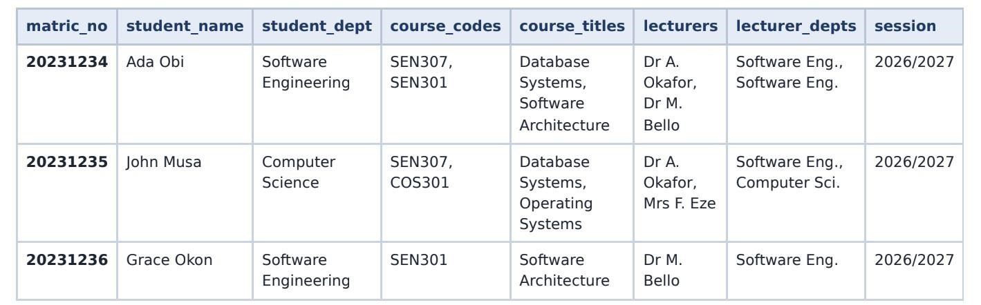
1NF: Lists were splitted and individual rows were created.
Matric_ no | Student_na me | Student_d ept | Course_co des | Course_tit  les | lecture  rs | Lecturer_de pts | session
202312  34 | Ada Obi | Software Engineerin  g | SEN 307 | Database  Systems | Dr A.  Okafor | Software Eng. | 2026/20  27
202312  34 | Ada Obi | Software Engineerin  g | SEN 301 | Software Architectu re | Dr M.  Bello | Software  Engineering | 2026/20  27
202312  35 | John Musa | Computer  Science | SEN 307 | Database  Systems | Dr A.  Okafor | Software Eng. | 2026/20  27
202312  35 | John Musa | Computer  Science | COS 301 | Operating  Systems | Mrs F.  Eze | Computer  Sci. | 2026/20  27
202312  36 | Grace Okon | Software Engineerin  g | SEN 301 | Software Architectu re | Dr M.  Bello | Software Eng. | 2026/20  27

2NF: Columns were moved and new tables created.
Table 1: Student
Matric_no (PK) | Student_name | Student_dept
20231234 | Ada Obi | Software Engineering
20231235 | John Musa | Computer Science
20231236 | Grace Okon | Software Engineering

Table 2: Course
Course_code (PK) | Course_title | lecturer | Lecturer_dept
SEN 307 | Database Systems | Dr A. Okafor | Software Engineering
SEN 301 | Software Architecture | Dr M. Bello | Software Engineering
COS 301 | Operating Systems | Mrs F. Eze | Computer Science

Table 3: Enrolment
matric_no (PK, FK) | Course_code(PK, FK) | session
20231234 | SEN 307 | 2026/2027
20231234 | SEN 301 | 2026/2027
20231235 | SEN 307 | 2026/2027
20231235 | COS 301 | 2026/2027
20231236 | SEN 301 | 2026/2027

3NF: Columns that described other columns were moved, and new tables were created. Table 1: Department
Dept_id(PK) | Dept_name
1 | Software Engineering
2 | Computer Science

Table 2: Student
Matric_no(PK) | Name | Dept_id(FK)
20231234 | Ada Obi | 1
20231235 | John Musa | 2
20231236 | Grace Okon | 1

Table 3: Course
Course_code (PK) | Course_title
SEN 307 | Database Systems
SEN 301 | Software Architecture
COS 301 | Operating Systems

Table 4: Lecturer
Lecturer_id(PK) | Lecturer_name | Dept_id(FK)
1 | Dr A. Okafor | 1
2 | Dr M. Bello | 1
3 | Mrs F. Eze | 2

Table 5: Enrolment
Matric_no(PK, FK) | Course_code(PK, FK) | Session
20231234 | SEN 307 | 2026/2027
20231234 | SEN 301 | 2026/2027
20231235 | SEN 307 | 2026/2027
20231235 | COS 301 | 2026/2027
20231236 | SEN 301 | 2026/2027

Table 6: CourseAndLecturer
Course_code(PK, FK) | Lecturer_id(PK, FK) | Session(PK)
SEN 307 | 1 | 2026/2027
SEN 301 | 2 | 2026/2027
COS 301 | 3 | 2026/2027

FINAL SCHEMA:
1. Department (dept_id PK, dept_name) 2. Student (matric_no PK, name, dept_id FK ->
Department) 3. Lecturer (lecturer_id PK, lecturer_name, dept_id FK -> Department) 4. Course
(course_code PK, course_title) 5. Enrolment (matric_no PK, FK -> Student; course_code PK, FK -> Course; session) 6. CourseAndLecturer (course_code PK, FK -> Course; lecturer_id PK, FK -> Lecturer; session PK)

