Loren McGinnis
CS143
PA2

All of my analysis was done using a python script to parse the tcpdump output and manipulate the packets. For Questions 1 – 6, I used Steve's “Log 1.” For Question 7, I used the 3 log files from TH. I run Ubuntu natively, but it seemed like tcpdump was always missing packets (e.g, the very first SYN packet was always absent)

Ql:
I determined the setup handshake by looking for the SYN packet (the first packet), and the following two packets. The teardown packets were just the first FIN packet to the end of the tcpdump. The total times are measured as differences between timestamps for the first and last packet in the handshakes.

opening connection
client > server SYN 16:38:20.196616
server > client SYN/ACK 16:38:20.430596
client > server ACK 16:38:20.430672
total time: 234.056ms

closing connection
client > server FIN/ACK 16:39:47.547187s
server > client FIN/ACK 16:39:47.784695
client > server ACK 16:39:47.784750
total time: 237.563ms

Q2:
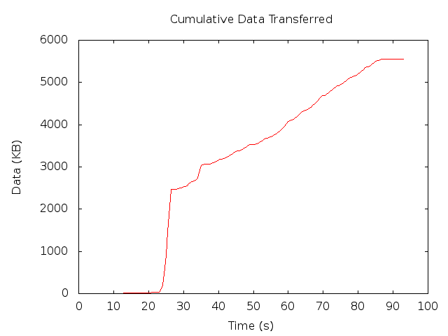
The cumulative payload was calculated by keeping a running total of the packet size sent by the client, and outputting that value every 100ms bucket.
The graph clearly shows the slow start, which jumps at 25s, then backs off to a more gradual increase, showing the switch in congestion control modes.

Q3:
To calculate a packets RTT, I used a simple O(n²) algorithm. For each packet coming from the client, I search all later packets from the server for an ACK that corresponds to the SEQ of the sent packet (ACK == SEQ+1). If the ACK could not be found, I ignored the sent packet. I then calculated the RTT and its statistics per bucket, then across buckets.
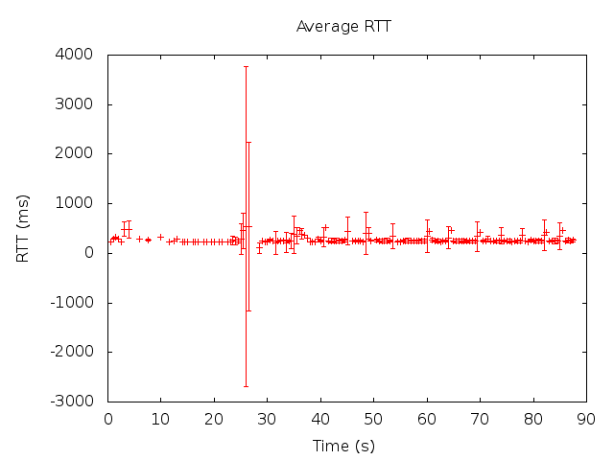
Around 25-30s, it seems like there was a lot of timeout without the server responding. After 40s or so, the RTTs converge to a pattern of low variance, with intermittent jumps occurring when WS reaches the maximum congestion window size (where packets will get dropped).
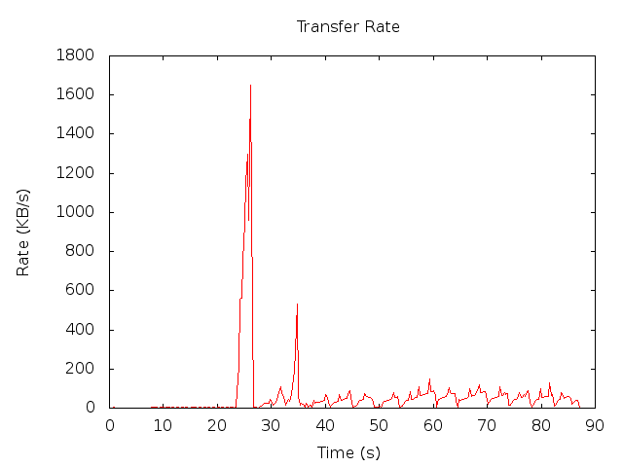
Q4:
Calculating the transfer rate was pretty straightforward, given the RTT value from 3 of 278.3ms.

We can clearly see here the slow-start, which then grows exponentially, then drops quickly into the exponential back-off phase, seen as the typical sawtooth pattern.

Q5:
The second plot was calculated by keeping track of the client's SEQ value and the server's ACK value, and printing them both out for every time-stamp. The first plot is a graph of their difference. This value, (SEQ – ACK), is bounded by CWND. Between 20 and 40 seconds, it grows to be very large, but then drops in the back-off phase, again showing a sawtooth pattern.
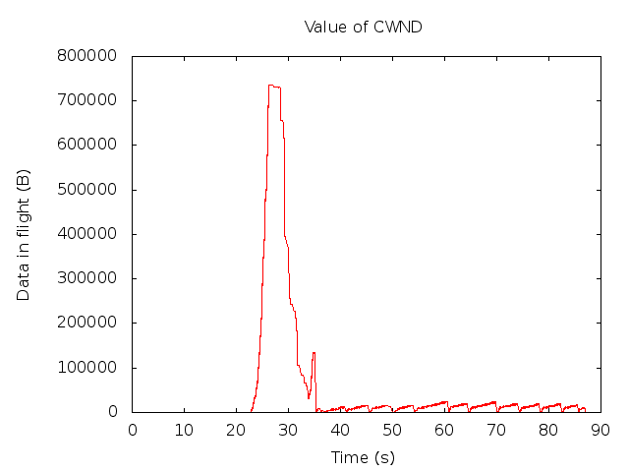
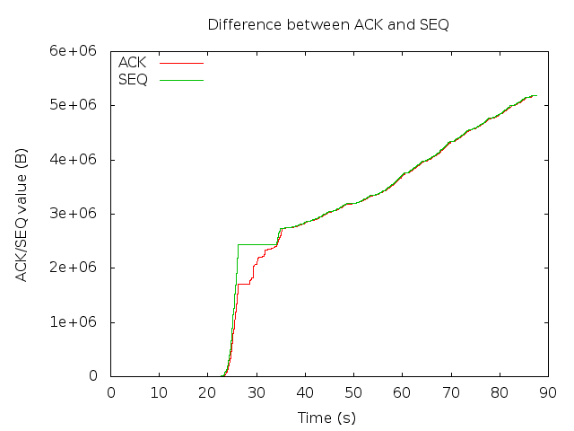
Q6:
Again, it was pretty straightforward to calculate the duplicate ACKs. I just scanned all the packets from the server, and watched the ACK value for (no) changes. Calculating the timeouts was a little trickier. I looked for every SEQ value from the client that had been sent before (a retransmission), and checked to see if those packets were preceded by duplicate ACKs. If they didn't, it probably was a timeout. We can see the fast retransmission working in the graph, with duplicate ACKs appearing at the peaks in Q4 where a packet is dropped.

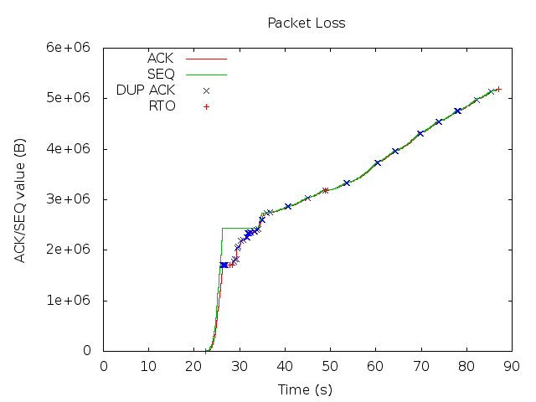
Q7:
I used the same method for calculating RTT and throughput as I did in questions 3 and 4, this time on the tcpdump data that TH emailed. The results are as follows:
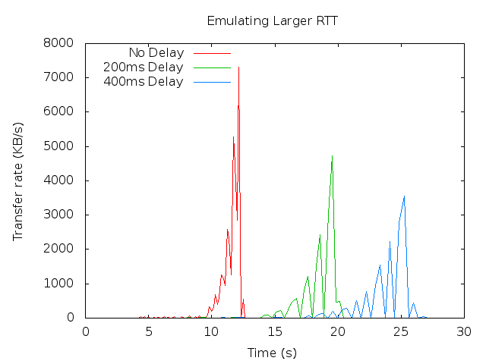
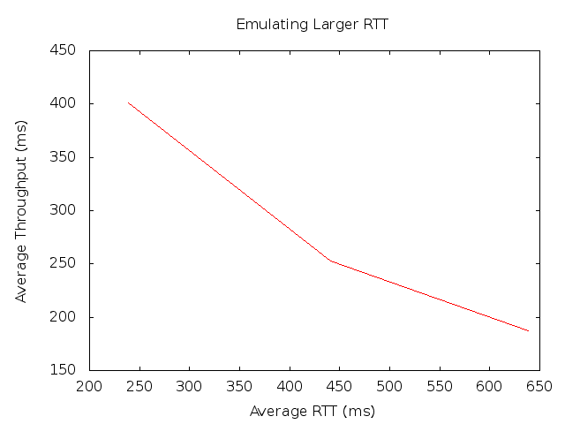
The above graph is the relationship between RTT and throughput, shown as inversely proportional. This substantiates the equation that WS / RTT =THR. Since the RTT is longer for the delayed data, the window size cannot grow as quickly, and the throughput suffers. The graph on the left is the throughput over time for each of the data files.

