**NOTE: GO TO ReadMe.txt FIRST (This was simply to have a manual listed for the project)

1. Connecting-Login 1

2. Admins 2

3. Sellers 3

4. Pharmacists 4

5. Drugs 5

6. Inventory 6

7. Orders 7

1. Connecting-Login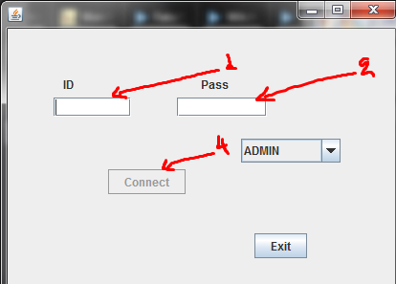

If any one the two white fields are empty (1 and 2) u cannot try to Connect-Login as the button (4) will not be enabled.

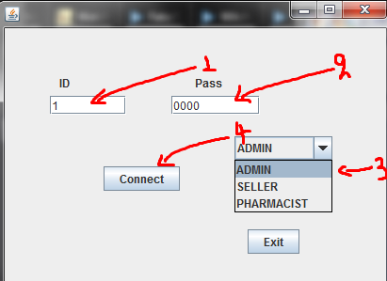

If all the white fields are filled (1 and 2) then u can press on Connect (4) with your selected account type(3).

1. Admins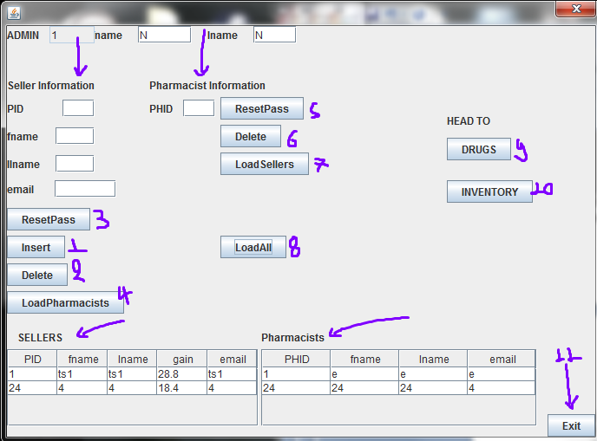

As an ADMIN u will be able to, by filling the white fields under Seller Information and clicking:

1. Insert(1) add a new seller USING your ID. Delete(2) delete a seller with the filled PID
2. ResetPass(3) or reset his password to 0000 incase he forgets it and wants to immediatly change.

Similarly by filling the PHID filed under Pharmacist Information and clicking:

1. Delete(6) delete the pharmacist of that filled PHID.
2. ResetPass(5)reset his password incase he forgets it and wants to immediatly change.

Also By clicking:

1. LoadPharmacist(4) you can load, on the Pharmacists table, the pharmacists corresponding to the filled PID. Similarly by filling a PHID and clicking
2. LoadSellers(7) you can load, on the Sellers table, all the Sellers corresponding to that pharmacist under the filled PHID.
3. Lastly with LoadAll(8) you can load all Pharmacists AND all Sellers, each role on the corresponding table.

To exit you can either click on Exit(11) you can sign out as the current connection will be terminated, or simply click the "red X" button on the top right of your window.

And by clicking on DRUGS (9) or INVENTORY (10) you can head to their respective pages (see 6. and 7. of the USER_MANUAL)

NOTES:*When inserting/adding the ID field is not necessary. But when deleting or updating it is

By clicking on a row of any table you can load automatically the respective fields

If an error pops up(small window simple click ok and try again.

More information on errors after the first update)

1. Sellers

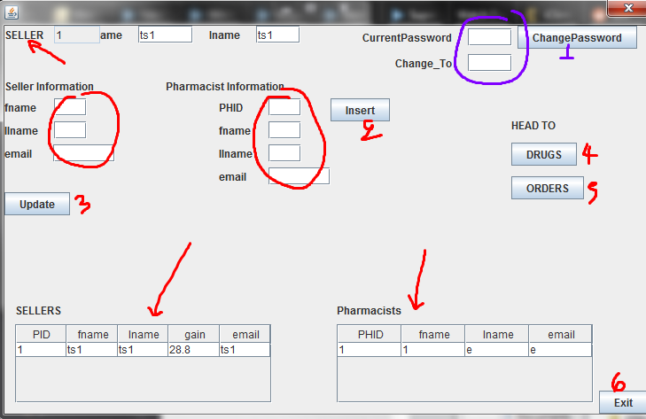

As a seller you can, by filling the white fields (RED , PURPLE CIRCLES) and clicking on the appropriate button perform one of 3 changes:

1. Update (3) your personal information
2. Add new pharmacists registered to and with your PID
3. Change your Password(1), by first filling BOTH your "CurrentPassword" AND the password you want to "Change_To".

To exit you can either click on Exit(11) you can sign out as the current connection will be terminated, or simply click the "red X" button on the top right of your window.

Lastly by clicking on DRUGS (4) or ORDERS (5) you can head to their respective pages (see 5. and 7. of the USER_MANUAL)

NOTES:*When inserting/adding the ID field is not necessary. And when updating all white field should be filled.

By clicking on a row of any table you can load automatically the respective fields

If an error pops up(small window simple click ok and try again.

More information on errors after the first update)

1. Pharmacists

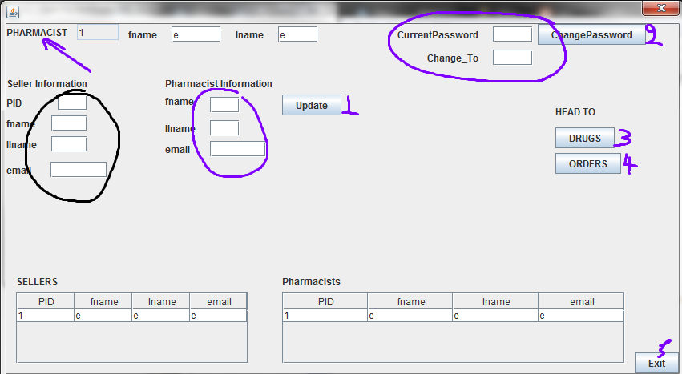

As a pharmacist you can, by filling the white fields (RED , PURPLE CIRCLES) and clicking on the appropriate button perform one of 3 changes:

1. Update (1) your personal information
2. Add new pharmacists registered to and with your PID
3. Change your Password(1), by first filling BOTH your "CurrentPassword" AND the password you want to "Change_To".

To exit you can either click on Exit(5) you can sign out as the current connection will be terminated, or simply click the "red X" button on the top right of your window.

Lastly by clicking on DRUGS (3) or ORDERS (4) you can head to their respective pages (see 5. and 7. of the USER_MANUAL)

NOTES:*When updating all white field should be filled.

By clicking on a row of any table you can load automatically the respective fields

If an error pops up(small window simple click ok and try again.

More information on errors after the first update)

1. Drugs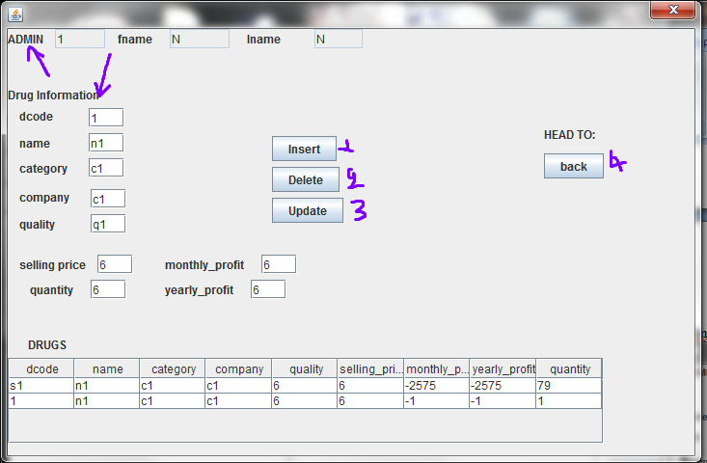

In the DRUGS page if you re an ADMIN you will have 3 buttons enabled

with which you can add (1) delete(2) or update(3) the information of a drug of a certain "dcode".

If your role is that of an seller or a pharmacist then the information is only for viewing, for your potential orders.

NOTES:*When inserting/adding the ID field is not necessary. But when deleting or updating it is.

By clicking on a row of any table you can load automatically the respective fields

If an error pops up(small window simple click ok and try again.

More information on errors after the first update)

1. Inventory

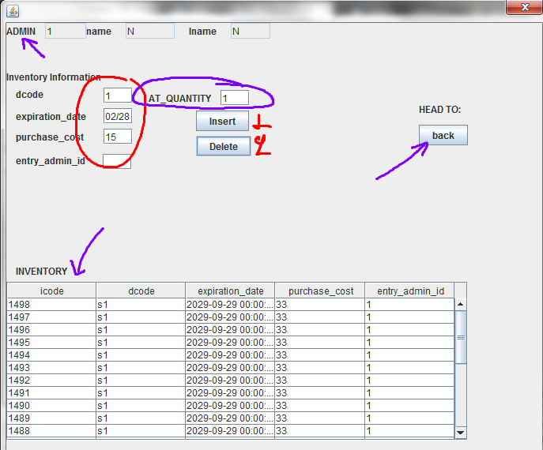

In the inventory the "admin" can see the existing "individual" drugs and add/insert(1) or delete(2), by filling the RED CIRCLE fields and a quantity (PURPLE CIRCLE)

NOTES:

By clicking on a row of any table you can load automatically the respective fields

If an error pops up(small window simple click ok and try again.

More information on errors after the first update)

1. Orders

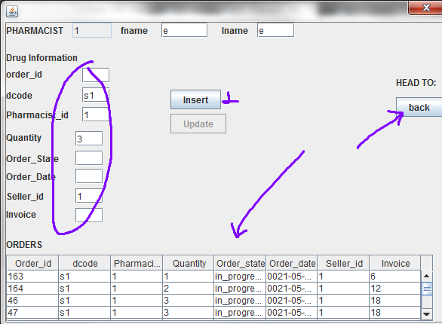

As a pharmacist you can view orders placed by yourself or those placed by a seller on your behalf USING YOUR ID.

Similarly as a seller you can view orders placed by yourself on behalf of oneof your pharmacists or those placed directly by them USING YOUR ID.

To insert/place a new order you need only fill the fields shown filled in the above example inside the PURPLE CIRCLE. Those are the drug' s unique code , your pharmacist' s or seller' s id and the quantity(dcode, Pharmacist_id,Seller_id,quantity). Lastly click insert(1) to complete the order

NOTES:*When inserting/placing an order the ID field is not necessary. But when deleting or updating it is.

The update function is currently disabled. It will be available after the first update

By clicking on a row of any table you can load automatically the respective fields

If an error pops up(small window simple click ok and try again.

More information on errors after the first update)