5. Gameplay

5.1 Overview

In a ancient land composed by 7 island where every island was protected by a goddess, an army of bad pirates appeared, people were subdued to the power of this army, once every island lose the battle, the darkness won and the won’t be peace anywhere. After they conquered the sixth island, the last goddess of the last island summoned a hero, the future of the land is in this person’s hand.

5.2 gameplay description

There is 2 playable mode, offline and online.

Offline

doesn’t require to be connected to play and everything will be stored locally (not by playerprefs).

First time

If it is the first time the player log in, he will be asked to insert a name and after that automatically switch to the tutorial.

Tutorial

The tutorial will explain about the story before the character arrived in Teyra land and will teach the player the base command.

Normally

If it is not the first time, after the player launches the offline mode the player will be sent to the world of Teyra, where he can move the character and decide to do whatever he wants like fight enemy and get money, use the money to buy new ship, to upgrade the ship or to interact with NPC, there will be a total of 7 island available, every island have a story, dialogue, it’s unique ship and enemies, in order to unlock other island, the player need to clear the story of the island.

Story and battle

For unlock the story, the player must fight the enemy, once the player is near an interactable object such as enemy, he can interact with it, it will show a description menu with the star achieved and 2 option, start the battle or back, and start the battle, the battle scene consist **in ….. PARTE DI MC**

In some battle, there will be a dialogue which would be activate at start or when the boss is about to appear. It is used for explains the situation or the story, for example a battle where we got ambushed, sometimes it will give advice or hidden tip for some strong enemies.

Dialogue

If a player is near an dialogue Npc such as goddess, the interact will be active and he can open a dialogue with the selected npc, there will be multiple choice in the dialogue which will lead to different answer from the npc, to discover every little thing, you need some more talk.

Reward and win

If the player won, they would get reward such as currency of the game for buy item in the shop.

Lost

If the player lost he can chose to restart or go back to the map.

Shop

The shop is an house gameObject which the player can interact, after the player clicked interact with shop, the shop panel will appear and show the item bought and the item available.

Upgrade & inventory

If the player bought a item which is a new ship, this will automatically update to other system, such as upgrade and inventory system.

The upgrade is a gameObject house which is the same as the shop, the difference is that it will show the stats of the ship and eventually give the player chance to upgrade it by spending money.

The inventory is a button, when clicked it will show the item bought from shop and its currently stats and give the functionality to switch ship to go for battle.

Currency

There is only 2 way to obtain the game currency, fight the enemy, the level are repeatable and you always get reward after clear it(some kind of farm) or you can directly charge the cash to obtain the game currency.

Map

When the player beat all enemy in the map once, he will unlock a new map, to travel around the map we have the ship set up in the map which allow our player to travel around all maps unlocked. Once you are near the travel ship, it will automatically activate the interact with player, and player can chose to switch map or stay in the current map.

Ending

The game is ended when the player successfully beat the last enemy pirates and set free all island in Teyra.

After this, there will be opened a challenge stage, which is a level where the enemy will appear at infinity to test the player skills, something for hardcore player.

Online

The online mode can be played also by single one player or by 2 player. Every function descripted above also work for online mode except for these, dialogue, switch map, enemy interact.

Why online and differences from offline

The purpose of this game is something like cuphead, you can play and enjoy the story alone, but you can also clear it and enjoy the story together with a friend, so the difference is:

-Dialogue system: if a player start a dialogue with a NPC, the other one start the same dialogue at the same time, if a player chose an option, the other one get the same chose and consequence.

-Switch map, if a player switched the map, both switch to the same map.

-Enemy interact, if a player opens the enemy menu, both open the same menu, if one press start battle, both player will be automatically sent to the scene to fight together.

After beat all enemy you can also play the challenge stage with your friend.

5.2.1 Game mechanics

Walking

The player can move by using the joystick in the screen

Interact

Once the player is near any interactable object, the button interact will change its image to fit the current interact object system, if the player clicked on it, it will activate the interact on that element, the interactable system are shop, upgrade, dialogue, enemy, switch map.

Inventory

Every player got an inventory, which display the current chosen ship and the ships available for battle, the player can switch the ship to use between them.

Switch map

It allow player to switch around the island.

Goddess blessing

When the player free an island and the goddess in the island, the goddess will bless the player and give him a skill to use during battle.

Final strike

Is the special attack of the ship, each kind of ship have a different final strike.

Battle

When a battle start, the enemy will be spawned per round until the last one(boss).

5.2.3 winning conditions

The winning conditions of the level is extremely easy, fight every wave until the boss appear, once you beat the boss you won the level.

5.3 controls

The game is distributed on mobile platform, so there is only the touch screen for move the player, the ship and to interact with everything else.

5.3.1 interface storyboard

Used Testing Model

Since the game is for mobile, the most used device for testing is iphone 12 mini, the view available is only portrait, the reason for this, is because all member of the team uses apple mobile phone.

Interface in game

The interface in the game is Menu, Joystick, interact button, inventory, upgrade, shop, dialogue, credits, tutorial, character customization, settings.

N.B.

All interfaces have illustrative purposes, some maybe will be the final look of the game, some may change after the release.

Opening screen

When the player launches the game, the first screen showed is the opening scene with a fader after around 5-6 sec it will fade and send player directly to the scene where he chose the game mode, in this scene we have the team logo, version number and the game name plus a background image, the player don’t need to do anything here. This is used as splash screen but, if is first time, he will send the player to the tutorial scene.

Menu scene

The menu scene is quite simple, the player have 4 choice, to play offline, host, join or change the settings. In the setting the player can change his preferences, such as language or switch off the sound.

Game Interface

The game interface offer the player the most important functionality to play the game, such as character control with joystick, interact button (without this you almost can do nothing) and the inventory.

In this case the interact is start a dialogue.

The game interface also include charge cash button, current money display, menu button for back to the previews scene.



Pause or setting menu

You can back to the default scene which you can chose the offline or online mode.

Cash charge UI

This is the most important user interface for us, it is almost where we get our income. There is only the price of coins, the true prices need still to be decided, and is not in this stage of the project.

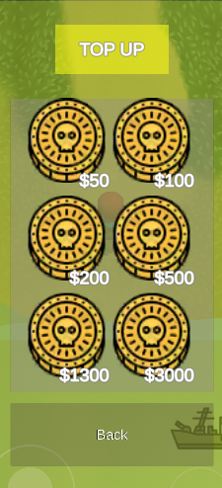

Inventory UI

The inventory is used for select the ship to be used in the battle, once you open it, you can see its current statement, such as upgrade status, unlocked ship, locked ship and a button for choice such ship.

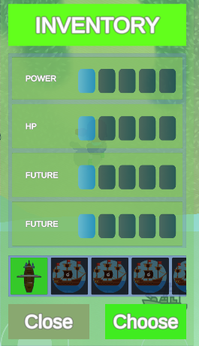

Shop UI

The shop ui is used to unlock new ship by spending game currency, it is made by using a scroll rect and grid layout group.

Upgrade UI

This can be considered the most challenge ui to realize.

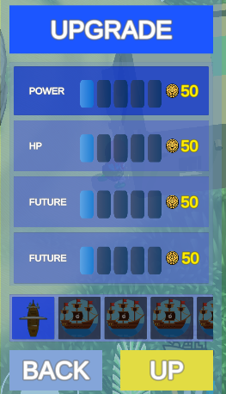

Dialogue UI

Once the player start a dialogue, the dialogue UI will show up, there is the name of who speak, and the dialogue plus the image of who speak, the setting of this is, unless the speaker says its name, the default name is ….

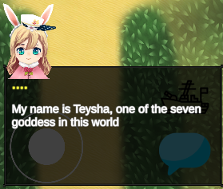

In this case, after the speaker says its name, it will appear as its name.

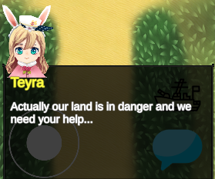

There will also be multiple choice sections

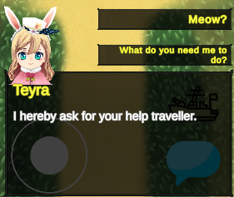

And some loop for increase the entertainment, the dialogue will end once you get out the information needed. Since this interface is offline, the online one will be slightly different, it will give the player one more choice, to close the conversation because maybe the friend you invited is ahead on you and don’t want to resaw the conversation.

Enemy UI

When you are near an enemy the interact image will change and give you the possibility to interact with it.

This UI is composed by the title, the score which is measured by star a description and the choice to fight or not.

Map switch UI

In this UI

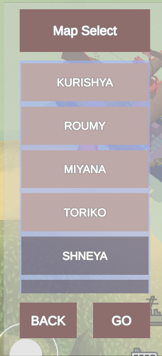

Player can choose the map to switch.

**5.5 level (parte di mc)**

**5.6 flowchart(parte di mc(si prende dal suo tdd))**

5.7 achievements

|  |  |
| --- | --- |
| Achievement | Description |
| A smooth start with some prices…. | Charge one time |
| Power of money | Charge 3 times |
| It is easy with the power of cash | Charge 10 times |
| A perfect start | Clear a 3* in one level |
| Nobody is perfect, I’m nobody, so I’m perfect. | Clear a stage without losing hp |
| Such a lovely island | Select all dialogue options with Teysha |
| Such a bravery island | Select all dialogue options with goddess2 |
| Such a give me a break island | Select all dialogue options with goddess3 |
| Such a sad island | Select all dialogue options with goddess4 |
| Such a pain in the island | Select all dialogue options with goddess5 |
| Such a sleepy island | Select all dialogue options with goddess6 |
| Such a difficult island | Select all dialogue options with goddess7 |
| Is it worth to travel? | Select all dialogue with all goddesses |
| The first adventures | Clear the first level |
| The first-time being hero | Clear the first island |
| The first travel into another island | Travel once in another island |
| The first time to buy ship | Unlock 1 ship in shop |
| I’m just too rich or too active | Unlock every ship in shop |
| Do you need power traveler? | Upgrade once one ship |
| This is the max power | Upgrade every stat to max for 1 ship |
| Aren’t you over doing this? | Upgrade every stat of every ship to its max value |
| The start of the legend | Clear the story of the first island |
| The upcoming challenge | Clear the story of the second island |
| The chilling island | Clear the story of the third island |
| The sorrow island | Clear the story of the forth island |
| The painful island | Clear the story of the fifth island |
| Do you still need to be sleepy? | Clear the story of the sixth island |
| I’m the greatest pirates | Clear the story |
| Race through seven island | Obtain every achievement |
| Coming soon…. | …. |

6. Game Characters

6.1 character design

Thieves races is a RPG game, which includes a lot of NPC characters, but the playable characters is currently one.

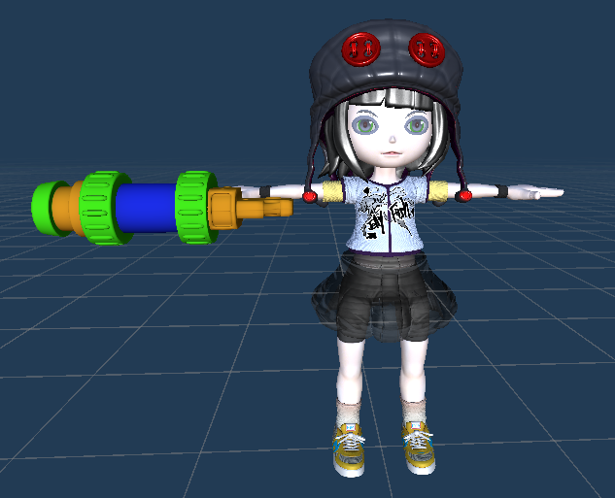

This is the controllable character, it is used for interact with map and system.

**….Parte di mc…. La tua barca….. con i stats…**

6.2

The npc are, Goddesses and helper.

6.2.1 Goddesses

There is 7 goddesses one per island who need your help to free the island and its populated people from bad pirates.

Each one has a dialogue and in base on the situation, she can give you the goddesses bless which is a skill that can help you to overcome some obstacles.

|  |  |
| --- | --- |
|  | **Base information**  Name: Teysha  Location: first island  Personality: diligent  Description: Teysha is the oldest goddesses so probably that’s why she’s so diligent.  **Powers**  Name: Healthy field  Description: Teysha is named the goddesses of healthy, this skill can recovery any injury, even for ship.  Effect: recovery a % amount of ship health.  Cooldown: 20s. |
|  | **Base information**  Name: Teywa  Location: Second island  Personality: bravery  Description: Teywa is the tiniest goddesses, she’s audacious and most of the case doesn’t like to listen.  **Powers**  Name: Strength Will  Description: Teywa is named the goddesses of bravery, this skill can increase the will of people.  Effect: increase the damage of the ship.  Duration: 10s.  Cooldown: 20s. |
|  | **Base information**  Name: Teyfee  Location: Third island  Personality: Chill, calm.  Description: Teyfee’s the 2nd goddesses, she’s island is called the island for rest, probably because of her personality.  **Powers**  Name: Sacred rest and chill  Description: Teyfee is named the goddesses of chilling, this skill can calm down the people.  Effect: decrease the damage of enemy ship.  Duration: 10s.  Cooldown: 20s. |
|  | **Base information**  Name: Teyma  Location: forth island  Personality: sorrow  Description: Teyfee’s the 3rd goddesses, she’s island is called the island for rest, probably because of her personality.  **Powers**  Name: Sacred crying  Description: Teyfee is named the goddesses of chilling, this skill can calm down the people.  Effect: decrease the %hp of enemy.  Cooldown: 20s. |
| Coming soon… | **Coming soon…** |

6.3.1 citizens

People in the island who submitted to pirates.

6.3.2 Helper

People in the island who offer to help you in order to release the island. They give you some suggestion about some specific level.

6.4 Enemy

The enemy npc is used for starts a thieves races battle.

6.4.1 Enemy General

Actually they are the boss of the island, you need to defeat them, they got more hp and have more attack pattern then other normal enemy.

7. story

A short recap

In an ancient era the world was populated by pirates, which were remarked as sea explorer with their extraordinary and resistent ship, they fought the sea with their strength and try to found treasure. A kid who admires them decided to became the greatest pirates of the world, so she starting to make the ship and started her first adventures, but unfortunately, she encountered a band of bad pirates who sink her ship and fall under water, just before she lost her conscious she heard a voices "Would you like to continue your dream?", when she open her eyes again, she was in an island and encountered a goddess, which told her that she was summoned by this goddess in this land named teyra a peaceful land which everyone could enjoy their life, but suddenly, out from nowhere, the army of darkness pirates appeared, they challenge people with "thieves races", a dangerous battle where who lose, lost everything. The goddess says that you were summoned because you have a strong will to complete your dream, with a bravery and kind heart, and asked you to free the island and her other sisters. In the meantime, the pirates army landed on this island, in front of the danger our main decided to help the goddesses, and started a fight with pirates, it was a tough fight but with Teyra blessing, you manage to defeat those pirates.

After that you asked what’s the current situation: Teyra have 7 island ruled by 7 goddess, every goddess possess a different kind of power, but they can't directly participate to the battle, all they can do is give some support, like the goddesses blessing, once every warrior on the island got defeated, the pirates win and can rule the island, actually they already conquered 6 island, so if they conquer this island, they can manipulate the land of teyra how they want, so again the goddesses pleased the traveler to help this land, The main character accepted to help the goddesses and started her story around Teyra.

She got through the seven island : Kurishya, Roumy, Miyana, Toriko, Shneya, Meisha, Kurishya, encountered the goddesses, fought the pirates kings army and their general.

After a long journey with surprise and danger, you finally manage to free the land from darkness pirates and also remembered as the greatest pirates in the Teyra land.

7.2 complete story

7.2.1 Act1

You got summoned by the goddess in the island, who ask for your help, in the meantime where you asks what’s going on, the enemy pirates landed on the island and challenging you to a thieves races, a battle who lose, love everything, you accepted the challenge, but enemy was well prepared for the battle, they were more tough then what you expected, just when the battle seems to go in the bad way, the goddesses offered her bless to you, actually the goddesses posses the power of healthy, it can heal everything that exist in the land, even a ship, so with her help you managed to defeat the pirates, after that the goddesses explain the situation of this world, an darkness army of pirates appeared and conquered 6 island over 7, she asks you to help her to free the island and the goddesses, you accepted this quest and started your journey.

7.2.2 Act2

In the second island Roumy you encountered the 2nd goddesses, the most young one, Teywa, she’s a bravely goddesses, she want to free the people of the island as soon as possible, so she asked for your help, the general on the island is well known as very strong because of his defense ship is very hard that only other general can pierce down, but also, he got one weak spot or point, it was a caused by the previews attack on the island, the best warrior of roumy caused it, but after that he lost the battle. So you started to gather information about this weak spot, after you fought and captured some of the subordinate of the general, you managed to get out from them where the weak spot of the enemy general ship was, then with the help of the goddesses blessing which increase hugely the ship damage, you manage to defeat the general and free the island.

7.2.3 act3

In the third island Miyana you encountered Teyfee, the goddess which speak very slowly that could let you sleep directly. This island is doomed by the most aggressive general of pirates army, but however, Miyana is the island of chilling, this means, perfect place for break, there is beach, sea and everything else needed for a good rest, actually, because of this, maybe this island’s pirates are playing everyday at the beach, because the beach was populated by a lot of pirates, you hardly could tell which one was the general and to find it meanwhile taking the goddesses, let your guard down and started to play with pirates together.

At the end of the day, you remembered you came for free the island, so in the next day you started to find the General, but, with Teyfee’s calms voices, you let your guard down again and started to play with pirates again.

Then the third time, you didn’t bring goddesses with you and finally found the general, after challenging him with a thieves races, but the fight was very tough, because this general is the most aggressive one, he’s known as “The piercer” every single attack from him could be critical, in the middle of the battle, the goddesses gave you her blessing “Sacred rest and chill” which calmed down the head of pirates and decreases their aggressivity, with this you managed to defeat the pirates of the island, but Miyana was considered the best island for rest, the main stayed in the island 1 week more before left.

7.2.4 act 4

After landing on the Toriko island, considered as the land of sorrow, you see not only the people of the island were all in bad status, but actually, even the bad pirates looks pretty down, because the goddesses of the island’s bless is given to everyone, you encountered the goddess and you fought the general in this island, it was some kind of sad general, but u managed to free the island…..

7.3 premise

The Teyra land is have the god authority which describe the rules of this entire world, in order to maintain these rules, every island have a goddess who protect the island the people who live on. So, to prevent the change of the rules of this world, only if seven goddesses agree, the world rules can be changed.

7.4 Narrative devices

The story is told mainly with talking with Npc and when enter the battle scene, once the player enters the battle scene, if there is a story directed in that battle scene, he will start the dialogue this also works when the boss appear they will start the dialogue.

7.5 subplot

Once every island warrior lose the battle, the goddesses would be submitted to the pirates, this means that she can’t oppose to the will of pirates, so if the pirates successfully submit all goddesses they can change the world rules how they want.

7.6 storyboard

**Da Decidere**

-