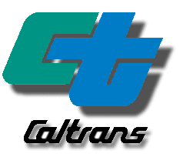
RESEARCH NOTES

April 2010

Cartesius and CTNET:
Integration and Field Operational Test

(PATH Task Order 6324)

Why was this research undertaken?
Non-recurrent congestion presents a difficult problem for existing localized automated traffic control systems. These systems operate with control parameters that are fine-tuned to meet the normal demands of recurrent congestion in the system. Incidents in the system can create disturbances that are beyond the control of such localized systems, rendering them incapable of mitigating the resulting congestion and leading to increased delays. This creates a compelling justification for interfacing such systems with a global traffic management subsystem to develop a general corridor traffic management architecture that can dynamically respond to incidents in the system.
PATH Task Order 6324 (TO-6324) is the second part of a multi-year project to combine research in multi-jurisdictional traffic management with functioning freeway and arterial traffic control systems. The main goal of the effort is to modify the Coordinated Adaptive Real-time Expert System for Incident management in Urban Systems (Cartesius) to work with the Caltrans Traffic Signal Management and Surveillance System (CTNET). Cartesius is a multi-agent incident management tool that provides coordinated, area-wide response strategies to incidents occurring in a multi-jurisdictional transportation network. In typical use, each participating traffic management agency maintains a Cartesius agent that is aware of the traffic control and information systems the agency can use for incident response. When an incident occurs, the collective of participating Cartesius agents use a generic distributed algorithm to search through available management responses provided by the available traffic management subsystems.
Earlier work was focused on interfacing Cartesius with the Caltrans Advanced Transportation Management System (ATMS) to provide freeway incident mitigation, but lacked ability to interact with arterial traffic management subsystems available outside of a simulation context. CTNET is just such a subsystem, providing for integrated management of traffic signals that allows operators to remotely manage, view, and log real-time traffic signal field data. Interfacing these two systems will bring Cartesius a step closer to practical deployment in the state of California by finally providing Cartesius with connections to both freeway and arterial control systems that are necessary to support true multi-jurisdictional management.
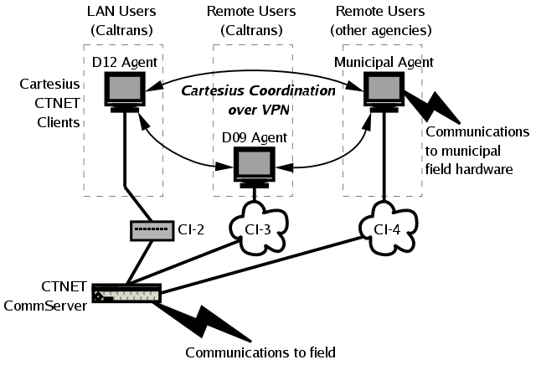
Figure 1: Typical Cartesius/CTNET Communications
What was done as part of this research?
As the second part of the multi-part effort, TO-6324 focused on implementing the requirements for modifying the Cartesius system to meet the needs of Caltrans, in general, and to integrate the system with CTNET, in particular. This portion of the effort focused on three major tasks. First we determined that the best way to integrate CTNET and Cartesius was to create a pair of general purpose interface libraries (Jab3418e and JCTNET) that allow third-party applications to connect with CTNET and perform client actions ranging from receiving sensor and timing data to setting the active signal timing patterns operating in managed field elements.
The designs of these libraries were influenced by the second of the major tasks---the re-implementation of Cartesius. This proved to be a significant undertaking, but was justified by a number of significant problems with the original Cartesius implementation that made its continued use problematic at best. The new version of Cartesius was implemented using the Java platform and a number of off-the-shelf frameworks for communications, persistence, and security. The system satisfies nearly the entire set of core functional requirements established for the re-implementation.
As such, the resulting integrated system combining Cartesius and CTNET achieves the core goals of the project. While the initial proposal called for a full-fledged field operational test of combined system, we were unable to create a suitable real-world environment to support this effort. The reasons for this were both technical and institutional. As an alternative to the planned Field Operation Test (FOT), we instead created custom plugins for the Paramics microsimulation model to allow CTNET to interact with the system. This proxy real world was then used to evaluate the functional performance of the integrated system in general, and the specific performance of the Cartesius re-implementation.
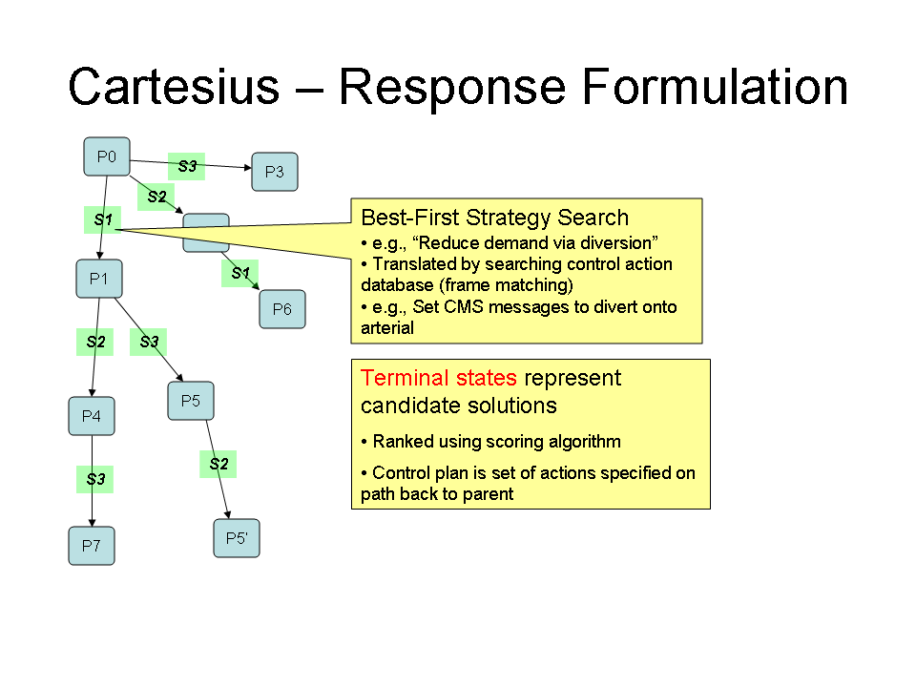
Figure 2: Cartesius Search Tree

What can be concluded?
CTNET is a flexible platform that can now be integrated with arbitrary traffic management systems using the software developed under this research. The combined Cartesius- CTNET system was evaluated by connecting Cartesius to the Paramics simulation via the new CTNET-Paramics connection and other existing plug-ins allowing simulated access to simulated freeway sensors and ramp controllers. The results of the evaluation demonstrate that the reimplementation produces performance similar to the original Cartesius system for a restricted evaluation subset.
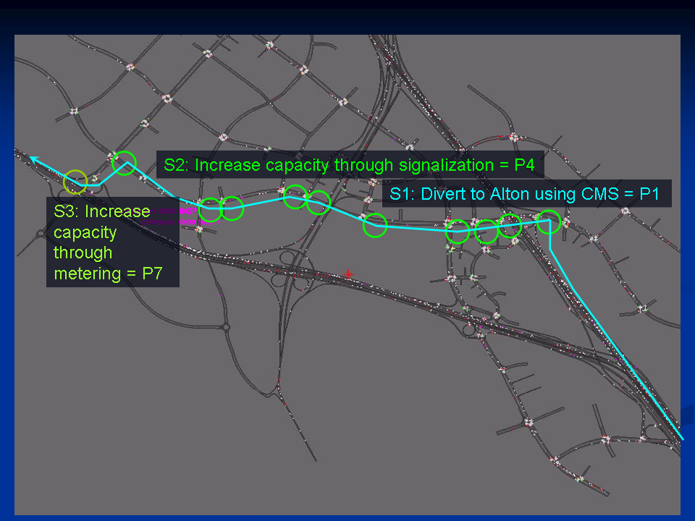
Figure 3: Typical Cartesius Response Strategy
What do Researchers Recommend?
Additional efforts will be necessary to use hooks placed in the current re-implementation of Cartesius to create a true multi-agent version. Furthermore, some external components required for general purpose deployment---such as an operational path demand estimator---are still unavailable for general deployment. As such, Cartesius still requires significant preprocessed inputs to become operational for a specific deployment. Targeted efforts to develop such near-term prediction models are needed before systems such as Cartesius can become fully operational and moved into deployment.
Finally, it became clear in this project that Caltrans TMC processes have evolved over time to achieve certain levels of efficiency with available human and technical resources. Altering these processes with new software and analytical tools is not a trivial task. We recommend that FOTs go through formal systems engineering steps in order to establish the specific modifications that will be made to active TMC operations and to obtain buy-in from stakeholders at all level prior to the start of the research effort.
Implementation Strategies
Cartesius and CTNET are complementary systems each serving vital roles in advanced traffic management. Coupled with the Caltrans ATMS system, this trio of tools has the potential to be a complete multi-jurisdictional traffic management system that offers cooperative incident management functions for neighboring agencies. The products of this research make it easier to integrate CTNET into modern traffic management systems and bring Cartesius and its multi-jurisdictional traffic management philosophies one step closer to deployment.

List of Contacts
Principal Investigator:
Michael G. McNally (mmcnally@uci.edu)
Institute of Transportation Studies
University of California at Irvine
Irvine, CA 92697-3600
Tel.: (949) 824-8462; Fax: (949) 824-8385
Other Investigators:
Craig R. Rindt (crindt@uci.edu)
Institute of Transportation Studies
University of California at Irvine
Irvine, CA 92697-3600
Tel.: (949) 824-6571; Fax: (949) 824-8385
Project Monitor:
Fred Yazdan (fred.yazdan@dot.ca.gov)
Caltrans, Division of Research and Innovations
Office of technology Applications; Advanced Testbed Program Branch
6681 Marine Way, Irvine, CA 92618
Tel.: (949) 936-3462; Fax: (949) 936-3461

