# APCS Lab: Picture Lab Student Handouts

## Description

In this lab, you work with a set of classes used to work with color and pictures. Along with practicing two- dimensional arrays and instantiating class variables, you will learn how color works on computers and learn to do simple photo manipulations.

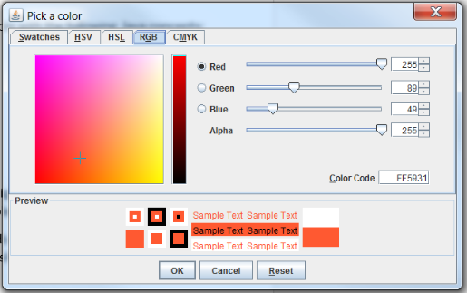

## Structure

The Picture Lab has nine activities that walk you through working with colors and photos. Collegeboard has a Student Activity Guide available to help you to work through the lab.

### The Collegeboard Student Guide is broken into nine activities:

* Activity 1 - Introduction to digital pictures and color
* Activity 2 - Picking a color
* Activity 3 - Exploring a picture
* Activity 4 - Two-dimensional arrays in Java
* Activity 5 - Modifying a picture
* Activity 6 - Mirroring pictures
* Activity 7 - Mirroring part of a picture
* Activity 8 - Creating a collage
* Activity 9 - Simple edge detection

We are working on this lab at the end of Unit 6 right as you begin your review for the AP Exam. Many of activities in this lab are a great way to review for the AP, especially some of the programming techniques you will see in the free-response section.

Term 2 – Weeks 15 - 17 Name:

Picture Lab: Worksheet 1

Activity 1 - Introduction to digital pictures and color

### Overview – RGB Colors

Digital pictures are made up of individual pixels. This activity walks you through how pixels work on computers, and set the stage for the picture transformations you will be doing in the later activities.



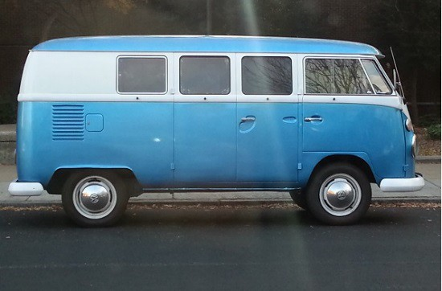

*Digital pictures are made up of individual blocks of color stored numerically as red, green and blue values.*

1. Read the activity guide on page 3. Why do you think RGB colors are different than mixing paint?

It uses light and combining rather than mixing colors.

1. Answer the questions from the activity guide on page 3: Question 1: 8

Question 2: 3

Question 3: 307200

Name:

Picture Lab: Worksheet 2 Activity 2 - Picking a color

### Overview –Working with Digital Color

This activity lets you explore colors by mixing RGB values. Working with colors on computers can be quite different than the color mixing you learned in kindergarten. For example, orange is a mix of red and green with a little blue tossed in:

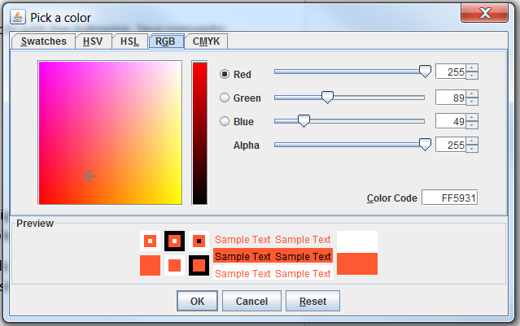This has to do with how the computer created color. Rather than being light reflected off of a surface, like a painting, the color on a screen is created by mixing three light sources – one red, one green and one blue. This works because the color rods in our eyes pick up red, green and blue.

So if the red value is at 255 it means the red is turned all the way up, while zero means it is turned off. By changing these the red, green and blue "switches" by adjusting the values from 0 to 255

you can mix millions of colors, specifically 16,777,216 variations.

1. Read the instructions for running the ColorChooser lab on page 4.
2. Fill in the following color chart:

|  |  |  |  |
| --- | --- | --- | --- |
| **Color** | **Red** | **Green** | **Blue** |
| **Purple-ish?** | **50** | **50** | **255** |
| **Grey** | **100** | **100** | **100** |
| **Pink-ish?** | **170** | **130** | **180** |
| **Yellow** | **255** | **255** | **0** |
| **Purple** | **100** | **0** | **255** |
| **Pink** | **255** | **0** | **255** |

Name:

Picture Lab: Worksheet 3 Activity 3 - Exploring a picture

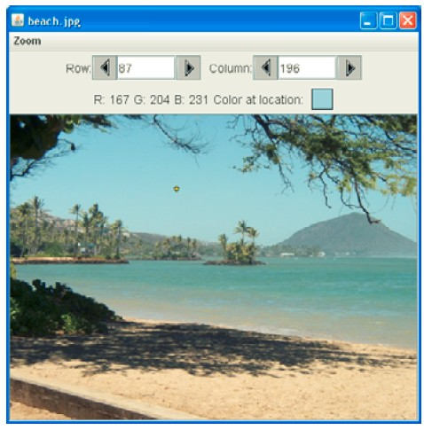In Activity 3 you will start putting the pixels together as you work with photos for the first time.

The program lets you explore a picture pixel by pixel. In the next activities you will use loops to make changes to the pictures you load.

* 1. Read the Student Guide page 5 and run PictureExplorer.java.
  2. Complete Activity 3 in the Picture Lab Student Guide on page 5.

Question 1: 0

Question 2: 0

Question 3: 639

Question 4: 479

Question 5: top to bottom

Question 6: left to right

Question 7: yes i can see squares

* 1. Complete the exercises on page 6.

Name:

Picture Lab: Worksheet 4 Activity 4 – 2-D arrays in Java

### Overview – Pictures stored as Two-Dimensional Arrays

This activity brings together what we learned in Unit 6 about 2-D arrays and the picture exploration classes.

1. Read the Student Guide pages 7 - 9.
2. Complete the Activity 4 exercises in the Picture Lab Student Guide on page 9. The activity description starts on page 7.

Exercise 1:

Exercise 2:

Exercise 3:

Name:

Picture Lab: Worksheet 5 Activity 5 - Modifying a picture

### Overview – Modifying

In this activity you start using the techniques we have covered to make modifications to pictures.

1. Read activity 5 on pages 10 to 12.
2. Follow the directions on page 11 and answer the questions: Question 1:

Question 2:

Question 3:

Question 4:

Question 5:

Question 6:

Question 7:

1. Work through the exercises on pages 12 and 13

Term 2 – Weeks 15 - 17 Name:

Picture Lab: Worksheet 6 Activity 6 - Mirroring pictures

### Overview – Mirroring Pictures

In Activity 6 you will be using the x and y values to work through the picture to create a mirrored effect.

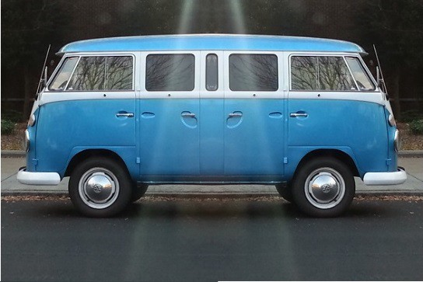

*Figure 1: Horizontal Mirror*

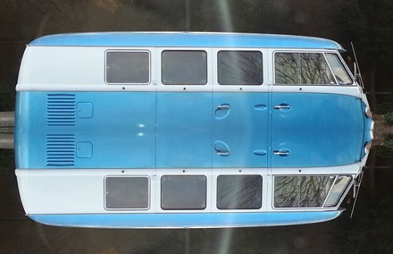

*Figure 2: Vertical Mirror*

1. In the Activity Guide read pages 14 to 16.
2. On pages 15 and 16 complete the exercises

Name:

Picture Lab: Worksheet 7

Activity 7 - Mirroring part of a picture

### Overview – Mirroring part of an image

Now that we have a working program to mirror an entire image either vertically or horizontally we will explore mirroring parts of an image.

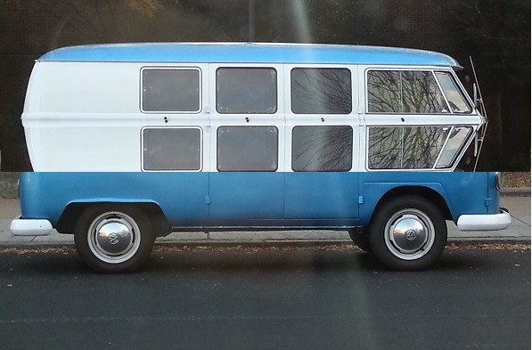

1. In the Activity Guide read pages 17 to 18.
2. On page 18 answer the questions: Question 1:

Question 2:

1. On page 18 work through exercises 1 to 3. Exercise 1:

Exercise 1 cont.:

Exercise 2:

Exercise 3:

Name:

Picture Lab: Worksheet 8 Activity 8 - Creating a collage

### Overview – Collage

Using the techniques we have learned in the previous activities we'll combine them to create a photo collage.

1. Read pages 19 to 21 in the Student Activity Guide.
2. On page 20 do Exercises 1 to 2.

Name:

Picture Lab: Worksheet 9 Activity 9 - Simple edge detection

### Overview – Edge Detection

This technique is common in photo processing software like Photoshop. It uses sharp changes in adjacent colors to find the edges of objects.

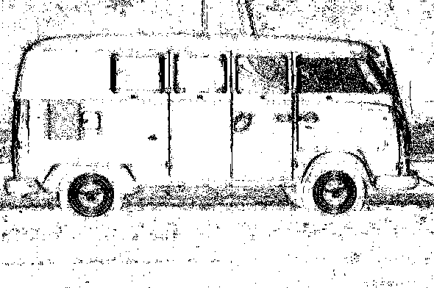

1. In the Student Activity Guide read pages 21 to 22.
2. Do exercises 1 to 2.