

University of Brighton Computing Division

CI536 Integrated Group Project

FlashLearn Quiz System Report

Group members:
- Charles Rios
- Emmanuella Onwubiko
- Jason Nylander
- Neve Leach
Lab Tutor: Nikolaos Polatidis

Word Count ___ 3000 - 5000

1. Introduction 3
2. Methodology 4
2.1 Project Management Approach 4
2.2 Development Tools & Environment 4
2.3 User-Centred Design 4
Example Persona: 5
2.4 Testing Strategy 5
3. Product Description 6
3.1 Requirements 6
Functional Requirements 6
Non-Functional Requirements 6
3.2 Design: Interface and software 6
3.3 Implementation 10
3.4 Testing 12
4. Legal & Ethical Issues 12
5. Critical Review 14
6. References 16
7. Appendices 17
Appendix 1: Record of Team Meetings 17
This appendix contains a summary of weekly team meetings conducted during the development of the project. Meetings were used to assign tasks, review progress, and resolve implementation issues. 17
Appendix 2: Source Code and Repository 17
Appendix 3: Project Management (Trello Board Screenshots) 18
Appendix 4: Additional Interface Screenshots 21
Appendix 5: Additional Resources 22

Introduction
As students, it is necessary to study and keep track of topics you struggle with so you can improve and further your subject knowledge. From this statement, our project's goal is to implement an interactive website that acts as an educational tool; where users can create and view their own deck of flashcards. This report examines the workflow behind the development of our chosen task, elaborating on the selected features we incorporated to elevate our programs functionality. It outlines the challenges we faced as a team and how we surmounted them.
Alongside our focus of flashcards, we aim to create a login page for user authentication. This will take the users personal data and store it in a secure database. Using accounts, we can integrate an analytics system where users can visualise their score history and accuracy percentage, allowing them the benefit of seeing their progress. With this data, an algorithm can establish which flashcards the user struggles with through a quiz system; following the simple logic of spaced repetition (ScienceInsights, 2026). If the question is answered incorrectly, the more frequently it should appear. If the question is answered correctly, the less frequent it should appear.
For user experience enhancement, the website should be intuitive and adhere to accessibility standards. Stylistic choices made will reflect a professional tone and be minimalistic so as not to distract users from the websites purpose: education. Usability must be prioritised in the design, with interactive cards that present questions and reveal answers on demand, supported by a spaced repetition system. To ensure a positive UX, we intend to carry out an observational study to test the effectiveness of the website and assess the accessibility. We will consider, record and implement any suggestions we deem reasonable from the participants.
We have divided the workload equally amongst ourselves, assigning specific roles to one another to strengthen our groups efficiency through streamlined teamwork, to deliver progress of our project in a professional and timely manner - ensuring we meet our own self-imposed deadlines. This was done using websites such as Trello to track our development process, and by holding regular meetings in the library to keep each other informed, offering assistance when needed.
Full demonstration video

Methodology

Project Management Approach
This project used iterative development and regular team collaboration. Weekly meetings were held as an opportunity to review group progress, assign tasks and address any issues. Trello was used to organise project features such as flashcards, quiz systems, and analytics into manageable components, and to track what had been completed and what was still being worked on.
An iterative approach was selected so that features such as multiple-choice quizzes, deck management, and theme customisation could be implemented incrementally. This allowed the team to test functionality regularly and refine the user experience based on ongoing feedback
Git was used to manage version control, with separate branches being used for project development (e.g. database models, quiz system). This helped to reduce merge conflicts, and the pull requests enabled peer review before safely integrating.

Development Tools & Environment
The system was developed using Django (Python) for backend functionality and HTML, CSS, and JavaScript for the frontend. Django was chosen because of its built-in support for database management, routing, and rapid prototyping
GitHub was used for version control and team collaboration; it allowed multiple team members to work on different project features simultaneously before integrating them all together. The development environment consisted of a local server setup, which enabled iterative testing and debugging.

User-Centred Design
This project adopted a user-centred approach to ensure usability and accessibility, with the interface structured around a clear navigation flow: Overview à Decks à Flashcards/Quiz.
The application includes many features to ensure intuitive interaction, such as flashcard flipping, simple navigation controls, and quiz feedback. The interface also includes light and dark mode themes, allowing users to customise the visual experience according to their preference and improve readability in different environments.

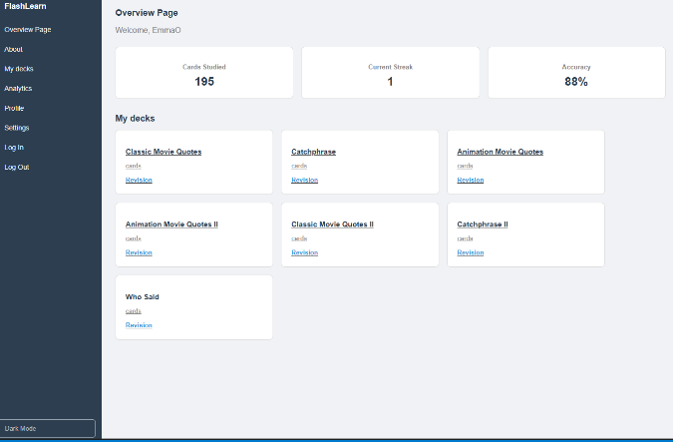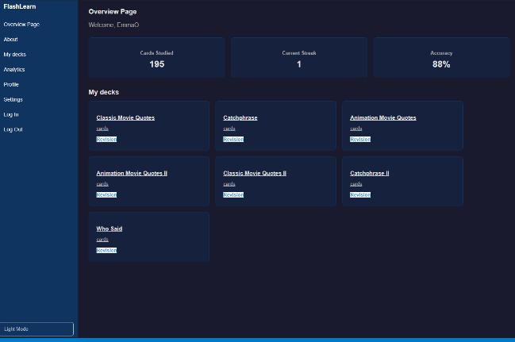
Figure 1: Light and dark mode interface comparison.
The target demographic for this application is university students and young adults who are familiar with digital learning tools such as Quizlet. These users are likely to prefer interactive and efficient revision methods, particularly for subjects that benefit from memorisation.
The application is designed to support this demographic through features such as flashcards, quiz-based learning, and simple navigation. The inclusion of themed decks (e.g. movie quotes and TV shows) also aims to increase engagement by incorporating familiar and entertaining content.
The interface prioritises ease of use, allowing users to quickly access decks, review flashcards, and complete quizzes with minimal friction.

Example Persona:
A typical user might be a second-year university student who prefers short, interactive revision sessions rather than reading large amounts of text. This user values quick feedback, simple navigation, and the ability to track progress over time.

Testing Strategy
Testing was conducted through iterative manual testing during development. Each feature, such as flashcard navigation and quiz scoring, was tested independently before integration. This shift-left testing approach was undertaken because identifying issues early on is often vital in full-stack projects, since multiple people are all collaborating to create a cohesive, functioning program. With this method, our team's efficiency will increase, since problems are solved before they escalate, and will not have to be fixed at a later part in our development process.
A series of UnitTests were implemented within the program to test the logic of the views.py and models.py modules.
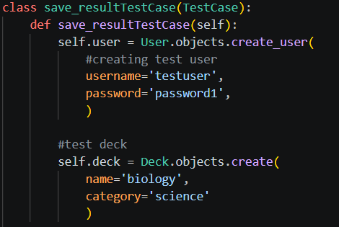
Figure 2: Unit Testing Example, found in tests.py.

Product Description

Requirements

Functional Requirements
The application was required to provide the following core functionality:
- Users must be able to create an account and log in securely.
- Users must be able to view flashcard decks.
- Users must be able to create, edit and delete flashcards.
- Users must be able to complete quizzes based on deck content.
- Quiz scores must be stored and displayed in analytics.
- Users must be able to navigate between pages using the sidebar.
- Users must be able to switch between light and dark mode themes.
- The system must support multiple-choice and text-answer quizzes.

Non-Functional Requirements
The system was also required to satisfy several non-functional requirements:
- The interface should be simple and intuitive for students.
- Pages should load quickly and respond smoothly to user interaction.
- The application should maintain visual consistency across pages.
- User data should be stored securely using Django’s authentication system.
- The website should be responsive across different screen sizes.
- The system should be maintainable through modular code and version control.

Design: Interface and software
The interface of the application was designed with simplicity and consistency in mind, allowing users to navigate the system without instruction. A persistent sidebar is present across all pages, providing access to the core areas of the application: Overview, My Decks, Analytics, About, and Settings. This supports a clear navigation flow and reduces cognitive load for users, aligning with the target demographic of students.
The application follows a consistent visual theme consisting of a dark navy sidebar (#2c3e50) and a light grey background (#f0f2f5). This contrast clearly separates navigation from content areas, while white card components are used throughout to display decks, statistics, and interactive elements in a clean and readable format.
After successful authentication, users are directed to the Overview page, which provides a summary of their activity and a dynamically generated list of available decks using Django template rendering.
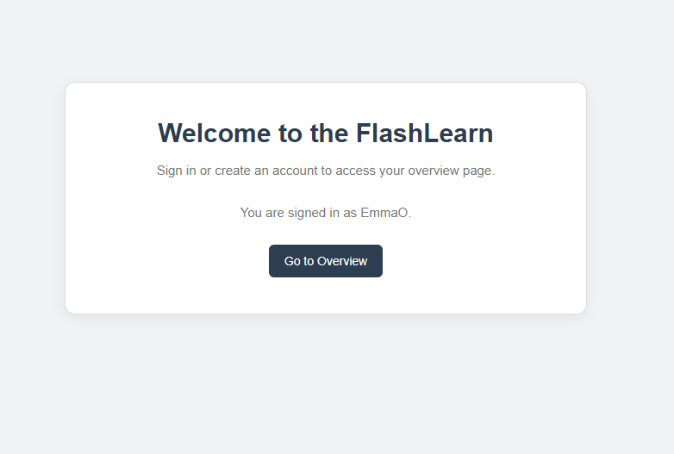
Figure 3: Dashboard page showing initial overview navigation.
This page acts as the central hub of the application, allowing users to quickly access their learning content and track progress at a glance.
The core learning experience is delivered through the flashcard study system. Each card presents a question first, after which the user clicks a “Show Answer” button to reveal the correct response. Instead of a linear navigation system (e.g. previous/reveal/next), the application uses a spaced repetition feedback mechanism.
After revealing the answer, users self-assess their performance using four rating options: Wrong, Hard, Good, and Easy. These responses directly influence the scheduling of the card within the spaced repetition algorithm, adjusting when the card will reappear for review.
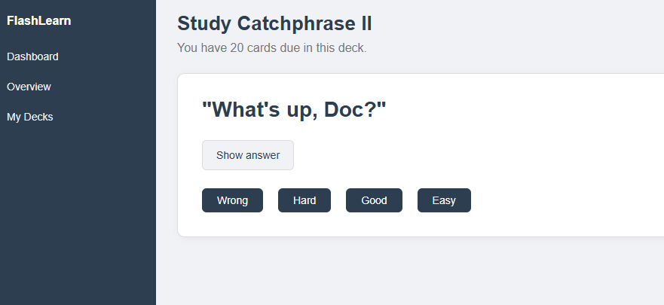
Figure 4: Flashcard study interface showing question display and answer rating buttons (Wrong, Hard, Good, Easy).
This approach encourages active recall and improves long-term retention by prioritising cards the user struggles with, while reducing exposure to well-known material.
The application also includes two quiz modes: a multiple-choice quiz and a text-based quiz. Both modes generate questions from deck content and store final scores in the database upon completion.
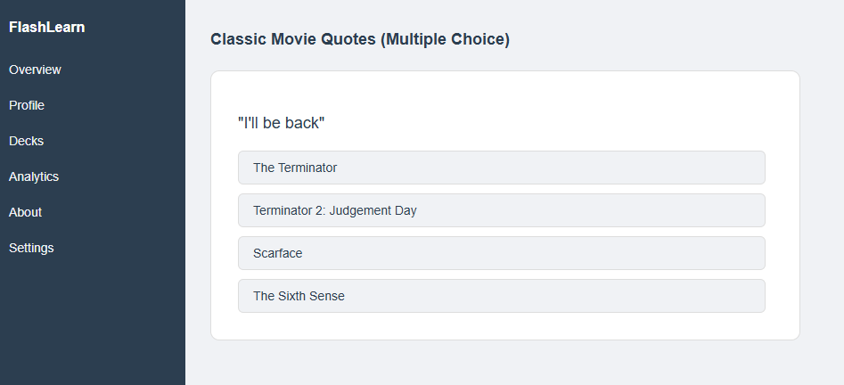
Figure 5: Multiple-choice quiz interface showing question selection and scoring system.
The Analytics page presents user performance data, including total quizzes taken, accuracy percentage, and average scores over time. This is enhanced using a Chart.js line graph to visualise progress.
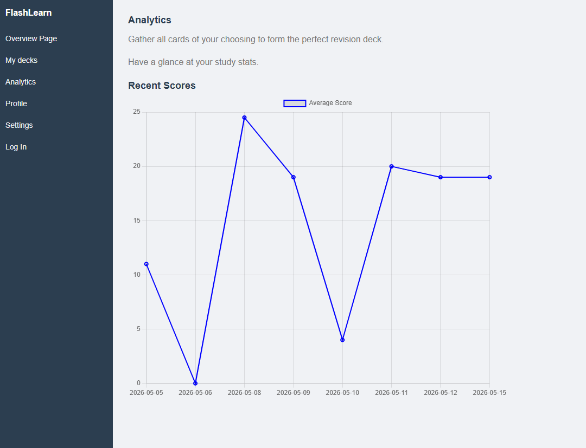
Figure 6: Analytics page showing performance graph generated using Chart.js
The Settings page allows users to manage preferences and account-related options, including theme switching and study data controls. All pages maintain a consistent layout and styling through a shared CSS stylesheet, ensuring a unified user experience across the application.

Figure 7: Light and dark mode interface comparison.
All screenshots represent the current implemented system at the time of submission and demonstrate key functional components of the application.

Implementation
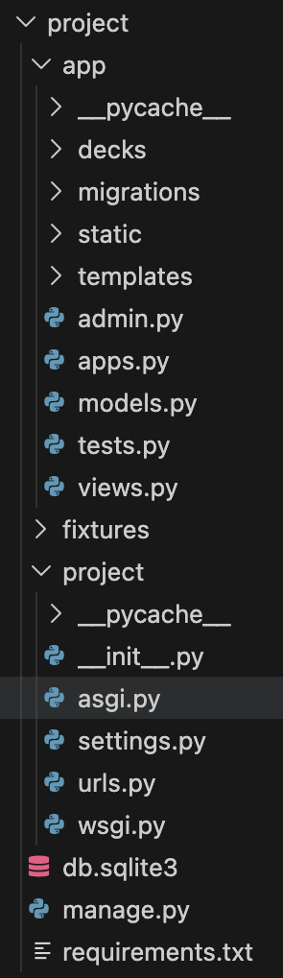
The project uses Django to build the website, which is a tool for creating websites that requires user accounts, pages, data storage, and server-side logic. Django handles tasks such as choosing the correct page, receiving request from the browser, connecting to the database, and managing users. This project follows a standard Django project structure. The project/manage.py file runs project commands, project/project/settings.py holds main settings configurations, and project/project/urls.py handles URL routing acting as a map that connects website addresses to the correct page logic.
Figure 8: Django Project Structure
SQLite is the database backend used for this project. The project also uses django-allauth for account features such as login, signup, logout, password reset, and profile pages. Users are directed to the dashboard where they are prompted to sign in or create an account. After entering their details, the user is sent to the overview page containing the project’s main features. After logging out, they return to the dashboard.
Stored information is separated into 4 components: Deck, Card, Result, and CardProgress. A Deck is a collection of flashcards. A name, owner, and category are stored within it as well as a is_default field. The owner is defined as the user who created the deck. The owner field is nullable due to every user starting with a set of starter decks. Any deck with a non-null owner value is a user created deck and not a starter one. A Card is a singular flashcard within a Deck, containing a question and an answer. A Result stores the outcome of a quiz attempt. This includes the user, score, total number of questions, score, and date taken. This provides the project with a foundation for demonstrating progress and analytics.
Each user’s progress for each individual Card is stored in CardProgress. This is important due to the fact 2 users might have the same card but at different progression levels. It stores card due date, number of repetitions, last review time, and how quickly future review times should increase (ease factor). No duplicate progress records are ensured so each user only contains 1 progress entry for each card.
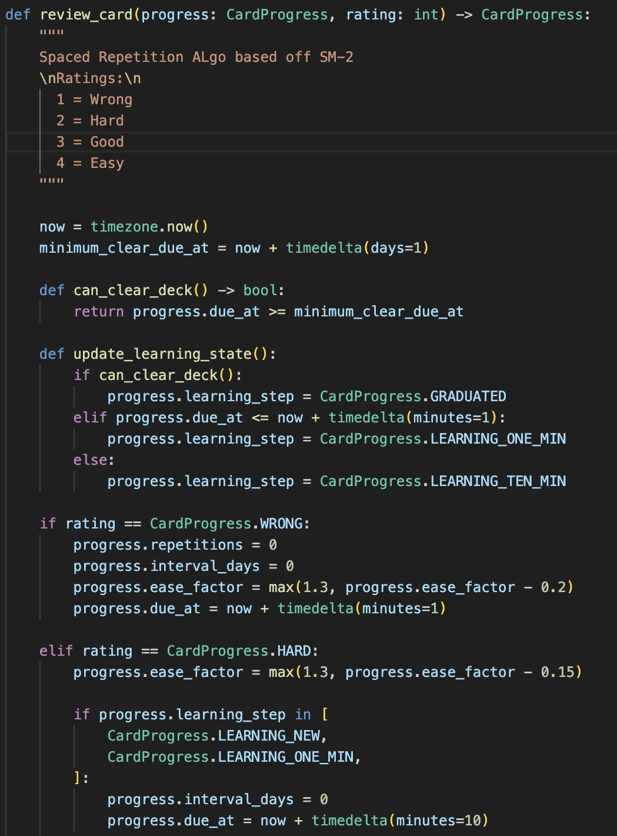
The revision system is handled in project/app/decks/services.py by a function called “review_card”. Answers are rated as Wrong, Hard, Good, or Easy. The application will then update the card’s next due date. Wrong will make the card due again very soon.
Figure 9: review card implementation
Hard slowly advances the cards due date (further than Wrong). Good and Easy move the card even further. Depending on a field in the system called “learning_step”, each answer will have varying due date changes.
Spaced Repetition is a way of studying information to retain your memory of it without revising it at unnecessary times. This means users do not study every card equally. Instead, the system focuses on which cards the user struggles with and pays less attention to those the user does well on.
The project/app/decks/selector.py file contains a function for selecting the cards that should be reviewed named “get_due_cards”. The logic selects cards that are overdue for the given user. The most overdue cards are studied first.
Main page behaviour is handled through the project/app/views.py file. The dashboard prompts users to sign in or create an account. The overview page contains a sidebar, greeting, deck list, and basic statistics. The decks page provides each deck with links for multiple study modes.
When a user creates a deck, the application attaches their account to it. The manage deck page provides a comprehensive list of cards inside the selected deck while providing functions for adding, deleting, or editing cards. The study material is customizable for the user.
Spaced repetition is used in the study page. Users can only study decks that they own or are shared (default starter decks with null owner fields). The application checks this and ensures every card in the deck has a valid progress record for the current user. During the studying process, the user is prompted with a question, reveals the answer, and rates their memory (Wrong, Hard, Good, Easy). The card’s progress is updated, and the next due card is rendered.
Two quiz modes were implemented. A typed answer quiz prompts a question while the user must type their answer back and a multiple-choice quiz that hides the correct answer among other answers from the same deck. Both quizzes keep track of score in the browser. After finishing the quiz, the final score is sent back to Django and saved as a Result.
The visual design is handled by css files in the project/app/static/app/css directory. A left sidebar, light page background, dark blue navigation, and white content cards are implemented through these css files.
The start decks are included in the project/fixtures/sample_data.json file. It contains the default starter decks that each user is provided. This allows for the application to be used right at start up.

Testing
Visual and performance testing revolves around the design and interactivity of the webpages in the front-end. All links to different webpages should be tested manually, as should the user login system. Furthermore, the intuitiveness of the page should be tested by an outside party who was not involved within the development process; for this, volunteers who fit our target demographic (students) were found and asked to navigate the website without direction. Feedback was provided, to further improve our programs user experience and design.

Legal & Ethical Issues
Ethically, it is our responsibility to ensure that nothing inappropriate or offensive is uploaded which can harm users, and in turn the reputation of the website; it’s intended to be used as an educational tool. This is a potential issue because the program can be interacted with by multiple users wherein, they can create their own content.
To be a trusted website used by respected institutions, this may cause further legal issues if the content isn’t regulated to some extent and a user perhaps uploads discriminatory or sexual content (College of Policing, 2020). To prevent this an admin system monitoring the contents of decks, or an algorithm implemented to detect discriminatory/inappropriate keywords may be implemented as a solution to combat this issue.
Furthermore, to be reliable, we must clarify that since the flashcard content is user-generated, there is margin for error - where entire decks could be factually incorrect. Whilst this isn’t a major ethical issue, it can still impact the website's image if misinterpreted by users, especially as it is anticipated to be used by students and false information may impact their studies/grades.
Though the program is intended to be used as an educational tool for studying, it may also be utilised as a trivia quiz software. Culturally speaking, spoilers for films/tv shows are generally frowned upon by a significant proportion of the population (Johnson B. & Rosenbaum J., 2018). Whilst this is lower on the ethical concerns list, it could be argued that it is unethical to not include a spoiler warning in a sense that it can upset users, principally regarding new and upcoming media. A solution to this is to implement a censor mechanic, or a statement on the website asking users to include a warning on their decks.
From a legal perspective, it is paramount to adhere to the Data (Use and Access) Act (2025) wherein we only collect relevant and necessary personal data from the user and specify what it will be used for. For analytical purposes and so users can make/save their flashcard content, they are asked to create their own account before proceeding. This requires they fill out two fields: username and password. It is our duty to protect this data in line with the law, and we would be liable if there were any leaks. Transparency with users is essential from both a business and legal standpoint as it is one of our goals to be a reliable website, therefore personal data will be processed legally and securely, and an option to delete their accounts should be provided alongside deleting their personal data from the database.
Copyright infringement may cause legal issues to arise, following the Copyright, Designs and Patents Act (1988) which states that it prevents your work from being distributed whether free of charge or for sale, and from being put on the internet. If flashcards are directly plagiarised from other websites/resources that have been copyrighted and they aren’t correctly referenced, then the user may be liable to civil or criminal penalties. This, therefore, discourages users to violate the Copyright Act (1988).
Whilst not illegal, the act of plagiarism is unethical and moreover discouraged. The websites reputation relies on the practicality of flashcards so plagiarised content is unnecessary from an educational view: you learn as you create the cards, then review incessantly until committed to memory.
To accurately assess the UX of our program, we recruited several students to participate in a study - they are the prime demographic that our website is aimed at. Evaluating this ethically requires a participant information sheet detailing all that is required, following a participant consent form which if all boxes are checked and signed by both the participant and the researcher the study may continue. This study consists of three activities for the participants to engage: a pre-test questionnaire to grasp their past knowledge of flashcard software and general IT prowess, an observational study to gain insight into how they interact with the program when directed to perform specific commands, and a post-test questionnaire to assess their opinions of the program alongside an opportunity to give feedback regarding their user experience. This is paired with a beforehand risk assessment which the participants are privy to: low risks of COVID-19 infections (as they are assessed in person), eye/back strain from computer usage, and data leaks from the study.

Critical Review
In review, our projects target was to create a program used as an educational tool, capable of creating decks of customisable flashcards for users to test their knowledge. Other criteria include: a clear and accessible user interface, a user authentication system, and graphical representation of data.
As a group we have successfully completed our goal, doing so by dividing work into smaller subsets: front-end and back-end to create our full stack application.

The front-end - being the interactive website display – consists of six webpages, each serving a core function of our mission. Stylised for maximum UX, thereby creating an intuitive design, easy to navigate between the different pages. This was manifested using a side-panel, avoiding a cluttered dashboard, keeping in line with accessibility standards (Gov.UK, 2012). Links to the other webpages are clearly labelled on the side panel, with a white font and navy background, this high contrast design further aids users who are hard of sight, making our program more accessible. A Light and dark mode toggle was implemented, allowing users to switch between themes to reduce eye strain and customise their experiences.
The dashboard features a profile webpage which provides users with options to manage their account details. A light and dark mode toggle is also available throughout the site, reducing potential eye strain. To further improve in terms of accessibility, an option to increase/decrease text size could aid those with impaired vision. Another incentive of creating the settings page is that it provides an area for the user to enter/edit their account details, linking to the next feature: analytics representation.
Analytics may only be collected for a user if they have an account. We chose to implement this feature as it benefits the user as it displays progress made in decks. The accuracy score is presented to the user on the Overview webpage. On the Analytics webpage: total quizzes taken, average score, accuracy % and total cards studied are displayed. To improve this from a user perspective, a graphical representation was provided to help visualise their progress - rather than looking at percentages and numeric values, and perhaps lacking context. Additionally, this enhances our websites aesthetics to appear more professional, through our handling of personal data, transforming it into a clear delineation of values for user interpretation.
The flashcard study system presents one card at a time, displaying the question first. The user reveals the answer by clicking ‘Show Answer’, then self-assesses using four rating system options: Wrong, Hard, Good and Easy. These ratings feed directly into the spaced repetition algorithm, determining when the card will appear next. This simple design further keeps in with the professional tone we intend to convey, encouraging a clear mind for user knowledge retention.
A combination of HTML, JavaScript and CSS achieved this result.

The back-end of the program was written primarily in Python, utilising Django. This decision was made because it implements an API route that integrates the front-end to the back-end seamlessly without a separate server – perfect for a full-stack application such as ours. Django provides a good framework for future projects as it is widely used by many major companies such as Spotify, therefore it is important to learn as it is often considered industry standard (Shajahan S. 2026).
The workflow of the back-end began with creating a database model in which the Django templates can be used to render the dynamic deck and flashcard system. This database is moreover necessary to handle personal data of users.
User authentication personalises the website to each individual user. To test run this, we created a ‘user profile’ in which a mock set of flashcards and data are involved. Username and password fields are taken, so users can login or sign up, along with the option for if the password was forgotten. We implemented this to be reliable and keep in line with the Data Protection Act (2025), so users still have access to their personal data if they can’t login.
The flashcard functionality, due to this being the primary focus of the project statement, was implemented next. We used the classical logic of spaced repetition, applying this through tracking the date that users interact with certain cards of the decks, and correlating it with whether the question was answered correctly. It is necessary to retain this data as this learning technique, often associated with flashcard studying, requires users to return to the same knowledge repeatedly long-term, therefore essential for analytical purposes. To improve, writing notes or a comments system to further aid memory retention.
For the analytics system, the back-end involves performing the calculations necessary for collecting and displaying the data: from accuracy percentages to creating lists to store the dates of practiced flashcards results. A method of improvement, as suggested by a test user, would be that a ranked system could be implemented; users who practice the same decks can compete for the highest accuracy score – a motivating factor which can merit those studying.

To conclude we have expanded upon our knowledge of full-stack development and project management, successful in our endeavours to improve upon the issue of tracking and closing the comprehension gap of students.

References
College of Policing (2020) Online Hate. Available at: Online hate | College of Policing (Accessed: 27/04/2026).
Gov.UK (1988) Copyright, Designs and Patents Act. Available at: Copyright, Designs and Patents Act 1988 - Consolidated (Accessed: 29/04/2026).
Gov.UK (2012) Universal Design Principles. Available at: Universal design principles | Accessibility manual - Department for Education. (Accessed: 29/04/2026).
Gov.UK (2025) Data (Use and Access) Act 2025: data protection and privacy changes. Available at: Data (Use and Access) Act 2025: data protection and privacy changes - GOV.UK (Accessed: 29/04/2026).
Johnson B. & Rosenbaum J. (2018). (Don’t) Tell Me How It Ends: Spoilers, Enjoyment, and Involvement in Television and Film, Media Psychology vol. 21, pages 583-609. Available at: (Don’t) Tell Me How It Ends: Spoilers, Enjoyment, and Involvement in Television and Film. (Accessed: 27/04/2026).
ScienceInsights (2026). What Is Spaced Repetition and How Does It Work?. Available at: https://scienceinsights.org/what-is-spaced-repetition-and-how-does-it-work/ (Accessed: 25/04/2026).
Shajahan S. (2026) Reasons for Selecting Django as the Best Framework for Full Stack Development. Available at: Full Stack Development with Django: Why It’s Ideal. (Accessed: 29/04/2026).

Appendices

Appendix 1: Record of Team Meetings

This appendix contains a summary of weekly team meetings conducted during the development of the project. Meetings were used to assign tasks, review progress, and resolve implementation issues.
Figure A1: Example meeting record showing task allocation and development discussion.
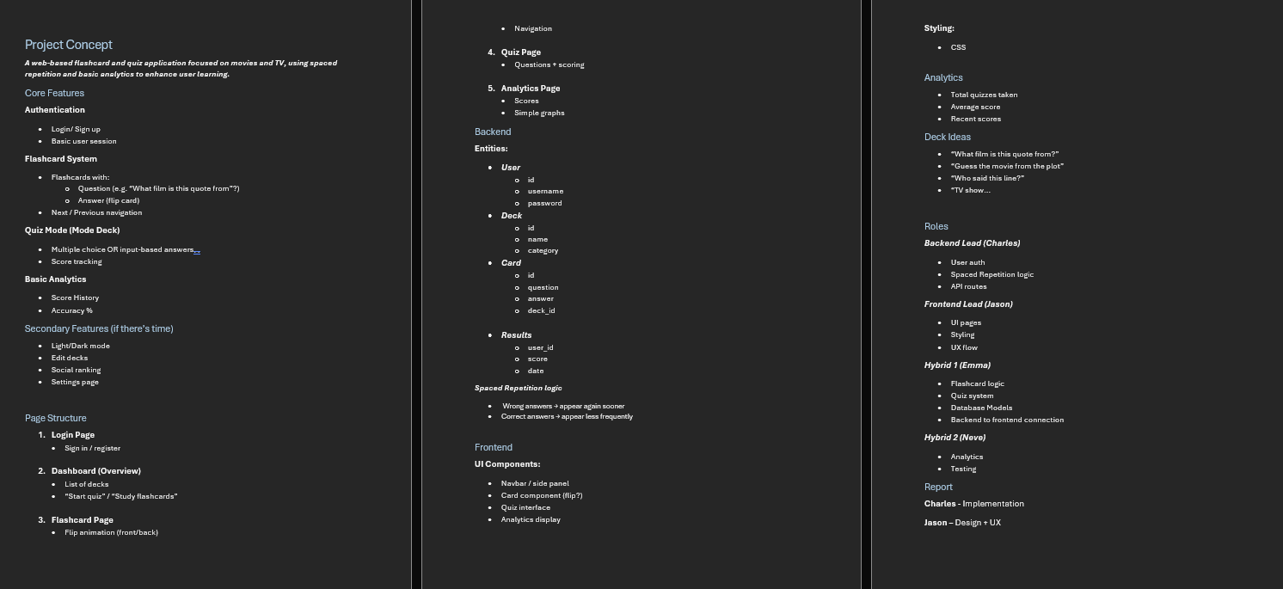
Week-by-week discussions included:
- Week 1: Project setup, GitHub repository initialisation, Django configuration
- Week 2: Database model design (Deck, Card, Result, CardProgress)
- Week 3: Flashcard system implementation and UI design
- Week 4: Quiz system development (multiple choice + text input)
- Week 5: Analytics implementation and Chart.js integration
- Week 6: Testing, bug fixing, and UI improvements
- Week 7: Final integration, documentation, and report preparation

Appendix 2: Source Code and Repository
All source code for the project is maintained in a GitHub repository for version control and collaboration.
Github Repository:
crios-uob/CI536_Group_Project
The repository includes:
- Django backend (views, models, URLs)
- Frontend templates (HTML)
- Static files (CSS, JavaScript)
- Database models and migrations
- Quiz and spaced repetition logic
Figure A2: GitHub repository showing project structure and commits.
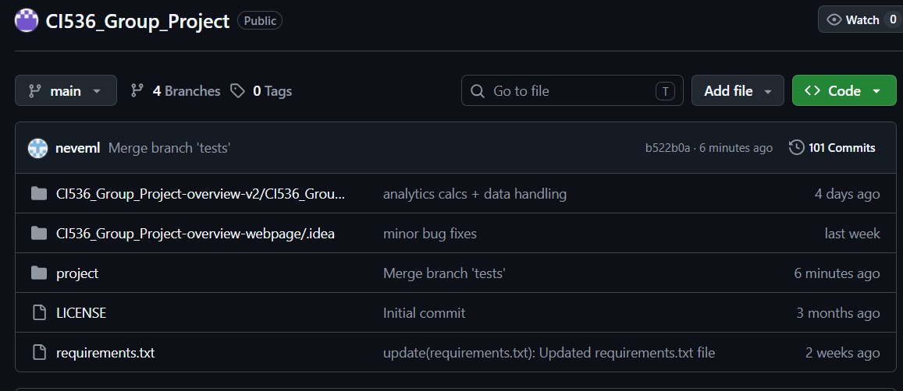
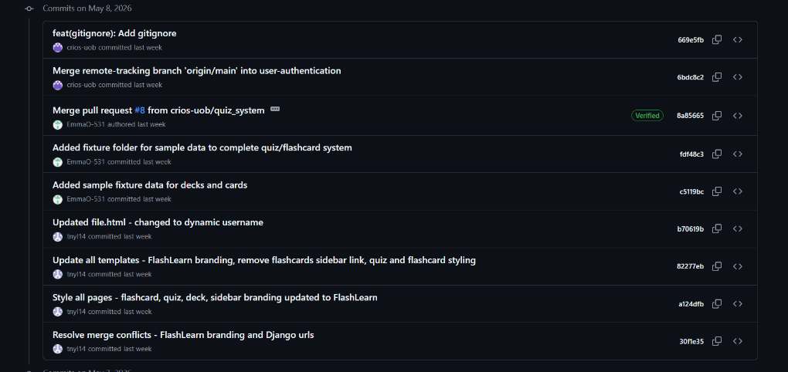

Appendix 3: Project Management (Trello Board Screenshots)
Project tasks were managed using Trello in an iterative workflow. Each feature was divided into manageable tasks and tracked across development stages.
Week 1:
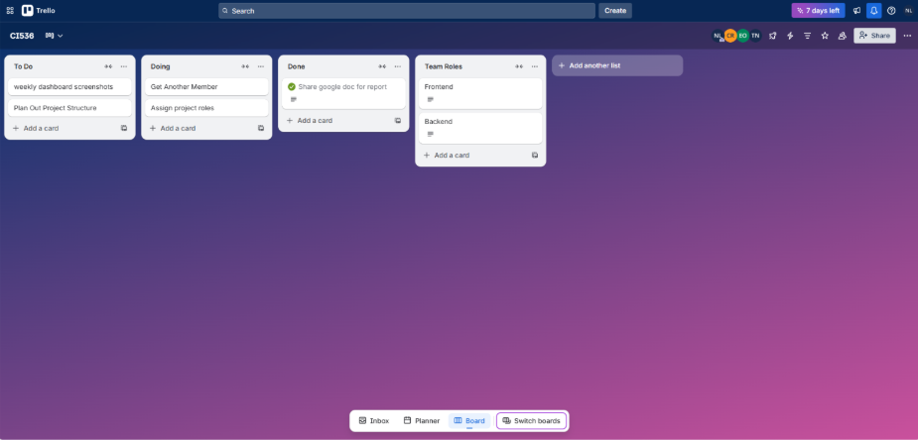
Week 2:
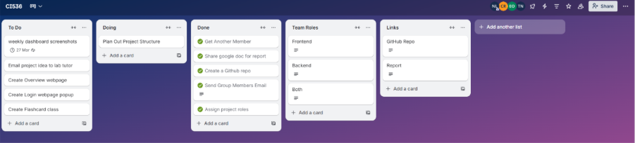
Week 3:
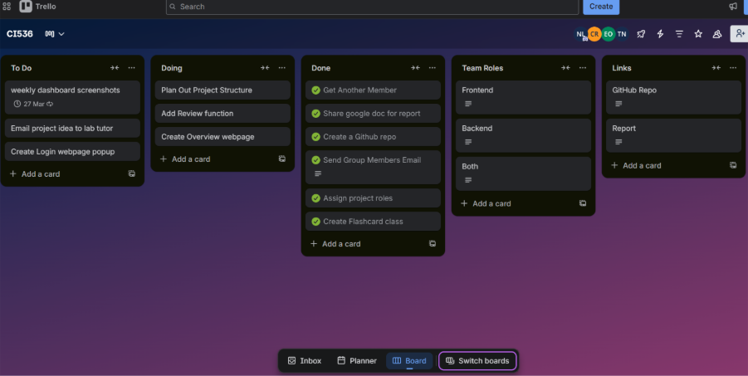
Week 4: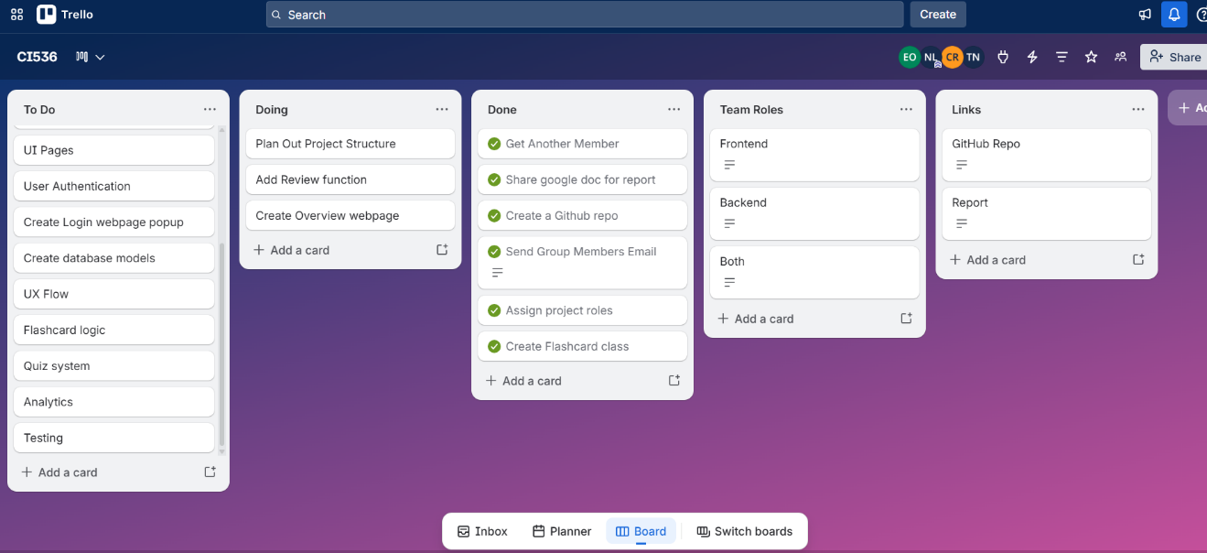
Week 5:
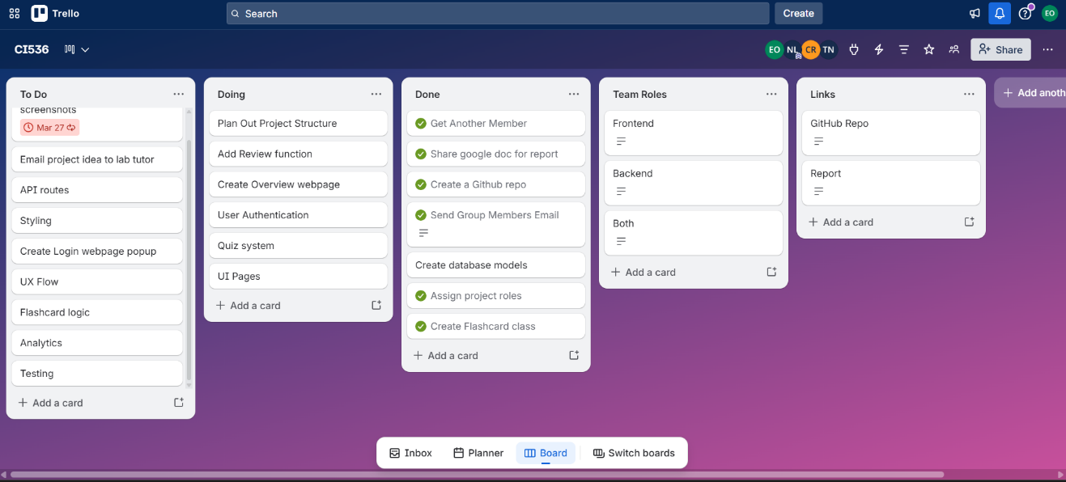
Week 6:
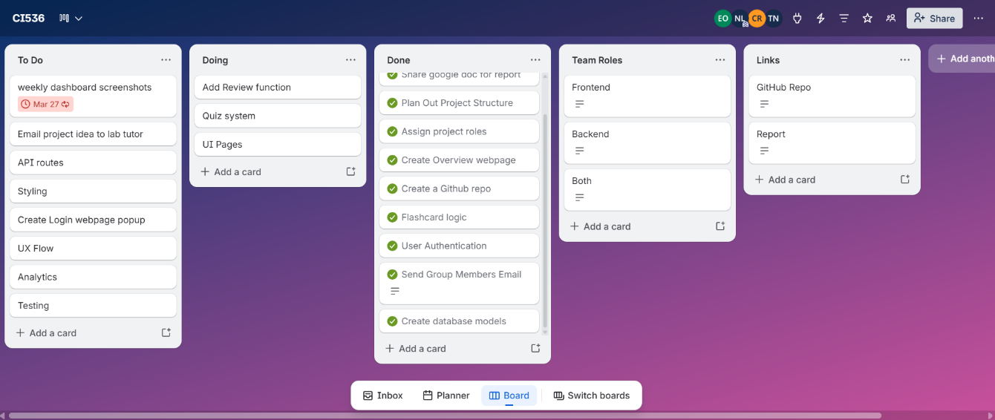
Week 7:
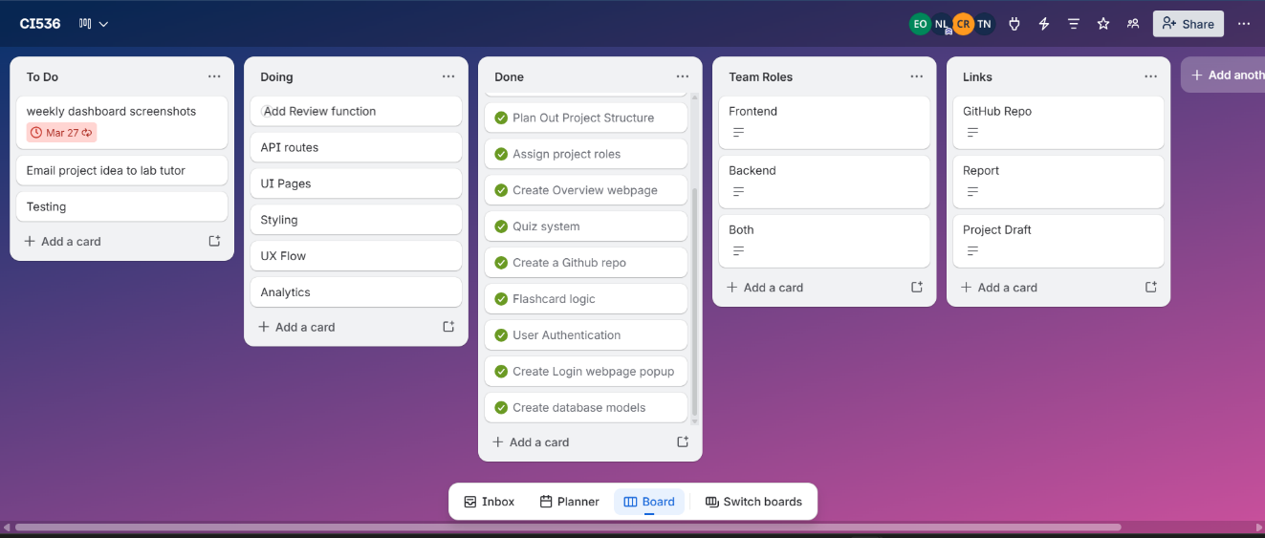

Appendix 4: Additional Interface Screenshots
User Authentication Page
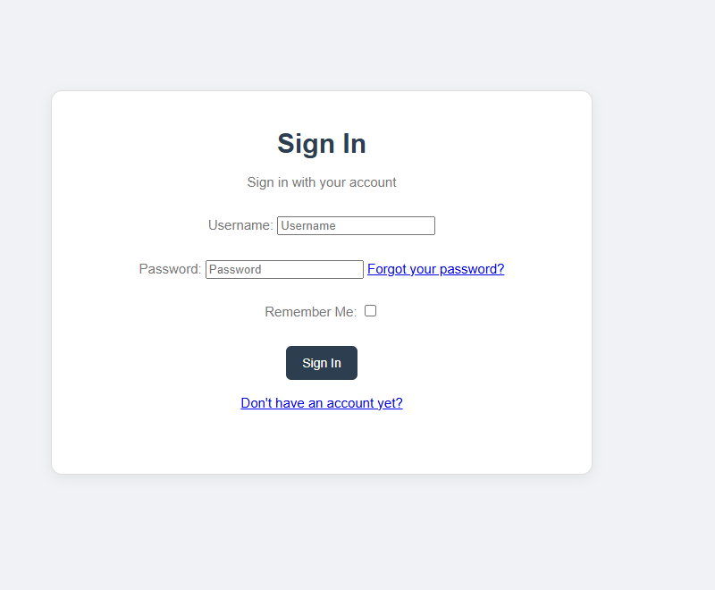
Figure A10: User login page using Django authentication system
User Settings Page
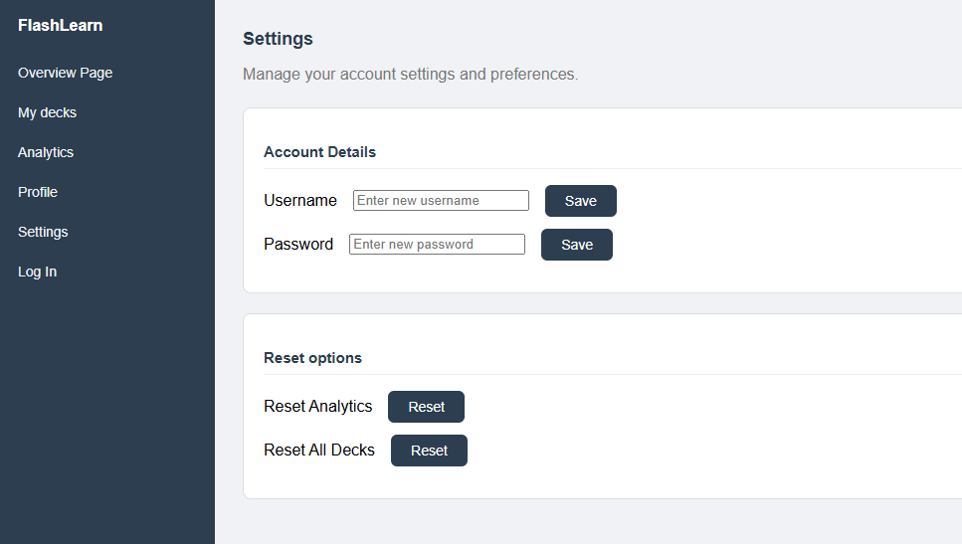
Figure A10: Settings page allowing theme and user preferences management

Appendix 5: Additional Resources
Django Administration Panel
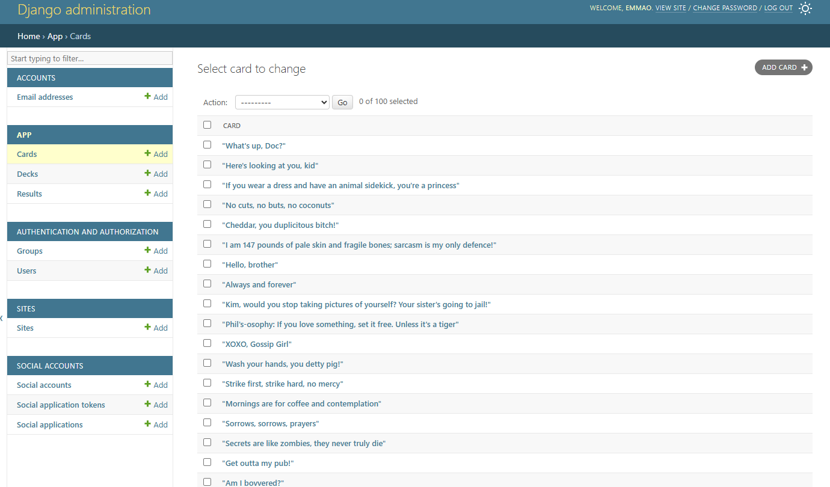
Figure A11: Django admin interface showing database models (Deck, Card, Result) and stored user data
This section includes supplementary materials used during development.
- Django documentation: https://docs.djangoproject.com/
- Chart.js documentation: https://www.chartjs.org/docs/
- Spaced repetition research reference (ScienceInsights, 2026)
- UX testing feedback notes from student participants
- Sample dataset used for testing decks and cards

